RTS Access Paratransit Plan

Summer 2019 to Summer 2020
APPROVED BOARD POLICY
Version 1, Approved by the Board of Commissioners on June 27, 2019
Table of Contents
Description of Submitting Entity 1
Introduction 2
Purpose of a Paratransit Plan 2
Glossary of Terms 2
Section 1: Description of the Fixed Route, Paratransit, and Demand Responsive Services 4
Exhibits for Section 1 15
Section 2: Plan to Provide Comparable Paratransit 42
Exhibits for Section 2 59
Section 3: Process for Determining A D A Paratransit Eligibility 80
Exhibit for Section 3 81
Section 4: Public Participation Process to Develop the Plan 103
Exhibits for Section 4 104
Section 5: Efforts to Coordinate with Other Entities 148
Section 6: Endorsements or Certifications 148
Exhibits for Section 6 149
Section 7: Plan Updates 163

Description of Submitting Entity
This section provides identifying information for Rochester Genesee Regional Transportation Authority ("R G R T A" or "the Authority"), as required in Subpart F, §37.139 (a)
R G R T A provides public bus transportation in Genesee, Livingston, Monroe, Ontario, Orleans, Seneca, Wayne, and Wyoming Counties. In Monroe County, R G R T A provides fixed route service and complementary paratransit service.
R G R T A Mission Statement: We partner with the communities we serve to provide safe and sustainable mobility, offering better access, frequency, and reliability.
R G R T A Vision: The innovative mobility choice.

Introduction
The Americans with Disabilities Act of 1990 (A D A) prohibits discrimination against individuals with disabilities with regard to their access to public transportation.
R G R T A provides fixed route bus service through Regional Transit Service ("RTS"). For people whose disabilities prevent them from using RTS all or some of the time, R G R T A provides complementary paratransit service through RTS Access. Federal regulations require that 1) RTS service is accessible to people with disabilities, and 2) the RTS Access service is comparable to RTS. R G R T A must ensure that the level of service for paratransit-eligible people who ride RTS Access is comparable to the level of service for people without disabilities who ride RTS.

Purpose of a Paratransit Plan
In 1991, the Code of Federal Regulations (CFR) issued criteria for paratransit service in “Title 49 – Transportation, Subtitle A – Office of the Secretary of Transportation, Part 37 – Transportation Services for Individuals with Disabilities, Subpart F – Paratransit as a Complement to Fixed Route Service” (“Subpart F”). Subpart F sets forth the general requirement for R G R T A to develop a Paratransit Plan, to submit the Plan to the Federal Transportation Administration (FTA), and to perform updates annually. R G R T A uses the A D A Paratransit Plan (“Plan”) as a tool to compare the service components of RTS and RTS Access and ensure compliance with Subpart F. This Plan will use the term “customer” to refer to any individual certified as A D A-paratransit eligible through the RTS Access eligibility certification process. In 1996, the Department of Transportation (D O T) amended the regulations to eliminate the requirement to update a paratransit plan annually. As a recipient of federal funding, R G R T A is still required to certify to the FTA annually that it has met and continues to meet the requirements under Subpart F. R G R T A performs this certification in the annual FTA Fiscal Year Certifications and Assurances. Exhibit 14 Certifications and Assurances provides an example of this certification.

Glossary of Terms
Bike Share: Bike Sharing is a program in which bicycles are available for shared use to individuals on a short-term basis. RTS and the City of Rochester offer bike sharing through their partner, Pace. More information is at myRTS.com/Rochester-Bike-Share-Program.
Community Mobility Zone (CMZ): Community Mobility Zones are areas with historically low fixed-route ridership. To improve service, RTS will provide new demand responsive service with technology-rich, customized mobility solutions that provide more flexible, reliable transportation.
Complementary Paratransit: Comparable transportation service required by the A D A for individuals with disabilities who are unable to use fixed route transportation systems for some or all of their trips. The requirement applies to all fixed route bus service except for commuter bus routes. Comparability is defined and measured by the following characteristics: hours and days of service; and service area; and response time (trip reservations); and fares; and operating without regard to trip purpose; and absence of capacity constraints.
Crosstown Route: Crosstown routes are new routes that are part of the fixed-route network. These routes neither start nor end at the RTS Transit Center, but are located in such a way to provide added connections to many routes that do serve the RTS Transit Center.
Connection Hub: A Connection Hub is a designated point in the transit system where customers may transfer between multiple RTS routes, CMZ solutions or other modes of transportation in order to reach their final destinations. Some of these other modes may include RTS On Demand, vanpools, and bike shares.
Demand Responsive System: A system of transporting individuals, including the provision of designated public transportation service by public entities, which is not a fixed route system. Demand responsive systems encompass a variety of service types including traditional dial-a-ride service, taxi subsidy service, vanpool service, and route deviation service. A key characteristic of demand responsive systems is that customers must contact the service provider to request service. True demand responsive services do not require complementary paratransit.
Fixed Route System: A system of transporting individuals, including the provision of designated public transportation service by public entities, on which a vehicle is operated along a prescribed route according to a fixed schedule. The fixed route system is the name of the network of routes on which we operate our 40- and 60-foot buses. This is the core of the public transit system. Ninety-five percent of our customers are served by the fixed route system.
Long Line: A long line refers to the full route that is partially covered by a short line route as part of the fixed route transit plan. The long line makes trips that cover the entire portion of a route. For example, the 22 Lake Long Line runs from the RTS Transit Center all the way to Charlotte Beach.
RTS On Demand: RTS On Demand is a transit option in which an A D A- accessible small bus or van provides demand responsive service in the CMZs, when requested by a customer. Customers will be able to request a ride through an RTS app, the RTS website or by calling RTS.
Short Line: A short line is a segment of a route that is part of the fixed route system. Short Line routes are part of the Frequent network of routes that will provide 15 minute service from 6:00 AM to 6:00 PM on weekdays. The short line makes trips that only cover a portion of a route that is completed by the Long Line. For example. The 22 Lake Short Line runs between the RTS Transit Center and the Connection Hub proposed in the Dewey/Ridge/Lake area.
Vanpool: A Vanpool is a transit option in which people commute together to and from similar geographic locations in a van or SUV. Vanpool commuters share driving responsibilities, rotating daily or weekly. RTS currently offers vanpooling through its partner, Commute with Enterprise. More information is online at myRTS.com/vanpool.

Section 1: Description of the Fixed Route, Paratransit, and Demand Responsive Services
This section is an overview of the R G R T A business structure. It describes the types of service, the fare structure, and the days/hours of service for RTS and RTS Access as it is expected to be implemented in the summer of 2020.

1.1. Business Structure Overview
The Rochester Genesee Regional Transportation Authority (“R G R T A” or “the Authority”) is a public benefit corporation and a component unit of the State of New York. Created in 1969 by an act of the State Legislature, the Authority is charged with the continuance, further development, and improvement of public transportation and other related services within the Genesee/Finger Lakes region. Since 1969, membership in the Authority has grown to eight counties with a total land area of 4,350 square miles and population of approximately 1.2 million. Current member counties include Genesee, Livingston, Monroe, Ontario, Orleans, Seneca, Wayne, and Wyoming. R G R T A’s services encompass urban, suburban, and rural areas, as well as complementary paratransit service incompliance with the Americans with Disabilities Act (A D A). The Authority has eleven incorporated business units.
The R G R T A business unit oversees the daily operation of ten subsidiaries.
The RTS (Regional Transit Service, Inc.) subsidiary provides fixed route service in Monroe County. Starting in the summer of 2020, RTS will provide a redesigned fixed route service and a new demand response service in Monroe County.
The RTS Access (Lift Line, Inc.) subsidiary provides complementary paratransit service in Monroe County. Starting in the summer of 2020, RTS Access will provide complementary and supplemental paratransit service in the redesigned RTS service area in Monroe County.
Seven subsidiaries currently provide demand responsive and countywide route deviation service in their respective counties. These services will not change as part of the redesign. The subsidiaries are referred to collectively as Regionals and include the following incorporated units:
- RTS Genesee (Batavia Bus Service, Inc.) in Genesee County
- RTS Livingston (Livingston Area Transportation Service, Inc.) in Livingston County
- RTS Ontario (County Area Transit Service, Inc.) in Ontario County
- RTS Orleans (Orleans Transit Service, Inc.) in Orleans County
- RTS Seneca (Seneca Transit Service, Inc.) in Seneca County
- RTS Wayne (Wayne Area Transportation Service, Inc.) in Wayne County
- RTS Wyoming (Wyoming Transit Service, Inc.) in Wyoming County
The GTCS (Genesee Transportation Council Staff, Inc.) serves as the host agency in order to provide staff, office space, financial backing, and other administrative support to the Genesee Transportation Council (GTC) which is the metropolitan planning organization (MPO) for R G R T A. Federal laws require M P O s to exist in each metropolitan area receiving federal transportation funds. The GTC is responsible for policy setting and decision making for transportation planning and programming activities in the Rochester urbanized area. R G R T A administers the central staff of GTCS, per an agreement enacted by New York State in 1977.
The City of Rochester is the region’s economic and cultural center. Most of the current and potential bus riders live and work in Monroe County and the City of Rochester. The fixed route system in Monroe County was designed decades ago when downtown Rochester was the center of the community from every perspective – economically, residentially, and culturally. Since then, the demographics of the area have changed, the locations of employment centers have changed, and the number of available mobility options has changed. In 2017, R G R T A launched an initiative called “Reimagine RTS” to redesign the public transit system in Monroe County. The process has five stages occurring from 2017 to 2020.
Stage One (2017)
During Stage One, R G R T A determined the new structure of the RTS fixed route system. Stage One of the project involved a wide variety of stakeholders. This included RTS customers and employees, business partners, community and neighborhood organizations, advocacy groups, elected officials, business owners, community members, potential future customers, and residents of Monroe County. To assist with technical analysis and community engagement during Stage 1, RTS engaged the services of a consulting team comprised of Transportation Management & Design, Inc. (TMD) and Highland Planning. TMD completed a study and provided recommendations for the redesigned system. R G R T A shared a draft of TMD’s recommendation to get feedback from the community. R G R T A conducted outreach to the community throughout Stage 1 to ensure customers, employees and stakeholders were involved, and that their priorities were represented in TMD’s recommendation.
Stage Two (2018)
During Stage Two, R G R T A worked with the IBI Group to identify solutions for Community Mobility Zones.
Stage Three (2019)
Stage Three focused on determining the solution for a paratransit service that complies with all necessary regulations and maintains service for all current customers.
Stage Four (2019)
The final proposed Plans and reports go before the R G R T A Board of Commissioners for approval. Upon approval, the preparations for implementing the redesigned system will begin.
Stage Five (Summer of 2020)
Stage Five is the implementation of the redesigned transit system for Monroe County, which will include fixed route, paratransit, and demand responsive service, and will go live in the summer of 2020.
This A D A Paratransit Plan will compare the redesigned RTS fixed route service and resulting RTS Access complementary paratransit service.

1.2. Description of Reimagine RTS Effective in the Summer of 2020
The fixed route system will offer the following features.
- Routes that run north to south and from east to west; and
- Four service tiers; and
- Two levels of service frequency; and
- Coverage that is consistent because all fixed routes run Monday through Sunday.
Because the fixed route network will cover a smaller geographic area than today’s system, the required paratransit service area will change. The goal is to ensure that all paratransit trips completed during phases one, two, and three of the Reimagine RTS project are able to be completed in the new paratransit service area. As a result, RTS Access will feature the required complementary paratransit service area, three levels of supplemental service to extend coverage beyond what is required, and subscription service.
RTS will provide demand responsive service in areas that do not support fixed-route transit due to low densities, disconnected development patterns, or poor road network structure. The demand responsive system will feature seven Community Mobility Zones (CMZs) and Connection Hubs to allow customers to access the fixed route system.

1.3. Description of Redesigned Fixed Route Service in Monroe County
This subsection describes the fixed route system as required in Subpart F, §37.139 (b) of the federal regulations.
The RTS campus is located at 1372 East Main Street, Rochester NY 14609 (Monroe County). The campus facilities house the RTS staff, maintain the RTS fleet, and function as R G R T A headquarters. The RTS Transit Center is located at 60 St. Paul Street, Rochester, NY 14604 (Monroe County) and serves RTS buses.

1.3.A. Fixed Route Service Tiers
Leading up to the summer of 2020, the RTS fixed route system will include 55 fixed routes with service tiers of Urban All Day, Express Transfer, ROC-it, Urban Supplemental, Suburban, and University.
Effective in the summer of 2020, the system will include 39 fixed routes and the service tiers will be Core, Commuter, Crosstown/Suburban, and Subsidized. RTS will continue to provide service that accommodates the needs of school students and personnel within the redesigned network.

1. Core Service
There will be 22 Core routes. Short Line trips provide increased frequency for part of a route with high ridership. Long Line Trips travel longer distances. An example is the service on Monroe Avenue. The Short Line trip runs between the RTS Transit Center and Highland Avenue. The Long Line trip continues to the Connection Hub proposed near the St. John Fisher Park & Ride. There are four routes with this combination of Short Line and Long Line trips. Routes that either include a Short Line trip or have a structure that allows high frequency are in the Frequent Network. The Frequent Network has nine routes and one corridor. Routes in the Core tier also transport students to various schools in the urban core of Rochester, such as the Rochester City School district. These routes are open to the public.

2. Commuter Service
Commuter service means fixed route bus service, characterized by service that runs predominantly in one direction during peak periods, limited stops, and routes of extended length, usually between the central business district and outlying suburbs. The commuter service transports customers to Connection Hubs, where they can transfer to fixed route service. Under § 37.121(c), commuter bus services are not subject to the requirement to provide complementary paratransit service. The redesigned system has eight Commuter routes serving Avon, Brighton, Brockport, Hilton/Hamlin, Newark/Lyons, Eastview, Webster, and St. John Fisher Park & Ride.
These routes will provide service for customers commuting to and from work during the morning and evening commute times between these suburban areas and Downtown Rochester. RTS will continue providing service to these areas of the community using a smaller vehicle that is more appropriate for the number of customers using the route.

3. Crosstown/Suburban Service
Crosstown routes connect communities without traveling downtown. While these routes do not serve the RTS Transit Center, they do connect with routes that go to the RTS Transit Center. The redesigned system has three crosstown routes: the Ridge Crosstown, the Culver/Goodman Crosstown, and the Lyell/Upper Falls Crosstown.
Suburban routes are fixed routes that serve a specific suburban area but do not serve the RTS Transit Center. A suburban fixed route may have reduced frequency due to lower demand than an urban fixed route. The redesigned system has two Suburban routes (50 Fairport/Penfield and 70 Seabreeze Seasonal).

4. Subsidized Service
Subsidized service is paid for by business partners with RTS to fill a specific transportation need for that particular business or institution. Subsidized service is open to the public. The total number of subsidized routes may vary over time. As of the summer of 2019, five subsidized routes are planned for the redesigned system.

1.3.B. Fixed Route Frequency
The redesigned fixed route system includes two frequency networks: Frequent and Local. The Frequent network includes nine fixed routes that are more direct and operate every 15 minutes on weekdays from 6:00 AM to 6:00 PM (peak hours). The Local network supplements the Frequent network and completes the fixed route system by filling gaps, extending coverage to areas that warrant fixed route service, and serving specific target markets. The Local network includes thirteen fixed routes that operate every 30 minutes on weekdays from 6:00 AM to 6:00 PM (peak hours). The routes in the Local network offer the potential to connect with the Frequent network during every other trip.

1.3.C. Fixed Route Connection Hubs
A central aspect of Reimagine RTS is an emphasis on network connections and an improvement in overall customer mobility. This will include connections between fixed routes at Connection Hubs. A Connection Hub is a shelter where customers may transfer between multiple RTS routes or transition to and from the RTS fixed route system. A customer can use demand responsive service in a CMZ to travel to the Connection Hub and then pick up RTS fixed route service (and vice versa). See 1.4.B. Demand Responsive Connection Hubs for more details.

1.3.D. Fixed Route Days and Hours of Service
RTS fixed route service runs from 5:00 AM to midnight on weekdays, from 6:00 AM Saturday morning to midnight Sunday, and from 6:00 AM Sunday morning to midnight Monday.

1. Weekdays
From 5:00 AM to 6:00 AM, routes in the Frequent network will run every 30 minutes and routes in the Local network will run every 60 minutes.
From 6:00 AM to 6:00 PM, routes in the Frequent network will run every 15 minutes and routes in the Local network will run every 30 minutes.
From 6:00 PM to midnight, routes in the Frequent network will run every 30 minutes and routes in the Local network will run every 60 minutes.
Commuter routes will run in the morning and the afternoon; the number of trips will vary based on the route.

2. Weekends
From 6:00 AM to 7:00 AM, routes in the Frequent network or the Local network will run every 60 minutes.
From 7:00 AM to 6:00 PM, routes in the Frequent network will run every 30 minutes and routes on the Local network will run every 60 minutes.
From 6:00 PM to midnight, routes on the Frequent network and the Local network will run every 60 minutes.

4. Holidays
On holidays, routes will run on the weekend schedule.

3. Customer Service
The RTS Transit Center facility is open Monday through Friday from 4:30 AM to midnight and Saturday to Sunday from 5:30 AM to midnight.
The Customer Information Desks at the RTS Transit Center have staff available on Monday through Friday from 6:15 AM to 7:45 PM.
The RTS Administration Building lobby is open to the public Monday through Friday from 8:00 AM to 5:00 PM and closed on weekends and holidays.
The RTS Customer Service Center Representatives are available Monday through Sunday from 5:00 AM to midnight.

1.3.E. Fixed Route Fare Structure
The base cash fare is one dollar.
Senior citizens age 90 or older can apply for an RTS Lifetime Pass, which allows them to ride fixed route free of charge.
Certified paratransit eligible customers must show their RTS Access ID Smartcard to the RTS Bus Operator or tap the smartcard on the RTS bus fare box to ride free of charge.
Children age five and under ride free with a limit of three children per each fare-paying adult.
RTS does not charge fare for service animals traveling with their handlers or pets traveling with their owners (pets must be in carriers).
When the new system is implemented, a reduced fare of $0.50 will be available to senior citizens and people with disabilities who are not certified paratransit eligible. The reduced fare will be valid for all times of day fixed route service is running.
When the new system is implemented, military veterans will have the ability to ride fixed route free of charge.
Customers can purchase fare media at authorized points of distribution, at the RTS Administration Building, and at ticket vending machines in the Transit Center. Starting in the summer of 2020, customers with smartphones and access to a credit card or bank account will be able to purchase fare using a mobile ticketing application.

1. Cash Fares
Cash fares are paid directly at the fare box at the time of boarding. Bus Operators do not handle money or dispense change. The fare box accepts coins and $1, $5, $10, and $20 bills. In the summer of 2020, the fare box will no longer dispense change cards and customers paying with cash must pay the exact amount.
- Adult cash fare is $1.00
- Children age 12 and over cash fare is $1.00.
- Children age 6 – 11 cash fare is $0.50.
- Senior citizen cash fare is $0.50 (individuals 65+ with photo ID, Medicare card, or Reduced Fare card)
- Disabled cash fare is $0.50 (with Reduced Fare card)
End of list.

2. Other Fare Media: Tap & Go Cards, Stored Value Cards, Reusable Smartcards, Mobile or Printed Tickets
Customers can purchase fare media at authorized points of distribution, online at www.myRTS.com, at the reception desk or at the ticket vending machine in the RTS Administration Building, and at ticket vending machines in the Transit Center. When the new system is implemented, customers with smartphones and access to a credit card or bank account will be able to purchase fare using a mobile ticketing application.
- 31 Day is $56.00.
- 31 Day Senior/Disabled is $28.00.
- All Day is $3.00.
- All Day Senior/Disabled is $1.50.
- 5 Day is $14.00.
- 5 Day Senior/Disabled is $7.00.
- 1 Ride is $1.00.
- Senior/Disabled 1 Ride is $0.50.
- Stored Value Pass is $10.00 when purchased online. Stored Value Passes can be purchased in $5, $10, $15, and $20 denominations at ticket vending machines.
End of List

1.3.F. Fixed Route Accessibility
The regulation 49 CFR A Part 37, Subpart G – Provision of Service covers the topic of fixed route accessibility. The description in this Plan is included for comparing RTS with RTS Access.
RTS fixed route service complies with the A D A accessibility requirements because 100% of its vehicles are accessible and all new routes are accessible. The municipality, rather than R G R T A, often determines the accessibility to the area (i.e. curbing, crosswalk, concrete pad) where a bus stop is located.
All 216 RTS fixed route buses are accessible. They accommodate wheelchairs and other mobility devices. They are equipped with ramps; are equipped with “kneelers” that lower the bus to ground level; and are equipped with audio and visual stop announcements to assist customers who are blind, deaf, hard-of-hearing, or have low vision.
RTS offers free training to people who would like to learn about using fixed route service. The Enjoy the Ride Ambassador program helps make riding the bus easy, safe and efficient. The program shows people how to plan a bus trip, where to locate schedule and route information, how to pay and purchase passes, and more.
The Enjoy the Ride Ambassador Program provides supportive information for non-driving mature adults and young people. The program can help individuals supplement paratransit services with regular bus service, and help with transitioning from paratransit services to fixed route bus service. There is no charge for this program, which can be customized to meet specific needs. For more information, contact RTS at (585) 654-0739.
Priority seats are at the front of RTS buses for seniors and people with disabilities. RTS requires Bus Operators to ask other customers to offer these seats to seniors and people with disabilities. However, Bus Operators are not obligated to compel a person to move.
RTS buses have areas reserved where people who need mobility devices can secure their mobility devices during the ride. RTS requires Bus Operators to ask customers to provide access to those areas for people using mobility devices. Shopping carts, bicycles, and skateboards are not mobility devices. Examples of mobility devices include manual wheelchairs, motorized wheelchairs, walkers, canes, or crutches.
Bus Operators will position and lower (“kneel”) RTS buses to make boarding as easy as possible for everyone. Customers can request the lift or ramp at any RTS bus stop. Bus Operators will ask customers to stay four to five feet back to allow the ramp to lower.
Operators are required to secure all mobility devices. It is the Bus Operator’s responsibility to verify that the securement and release of a mobility device is performed properly for the safety of all. If an aide, personal care attendant (PCA), or other customer performs the securement or release, please ask the Bus Operator to oversee or check it. Mobility devices must be secured with three or four point securements anytime they are on the bus.
RTS encourages customers to use the shoulder and lap belt securement for their safety. Bus Operators are trained to ask customers in mobility devices if they would like assistance with securing the shoulder and lap belt (vehicle seat belt). However, Bus Operators must not apply the vehicle seatbelt to people in mobility devices if the customer declines it or it is not possible to secure the mobility device to the satisfaction of both parties. For safety, RTS encourages customers to lock manual wheelchairs or to turn off automated / motorized mobility devices. Per A D A, however, RTS will provide transportation to wheelchair users even if 1) the device does not have brakes; or 2) the user chooses to leave the wheelchair unlocked; or not to set the brakes; or to leave the device turned on.
A stop request button is located in the wheelchair bay (created when a bank of seats flip up to create space for mobility devices; the button faces outward from the flipped up seat). Pressing the button will notify the Bus Operator that a person with a mobility device will need to disembark. Customers who need to use the ramp will disembark from the front doors of the bus.
RTS continues to improve the accuracy and consistency of its onboard route announcements (automated vehicle annunciation).

1.4. Description of New Demand Responsive Service in Monroe County

1.4.A. Demand Responsive Service Area
When the new Reimagine RTS system is implemented, it will include Community Mobility Zones (CMZs). CMZs are areas in the community where fixed route service will be replaced with demand responsive service, called RTS On Demand.
The Community Mobility Zones will exist in the following areas surrounding the City of Rochester: Brockport, Greece, Henrietta, Irondequoit, Lexington Avenue (City of Rochester), Pittsford/Eastview, and Webster. More details are provided in Exhibit 2.
RTS will operate the RTS On Demand service with RTS-owned accessible vehicles and with RTS Operators. RTS On Demand will operate during hours similar to the fixed route network based on ridership demand.
The RTS On Demand service will operate based on trips requested within each CMZ. The trips are curb-to-curb based on each customer’s origin and destination. There is no set route or schedule like that found in a conventional transit service. Customers can use RTS On Demand to make a complete trip inside the CMZ, or they can use it to travel to a Connection Hub or a fixed route bus stop and use RTS fixed route to travel outside the CMZ. RTS On Demand customers can request a trip through the RTS mobile app, the RTS website, or by calling the RTS customer call center.

1.4.B. Demand Responsive Connection Hubs
RTS will create Connection Hubs throughout the service area at key network convergence points and outer network areas where customers may transfer between multiple RTS fixed routes or connect to RTS On Demand service at a CMZ. More details are provided in Exhibit 2.
RTS plans to have at least three Connection Hubs fully developed in time for the launch of Reimagine RTS in the summer of 2020. The remaining hubs will be operational with a base level of infrastructure to facilitate the necessary connections in 2020, while RTS works to fully develop each site. RTS is working to develop Connection Hubs at or near the following locations:
- St. John Fisher Park & Ride
- Baytowne Plaza
- Blossom Loop
- Hylan Drive
- Irondequoit Plaza
- Rochester Tech Park
- Dewey/Ridge/Lake area near Eastman Business Park
- Goodman/Ridge/Culver area near Skyview on the Ridge (previously Medley Center/Irondequoit Mall)
- The Mall at Greece Ridge
- University of Rochester Medical Center

1.4.C. Demand Responsive Days and Hours of Service
- Brockport CMZ
Weekdays 5:00 AM to 10:00 PM, Saturdays 6:00 AM to 10:00 PM, and Sundays and holidays 6:00 AM to 6:00 PM.
- Greece CMZ
Weekdays 5:00 AM to midnight, Saturdays 6:00 AM to midnight, and Sundays and holidays 6:00 AM to 10:00 PM.
- Henrietta CMZ
Weekdays 5:00 AM to midnight, Saturdays 6:00 AM to midnight, and Sundays and holidays 6:00 AM to 10:00 PM.
- Irondequoit CMZ
Weekdays 5:00 AM to 10:00 PM, Saturdays 6:00 AM to 10:00 PM, and Sundays and holidays 6:00 AM to 10:00 PM.
- Lexington Avenue CMZ
Weekdays 5:00 AM to 10:00 PM. No weekend service.
- Pittsford/Eastview CMZ
Weekdays 5:00 AM to 10:00 PM, Saturdays 6:00 AM to 10:00 PM, and Sundays and holidays 6:00 AM to 6:00 PM.
- Webster CMZ
Weekdays 5:00 AM to 10:00 PM, Saturdays 6:00 AM to 10:00 PM, and Sundays and holidays 6:00 AM to 6:00 PM.

1.4.D. Demand Responsive Fare Structure
- RTS On Demand service to or from an RTS bus stop will cost $1.
- RTS On Demand service curb-to-curb within the CMZ will cost $3.
- RTS Access paratransit eligible customers can ride RTS On Demand service for free.

1.5. Description of Redesigned A D A Paratransit Service in Monroe County
This subsection describes the paratransit services that will go into effect in the Summer of 2020 and as required in Subpart F, §37.139 (c) of the federal regulations.
Created in 1985, RTS Access provides a transportation option for eligible individuals whose disabilities prevent them from using the fixed route system in accordance with the A D A and its implementing regulations. RTS Access provides paratransit services to complement the fixed route services of RTS in Monroe County. The operations and administrative headquarters for RTS Access are located on Trabold Road in the Town of Gates. The annual ridership is 198,640. RTS Access operates 53 buses and has 116 employees. The service area population is 747,642. The types of paratransit service are origin-to-destination service, subscription service, and same-day service.

1.5.A. Paratransit Service Area
The RTS Access paratransit service areas are complementary (required) and supplemental.
Until the new system is implemented, the complementary paratransit service area mirrors the existing RTS fixed route service area ¾ of a mile around any fixed route, including the start and end points of a fixed route. The supplemental service area extends paratransit coverage. The supplemental service area extends 1 ½ miles beyond the complementary service area, for a total service area of 2 ¼ miles.
When the new system is implemented in the summer of 2020, the complementary paratransit service area will mirror the redesigned RTS fixed route service area ¾ of a mile around each fixed route. There will be three levels of supplemental service. Level One extends ¾ mile beyond the required complementary area. Level Two extends to all areas of the Community Mobility Zones that are not already covered. Level Three extends to form a 1.25 mile border around the required complementary area and Level Two.

1.5.B. Paratransit Same-day Service
There will be no change to this service. Customers may reserve a trip for later that same day. Same-day service is provided for an added cost and only if space is available. RTS Access will expect customers who wish to use the same-day service to accept the possibility of unavailable space when attempting to reserve a trip and pay the same-day rate upon boarding for the bus for a scheduled same-day trip. Refer to Subsection 2.4.C Fares for details on the same-day fare.

1.5.C. Paratransit Subscription Service
Subscription service allows customers to reserve a schedule of repeat trips to the same location at the same time of day. The fare for a trip provided through Subscription service is identical to the fare of an individually scheduled trip. When the new system is implemented, subscription trips will be available in the Required Area, Level 1, and Level 2. The full Paratransit Trip Subscriptions policy is in Exhibit 4.

1.5.D. Paratransit Origin-to-Destination Next-Day Service

1. Origin-to-Destination
Paratransit trips occur within the RTS Access complementary and supplemental service areas. RTS Access trips must begin and end within the paratransit service area.

2. Curb-to-Curb
By default, RTS Access will pick up and drop off customers at the curb, and provide assistance beyond the curb only on an as-needed basis. Customers who anticipate an occasional need for assistance beyond the curb to reach their destinations may request it when making a reservation.
Applicants who anticipate a regular need for assistance beyond the curb to reach their destinations may notify the A D A Certification Coordinator when applying for paratransit eligibility certification or recertification. Those who are already certified paratransit eligible may discuss this need with an RTS Access Scheduler or with the A D A Certification Coordinator.
If the need for assistance beyond the curb occurs during a ride, customers may ask the Bus Operator for assistance and the Bus Operator will follow the process for reasonable modifications. RTS Access will aim to accommodate requests, but will direct Bus Operators to decline requests that would fundamentally alter the nature of the paratransit service, create undue burdens, or present direct threats to safety. RTS Access will direct Bus Operators to decline requests for personal services such as those a personal care attendant provides.

3. Next-Day Service
RTS Access requires customers to reserve their trips. RTS Access is required to provide customers with the ability to reserve a trip for the next day. To reserve a ride for the next day, customers must contact RTS Access Scheduling on Monday through Friday between 8:00 AM and 5:00 PM. Currently, Scheduling is open on weekends from 8:00 AM to 5:00 PM. As soon as is operationally feasible, the RTS Access Scheduling hours on Saturday and Sunday will be from 8:00 AM to 1:00 PM in order to reserve scheduling resources for peak times during the week.
Currently customers have the option to reserve a ride up to seven days in advance. As soon as is operationally feasible, customers will have the option to reserve a ride up to five days in advance. When the new system is implemented, customers can make advance reservations for trips in the Required area, supplemental Level 1 area, and supplemental Level 2 area.

1.5.E. Paratransit Supplemental Service
When the new system is implemented, RTS Access will provide three levels of supplemental service. Each level extends the physical geographic paratransit service area.
We encourage customers to use the following interactive online map at https://arcg.is/0unvvv along with other resources such as Customer Service, assistive technologies or friends, family, attendants, in order to better understand where their points of interest are in the proposed areas.
Level 1 supplemental service will provide paratransit service to the geographic area ¾ miles beyond the ¾-mile Required Area (complementary), for a total service area of 1 and ½ miles. Each trip in Level 1 will cost $2. RTS Access will make its best effort to deliver the same service criteria for Level 1 as it does in the Required Area. This includes allowing customers to negotiate pickup times and reserve rides up to five days ahead, and guaranteeing a ride with a one-day advance reservation. The weekday service hours for Level 1 are Monday through Friday from 5:00 AM to midnight. The weekend service hours for Level 1 are Saturday and Sunday from 6:00 AM to midnight and include holidays. Subscription trips are available in Level 1.
Level 2 supplemental service will serve the geographic areas for portions of the Community Mobility Zones that are not covered by the Required Area or Level 1. Each trip in Level 2 will cost $5. RTS Access will make its best effort to deliver the same service criteria for Level 2 as it does in the Required Area. This includes allowing customers to negotiate pickup times and reserve rides up to five days ahead, and guaranteeing a ride with a one-day advance reservation. The weekday service hours for Level 2 are Monday through Friday from 5:00 AM to 10:00 PM, excluding holidays. The supplemental service for Level 2 does not run on weekends. There is no charge if paratransit customers present their RTS Access ID and ride RTS On Demand from a location in Level 2 to a location in Level 1 or the Required Area, where the customer has scheduled a pickup by RTS Access. Subscription trips are available in Level 2.
Level 3 supplemental service will be in a set geographic area which is 1.25 miles around the Required Area and/or Level 2 at the time of R G R T A Board approval of the Paratransit Plan for 2020. Note, however, that the Level 3 geographic area will not be subject to change, either smaller or larger, in the event of potential subsequent changes in the Required Area and/or Level 2. Each trip in Level 3 will cost $8. The supplemental service in Level 3 will be provided only if space is available after accommodating requests for service within the Required Area, Level 1, and Level 2. RTS Access will expect customers to accept the possibility of unavailable space when attempting to reserve a trip to an origin or destination in Level 3, and pay the supplemental rate upon boarding the bus. Reservations can be made up to one day in advance only and trips are not guaranteed. The weekday service hours for Level 3 are Monday through Friday from 5:00 AM to 10:00 PM, excluding holidays. The supplemental service for Level 3 does not run on weekends. Subscription trips are not available in Level 3.
Exhibit 3 of the Plan describes the paratransit service area, including the geographic areas served by the supplemental services in Level 1 (Regular), Level 2, and Level 3.

1.5.F. Paratransit Days and Hours of Service
If customers can take a particular trip between two points on the RTS fixed route system at a specific time of day, comparability criteria requires the same trip to be available on complementary paratransit. The RTS Access complementary paratransit service area may change by time of day and day of week when certain fixed routes are not in service. The service area may also expand and contract as individual bus routes begin and end operation each day.
RTS Access days and hours of service in the new system will emulate those of the redesigned RTS fixed route service.

1. Weekdays
In the Required complementary paratransit area and in supplemental Level 1, paratransit service runs 5:00 AM to midnight.
In the supplemental Level 2 and Level 3 areas, paratransit service runs 5:00 AM to 10:00 PM, excluding holidays.

2. Weekends
In the Required complementary paratransit area and in supplemental Level 1, paratransit service runs 6:00 AM to midnight. There is no weekend paratransit service in the supplemental Level 2 and Level 3 areas.

1.5.G. Paratransit Fare Structure
Leading up to the implementation of the new system, the following paratransit fare structure will remain in place.

1. Existing Fare Structure
Total cost per trip is determined by the distance traveled.
- One mile or less from origin costs $1.50.
- One to three miles from origin costs $1.75.
- Three to 20 miles from origin costs $2.00.
- Over 20 miles from origin costs $4.00.
- Same-day service costs $6.00 in addition to the distance-based fare.
- Supplemental-area service costs $6.00 in addition to the distanced-based fare.

2. New Fare Structure
After the new system is implemented in the summer of 2020, the paratransit fare structure will change. With the exceptions of supplemental service for Level 2 and Level 3 and same-day service, RTS Access will charge customers riding within the regular A D A paratransit service area no more than twice the fare it charges an individual paying full fare for a trip of similar length, at a similar time of day on the RTS fixed route.

A. Cash Fares
- Each one-way trip in the Required area and supplemental Level 1 costs $2.00.
- Each one-way trip in the supplemental Level 2 area costs $4.00.
- Each one-way trip in the supplemental Level 3 area costs $8.00.
- In addition to the cash fare for the trip, same-day service costs $6.00.
Details are in Subsection 2.4.C Fares.

B. Other Fare Media
Customers can purchase paratransit $18 and $20 Value Passes. The Bus Operator marks/deducts the appropriate amount for the ride from the pass. When the new fare structure is implemented, the $18 Value Pass will be discontinued and any customer who purchases a $20 Value Pass will receive the equivalent of $22 in fares.

1.6. Other Service
For a description of other paratransit service in the same geographic area as RTS Access, please refer to Subsection 6.2 Survey of Existing Paratransit Service.

1.7. Accessible Formats and Language Assistance
It is particularly important for RTS Access to provide information to people with disabilities in a format that they can use. RTS Access is committed to communicating in the appropriate formats, especially when the information is time-sensitive such as eligibility certification, recertification reminders, warnings, suspension notices, or information related to appeals. RTS Access will use a Customer Relationship Management (CRM) system to track accessible formats that paratransit customers are able to use and provide the appropriate formats consistently.
People can call 585-654-0608 to discuss or request accessible formats for RTS Access information. People can contact RTS Customer Service to request accessible formats for information about RTS service (fixed route) at 585-288-1700 and TTY 585-654-0210. Another way to send a request is to use the online Contact-Us form available at https://www.myrts.com/Contact-Us.
RTS is pleased to provide its customers with access to Language Line Personal Interpreter Services as an efficient way for non-English speaking customers to communicate with Customer Service Representatives and RTS Access Schedulers during business hours. This is a free service.
Call 585-288-1700 for RTS Customer Service Monday through Friday, 7:00 AM to 6:00 PM. Call 585-654-0747 for RTS Access Operations Monday through Friday, 8:00 AM to 5:00 PM. Operations will coordinate the connection between the interpreter, the customer, and a Scheduler.
End of Section 1

Exhibits for Section 1
The exhibits included in Section 1 are Exhibit 1: Reimagine RTS Fixed Route System Description, Exhibit 2: Reimagine RTS Demand Responsive Services for Community Mobility Zones; Exhibit 3: Reimagine RTS Access Paratransit Service Area Description, and Exhibit 4: Paratransit Trip Subscriptions.

Exhibit 1: Reimagine RTS Fixed Route System Description
A map of the existing RTS fixed route system is available at https://www.myrts.com/Portals/0/Schedules/RTS-System-Map-April-3-2017.pdf.
The Reimagine RTS Fixed Route System map for summer of 2020 is available online at the following site location:
https://reimagine.myrts.com/transit-plan/
Historically, the fixed route system was a radial network where all routes went downtown to the RTS Transit Center. The redesigned network is similar to a grid, with the introduction of new crosstown routes. However, the current street network and natural barriers like the Genesee River limit the ability to implement a true grid system. The redesigned network respects current travel patterns while creating new opportunities for faster trips using new transfers available in the radial/crosstown connections.
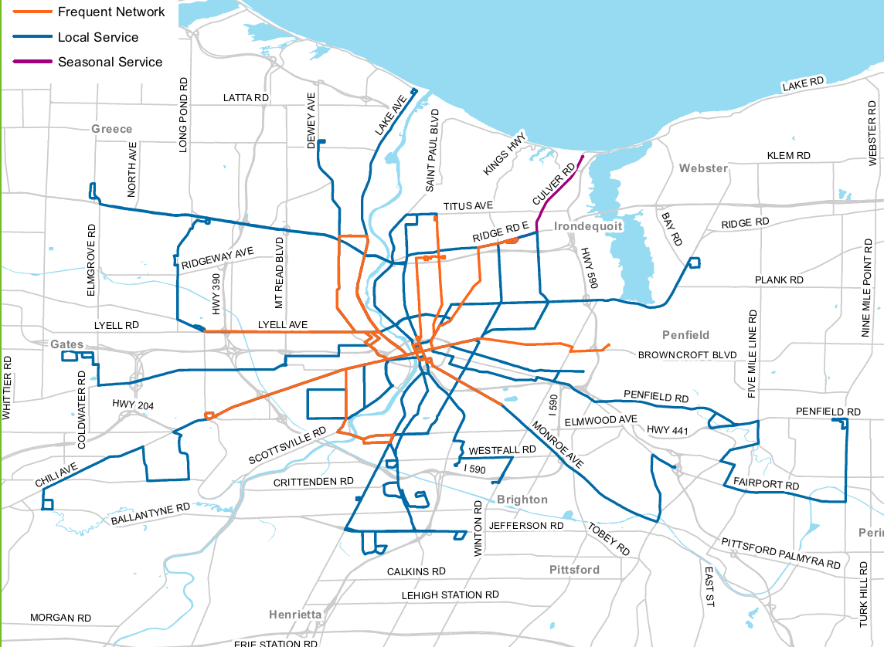

Descriptions of the Redesigned Fixed Routes
For an explanation of the terms used in this Exhibit, please refer to the Glossary of Terms and subsections 1.3.A, 1.3.B., 1.3.C., 1.4.A., and 1.4.B. in Section 1.

Core Routes

1 St. Paul
- 1 St. Paul will run in the Local network between the RTS Transit Center and Irondequoit Plaza via St. Paul Street and Titus Avenue every 30 minutes on weekdays between 6:00 AM and 6:00 PM.
- It will run every 60 minutes all other times.
- Customers traveling north of Titus Avenue can use RTS On Demand service within the Irondequoit CMZ. The route is similar to the former Route 35 St. Paul but will not serve Summerville or Cooper Road.

2 North Clinton
- 2 North Clinton will run in the Local network between the RTS Transit Center and Irondequoit Plaza via North Clinton Avenue every 30 minutes between 6:00 AM and 6:00 PM on weekdays.
- It will run every 60 minutes all other times.
- Customers traveling north of Titus Avenue can use RTS On Demand service within the Irondequoit CMZ.
- The route is similar to the former Route 37 North Clinton but will only serve Cooper Road at school times.

3 Joseph
- 3 Joseph will run in the Frequent network between the RTS Transit Center and Walmart on Hudson Avenue via Joseph Avenue and Seneca Manor Drive.
- It will run on weekdays every 15 minutes from 6:00 AM to 6:00 PM.
- At all other times, the route will run every 30 minutes.
- The route is similar to the former Route 41 Joseph.

4 Hudson
- 4 Hudson will run in the Frequent network on weekdays every 15 minutes from 6:00 AM to 6:00 PM.
- At all other times, the route will run every 30 minutes.
- The route is similar to the former Routes 34 Hudson and 134 Hudson ROC-it but will not deviate to Carter Street or Hudson Ridge Towers.

5 Portland
- 5 Portland will run in the Frequent network on weekdays every 15 minutes between 6:00 AM and 6:00 PM on weekdays and every 30 minutes at all other times.
- It will travel to the proposed Connection Hub near the Goodman/Ridge/Culver area in the Irondequoit CMZ.
- The route is similar to the former Route 40 Portland but will not serve Culver Road.
- Customers can use the seasonal Route 70 Seabreeze between Memorial Day and Labor Day or RTS On Demand service within the Irondequoit CMZ.

6 North Goodman
- 6 North Goodman will run in the Frequent network between the RTS Transit Center and the Connection Hub proposed near the Goodman/Ridge/Culver area.
- It will run on weekdays every 15 minutes from 6:00 AM to 6:00 PM.
- At all other times, the route will run every 30 minutes.
- The route is similar to the former Route 33 Goodman but will not run north of Ridge Road or deviate to St. Ann’s Home.
- Customers can still get to Irondequoit Plaza using Routes 1 St. Paul, 2 North Clinton, and 4 Hudson. Customers traveling north of Ridge Road can use RTS On Demand service within the Irondequoit CMZ.

7 Clifford/Empire
- 7 Clifford/Empire will run in the Local network between the RTS Transit Center and BayTowne Plaza via Clifford Avenue and Empire Boulevard every 30 minutes on weekdays between 6:00 AM and 6:00 PM and every 60 minutes at all other times.
- The route is similar to the former Routes 36 Clifford and 103 Webster but will not serve the Culver/ Norton/Waring loop or the town of Webster.
- Customers traveling within the Webster CMZ beyond BayTowne Plaza can use RTS On Demand service.

8 East Main
- 8 East Main will run in the Frequent network between the RTS Transit Center and Landing Heights via East Main Street every 15 minutes between 6:00 AM and 6:00 PM on weekdays.
- It will run every 30 minutes all other times.
- The route is similar to the former Route 38 East Main but will not deviate to Wyand Crescent or Blossom Road.

9 University
- 9 University will run in the Local network on University Avenue between the RTS Transit Center and the Blossom Loop.
- It will run every 30 minutes on weekdays 6:00 AM to 6:00 PM, and every 60 minutes all other times.
- At Winton Road or Blossom Loop, customers can connect to the 9 Park and 50 Fairport.
- Customers along Winton Road and Elmwood Avenue can connect to Twelve Corners and URMC using the new Routes 11 Monroe, 12 South Clinton, and 41 Culver/Goodman Crosstown.

10 Park
- 10 Park will run in the Local network along Park Avenue between the RTS Transit Center and Blossom Loop.
- It will run every 30 minutes on weekdays 6:00 AM to 6:00 PM, and every 60 minutes all other times.
- It is similar to the former Route 31 Park, but will not deviate to Pittsford.
- Customers can use the 11 Monroe to access St. John Fisher College, Nazareth College, and the RTS On Demand service in the Pittsford/Eastview CMZ.

11 Monroe
- 11 Monroe will run short line and long line service in the Frequent network.
- The short line will run between the RTS Transit Center and Highland Avenue every 15 minutes from 6:00 AM to 6:00 PM on weekdays.
- The long line will continue to the St. John Fisher Park & Ride Connection Hub every 30 minutes from 6:00 AM to 6:00 PM on weekdays.
- On weekends, the frequency will be 30 minutes for all trips.
- Customers traveling beyond the St. John Fisher Park & Ride Connection Hub can use the 95 Eastview Commuter or RTS On Demand service within the Pittsford/Eastview CMZ.

12 South Clinton
- 12 South Clinton will run in the Local network between the RTS Transit Center and the Jewish Home by way of Clinton Crossings every 30 minutes on weekdays from 6:00 AM and 6:00 PM and every 60 minutes at all other times.
- The route is similar to the former Route 51 South Clinton and travels eastbound along Westfall Road to the Jewish Home but will not serve the Monroe Developmental Center.

13 South Ave
- 13 South Avenue will run in the Local network between the RTS Transit Center and Monroe Community College by way of the Monroe Community Hospital.
- The route will run every 30 minutes on weekdays between 6:00 AM and 6:00 PM and every 60 minutes at all other times.
- For service to Strong Hospital, customers can use the new Routes 14 Marketplace, 15 Plymouth, 16 Genesee, 17 Jefferson/Nineteenth Ward, or 41 Culver/Goodman Crosstown. Customers traveling to MCC can also use the new routes 17 Jefferson/Nineteenth Ward and 41 Culver/Goodman Crosstown.
- The route is similar to the former Routes 45 South, 55 MCC Brighton, and 145 South ROC-it but will not travel to Strong Hospital.

14 Marketplace
- 14 Marketplace will run in the Local network to West Henrietta Road and Jefferson Road via Marketplace Mall.
- The weekday frequency will be 30 minutes between 6:00 AM and 6:00 PM and every 60 minutes at all other times.
- Customers headed elsewhere in Henrietta can use the RTS On Demand service in the Henrietta CMZ.
- The route is similar to the former Routes 24 Marketplace and 124 Marketplace ROC-it, but will not serve Monroe Community College (MCC) or the Rochester Institute of Technology (RIT).
- Customers bound for MCC can use the new Routes 13 South, 17 Jefferson/Nineteenth Ward, or 41 Culver/Goodman Crosstown. Customers bound for RIT can connect with RIT-operated shuttle services at the MCC Applied Tech Center on West Henrietta Road.

15 Plymouth
- 15 Plymouth will run in the Local network between the RTS Transit Center and Strong Hospital via Ford Street and Plymouth Avenue.
- It will run every 30 minutes on weekdays 6:00 AM to 6:00 PM, and every 60 minutes all other times.
- The route will go to the Hall of Justice via Broad Street. It is similar to the former Route 19 Plymouth, but will not deviate through Corn Hill or serve the University of Rochester campus.

16 Genesee
- 16 Genesee will run in the Frequent network between the RTS Transit Center and Strong Hospital every 15 minutes from 6:00 AM to 6:00 PM on weekdays, and every 30 minutes all other times.
- It is similar to the former Route 4 Genesee, but will not deviate to East River Road or the Arnett/Thurston/ Brooks loop.

17 Jefferson/Nineteenth Ward
- 17 Jefferson/Nineteenth Ward will run in the Local network on Jefferson Avenue between Main Street and Plymouth Avenue before proceeding to Strong Hospital and Monroe Community College (MCC) via the Arnett, Thurston, and Brooks loop.
- It will run every 30 minutes weekdays between 6:00 AM and 6:00 PM and every 60 minutes all other times.
- It is similar to the former Routes 6 Jefferson Avenue and 25 Thurston/MCC, but will not serve the Airport, Wegmans Distribution Center, or Metro Park.

18 Chili
- 18 Chili will run short line and long line service in the Frequent network.
- The short line will run from the RTS Transit Center to the Chili Walmart every 15 minutes from 6:00 AM to 6:00 PM on weekdays.
- The long line will continue along Chili Avenue, Jetview Drive, Paul Road, and Marshall Road to the Cedars of Chili every 30 minutes on weekdays.
- On weekends, the frequency is 30 minutes for all trips and all trips will extend from the RTS Transit Center to the Cedars of Chili.
- It is similar to the former Route 8 Chili.

19 Buffalo Road
- 19 Buffalo Road will run in the Local network between the RTS Transit Center and Rochester Tech Park.
- The frequency will be every 30 minutes weekdays between 6:00 AM and 6:00 PM, and every 60 minutes for all other trips.
- All trips will serve Jay Street between Broad and Child, Maple Street between Child and Mount Read, and the Rochester Tech Park.
- It is similar to the former Route 9 Jay/Maple, but will not serve Jay Street west of Child Street.

20 Lyell
- 20 Lyell will run in the Local network from the RTS Transit Center to The Mall at Greece Ridge every 30 minutes from 6:00 AM to 6:00 PM on weekdays and every 60 minutes at all other times.
- It will connect to Frequent service on the new Route 18 Chili for Walmart-bound customers. Customers can also connect to the Greece or Lexington CMZs at Greece Ridge Mall.
- The route is similar to the former Routes 3 Lyell and 163 Lyell ROC-it, but will not serve Howard Road or the Chili Walmart.

Lyell Avenue Corridor
- An area called the “Lyell Avenue Corridor” is between the 20 Lyell and the 42 Lyell/Upper Falls Crosstown. Frequent network bus service will run along the Lyell Avenue corridor every 15 minutes from 6:00 AM to 6:00 PM on weekdays.

21 Dewey
- 21 Dewey will run short line and long line service in the Frequent network.
- The short line will run from the RTS Transit Center to the Connection Hub proposed near the Dewey/Ridge/Lake area every 15 minutes from 6:00 AM to 6:00 PM on weekdays.
- The long line will continue to the Dewey Walmart every 30 minutes on weekdays. On weekends, the frequency will be 30 minutes.
- The route is similar to former Routes 10 Dewey, 15 Latta, and 150 Dewey ROC-it, but will not serve English Road, Mount Read Boulevard, or areas north of the Dewey Avenue Walmart.
- Customers can connect to the Greece and Lexington CMZs at the Connection Hub proposed near the Dewey/Ridge/Lake area.

22 Lake
- 22 Lake will run short line and long line service in the Frequent network.
- The short line will run from the RTS Transit Center to the Connection Hub proposed near the Dewey/Ridge/Lake area every 15 minutes from 6:00 AM to 6:00 PM on weekdays, and every 30 minutes all other times.
- The long line will continue to Charlotte every 30 minutes.
- The route is similar to the former Route 1 Lake, but will not serve the Beach/Dewey/Ling/Greenleaf/Latta loop.
- Customers can connect to RTS On Demand service in the Greece and Lexington CMZs at the Connection Hub proposed near Dewey/Ridge/Lake area.
End of Core routes.

Crosstown/Suburban Routes

40 Ridge Crosstown
- 40 Ridge Crosstown will run in the Local network to connect Elmridge Center in Greece to Goodman, Ridge, and Culver area in Irondequoit via Ridge Road.
- Service will operate every 30 minutes from 6:00 AM to 6:00 PM on weekdays and every 60 minutes at all other times.
- Connections to the RTS Transit Center will be available on the 2 North Clinton, 4 Hudson, 5 Portland, 6 North Goodman, 20 Lyell, 21 Dewey, and 22 Lake. Direct service from the RTS Transit Center to Greece Ridge Mall will be available on the Route 20 Lyell.
- It is similar to the former Route 14 Ridge, but will not serve Lake Avenue or the RTS Transit Center. Customers can connect to RTS On Demand service in the Greece and Lexington CMZs at the Connection Hub proposed near The Mall at Greece Ridge and in the Irondequoit CMZ at the Connection Hub proposed near the Goodman/Ridge/Culver area.

41 Culver/Goodman Crosstown
- 41 Culver / Goodman Crosstown will run in the Local network to connect Irondequoit to Marketplace Mall by way of Strong Hospital and MCC.
- Service will operate every 30 minutes from 6:00 AM to 6:00 PM on weekdays and every 60 minutes at all other times.
- It will run east from the proposed Connection Hub in the Goodman, Ridge, and Culver area to Culver, Parsells, Goodman, Elmwood, East Henrietta, and Jefferson to Marketplace Mall.
- It will provide connections to the new Routes 5, 6, 7, 8, 9, 10, 11, 12, 13, 14, 15, 16, 17, 40, and 70. Customers can connect with RTS On Demand service in the Irondequoit CMZ at the Connection Hub proposed near the Goodman/Ridge/Culver area and in the Henrietta CMZ at the Connection Hub proposed near Hylan Drive.

42 Lyell/Upper Falls Crosstown
- 42 Lyell/Upper Falls Crosstown will run in the Local network to provide an east-west crosstown connection closer to the city center with service along Lyell Avenue every 30 minutes on weekdays 6:00 AM to 6:00 PM and every 60 minutes for all other trips.
- Service operates between Lyell & Howard Road in Gates and Portland Avenue via Lyell Avenue and Upper Falls Boulevard. It will connect to downtown by way of the Routes 1, 2, 3, 4, 5, 7, 20, 21, and 22. Customers can connect to RTS On Demand service in the Lexington CMZ at any bus stop between Howard Road and Dewey Avenue.
Lyell Avenue Corridor
- An area called the “Lyell Avenue Corridor” is between the 20 Lyell and the 42 Lyell/Upper Falls Crosstown. Frequent network bus service will run along the Lyell Avenue corridor every 15 minutes from 6:00 AM to 6:00 PM on weekdays.

50 Fairport/Penfield
- 50 Fairport/Penfield will run in the Local network between the Blossom Loop and East Rochester, Fairport, and Penfield.
- The route will run every 90 minutes all day on weekdays and weekends.
- Customers can connect to downtown on the new Routes 9 University and 10 Park.
- The route is similar to the former Routes 81 Fairport and 82 Penfield.

70 Seabreeze Seasonal
- 70 Seabreeze will run in the Local network between at the Connection Hub proposed near the Goodman/Ridge/Culver area and Seabreeze Amusement Park between Memorial Day and Labor Day.
- It will run every 30 minutes from 10:00 AM to 6:00 PM and every 60 minutes from 6:00 PM to 11:00 PM on weekdays and weekends.
- Customers can also use the RTS On Demand service in the Irondequoit CMZ year-round.
End of Crosstown/Suburban routes.

Commuter Routes

90 Avon Commuter
- Customers commuting from Avon and Rush will have service to the Connection Hub near Hylan Drive and can transfer to the 14 Marketplace or the 41 Culver/Goodman Crosstown.
- There will be two trips daily, one in the morning and one in the afternoon.
- Customers along South Avenue can use the 13 South, and customers along East Henrietta Road can use the 41 Culver/Goodman Crosstown.
- Customers can also use RTS On Demand service within the Henrietta CMZ.

91 Newark/Lyons Commuter
- Customers commuting from Newark and Lyons will have service to the St. John Fisher Park & Ride and can connect with the 11 Monroe or 96 St. John Fisher Park & Ride Commuter that will transport them to the RTS Transit Center.
- There will be two trips daily, one in the morning and one in the afternoon.
- Customers can also use RTS On Demand service within the Pittsford/Eastview CMZ.

92 Hilton/Hamlin Commuter
- Customers commuting from Hamlin, Hilton, and Clarkson will have service to the Connection Hub proposed near the Dewey/Ridge/Lake area.
- There will be four trips daily, two in the morning and two in the afternoon.
- They can connect to the new Routes 21 Dewey, 22 Lake, or 40 Ridge Crosstown.

93 Webster Commuter
- Customers commuting from Webster will have service to the Connection Hub proposed near BayTowne Plaza and can transfer to the 7 Clifford/Empire for service to the RTS Transit Center.
- There will be two trips daily, one in the morning and one in the afternoon.
- At other times, customers can use the RTS On Demand service within the Webster CMZ.

94 Brockport Commuter
- Customers commuting from Brockport will have service to the Connection Hub proposed near Rochester Tech Park and can transfer to the 19 Buffalo Road for service to the RTS Transit Center.
- There will be two trips daily, one in the morning and one in the afternoon.
- At other times, customers can use the RTS On Demand service within the Brockport CMZ.

95 Eastview Commuter
- Customers commuting to and from Victor/Eastview Mall will have service to the Connection Hub near the St. John Fisher Park & Ride and can transfer to the Route 11 Monroe or 96 St. John Fisher Park & Ride Commuter for service to the RTS Transit Center.
- There will be four trips daily, two in the morning and two in the afternoon.
- At other times, customers can use the RTS On Demand service within the Pittsford/Eastview CMZ.

96 St. John Fisher Park & Ride Commuter
- This Commuter route will operate between the RTS Transit Center and the St. John Fisher Park & Ride.
- At the St. John Fisher Park & Ride, customers can connect to the new Routes 91 Newark/Lyons Commuter, 95 Eastview Commuter, or the new RTS On Demand service in the Pittsford/Eastview CMZ.
- There will be two trips daily, one in the morning and one in the afternoon.

97 Elmwood Commuter
- Customers commuting between the Twelve Corners area and URMC will have service along Elmwood Avenue.
- There will be five round trips per day.
- Customers can connect to 11 Monroe, 12 South Clinton, 13 South Ave, 14 Marketplace, 15 Plymouth, 17 Jefferson/Nineteenth Ward, and 41 Culver/Goodman Crosstown.
End of Commuter routes.

Subsidized

105 MCC Downtown
This Subsidized route will operate between the RTS Transit Center and the MCC Downtown Campus on weekdays when MCC is in session.

159 MCC Connector
This Subsidized route will operate between the MCC Brighton and MCC Downtown Campuses on weekdays when MCC is in session.

172 Nazareth-Pittsford Plaza Sunday
This Subsidized route will operate between Nazareth College and Pittsford Plaza on Sunday afternoons when Nazareth is in session.

174 TE3
This Subsidized route will operate between RIT and the East End on Saturday nights when RIT is in session.

177 Nazareth-East End Friday and Saturday
This Subsidized route will operate between Nazareth College and the East End on Saturday nights when Nazareth is in session.
End of Subsidized routes.
End of the Descriptions of the redesigned system routes.

Route Transition Guide
This subsection lists the name of each route in the existing RTS fixed route system and its corresponding new fixed route or demand responsive service in the redesigned system.

1 LAKE
1 Lake will be redesigned to the 22 Lake Core fixed route or RTS On Demand in the new system.

3 LYELL
3 Lyell will be redesigned to the 20 Lyell Core fixed route or 42 Lyell/Upper Falls Crosstown fixed route in the new system.

4 GENESEE
4 Genesee will be redesigned to the 16 Genesee Core fixed route in the new system.

6 JEFFERSON AVE
6 Jefferson Avenue will be redesigned to the 17 Jefferson/Nineteenth Ward Core fixed route in the new system.

8 CHILI
8 Chili will be redesigned to the 18 Chili Core fixed route in the new system.

9 JAY/MAPLE
9 Jay/Maple will be redesigned to the 19 Buffalo Road Core fixed route in the new system.

10 DEWEY
10 Dewey will be redesigned to the 21 Dewey Core fixed route or RTS On Demand service in the new system.

13 EDISON
13 Edison will be redesigned to RTS On Demand in the new system.

14 RIDGE
14 Ridge will be redesigned to the 40 Ridge Crosstown fixed route in the new system.

15 LATTA
15 Latta will be redesigned to the 21 Dewey and 22 Lake Core fixed routes or RTS On Demand service in the new system.

16 CROSSTOWN
16 Crosstown will be redesigned to the RTS On Demand service in the new system.

19 PLYMOUTH
19 Plymouth will be redesigned to the 15 Plymouth Core fixed route in the new system.

23 JEFFERSON RD
23 Jefferson Rd will be redesigned to the 14 Marketplace Core fixed route and 41 Culver/Goodman Crosstown fixed route or RTS On Demand service in the new system.

24 MARKETPLACE
24 Marketplace will be redesigned to the 14 Marketplace Core fixed route or RTS On Demand service in the new system.

25 THURSTON/MCC
25 Thurston/MCC will be redesigned to the 17 Jefferson/Nineteenth Ward Core fixed route in the new system.

28 GENESEE PARK BLVD
28 Genesee Park Blvd will be redesigned to the 17 Jefferson/Nineteenth Ward and 18 Chili Core fixed route in the new system.

31 PARK
31 Park will be redesigned to the 10 Park Core fixed route or RTS On Demand in the new system.

33 GOODMAN
33 Goodman will be redesigned to the 6 North Goodman Core fixed route or RTS On Demand in the new system.

34 HUDSON
34 Hudson will be redesigned to the 4 Hudson Core fixed route in the new system.

35 ST. PAUL
35 St. Paul will be redesigned to the 1 St. Paul Core fixed route or RTS On Demand in the new system.

36 CLIFFORD
36 Clifford will be redesigned to the 7 Clifford/Empire Core fixed route in the new system.

37 CLINTON
37 Clinton will be redesigned to the 2 North Clinton Core fixed route in the new system.

38 EAST MAIN
38 East Main will be redesigned to the 8 East Main Core fixed route in the new system.

39 BAY/WEBSTER
39 Bay/Webster will be redesigned to the 41 Culver/Goodman Crosstown fixed route in the new system.

40 PORTLAND
40 Portland will be redesigned to the 5 Portland Core fixed route, the 70 Seabreeze Seasonal Suburban fixed route, or the RTS On Demand service in the new system.

41 JOSEPH
41 Joseph will be redesigned to the 3 Joseph Core fixed route in the new system.

42 PARSELLS
42 Parsells will be redesigned to the 41 Culver/Goodman Crosstown fixed route in the new system.

45 SOUTH
45 South will be redesigned to the 13 South Core fixed route in the new system.

47 MONROE
47 Monroe will be redesigned to the 11 Monroe Core fixed route or RTS On Demand in the new system.

48 UNIVERSITY
48 University will be redesigned to the 9 University Core fixed route in the new system.

51 SOUTH CLINTON
51 South Clinton will be redesigned to the 12 South Clinton Core fixed route in the new system.

53 SOUTH GOODMAN
53 South Goodman will be redesigned to the 41 Culver/Goodman Crosstown fixed route in the new system.

55 MCC BRIGHTON
55 MCC Brighton will be redesigned to the 13 South Core fixed route in the new system.

57 EAST
57 East will be redesigned to the 9 University Core fixed route, the 10 Park Core fixed route, or RTS On Demand in the new system.

81 FAIRPORT
81 Fairport will be redesigned to the 50 Fairport Suburban fixed route in the new system.

82 PENFIELD
82 Penfield will be redesigned to the 50 Fairport Suburban fixed route in the new system.

83 CALKINS RD
83 Calkins will be redesigned to the RTS On Demand service in the new system.

84 EASTVIEW MALL
84 Eastview Mall will be redesigned to the 95 Eastview Commuter fixed route or RTS On Demand service in the new system.

101 AVON/RUSH
101 Avon/Rush will be redesigned to the 90 Avon/Rush Commuter fixed route in the new system.

102 NEWARK/LYONS
102 Newark/Lyons will be redesigned to the 91 Newark/Lyons Commuter fixed route in the new system.

103 WEBSTER
103 Webster will be redesigned to the 7 Clifford/Empire Core fixed route, 93 Webster Commuter fixed route, or RTS On Demand service in the new system.

104 BROCKPORT
104 Brockport will be redesigned to the 19 Buffalo Road Core fixed route, 94 Brockport Commuter fixed route, or the RTS On Demand service in the new system.

106 HILTON/HAMLIN/ CLARKSON
106 Hilton/Hamlin/Clarkson will be redesigned to the 92 Hilton/Hamlin Commuter fixed route in the new system.

124 MARKETPLACE ROC-IT
124 Marketplace ROC-it will be redesigned to the 14 Marketplace Core fixed route in the new system.

134 HUDSON ROC-IT
134 Hudson ROC-it will be redesigned to the 4 Hudson Core fixed route in the new system.

145 SOUTH ROC-IT
145 South ROC-it will be redesigned to the 13 South Core fixed route in the new system.

150 DEWEY ROC-IT
150 Dewey ROC-it will be redesigned to the 21 Dewey Core fixed route in the new system.

163 LYELL ROC-IT
163 Lyell ROC-it will be redesigned to the 20 Lyell Core fixed route and 42 Lyell/Upper Falls Crosstown fixed route in the new system.
End of Route Transition Guide.

Fixed Route Schedules
The existing RTS fixed route schedules are available online at the following site location:
https://www.myrts.com/Maps-Schedules/RTS-Monroe/Schedule-pdfs
The RTS fixed route schedules effective as of summer 2020 will be available online at the same site location prior to implementation.
If you have questions about using fixed routes or need an accessible format for a fixed route schedule, call 585-288-1700. A Representative is available Monday through Friday 7:00 AM to 6:00 PM. You can also tell Representatives about complaints or concerns while riding fixed route.
You can send requests or make comments anytime through the online Contact-Us form available at this site location: http://rts.force.com/RTSContactUs
End of Fixed Route Schedules.
End of Exhibit 1

Exhibit 2: Reimagine RTS Demand Responsive Services for Community Mobility Zones

Demand Responsive Services
In the Community Mobility Zones (CMZs), customers will have access to demand responsive service. RTS On Demand is a dial-a-ride service provided to the public on accessible vehicles. Dial-a-ride is a type of demand responsive service that operates in a CMZ area during set days and hours. Pickups and drop-offs can occur anywhere in the CMZ, so customers can arrange to travel to and from specific locations. Customers must make a request for service and arrange a pickup time. RTS will develop the schedules and routes for a particular day based on the requests. Customers can use RTS On Demand to arrange for transport from a location in the CMZ to a Connection Hub, where they can transfer to fixed route service or paratransit service to complete their trip. When returning from the fixed route or paratransit system, customers use fixed route or paratransit to travel to a Connection Hub. Customers contact RTS to arrange for on-demand transport from the Connection Hub to their destination within the CMZ. While the demand responsive services do not require complementary paratransit service, the level of service provided to paratransit eligible customers with disabilities and to customers without disabilities shall be equivalent.
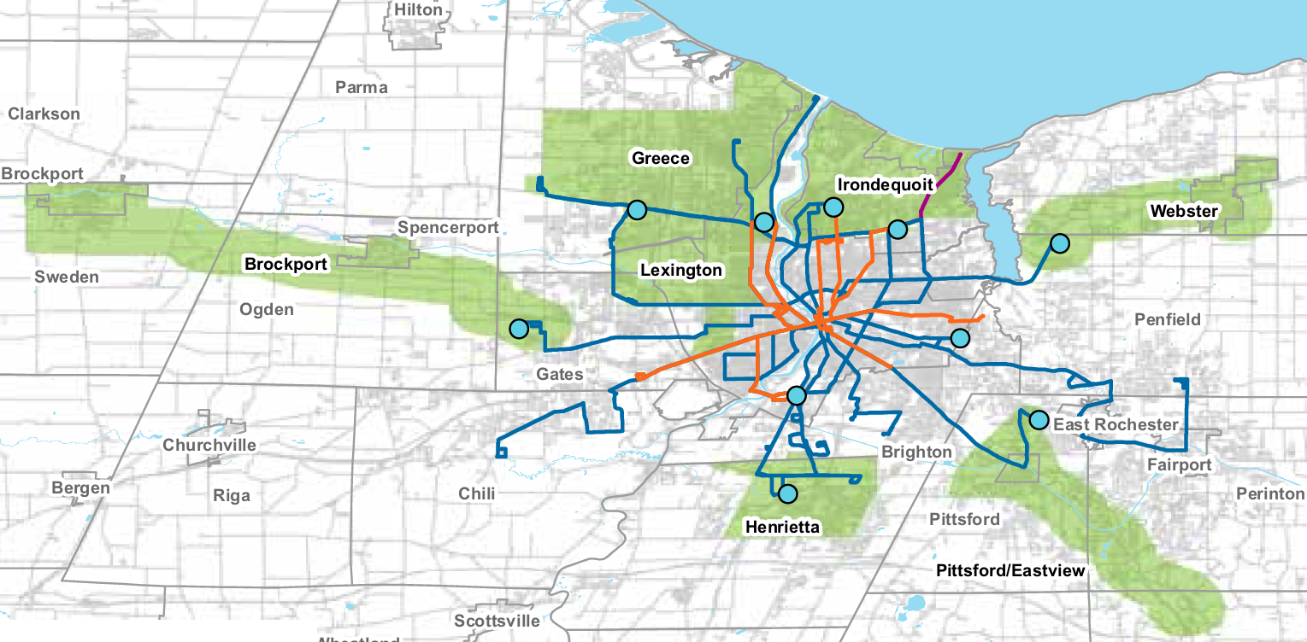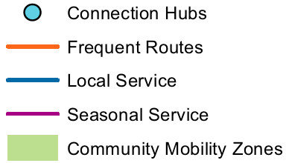

Descriptions of Community Mobility Zones

Brockport Community Mobility Zone
The Brockport CMZ will provide service in areas affected by the proposed discontinuation of the current Route 104 Brockport in the towns of Ogden and Sweden and the villages of Brockport and Spencerport. This proposed 30.56 square-mile zone focuses on the more populated areas north of NY Route 31. This zone will provide an important link between Rochester and the College at Brockport, State University of New York campus (SUNY Brockport) through a transfer to the fixed route network at a Connection Hub located near the Rochester Tech Park in the Town of Gates. The CMZ boundary includes the Villages of Brockport and Spencerport. Key destinations include Rochester Tech Park, the Village of Spencerport, Lifetime Assistance, Frances Apartments, Woodlands Apartments, and retail on Owens Road, Brockport retail corridors, Sweden Senior Center, A.D. Oliver Middle School, the College at Brockport, and Brockport High School.
Customers can take the fixed route 19 Buffalo Road serving Jay Street between Broad and Child, Maple Street between Child and Mount Read, and Rochester Tech Park. Customers can ride the entire route to reach the RTS Transit Center. The fixed route 94 Brockport Commuter travels from the Brockport Park & Ride to the Connection Hub once in each direction in the AM and PM during peak periods. Customers can also arrange for an RTS On Demand trip from the Connection Hub to any location within the Brockport CMZ.
RTS On Demand service will run within the Brockport CMZ from 5:00 AM to 10:00 PM weekdays, 6:00 AM to 10:00 PM Saturdays, and 6:00 AM to 6:00 PM Sundays and holidays.
Paratransit eligible customers can schedule a trip on RTS Access to travel from origins in the paratransit service area to the Connection Hub, and schedule a trip on RTS On Demand to travel within the CMZ. Similarly, paratransit eligible customers can schedule RTS Access to pick them up at a Connection Hub to travel from the CMZ into the supplemental or complementary service area during the paratransit service span.
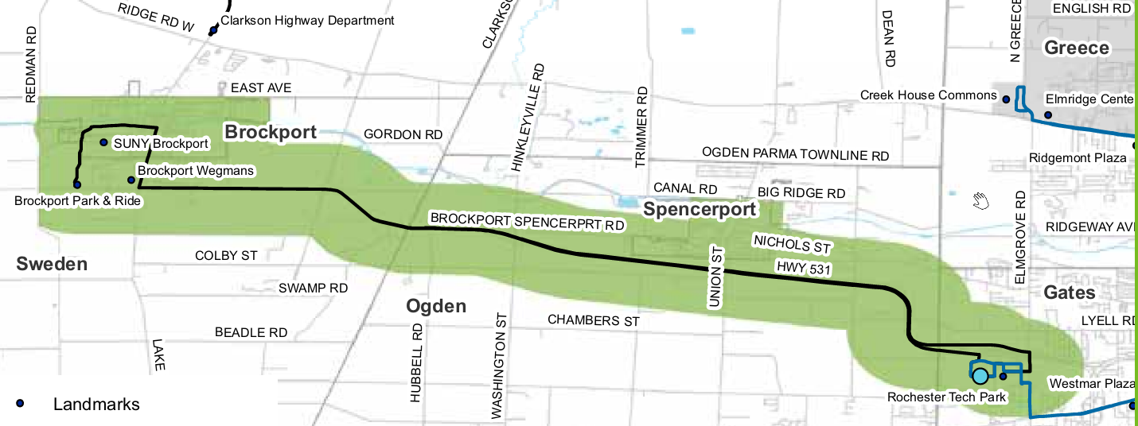

Greece Community Mobility Zone
The Greece Community Mobility Zone will provide service to residents and businesses in the town of Greece where 40-foot bus service has been determined to be infeasible. The 24.35 square-mile CMZ is bisected by the I-390 expressway and encompasses major retail locations such as The Mall at Greece Ridge and Northgate Plaza, as well as a site of higher education in Bryant & Stratton College. Several major roads define the boundary of the Greece CMZ. North Greece Road forms the west boundary; West Ridge Road forms the south boundary; Lake Avenue forms the east boundary; and Latta Road forms part of the north boundary, extending farther north along Dewey Avenue, English Road, and Edgemere Drive. The Greece CMZ has a Connection Hub proposed near the Dewey/Ridge/Lake area and another Connection Hub proposed near The Mall at Greece Ridge. Key destinations in the CMZ include The Mall at Greece Ridge, Bryant and Stratton College, Kodak Park, Northgate Plaza, Affinity Orchard Apartments, Ridge Road retail corridor, Latta Road corridor, retail and shopping centers (Wegmans, Walmart), Ontario Beach and Charlotte recreation facilities, and K through 12 schools.
The 22 Lake long line travels along the east boundary of the Greece CMZ to Ontario Beach Park. The 21 Dewey travels into the Greece CMZ and continues to the Dewey Walmart. The 40 Ridge Crosstown on West Ridge Road travels the west boundary between Elmridge Center and the Connection Hub proposed in the Dewey/Ridge/Lake area. The 20 Lyell travels from the RTS Transit Center to Lyell Avenue, and on to Spencerport Road, Long Pond Road, Parkridge near Park Ridge Hospital and Park Ridge Living Center, returns to Long Pond, and continues on West Ridge Road to The Mall at Greece Ridge.
Customers commuting from Hamlin, Hilton, and Clarkson can take the fixed route 92 Hilton/Hamlin Commuter to the Connection Hub proposed near the Dewey/Ridge/Lake area, and connect to the 21 Dewey, 22 Lake, or 40 Ridge Crosstown. Customers can also arrange for an RTS On Demand trip from the Connection Hub to any location within the Greece CMZ. RTS On Demand service will run within the Greece CMZ from 5:00 AM to midnight weekdays, 6:00 AM to midnight Saturdays, and 6:00 AM to 10:00 PM Sundays and holidays.
Paratransit eligible customers can schedule a trip on RTS Access to travel from origins in the paratransit service area to the Connection Hub, and schedule a trip on RTS On Demand to travel within the CMZ. Similarly, paratransit eligible customers can schedule RTS Access to pick them up at a Connection Hub to travel from the CMZ into the supplemental or complementary service area during the paratransit service span.
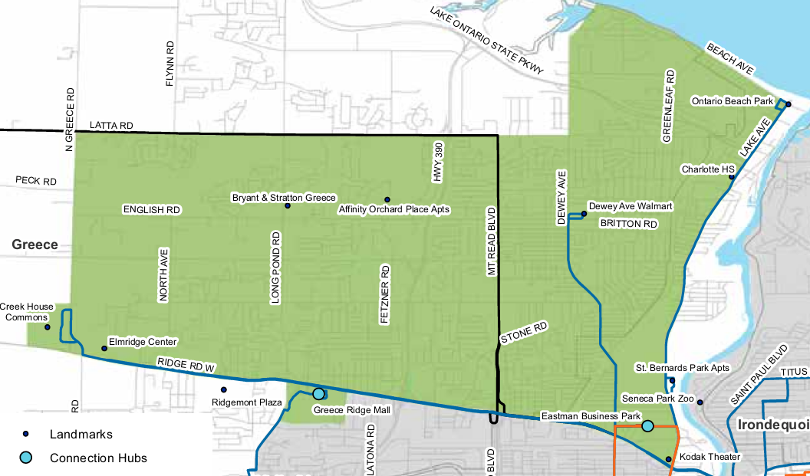

Henrietta Community Mobility Zone
The Henrietta CMZ will provide connections beyond the fixed route network to destinations within the Town of Henrietta. The Henrietta CMZ is a 19.57 square-mile area located south of the City of Rochester. The CMZ is bisected by the I-390 expressway, Jefferson Road (252) and West Henrietta Road (15) and is home to regional retail destinations, such as Marketplace Mall, Southtown Plaza, a Walmart Supercenter and Frontier Commons. The Henrietta CMZ area is defined as the Town of Henrietta north of Lehigh Station Road and includes core retail and commercial areas of Henrietta and residential and service destinations. Lehigh Station Road forms the south boundary, Jefferson Road and Henrietta-Brighton Town Line Road forming the north boundary, Pinnacle Road forms the east boundary, and West Henrietta Road forms the west boundary. A Connection Hub near Hylan Avenue will allow customers to transfer to or from the 41 Culver/Goodman Crosstown or 14 Marketplace fixed route service and use RTS On Demand within the CMZ.
The key destinations in the Henrietta CMZ include Marketplace Mall and Henrietta retail core, Jefferson Road corridor, the Henrietta Town Hall, the Henrietta Town Library, the Future Veterans Administration Outpatient Facility on Calkins Road, and dispersed senior, affordable or assisted housing and student housing locations throughout the CMZ.
The 41 Culver/Goodman Crosstown connects Irondequoit to Marketplace Mall by way of the Connection Hub proposed near the Goodman/Ridge/Culver area to Culver Road, Parsells Avenue, Goodman Street, MCC, and East Henrietta Road. The 14 Marketplace serves West Henrietta Road and Jefferson Road via Marketplace Mall.
RTS On Demand service will run within the Henrietta CMZ from 5:00 AM to midnight weekdays, 6:00 AM to midnight Saturdays, and 6:00 AM to 10:00 PM Sundays and holidays.
Paratransit eligible customers can schedule a trip on RTS Access to travel from origins in the paratransit service area to the Connection Hub, and schedule a trip on RTS On Demand to travel within the CMZ. Similarly, paratransit eligible customers can schedule RTS Access to pick them up at a Connection Hub to travel from the CMZ into the supplemental or complementary service area during the paratransit service span.
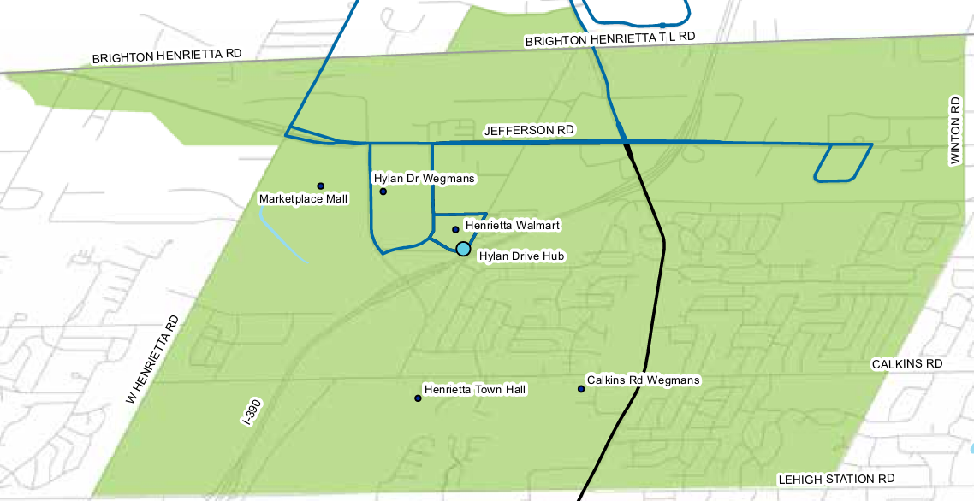
E HENRIETTA RD

Irondequoit Community Mobility Zone
The Irondequoit CMZ is outlined by the Genesee River and the Irondequoit town line on the west; by Lake Ontario to the north; Irondequoit Bay to the east; and East Ridge Road, Seneca Avenue, and Long Acre Road to the south. The 12.12 square-mile area includes or is near several recreational and cultural opportunities, including Ontario Beach, Seneca Park Zoo, Durand Eastman County Park and Seabreeze Amusement Park. The southern portion of the CMZ includes connections to fixed route transit. There is a Connection Hub proposed near Irondequoit Plaza and a Connection Hub proposed near the Goodman/Ridge/Culver area.
The key destinations in the Irondequoit CMZ include Rochester Regional Health, Ridge/Titus retail corridors, Wegmans, Irondequoit Plaza, Pattonwood Drive, Irondequoit Bay Park, West Irondequoit High School, Dake Middle School, Seabreeze Amusement Park, and Lakeshore communities and attractions.
The 41 Culver/Culver Crosstown travels into the CMZ and connects to the 70 Seabreeze traveling to Seabreeze Amusement Park. Portions of the 1 St. Paul, 2 North Clinton, and 4 Hudson travel into the CMZ and go to the Connection Hub proposed near Irondequoit Plaza. The 41 Culver/Ridge Crosstown and 40 Ridge Crosstown also travel along the southern boundary of the Irondequoit CMZ. The 40 Ridge Crosstown continues to travel along the southern boundary of the Greece CMZ and goes to the Connection Hub proposed near the Goodman/Ridge/Culver area.
RTS On Demand service will run within the Irondequoit CMZ from 5:00 AM to 10:00 PM weekdays, 6:00 AM to 10:00 PM Saturdays, and 6:00 AM to 10:00 PM Sundays and holidays.
Paratransit eligible customers can schedule a trip on RTS Access to travel from origins in the paratransit service area to the Connection Hub, and schedule a trip on RTS On Demand to travel within the CMZ. Similarly, paratransit eligible customers can schedule RTS Access to pick them up at a Connection Hub to travel from the CMZ into the supplemental or complementary service area during the paratransit service span.
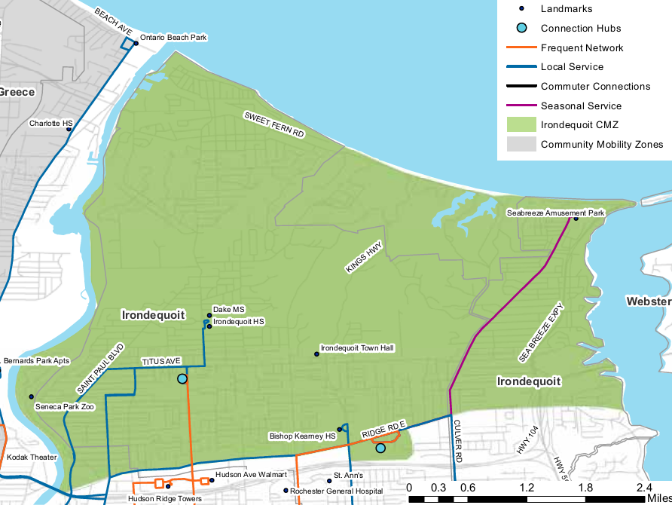

Lexington Community Mobility Zone
The Lexington CMZ represents a mostly industrial area within the City of Rochester. At 8.89 square miles, the Lexington CMZ is the smallest by area but major employers are located within the zone, as well as community services such as FoodLink. The Lexington CMZ is the area within the following boundaries: Ridge Road to the north; Dewey Avenue to the east; Lyell Avenue to the south; and Long Pond Road to the west. The Zone partially overlaps with the Greece CMZ along Ridge Road West.
The zone also extends south beyond Lyell Avenue and into an area surrounded by Mount Read Boulevard and Cairn Street to the west, Chili Avenue to the south, and Hague Street to the east. The Lexington CMZ Connection Hub is proposed near the Dewey/Ridge/Lake area. Key destinations in the Lexington CMZ include the Lexington Avenue Industrial Corridor, Eastman Business Park, LiDestri Foods, Love Beets, Edison Career and Technology High School, community services such as FoodLink, and The Mall at Greece Ridge.
Access to fixed route service is possible along the north, south, east, and west edges of the zone. The CMZ has a Connection Hub proposed near The Mall at Greece Ridge and near the Dewey/Ridge/Lake area.
RTS On Demand service will run within the Lexington CMZ from 5:00 AM to 10:00 PM weekdays.
Paratransit eligible customers can schedule a trip on RTS Access to travel from origins in the paratransit service area to the Connection Hub, and schedule a trip on RTS On Demand to travel within the CMZ. Similarly, paratransit eligible customers can schedule RTS Access to pick them up at a Connection Hub to travel from the CMZ into the supplemental or complementary service area during the paratransit service span.
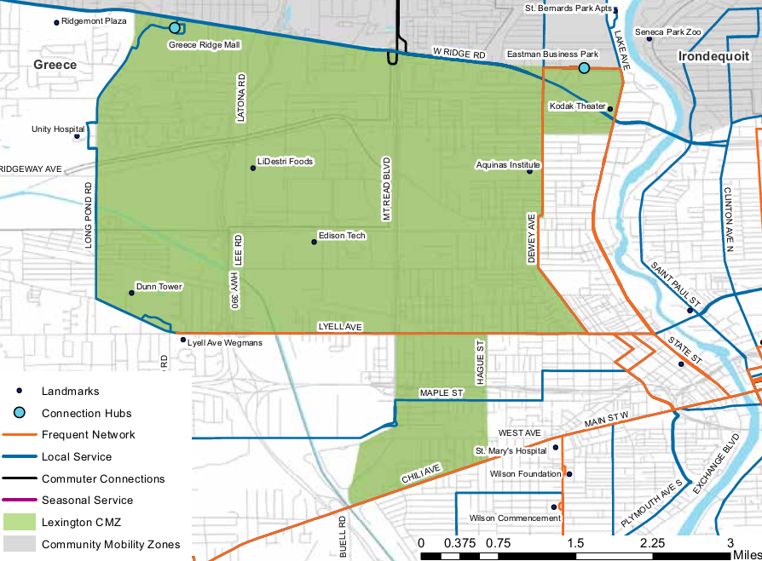

Pittsford and Eastview Community Mobility Zone
The Pittsford/Eastview CMZ contains the New York Route 96 corridor between Eastview Mall and the Town of Pittsford. It will have a Connection Hub proposed near the St. John Fisher Park & Ride to cover Pittsford Plaza in the Town of Pittsford to Eastview Mall in Victor, (Ontario County) along NYS Routes 31 and 96.
Key destinations in the CMZ include Nazareth College, St. John Fisher College, the Village of Pittsford, Cloverwood Senior Living, Concentrix Plaza, Pittsford Plaza, Pittsford Sutherland High School, Pittsford Mendon High School, Southeast Family Branch YMCA at Clover and Jefferson, Eastview Mall retail corridor, and Eastview Mall Park & Ride.
The 11 Monroe continues into the CMZ and will go to the Connection Hub proposed near the St. John Fisher Park & Ride. The 95 Eastview Commuter travels to and from East View Mall.
RTS On Demand service will run within the Pittsford and Eastview CMZ from 5:00 AM to 10:00 PM weekdays, 6:00 AM to 10:00 PM Saturdays, and 6:00 AM to 6:00 PM Sundays and holidays.
Paratransit eligible customers can schedule a trip on RTS Access to travel from origins in the paratransit service area to the Connection Hub, and schedule a trip on RTS On Demand to travel within the CMZ. Similarly, paratransit eligible customers can schedule RTS Access to pick them up at a Connection Hub to travel from the CMZ into the supplemental or complementary service area during the paratransit service span.
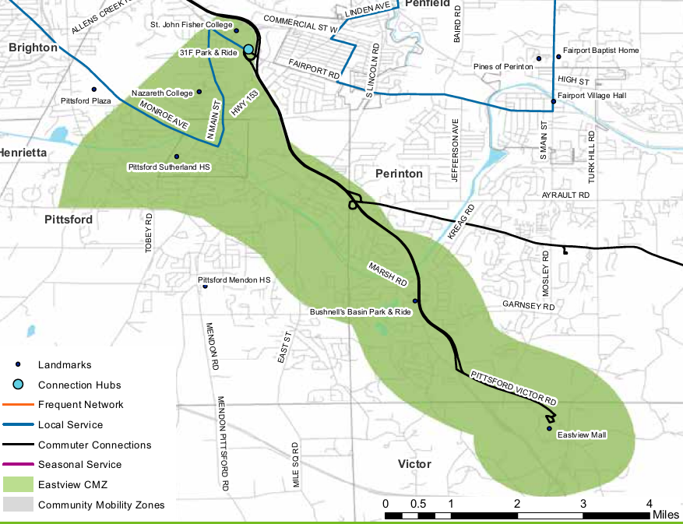

Webster Community Mobility Zone
The Webster CMZ provides connections to the fixed-route system through a Connection Hub proposed near BayTowne Plaza in Penfield. The 10.8 square-mile zone has important retail and commercial corridors along Ridge Road, in the village center and is home to a Xerox facility. The Webster CMZ covers the surrounding area between BayTowne Plaza in the Town of Penfield and Phillips Village (Phillips Road) in the Village of Webster along Empire Boulevard and Ridge Road. The CMZ has a northerly extension that encompasses the Xerox Webster site.
Key destinations in the CMZ include Ridge Road retail and service corridor, BayTowne Shopping Center, the Town Center at Webster, the Webster Town Hall, Phillips Village, Hill Haven on Empire Boulevard, Basket Road, the Village of Webster, apartment complexes on Holt Road and Hard Road, and the Xerox Webster campus.
The 7 Clifford/Empire continues into the CMZ and goes to the Connection Hub proposed near BayTowne Plaza. The 93 Webster Commuter allows customers to travel back and forth from Webster (Phillips Village) and the Connection Hub.
RTS On Demand service will run within the Webster CMZ from 5:00 AM to 10:00 PM weekdays, 6:00 AM to 10:00 PM Saturdays, and 6:00 AM to 6:00 PM Sundays and holidays.
Paratransit eligible customers can schedule a trip on RTS Access to travel from origins in the paratransit service area to the Connection Hub, and schedule a trip on RTS On Demand to travel within the CMZ. Similarly, paratransit eligible customers can schedule RTS Access to pick them up at a Connection Hub to travel from the CMZ into the supplemental or complementary service area during the paratransit service span.
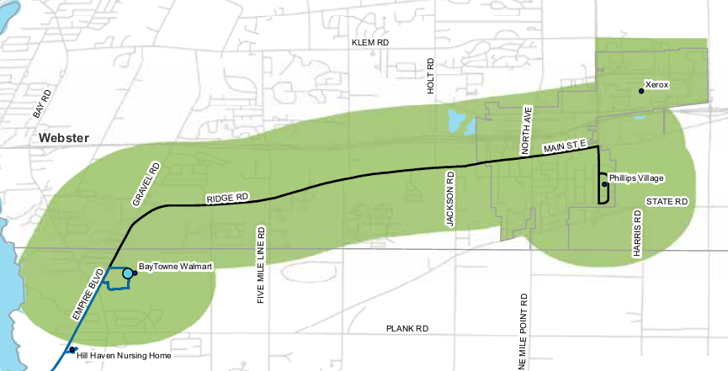
End of Exhibit 2.

Exhibit 3: Reimagine RTS Access Paratransit Service Area

Weekday Service Area
Weekday paratransit service includes four areas, each with unique characteristics. The areas are categorized as the Required Area and three supplemental service levels (Level 1, Level 2, and Level 3).
The RTS interactive online map at https://arcg.is/0unvvv and other resources such as assistive technologies or friends, family, and attendants, will assist paratransit eligible customers in locating addresses in the proposed areas if they would like to understand more about the upcoming changes to the service area.
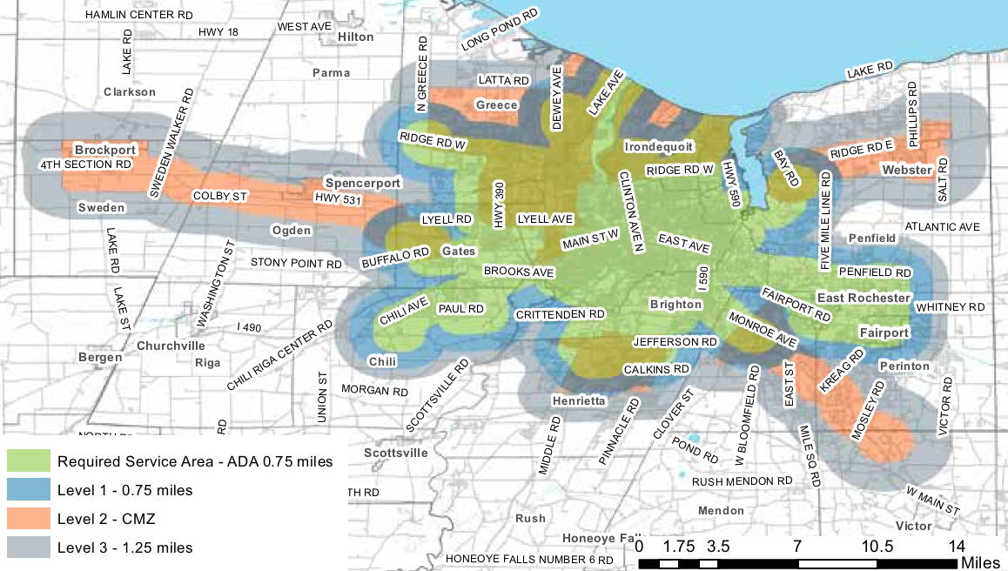
The Required Area surrounds the fixed route service and is shown on the map as a large green “blob” shape. This is the area where the Authority is obligated by law to provide complementary paratransit service. The Required Area is a corridor with a width of ¾ of a mile on each side of each fixed route. At the end of a route, there is a semicircular “cap” on the corridor, consisting of a ¾- mile radius from the endpoint of the route to the parallel sides of the corridor. RTS Access will provide paratransit service to any origin or destination point within a corridor fitting this description around any fixed route in the RTS system. The weekday service hours for the Required Area are Monday through Friday from 5:00 AM to midnight.
For Level 1, Level 2, and Level 3, RTS Access will provide supplemental services with varying characteristics. One way to imagine these levels is to think of a pat of butter melting in a pan on a stovetop. The Required area is the center of the pan on the burner, and as the butter melts, it covers more and more of the pan’s surface, spreading to the edges. If the pan represents Rochester, the center is the urban core and the farthest edges of the pan are areas surrounding the suburbs of Brockport, Greece, Henrietta, Irondequoit, Pittsford/Eastview, and Webster.
Level 1 is shown on the map as a thick blue outline surrounding the green blob. The supplemental service in Level 1 goes ¾ miles beyond the ¾-mile Required Area, for a total service area of 1 and ½ miles. RTS Access will make its best effort to deliver the same service criteria for Level 1 as it does in the Required Area; rather than treating this area as supplemental, RTS Access will service it as though it is in the required area and will refer to this as a regular service area. This includes allowing customers to negotiate pickup times and reserve rides up to five days ahead, and guaranteeing a ride with a one-day advance reservation. The weekday service hours for Level 1 are Monday through Friday from 5:00 AM to midnight.
For customers traveling to the RTS Transit Center in order to use fixed route for some trips, RTS Access will perform drop-offs and pickups at Clinton Avenue, at the RTS Transit Center plaza.
Level 2 consists of portions of the Community Mobility Zones that are not covered by the Required Area or Level 1. The map shows each Community Mobility Zone as an orange shape that corresponds to the geographic boundaries of the zone. Portions of each shape are obscured because the Required Area or Level 1 overlaps it. The Level 2 areas are the remaining visible orange portions without any overlap. The Required Area and Level 1 overlap significantly with the Greece, Henrietta, and Irondequoit CMZs. RTS Access will make its best effort to deliver the same service criteria for Level 2 as it does in the Required Area. This includes allowing customers to negotiate pickup times and reserve rides up to five days ahead, and guaranteeing a ride with a one-day advance reservation. The weekday service hours for Level 2 are Monday through Friday from 5:00 AM to 10:00 PM, excluding holidays. There is no charge if paratransit customers present their RTS Access ID and ride RTS On Demand from a location in Level 2 to a location in Level 1 or the Required Area, where the customer has scheduled a pickup by RTS Access.
Level 3 supplemental service will be in a set geographic area which is 1.25 miles around the Required Area and/or Level 2 at the time of R G R T A Board approval of the Paratransit Plan for 2020. Note, however, that the Level 3 geographic area will not be subject to change, either smaller or larger, in the event of potential subsequent changes in the Required Area and/or Level 2. It is shown on the map as a thick grey outline around Levels 1 and 2. The supplemental service will be provided only if space is available after accommodating requests for service within the Required Area, Level 1, and Level 2. RTS Access will expect customers to accept the possibility of unavailable space when attempting to reserve a trip to an origin or destination in Level 3, and pay the supplemental rate upon boarding the bus. Reservations can be made up to one day in advance only and trips are not guaranteed. The weekday service hours for Level 3 are Monday through Friday from 5:00 AM to 10:00 PM, excluding holidays.
RTS Access customers with subscriptions can take subscription trips in the Required Area, Level 1, and Level 2.
People must not assume they live in the paratransit service area based on the maps. RTS Access recommends asking the appropriate representatives whether a trip is in the paratransit service area. Do not consult anyone outside the appropriate representatives at RTS Access for this determination. Dial 585-224-8330 Option 3 to ask about the service area or about pickup times available for a specific origin/destination.

Weekend Service Area
Weekend paratransit service includes the Required Area and Level 1.
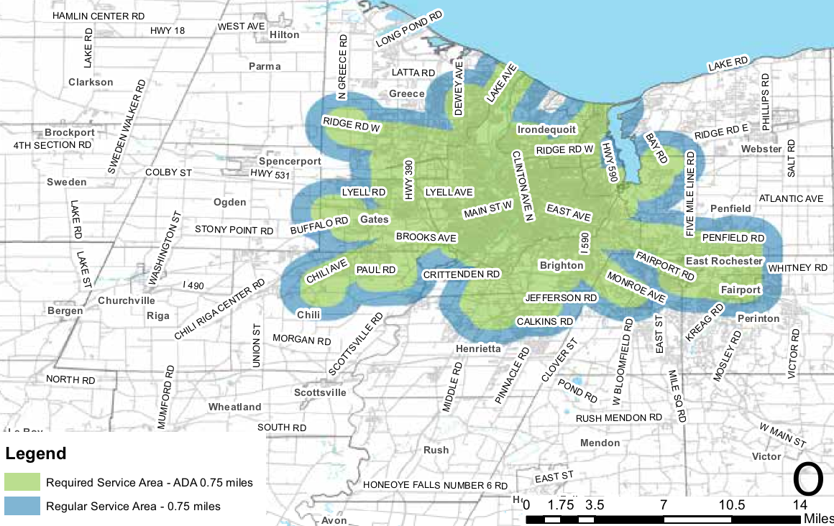
The Required Area surrounds the fixed route service and is shown on the map as a large green “blob” shape. This is the area where the Authority is obligated by law to provide complementary paratransit service. . RTS Access will provide paratransit service to any origin or destination point within a corridor fitting this description around any fixed route in the RTS system. The weekend service hours for the Required Area are Saturday and Sunday from 6:00 AM to midnight and include holidays.
Level 1 is shown on the map as a thick blue outline surrounding the green blob. The supplemental service in Level 1 goes ¾ miles beyond the ¾-mile Required Area, for a total service area of 1 and ½ miles. RTS Access will make its best effort to deliver the same service criteria for Level 1 as it does in the Required Area; rather than treating this area as supplemental, RTS Access will service it as though it is in the required area and will refer to this as a regular service area. This includes allowing customers to negotiate pickup times and reserve rides up to five days ahead, and guaranteeing a ride with a one-day advance reservation. The weekend service hours for Level 1 are Saturday and Sunday from 6:00 AM to midnight and include holidays.
RTS Access customers with subscriptions can take subscription trips in the Required Area and Level 1.
For customers traveling to the RTS Transit Center in order to use fixed route for some trips, RTS Access will perform drop-offs and pickups at Clinton Avenue, at the RTS Transit Center plaza.
People must not assume they live in the paratransit service area based on the maps. RTS Access recommends asking the appropriate representatives whether a trip is in the paratransit service area. Do not consult anyone outside the appropriate representatives at RTS Access for this determination. Dial 585-224-8330 Option 3 to ask about the service area or about pickup times available for a specific origin/destination.
End of Exhibit 3

Exhibit 4: Paratransit Trip Subscriptions Policy
This Policy will be implemented as soon as is practicable following Board approval of the Paratransit Plan in 2019. RTS Access will communicate the time-frame of the changes to all paratransit customers in advance of implementation.

1.0. Policy
“Subscriptions” will allow customers to set a schedule of repeated trips. RTS Access will offer Subscriptions to customers who meet the conditions described in this policy. The cost of a Subscription trip is identical to the fare for an individually scheduled trip. It is important for you to meet our conditions and use the Subscription trips responsibly. If you engage in disqualifying conduct, we will revoke your trip Subscription. We expect all customers to follow these rules for Subscriptions:
- Regularly use your allotted Subscription trips.
- Cancel Subscription trips at least six days before the next scheduled trip.
- Notify us if you miss a trip due to unforeseen situations or operational error.
- Keep your eligibility certification current (recertify or renew by the due dates).
- Request a hold six days before your next Subscription trip if you will be on vacation, recess, or holiday, and do not require the trip for one or more days.
We expect you to notify us if you will no longer need the Subscription. We expect you to follow the rules in the most current version of our Paratransit Service Infractions and Suspensions policy.

2.0. Qualifying for a Subscription

2.1. Eligibility Certification
To qualify for a Subscription, you must have All-Trip or Conditional certification. The certification must be current.

2.2. Frequent Identical Travel
To qualify for a Subscription, you must take one or more identical trips per week. Identical trips have the same origin and destination and the same pick-up or drop-off time on the same day or days of the week. We will consider trip purpose. Appropriate trips for a Subscription might include going to work, medical treatments such as dialysis, or a day treatment or rehabilitation program. The trips must occur on a regular ongoing basis. If you volunteer or work for an organization three times per week but your schedule changes monthly, a Subscription is not appropriate due to the variability in your schedule.

2.3. Short-Term Subscriptions
We will offer short-term subscription service to customers who will have frequent, identical travel for a specific need such as medical appointments or work programs. Short-term subscriptions are for periods between three weeks and no greater than 90 days. You cannot change short-term subscriptions or place a short-term subscription on hold. The same rules used in regular Subscriptions will apply to short-term Subscriptions with regard to waiting lists, capacity, availability, and peak demand. You must provide us with the start and end dates of the short-term Subscription.

3.0. Unforeseen Circumstances
Unexpected situations may cause you to miss a Subscription trip unintentionally or force you to cancel at the last minute. We will excuse situations when you miss or cancel a trip due to a reason outside your control. This includes sudden illness, a personal, household, or medical emergency, or needing to care for a sick family member. Before your pick up window begins, call 585-654-0675 and let us know about the situation. If an urgent situation prevents you from calling before your pickup, please notify us at a suitable time. We will also excuse situations when a scheduling or operations error causes you to miss your trip. Call 585-224-8330 (Option Number 3) so we are aware of the problem and do not assign a Service Infraction.

4.0. Temporary Holds (Vacation, Recess, Employer Holiday)
You can put your Subscriptions on hold for up to three months. When a Subscription is on hold, you can stop using the Subscription temporarily without penalty. Vacations are an appropriate situation for putting a Subscription on hold. Another example is a school recess or an employer-sponsored holiday. Call 585-224-8330 (Option Number 3) to request your hold six days in advance of the date for your vacation, recess, or holiday. You will need to tell us the start date for the hold and you will need to call us within three months to resume your Subscription trips as usual. If you do not resume Subscription use after three months, your Subscription will be revoked.

5.0. Offering Subscriptions
You may call 585-224-8330 (Option Number 3) and request a Subscription at any time during normal business hours. If capacity is sufficient, we will offer the Subscription at that time. If capacity is insufficient, we will add you to the waiting list. When RTS Access has capacity to offer a Subscription, the Subscription Coordinator will select the next customer from the waiting list.
When we offer a Subscription, the Subscription Coordinator will issue a message in an accessible format to notify the customer. The message will outline the required conditions, restrictions, and actions that will result in losing the Subscription. New Subscriptions that can be offered will begin 21 days after the date of the request. You must call us at 585-224-8330 (Option Number 3) to confirm that you still need the Subscription. If we do not hear from you within 21 days of the date of the message, we will move your name to the end of the waiting list.
From time to time, RTS Access may use the travel data from the paratransit scheduling system (Trapeze PASS), and the Customer Relationship Management system (CRM Salesforce) to identify customers who meet the conditions for Subscription service, as long as capacity exists and there is no waiting list. We will notify customers who meet the conditions for Subscription service in an accessible format.

6.0. Revoking Subscriptions
We will revoke your Subscription service if you fail to maintain the required conditions, which are: identical and frequent travel, reliable ridership, and current eligibility certification.
You will receive a message in an accessible format that we are revoking your Subscription service. The message will include the date that the Subscription will terminate. After we notify you, you must call to schedule all trips. If you do not renew the information for an All-Trip eligibility certification, your paratransit trips will be suspended until the updated information is provided, including subscription trips.

6.1. Failure to Maintain Identical and Frequent Travel
When you accept an offer of a Subscription and complete the reservation process, the Subscription trips will have an agreed upon time, location, day of the week, and frequency. If you use the Subscription service and your schedule changes, you will need to reapply. Call RTS Access at 585-224-8330 (Option Number 3) to apply for Subscription service. If Subscription service cannot be immediately re-arranged, you can be added to a waiting list. You may still call RTS Access during regular business hours and schedule your desired trips individually.
If you had a temporary hold applied to your Subscription, but failed to resume using it after your hold period ended, we will revoke the Subscription.

6.2. Failure to Maintain Reliable Ridership
We expect customers to use their Subscription trips responsibly. If we identify a pattern of absenteeism or excessive cancellation, we will revoke your Subscription. In some situations, a Subscription is not a good fit for your work or program schedule.

A. Repeated Service Infractions
The first time you receive a Repeated Service Infraction, you will lose your Subscription. We will revoke your Subscription and tell you the date to begin scheduling every trip. If you are suspended, the suspension will apply to all trips, including Subscription trips. Repeated Service Infractions, exclusions, and penalties are explained in the “Paratransit Service Infractions and Suspensions” policy.

B. Excessive Cancellation of Subscription Trips
RTS Access may revoke any Subscription that is canceled 30% or more in two consecutive months. A customer cannot miss more than seven Subscription trips in one month. Seven or more missed trips in one month will be considered a consistent pattern of cancellations of any part of a Subscription. The decision to revoke a Subscription because of excessive cancellations is final. We will exclude all subscriptions canceled six days in advance of travel. If you are suspended, the suspension will apply to all paratransit trips, including Subscription trips.

6.3. Failure to Maintain Eligibility Certification
If you have a Conditional eligibility certification, you must keep it current. If you have a trip Subscription but allow the Conditional eligibility certification to expire, we will revoke the trip Subscription privilege on the date of expiration. If you get an extension, you still have the ability to use paratransit service.
The RTS Access A D A Coordinator will issue a message in an accessible format to you 90 days before your Conditional eligibility certification expires. The message will remind you to recertify to maintain the eligibility condition for paratransit and for Subscription service. If you have not recertified within 60 days of the expiration date, you will receive a reminder notification. If the certification expires, RTS Access will notify you that you cannot use paratransit service until you re-establish eligibility. Your Subscription will be revoked.
Contact the A D A Certification Coordinator before your eligibility expires to request an extension of time to obtain approval of your Conditional eligibility certification. If approved, the extension will apply to all Subscriptions.

6.4. Requesting Reinstatement of a Revoked Subscription
If we revoke your Subscription service, you may request to reinstate that service or apply for a new Subscription 60 days after the date the Subscription was revoked. You must not have any Service Infractions during that period. If you qualify and capacity is available, we will reinstate the Subscription or create a new Subscription. If the Subscription requests exceed capacity, availability, or peak demand, we will add you to a waiting list.
If your Subscription service has been revoked due to Repeated Service Infractions three times within 18 months, you will no longer qualify for Subscription service.

7.0. Restrictions
Paratransit is a shared ride service and must reasonably satisfy non-subscription demand. Operational costs, performance standards, customer demand, scheduling logistics, and physical capacity all affect the distribution of service. The following restrictions will apply to Subscriptions to balance service distribution.
- Subscription service will not exceed more than 50% of the number of trips available at a given time of day, unless there is non-subscription capacity.
- Subscription trips will not run on major holidays.
- Subscriptions will not be available for unique trips, or during hours or days with peak demand.
- Subscriptions will not be available to customers with Temporary eligibility certifications.
- Subscriptions will not be available for supplemental service in Level 3 of the paratransit service area.

7.1. Capacity, Availability, and Peak Demand
RTS Access will make the maximum percentage of Subscription trips available to qualifying customers according to the non-subscription capacity for trips during a particular day and time. For example, if we have the capacity to provide 50 complementary paratransit trips between 8:00 AM and 9:00 AM on Mondays, then the maximum number of trips available for Subscription trips is 25 trips (or 50%). If our capacity for paratransit trips during that period increases, the percentage of Subscription trips will also increase.
We will add customers who qualify for a Subscription to a waiting list if their trip occurs on particular days or times when RTS Access experiences capacity constraints and cannot absorb additional riders. When our capacity allows an increase in Subscription riders during a particular day and time, RTS Access will contact the appropriate number of customers on the waiting list and schedule the Subscription trip. Customers on a waiting list can expect to wait 6 to 9 months for the necessary capacity to become available.
Availability of Subscriptions will not affect general paratransit service or the eligibility determination process. We will reduce or exclude Subscriptions from days or times with high non-subscription ridership demand. Demand may fluctuate seasonally. Subscription service availability during peak work times may be limited and/or priority may be given to customers who use the Subscription service for work trips.

7.2. Major Holidays
RTS Access does not provide Subscription service on these major holidays: New Year’s Day, Memorial Day, July 4th, Labor Day, Thanksgiving Day, and Christmas Day. RTS Access does not provide Subscription service on any day that RTS determines is a holiday (i.e. floating holiday).

7.3. Unique Trips
Subscription service will only apply to identical trips that repeat on a regular basis. For example, routine travel to the same facility for a standing appointment on Tuesdays and Thursdays each week will qualify for a Subscription. Unique trips vary from week to week or month to month (a different destination, a different pick-up, different times, or different days of the week). Unique trips will not be included in a Subscription. Subscription and non-subscription customers must call and reserve each unique trip.

7.4. Eligibility Certification
We do not issue Subscriptions to customers with Temporary or expired Conditional eligibility certifications. Subscription service will be available only to customers with up-to-date All-Trip or current Conditional paratransit eligibility certifications. If your certification expires, we will revoke your Subscription. If you do not keep your information current (All-Trip renewal), we may suspend paratransit service, including Subscription trips, temporarily until you provide the information.

8.0. Rights Reserved
RTS Access will reserve the right to cancel a specific Subscription trip or terminate the entire Subscription if we experience capacity constraints. In that case, we will 1) inform you in advance of a scheduled trip that we are cancelling the trip or revoking the Subscription; and 2) instruct you to schedule trips separately. Along with restrictions, RTS Access will reserve the right to discontinue Subscription service if we cannot provide it while maintaining efficiency in our runs and service. If necessary, we may place Subscription service on hold temporarily for a period of up to three months. To preserve operational feasibility, we may modify the Subscription trip. We will contact the affected customers to negotiate pickup windows.
End of Exhibit 4
End of Exhibits for Section 1

Section 2: Plan to Provide Comparable Paratransit
This section estimates the demand for comparable paratransit service in Monroe County, describes planned modifications to operational practices, and compares RTS Access service as it relates to the service criteria for complementary paratransit. RTS Access extends the comparison criteria to include the process for considering reasonable modification requests, allowing service animals, and complaint procedures. The section closes with a time-line and the 2017-2023 budget for comparable paratransit service.

2.1. Estimate of Demand
This subsection estimates the demand for comparable paratransit service as required in Subpart F, §37.139 (d) (1) of the federal regulations.
RTS Access tracks each ride for reporting purposes. RTS Access anticipates a stable trend for paratransit demand and predicts that demand will increase at a rate of about 3% each year.
R G R T A and RTS Access will rely on the Demographic Profiles and Major Destinations information for Monroe County provided through the Coordinated Public Transit-Human Services Transportation Plans developed by the Genesee Transportation Council.

2.2. Analysis of Existing Service and Proposed Modifications to Operational Practices
R G R T A determines that the current RTS Access service complies with the service criteria for complementary paratransit set forth in Subpart F, §37.131 of the federal regulations. Proposed modifications include changes to the service area, to Subscription service, to Service Suspensions, to Eligibility categories, to the period for Advance Reservations, and to the base trip fare.

2.2.A. Origin-to-Destination Next-Day Service
The basic operating mode for RTS Access is curb-to-curb. If a customer needs help beyond the curb to reach a destination beyond the curb, the customer can request assistance beyond the curb in advance of or during the ride. RTS Access will refer to the practice of providing assistance beyond the curb as a reasonable modification and will discontinue using the term “enhanced service.” RTS Access will treat requests for “door-to-door” assistance or “enhanced service” as reasonable modification requests. More details are in Subsection 2.5.A and 2.5.C of this Plan.

2.2.B. Service Area
The paratransit service area will change according to the redesigned RTS fixed route system going into effect in the summer of 2020. The service area where R G R T A is obligated by law to provide complementary paratransit is a corridor with a width of ¾ of a mile on each side of each fixed route. At the end of a fixed route, there is a semicircular “cap” on the corridor, consisting of a ¾- mile radius from the endpoint of the route to the parallel sides of the corridor. These areas are all considered the Required Area for RTS Access paratransit service.
RTS Access will provide supplemental paratransit service in geographic areas extending outward from the Required Area. In 2020, there will be three levels of paratransit service, each covering a specific geographic area. Refer to 1.5.D. Supplemental Service for details.
The redesigned RTS system includes Community Mobility Zones, where fixed route service connects to demand responsive services. Exhibit 2 provides details about demand responsive service in the community mobility zones, and Exhibit 3 provides details about the paratransit service area, including the Required Area for complementary paratransit and the three levels where supplemental services are provided.
In circumstances where service changes to fixed route affect the paratransit service area, RTS Access will follow the process in a notification policy in order to communicate the change to RTS Access customers in advance of the changes. See Exhibit 5 Notifications Regarding Changes to the RTS Access Service Area Policy.

2.2.C. Subscription Service
The FTA rules allow transit agencies to 1) provide Subscription service at their discretion, and 2) use waiting lists, capacity constraints, trip purpose restrictions, or priorities for participation in the Subscription service. Unless there is also capacity for regular paratransit trips, the FTA limits Subscription trips to no more than 50% of the number of trip available at a given time of day. RTS Access will make the maximum percentage of Subscription trips available based on capacity.
RTS Access will provide the Paratransit Trip Subscriptions policy in an accessible format. RTS Access will offer Subscriptions to customers who meet the conditions described in the policy. The policy explains the criteria for getting a Subscription, for using a Subscription, and for revoking a Subscription. The policy outlines restrictions and expectations.
The policy offers a new set of criteria to qualify for a Subscription. The frequent identical travel criterion considers the purpose of the trip along with the consistency and regularity of the trip. Customers do not have to establish a record of identical trips prior to being offered a subscription. We will also offer Short-term subscription service to customers if there is capacity. The Short-term subscription can be for a period of 21 days up to 90 days and applies to a specific need, such as a work program or specific medical treatment. We will add customers who qualify for a Subscription to a waiting list if their trip occurs on particular days or times when RTS Access experiences capacity constraints and cannot absorb additional riders. When our capacity allows an increase in Subscription riders during a particular day and time, RTS Access will contact the appropriate number of customers on the waiting list and schedule the Subscription trip. Subscription service will be available in the following paratransit service areas: the Required Area, Level 1, and Level 2. RTS Access will excuse situations when customers miss or cancel a trip due to a reason outside their control. However, customers are responsible for notifying RTS Access about these situations. The policy explains the process for applying temporary holds to Subscriptions during vacation, school recesses, or employer-sponsored holidays. The policy explains what actions will cause the revocation of a Subscription and the options for reinstating a Subscription. We will revoke a Subscription the first time you receive a Repeated Service Infraction. Sixty days after the date of the revocation, you can request to reinstate the Subscription or apply for a new Subscription. The policy explains what RTS Access considers a pattern of excessive cancellations and the consequences for Subscriptions.
The full Paratransit Trip Subscriptions policy is in Exhibit 4 of the Plan.

2.2.D. Service Infractions and Suspensions
RTS Access will use a calculation method recommended by FTA guidance to determine whether a pattern of missing scheduled trips exists and indicates an abuse or misuse of paratransit service. In such circumstances, it is appropriate for RTS Access to apply a penalty where the customer cannot use paratransit service for a temporary period (service suspension).
RTS Access will provide the Paratransit Service Infractions and Suspensions policy in an accessible format. The policy will use simple language to help customers understand the rules, to help customers avoid service suspensions, and to help employees apply the process consistently.
RTS Access will track Service Infractions. Service Infractions include all of the following situations: 1) not showing up for the ride (No-Show), 2) cancelling less than two hours before the Pickup Period (Late Cancellation), and 3) refusing the ride when the bus arrives for your pickup (Cancel at Pickup). The system-wide data supports a 5% threshold for calculating Service Infractions and the approach complies with the guidance from the FTA. RTS Access will excuse situations when customers miss or cancel a trip due to a reason outside their control. However, customers are responsible for notifying RTS Access about these situations before the 15th of the following month. The policy gives instructions for notifying RTS Access when such a situation occurs, as well as for when customers believe they received a Service Infraction due to operational or scheduling error. On the 15th of each month, RTS Access will evaluate the customer’s actual usage of his or her reserved trips during the prior month. RTS Access will exclude the following: 1) excused missed trips; and 2) individual trips canceled two or more hours in advance of the scheduled pick up window; 3) Subscription trips canceled six or more days in advance of the trip date; and 4) Subscription trips that are put on hold six or more days in advance of the trip date. After these exclusions, if the RTS Access records indicate that 5% or more of the trips resulted in Service Infractions, RTS Access will apply penalties as defined in the policy. The accumulation of Repeated Service Infractions serves as the basis for a Service Suspension. RTS Access will add the number of times a customer has a Repeated Service Infraction in one calendar year to determine the penalty. The calendar year starts on January 1 and ends on December 31. The first Repeated Service Infraction in one calendar year will result in a penalty of a Warning Letter. The subsequent Repeated Service Infractions in one calendar year will result in service suspensions of increasing length, starting with five days but not exceeding 20 days. Repeated Service Infractions that occur in the last two months of the calendar year could result in a service suspension in the next calendar year, even though the tracking mechanism restarts for each calendar year. Any Repeated Service Infraction will also result in the revocation of any Subscription service a customer has. The customer can request reinstatement of the Subscription or apply for new Subscription service 60 days after the original revocation date. If Subscriptions are revoked three times during a period of 18 months, the customer will no longer qualify for Subscription service. RTS Access will provide any warnings, suspension notifications, or information about the appeals process in an accessible format. The full Paratransit Service Infractions and Suspensions policy is in Exhibit 6 of the Plan.
If a customer appeals a notice of service suspension, RTS Access will continue to provide paratransit service as usual to the customer while the appeal is pending. Important details about the appeal process are in the full Paratransit Appeal Process and Procedures available in Exhibit 11 of the Plan.
The A D A permits the suspension of customers from using complementary paratransit service if the customers engage in violent, seriously disruptive, or illegal conduct. Appeals for these types of suspensions follow a different process, which is explained in the Paratransit Appeal Process and Procedures in Exhibit 11 of the Plan. The full Paratransit Service Suspensions for Prohibited Conduct policy is in Exhibit 6 of the Plan.

2.2.E. Eligibility
RTS Access uses an application for eligibility certification and recertification. RTS Access will provide a PDF file of the application online at https://www.myrts.com/RTS-Access/Apply.
RTS Access will mail paper copies on request. People can call 585-654-0618 to request an application.
Many sections of the application are multiple-choice questions to reduce the need for extensive writing or typing. The A D A Certification Coordinator is unable to perform eligibility determinations without all the information and all parts of the application. As a result, the application includes a mandatory checklist to assist people in completing the form correctly. RTS Access will return incomplete applications to the person for completion.
Applicants will be required to submit the entire application at the same time: all pages, all signatures, and all supporting materials. Applicants will be required to authorize medical or health care providers to release specific information to the A D A Certification Coordinator for the purpose of eligibility determination. The applicant will be required to obtain the information and signatures requested in Part 5 of the application.
The Paratransit Eligibility policy proposes the following certification types: All-Trip, Conditional, and Temporary. The term “All-Trip” will replace the term “Unconditional.” The All-Trip Certification grants the person eligibility to use paratransit service for all trips within the service area because the condition preventing the person from functionally using fixed route service is unlikely to improve and any other external improvements are unlikely to provide functional ability to use fixed route. All-Trip Certifications must be renewed every three years. The renewal consists of a basic form to obtain updated contact information and note any changes in travel abilities or needs. The renewal process also allows RTS Access to issue a new Tap &Go Access ID card if necessary. The renewal does not involve recertification.
Previously, the “Seasonal” eligibility certification applied to the period between October and April. However, this does not take into account seasonal conditions during other months of the year. As a result, “Seasonal” will not continue to exist as a separate eligibility category. Seasonal conditions are part of the wider set of conditions that can result in barriers to travel and result in a determination of Conditional eligibility.
Our Conditional eligibility category is revised to adhere more clearly to the Code of Federal Regulations set forth in Part 37 Transportation Services for Individuals with Disabilities (A D A). As Appendix D to § 37.123 explains, “A person may be A D A paratransit eligible for some trips but not others. Eligibility does not inhere in the individual or his or her disability, as such, but in meeting the functional criteria of inability to use the fixed route system established by the A D A. This inability is likely to change with different circumstances.” Conditional eligibility applies to individuals who are able to independently use fixed route transit service under some circumstances. Rather than basing Conditional eligibility on the degree to which a person’s specific disability could change, we are assessing a wide assortment of conditions, such as weather, season, and the physical characteristics of the location, to identify whether there are barriers that can affect travel. The policy further explains that a person’s functional ability to use fixed route service may increase or decrease based on specific, measurable conditions. The A D A Certification Coordinator will provide individuals with a description of the conditions under which he or she can use paratransit, as well as the basis for the eligibility determination.
When a person is certified or recertified as paratransit eligible, the A D A Certification Coordinator will send information about rights under Title VI along with the eligibility materials. RTS Access will provide recertification messages, renewals, eligibility determinations, and Title VI information in an appropriate accessible format. Applicants and customers can call 585-654-0608 during regular office hours for additional assistance.
Anyone who believes that his or her functional abilities have changed and the conditions established no longer reflect his or her abilities, can submit new documentation, or reapply at any time during the current term of eligibility.
The full Paratransit Eligibility Policy is available in Exhibit 11.
Applicants can elect to appeal a decision to deny eligibility or appeal the type of eligibility granted. Once the appeal process is complete, RTS Access will have 30 days to issue the decision. RTS Access will not provide paratransit service to the appellant while the appeal decision is pending. However, if RTS Access takes longer than 30 days to issue the appeal decision, it must provide paratransit service to the appellant until it issues the decision. Important details about the appeal process are in the full Paratransit Appeal Process and Procedures available in Exhibit 11 of the Plan.

2.2.F. Lack of Capacity Constraints
Customer feedback shows that on-time performance (OTP) is a strong indicator of service quality and correlates to customer satisfaction. RTS Access established an OTP goal of 95.25% in 2019. The goal may adjust on an annual basis, with the aim to provide an accurate measure of quality. RTS Access uses extensive technology, data points, and calculations to determine the on-time performance each month. Management monitors the results with the aim to identify causes for performance below the goal and ways to improve performance. However, customers can provide input about their direct experiences regarding the timeliness of service through the RTS Access Bus Service Questionnaire or the online Contact-Us form available at http://rts.force.com/RTSContactUs. A sample of the questionnaire is available in Exhibit 8.
For 2019-20, RTS Access will replace 9 buses at a cost of $759,126.
RTS Access will mitigate early arrivals. It is the Bus Operator’s responsibility to wait until the pickup window starts before counting down the 5 minutes. Customers will have the ability to report the problem through several points of contact by calling Dispatch, Scheduling, or management.
- Dispatch Office, 585-654-0675
- Scheduling Office, 585-224-8330, Option 3
- Cancellations/No-Shows, 585-654-0647
- Operations, 585-654-0747
Customers can also report the problem through the online Contact-Us form available at http://rts.force.com/RTSContactUs.
If we made the error, we will not count the missed ride as a Service Infraction. We will continue to train all Bus Operators on the correct procedure, and work with individual Bus Operators as necessary.

2.2.G. Pickup Periods for Return Trips and No Strand Policy
RTS Access will provide a policy to explain the practice of return service. The policy will explain the concept of the Final Pickup Period, which is the latest available pickup period that will allow RTS Access to finish transporting customers no later than the latest comparable fixed route drop-off. RTS Access will not provide return trips after the Final Pickup Period. If the customer either cancels or does not use the outgoing ride for a scheduled round-trip, RTS Access will provide the return ride as scheduled unless the customer cancels it. If a customer fails to appear for boarding within the scheduled Pickup Period for the return ride, RTS Access, at the request of the customer, will attempt to schedule a return trip so that the customer is not stranded. Exhibit 9 of the Plan provides the full Paratransit “No Strand” Policy.

2.3. Additional Points of Comparison
For planning purposes and operational consistency, RTS Access will include in this Plan requirements from other Subparts found in 49 CFR 37 of the federal regulations. As points of comparison, RTS Access will evaluate its processes for considering reasonable modification requests and for allowing service animals to ride (49 CFR 37 Subpart G). RTS Access will evaluate its procedures for handling complaints (49 CFR 37 Subpart A). The process that RTS Access follows for a reasonable modification request is described online at https://www.myrts.com/Riders-Guide/ADA-Compliance. For more details, refer to Subsection 2.5 of this Plan.

2.4. Comparable Paratransit Service
This subsection compares RTS Access service as it relates to the service criteria for complementary paratransit as required by Subpart F, §37.131. The criteria includes service area, response time, fares, trip purpose restrictions, hours and days of service, capacity constraints, and additional service.

2.4.A. Service Area as required in §37.131 (a) of the federal regulations
RTS fixed route service forms the basis for complementary paratransit. This is referred as the Required Area for paratransit service. RTS Access uses supplemental paratransit service in Level 1 to extend the service area coverage ¾ miles beyond the Required Area on weekdays and weekends, for a total service area of 1 and ½ miles. Suburban areas are now categorized as Community Mobility Zones. These zones are served by RTS demand responsive services. The Required Area and Level 1 cover some of the geographic areas now categorized as Community Mobility Zones. For the geographic areas that are still within the CMZs but outside the Required Area and Level, RTS Access has a Level 2 service area where it provides supplemental service on weekdays. For the geographic areas 1.25 miles outside the geographic boundaries of the CMZs and ½ mile outside the geographic boundaries where no CMZ exists, RTS Access has a Level 3 service area where it provides supplemental service on weekdays.
Living within the RTS Access service area is not a requirement for eligibility certification. However, RTS Access will provide paratransit service only to points within its service area as defined for weekdays and weekends. It will be the responsibility of customers living outside the service area to arrange for alternate transportation to and from the paratransit service areas.
Customers who live within a supplemental service area may elect to use the RTS Access supplemental service as described in Subsection 1.5.E. Supplemental Service. Because RTS Access complementary paratransit mirrors RTS fixed route (Required Area), the coverage of the service area will vary. Areas served by demand responsive service do not require complementary paratransit. Exhibit 3 shows that RTS Access serves the entire service area during weekdays, but weekend service runs in the Required Area and Level 1 only.
The service area maps do not represent the schedule of service. RTS Access customers may consult RTS Access Scheduling, RTS Customer Service, or RTS fixed route schedules to learn which times of day buses run in a specific location within the service area.
The supplemental service provided in Level 1, Level 2, and Level 3 may change if so authorized as a resolution from the Board of Commissioners.
A service change that affects the RTS fixed route service area will affect the RTS Access service area. If such a change is proposed, it will be subject to input from the public. Such changes may result in the loss or expansion of service for RTS Access customers. If such a change is approved, RTS Access will notify RTS Access customers in writing and continue to provide paratransit service for a pre-defined period to allow them to make adjustments or arrangements regarding their origins and destinations. Exhibit 5 provides the procedures and processes for public participation and describes the notification process.

2.4.B. Responding to Requests for Rides (Response Time) as required in §37.131 (b) of the federal regulations

1. Resources for Making Trip Reservations
Customers must call RTS Access staff (Schedulers) to request rides (“reserve,” “book,” or “schedule”). RTS Access will not allow Bus Operators to reserve rides.
The Schedulers will book rides occurring during the same hours and days as RTS fixed route services. The RTS Access Scheduling office is open from 8:00 AM to 5:00 PM Monday through Friday. Scheduling hours for Saturday, Sunday, New Year’s Day, Memorial Day, Independence Day, Labor Day, and Thanksgiving Day will be from 8:00 AM to 1:00 PM. The Scheduling office will be closed on Christmas day. The change to the weekend scheduling hours will go into effect as soon as is practicable after Board approval of the Paratransit Plan.
RTS Access has a phone line for scheduling (reserving) trips. To request a trip, customers must dial 585-224-8330, and press 3 at the prompt.
RTS Access has received funding to upgrade the reservation system to allow online reservations. The software product called “PASS Web” will provide customers of RTS Access with the online reservation capability to confirm, cancel, and book their own trips over the Internet.
RTS Access has phone lines for questions or requests unrelated to trip reservation. Customers can reduce hold times for those who are scheduling trips by using the appropriate phone lines designated for other types of calls. These phone numbers are online at https://www.myrts.com/RTS-Access/Calling-RTS-Access.
The Dispatch office is open 4:00 AM to 1:00 AM Monday through Friday and 5:00 AM to 1:00 AM on weekends. The Dispatchers’ primary job is to support bus operations. During Scheduling office hours, they will transfer trip requests to Scheduling. Dispatchers will schedule same-day trips when the Scheduling office is closed.

2. Next Day Service and Advance Trip Reservations
Customers must reserve the ride at least one day in advance to ensure a ride. This is “Next-Day” service. RTS Access will document any instance when it is unable to accommodate a ride request made the previous day.
Customers can book up to six rides (three round trips) in advance during the same phone call. Booking rides in advance is an option, not a requirement. RTS Access recommends booking in advance to ensure getting the rides. However, RTS Access will accommodate Same-Day trip reservations if space is available.
Effective as soon as practicable after the Paratransit Plan is approved by the Board, customers will have the option to book rides up to five days in advance for trips in the existing Paratransit Service area. When the redesigned system is implemented in 2020, customers will have the option to book rides up to five days in advance for trips in the Required Area and supplemental trips in Level 1 and Level 2. For trips in Level 3 of the service area (available during weekdays only), customers can book one day in advance.

3. Time Between Trips
RTS Access will require customers to stay a minimum of one hour between the drop-off at any destination and a return trip. The FTA guidance acknowledges that transit agencies may separate two trip requests by 60 minutes and, in some instances, 90 minutes. Every trip involves a pickup time, pickup window, and travel time. When a customer reserves a trip, the Schedulers need to know the origin, destination, time of travel, the number of people traveling, and the number of service animals. The FTA rules prohibit RTS Access from prioritizing one type of trip over another (excluding subscription trips). While it may seem sensible to allow the Bus Operator to wait a short period for one customer to perform an errand and return to the bus, doing so could delay the pickup or drop off for another customer. Allowing the Bus Operators to wait for some trips, but not for all trips, is not compliant with the regulations. As a shared ride service, RTS Access will strive to operate in a manner that is consistent for all trips.

4. Trip Negotiations
When booking a ride, the Scheduler will explain that the customer’s travel time on the bus could be up to one hour.
The Scheduler will ask “What time do you want to be picked up?” The Scheduler may negotiate pickup times, but cannot require customers to schedule their trip to begin more than one hour before or after the requested time. RTS Access will document any instance when it cannot schedule the ride within a one-hour window of the time requested. After negotiating the pickup time, the Scheduler will communicate the pickup period to the customer. For the existing system, Schedulers will conduct trip negotiations for all trips in the Required complementary service area only. Trip negotiations will not occur for trips in supplemental areas. When the redesigned system is implemented in the summer of 2020, Schedulers will conduct trip negotiations for the Required area and for the supplemental Regular area (Level 1) and Level 2 area.
If Schedulers are not conducting trip negotiations as described here, customers should report the issue immediately using Contact-Us or by calling Customer Service at 585-288-1700 or RTS Access Operations at 585-654-0747. Include the details of your trip request and the date of the call.

5. Pickup Period
A pickup period is the window of time during which the customer can expect the bus to arrive for the pickup time. Effective as soon as is practicable after the Paratransit Plan is approved by the Board, the window will start five minutes before the pickup time and end 15 minutes after the pickup time. After the pickup period begins, the Bus Operator will wait five minutes for the customer to show up for the booked ride. If the Bus Operator arrives before the pickup period begins, the Bus Operator will wait until the starting time of the pickup period and, if the customer has not yet appeared, then wait the additional five minutes.
For example, if the bus arrives at 1:12 PM for a 1:30 PM pickup, the Bus Operator must wait until the pickup period starts at 1:25 PM. If the customer does not appear at 1:25 PM for boarding, the Bus Operator must wait for a full five minutes to elapse (1:30 PM) before departing.

6. Early Departures
It is the Bus Operator’s responsibility to wait until the pickup window starts before counting down the five minutes. An “Early Departure” occurs if the Bus Operator departs before the pickup window starts. If customers miss their trip due to an early departure, they are encouraged to report it to RTS Access. RTS Access will excuse the missed trip when the Bus Operator departs early. RTS Access will work with individual Bus Operators as necessary. RTS Access customers can use any of these phone numbers to report early departures.
1. Dispatch Office, 585-654-0675
2. Scheduling Office, 585-224-8330, Option 3
3. Cancellations or No-Shows, 585-654-0647
4. Operations, 585-654-0747
If the bus arrives at 1:30 PM for a 1:30 PM pickup and the customer is not ready to board, the Bus Operator will wait for a full five minutes to elapse. If the bus arrives at 1:44 PM and the customer is not ready to board, the Bus Operator will wait for a full five minutes to elapse. If the customer is not actively boarding the bus by minute five, the Bus Operator will report a missed trip and proceed to the next pickup location.

7. Late Arrivals
If the bus arrives 16 minutes or more after the pickup time, RTS Access will require the Bus Operator to notify Dispatch. The bus will be considered late. If the late arrival will affect customers, RTS Access will contact and notify them of the issue. RTS Access will document any instance when it was late for a scheduled pick up.

8. Canceling Rides
RTS Access expects customers to use their booked rides. RTS Access expects customers to cancel any ride they do not need in advance.
Customers must cancel rides by phone. Bus Operators will not be able to cancel rides. Customers will have the ability to cancel rides 24-hours a day, 7-days a week by leaving a voice-mail message with their ride information. Customers can call 585-224-8529 or 585-224-8330, Option 1. When cancelling a round trip, the customer will need to cancel the pickup ride and the return ride. RTS Access will not cancel the return ride automatically.
RTS Access will expect customers to cancel an individual ride at least two hours before the pickup period starts. An “Advance Cancellation” is when the customer calls and cancels the ride at least two hours in advance of the pickup. Advance Cancellations will not carry any penalty.
A “Late Cancellation” will occur if the customer cancels a ride less than two hours ahead of the pickup period. RTS Access will count a Late Cancellation as a Service Infraction unless the customer notifies RTS Access that the situation was beyond his or her control.
A “Cancel at Door” will occur if the customer cancels a ride when the Operator arrives for the pickup. RTS Access will count a Cancel at Door as a Service Infraction unless the customer notifies RTS Access that the situation was beyond his or her control.
The full Paratransit Service Infractions and Suspension policy is in Exhibit 6 of the Plan and explains the thresholds in detail.

9. Round Trips
An individual trip has one outgoing ride with a single origin (pickup) and single destination (drop-off). Such a trip has one part, which can be explained as going from point A to point B.
A round trip has two booked rides, first outgoing from an origin to a destination, and then returning from the same destination to the same origin. A round trip has two parts, which can be described as going from point A to point B in the first part, and then going from point B to point A in the second part. Each trip must be requested and reserved explicitly with the RTS Access staff.
A multi-part trip connects several parts. The drop-off point for one part becomes the pickup point for the next part. For example, going from point A to point B is part 1 of the trip. Then, going from point B to point C is part 2. Going from point C to point D is part 3, and going from point D to point A is part 4 of the trip. In this example, the trip is not a round trip even though the end of the trip returns to the same point where part 1 originated (point A). A multi-part trip requires a reservation for each part. The trip described in our example would require four separate reservations.

10. Companions
Customers have the right to travel with one accompanying companion during the trip. The accompanying companion must travel the same trip, beginning at the customer’s origin and ending at the customer’s destination. Customers have the right to bring one child as the accompanying companion. If space is available and they do not displace other eligible riders with reserved trips, customers may bring more companions, including children. It is important to discuss the number of companions when scheduling the ride. RTS Access recommends that customers tell the Scheduler when they will travel with multiple children. Discussing the size of the group will ensure the trip includes the full group and does not infringe on the rights of other customers, who may be traveling with PCAs or companions on that same trip.

11. Sedans and Children
Safety is an important reason for discussing children with the Scheduler. The Scheduler may need to ask about the age and size of the children accompanying the customer. Some paratransit rides are booked on sedans. New York State law requires that children under the age of four ride in child safety seats and that all children ride in child safety restraint systems until their 8th birthday. RTS Access will not transport children in sedans without a safety seat if they are younger than 8 years and/or are physically smaller than recommended. The child must weigh at least 80 pounds and measure 4 feet, 9 inches in height. Knowing the age and size of the accompanying children will allow the Schedulers to reserve the ride on the appropriate vehicle. Effective immediately upon approval of the Paratransit Plan, RTS Access will have specific requirements for children who are either younger than 8 or physically smaller than the recommended standard with regard to traveling in sedans. RTS Access will require adults who wish to travel in a sedan with such a child to provide an appropriate child safety seat and install it at the time of the ride. RTS Access Schedulers will take note of the option to book a sedan and inform customers at the time of reservation about the policy regarding children and safety seats.
If an RTS Access sedan arrives for a pickup and the adult is not prepared with a safety seat for a child under 8, RTS Access will not transport them in the sedan. The Operator will give the adult sufficient time to obtain the safety seat and return to the sedan. The child must remain in the care of the adult; the Operator cannot supervise the child. The adult must install the seat; the Operator cannot provide assistance with seat installation. If the adult does not possess a safety seat, the situation may result in a Cancel at Door Service Infraction if the customer was informed about the requirement at the time of booking. The customer can contact RTS Access Scheduling to request a same-day trip on a vehicle that is not a sedan.

12. Personal Care Attendants
Customers have the right to travel with one Personal Care Attendant (PCA) who assists them with a daily life activity. The PCA must travel from the same origin to the same destination as the customer. A friend or family member is a PCA if the customer regularly makes use of a PCA and the friend or family member is actually acting to assist the customer with personal needs. RTS Access realizes that a child may act as a customer’s PCA. In these cases, RTS Access recommends that customers explain to the Scheduler that their PCA is a child when they schedule the trip. This is not a requirement. However, giving the information to the Scheduler will better ensure that the Bus Operator is informed in advance that the customer will board with a child acting as the PCA.
If a customer brings a PCA on his or her trip, the customer has the right to bring one child or one adult as an accompanying companion.

13. Scheduling Questions
Customers have the right to travel with their PCAs, service animals, mobility devices, and assistive devices according to their needs. When reserving a ride, RTS Access Schedulers may ask whether the customer will travel with a PCA, a service animal, or a device. These answers will help the Schedulers to book a trip on a vehicle best suited for all the components to which each customer is entitled, especially during busy times of the day.

14. Service Animals and Guide Dogs
Customers have the right to travel with their service animals and guide dogs on any RTS vehicle, including RTS Access sedans. The customers or PCAs are responsible for keeping the service animal under their control at all times. The service animal must not block the aisle and must not pose a direct threat to the health and safety of others. RTS Access Schedulers may ask if customers intend to ride with a service animal to ensure adequate space is available for the animal. The FTA guidance acknowledges that this practice is acceptable.
In accordance with A D A Requirements, a person with a disability cannot be asked to remove his or her service animal from the vehicle or premises unless: (1) the animal is out of control and the handler does not take effective action to control it or (2) the animal is not housebroken. When there is a legitimate reason to ask that a service animal be removed, the Operator must offer the customer the opportunity to take the ride without the animal’s presence. If the customer wants to take the trip, the Operator must provide the customer with sufficient time to return the service animal to a safe location (i.e. house) and come back to the vehicle.
Different service animals may provide different services to a customer during trips or at the destination. As a result, RTS Access does not prescribe limits on the number of service animals that accompany a customer on a single trip. A customer can travel with more than one service animal only when the service animals are 1) under the customer’s control at all times and 2) the number of service animals does not significantly disrupt service, such as displacement of paying customers.
RTS Access will transport multiple service animals on a single trip regardless of whether several animals accompany a single customer or several customers are bringing their service animals. If the number of service animals will displace other people scheduled for pickup during that trip, Operators shall contact Dispatch for assistance to ensure all customers and their service animals get a ride. RTS Access staff shall not treat customers who use service animals less favorably. Operators shall not deny service to a customer on the basis of traveling with a service animal.

15. Urgent Restroom Requests
RTS Access will grant occasional requests to interrupt the trip when a customer has an urgent need to use a restroom before reaching his or her planned destination. RTS Access will expect customers to make such requests out of necessity rather than personal convenience. The RTS Access Bus Operator will work with Dispatch to determine if there is a safe location for the customer to exit the bus and access a public restroom. If scheduling and safety conditions allow, the Bus Operator may wait at the location for the customer to return. However, in the interest of operating consistently, the Bus Operator may need to continue with the next pickups and drop offs as scheduled, and return to pick up the customer in a reasonable period of time to finish the original trip.

2.4.C. Fares as required in §37.131 (c) of the federal regulations
With the exceptions of supplemental service in Level 2 and Level 3 and same-day service, RTS Access will charge customers no more than twice the fare it charges customers paying full fare (i.e., without regard to discounts provided to customers on the RTS fixed route) for a trip of similar length, at a similar time of day on the RTS fixed route.
RTS Access will expect customers to pay the Bus Operator the exact fare each time they board. RTS Access will not allow Bus Operators to accept the fares for a round-trip in one transaction. It will be the customer’s responsibility to pay the exact fare amount. RTS Access will not allow a Bus Operator to provide change. RTS Access will not allow Bus Operators to transport customers, visitors, or companions who fail to pay the exact fare.
Information about fares and purchasing passes is available online at this website address: https://www.myrts.com/RTS-Access/Fares-Passes.
Customers can purchase Value Passes online, over the phone, from an RTS Access Bus Operator, or at the Reception Desk at the RTS Campus.
Customers can perform the online transaction at the following website address: https://www.myrts.com/Buy-Passes/rts-access. To purchase a pass by phone, customers can call 585-426-3520 and press Option 0. The Reception Desk is located at 1372 East Main Street, and is open Monday through Friday from 8:00 AM to 5:00 PM.
When purchasing a paratransit Value Pass directly from an RTS Access Bus Operator, the customer must pay the exact amount for the pass at the time of purchase.
For the period of June 2019 through May 31, 2020, the fares will continue to be as described in 1.5.G.1. Existing Fare Structure.
Effective summer 2020, the distance-based structure will be discontinued and the fares will change as follows.
- Total cost per trip is $2.00 in the Required and Regular (Level 1) Areas on weekdays and weekends.
- Supplemental service in Level 2 during weekdays costs $4.00 per trip.
- Supplemental service in Level 3 during weekdays costs $8.00 per trip.
- Same-day service costs $6.00 in addition to the base fare per trip.
With the new fare structure, RTS Access is discontinuing the $18 Value Pass. Customers can continue to purchase paratransit $20 Value Passes. The Bus Operator marks/deducts the appropriate amount for the ride from the pass.
Effective summer 2020, RTS Access is discontinuing its Rider Rewards Program. In lieu of Rider Rewards, any customer who purchases a $20 Value Pass will receive the equivalent of $22 in fares.
RTS Access will expect customers to show the Bus Operator their Access Photo ID Smartcard each time they board. RTS Access will not allow Bus Operators to transport customers who do not show photo identification.
An eligible customer must pay the appropriate fare for the trip and show his or her Access ID Smartcard to board the RTS Access bus.
An eligible visitor must pay the appropriate fare for the trip and show proof of eligibility or visitor status to board the RTS Access bus.
A single personal care attendant (PCA) must ride the same origin to destination trip with the customer or visitor to board the RTS Access bus. The PCA does not pay a fare.
A single companion must pay the appropriate fare for the trip and ride the same origin to destination trip with the customer or visitor to board the RTS Access bus.
Any additional companions must pay the appropriate fare for the trip and ride the same origin to destination trip with the customer or visitor if space is available.
Customers with Conditional or Temporary eligibility can ride any RTS fixed route service free by tapping their RTS Access Photo ID Smartcard on the farebox reader when they board. If the eligibility certification is expired or they do not tap or show their RTS Access Photo ID Smartcard, they will be required to pay the fixed route fare when riding RTS fixed route ($1.00 per trip).
When the redesigned system is implemented in summer of 2020, any RTS Access customer can reserve a trip with RTS On Demand and take the trip for free within the CMZ. The RTS Access customers must present their RTS Access Photo ID Smartcard when they board; otherwise they will be required to pay the demand responsive fares ($1 to bus stops, $3 curb-to-curb).
It is fraudulent for any person who is not certified paratransit eligible to use an RTS Access Smartcard to ride fixed route for free. A certified paratransit eligible person must not give his or her RTS Access Smartcard to a friend or family member for the purpose of riding RTS fixed route or RTS On Demand for free.
Applicants whose complete application is processing are not eligible to ride RTS Access. Applicants can ride RTS fixed route and must pay the RTS fixed route fare. However, if the complete application is not processed 21 days after receipt, the applicant is granted the ability to ride RTS Access temporarily until the decision is issued. During the temporary period, the applicant must pay the appropriate fare for the trip and show a photo ID to board the RTS Access bus. During the same period, the applicant may ride RTS fixed route service free. RTS Access may need to notify RTS of the arrangement and perform appropriate coordination.
Any appellant whose appeal decision is not issued within 30 days of the scheduled hearing will be granted the ability to use paratransit temporarily until the appeal decision is made. During the temporary period, the appellant must pay the appropriate fare for the trip and show a photo ID to board the RTS Access bus. During the same period, the appellant may ride RTS fixed route service free. RTS Access may need to notify RTS of the arrangement and perform appropriate coordination.
Any pet in a cage must remain under its handler's control at all times in order to board the RTS Access bus. The pet's cage cannot block the aisle. There is no fare for the pet.
Any service animal must remain under its handler's control at all times in order to board the RTS Access bus. There is no fare for the service animal.

2.4.D. Absence of Restrictions or Priorities on Trip Purpose as required in §37.131 (d) of the federal regulations
RTS Access will not impose any restrictions or priorities based on trip purpose for individual trips in the required or regular service areas (complementary service). When a customer reserves a ride, RTS Access will need to know the origin, destination, desired pick-up time, the number of people traveling (i.e. PCA or companion), and the number of service animals traveling. RTS Access may limit subscription service to certain trip purposes, such as day-treatment programs or employment.

2.4.E. Hours and Days of Service as required in §37.131 (e) of the federal regulations
The goal of RTS Access is to provide paratransit service on the same days, during the same hours, and in the same corridors as RTS fixed route service. During times when RTS fixed route service does not operate, or if it does not travel to certain locations, RTS Access paratransit service will not be available on those days or travel to those locations. The span of service for RTS Access paratransit service will mirror the span of service for RTS fixed route service, including on holidays. RTS Access will follow a weekend schedule during the following holidays: New Year’s Day, Memorial Day, Independence Day, Labor Day, Thanksgiving Day, the Day after Thanksgiving, and Christmas Day.

2.4.F. Lack of Capacity Constraints as required in §37.131 (f) of the federal regulations
RTS Access will not limit the availability of complementary paratransit service. It will not limit the number of trips per day or trips per person that can be made. With the exception of Trip Subscriptions, RTS Access will not use waiting lists for access to service or any operational pattern or practice that significantly limits the availability of service to RTS Access customers.
RTS Access will take steps to ensure that it provides timely pickups within the pickup window. Travel time on paratransit service will be comparable to the amount of time it would take to make the same trip using RTS fixed-route bus service with connections. When customers have two or more rides on the same day, RTS Access will require a minimum of 60 minutes (1 hour) between each drop-off and pickup time.
To encourage timely service, on-time performance will continue to be measured for RTS Access in the Transit Operations Performance Scorecard (TOPS) in accordance with company procedures for recording, calculating, and reporting time points, as described in section 2.2.F. Lack of Capacity Constraints.

2.4.G. Additional Service §37.131 (g) and §37.133
Based on available capacity RTS Access will offer trip subscriptions. Subscriptions will not absorb more than 50% of the number of trips available at a given time of day, unless there is non-subscription capacity. RTS Access will make the maximum percentage of subscription trips available based on capacity. Exhibit 4 of the Plan provides the procedures and processes for Subscription Service.

2.5. Additional Components of Comparable Paratransit Service
For planning purposes and operational consistency, RTS Access is including requirements from other Subparts of 49 CFR 37 in this Plan as points of comparison. From 49 CFR 37 Subpart G—Provision of Service, RTS Access will evaluate its processes for reasonable modification requests and service animals. From 49 CFR 37 Subpart A—General, RTS Access will evaluate its process for complaint procedures.

2.5.A. Process for Considering Requests for Reasonable Modification as required in Subpart G, §37.169 of the federal regulations
RTS, RTS Access, and RTS On Demand shall make reasonable modifications to policies, practices, and procedures when such modifications are requested and necessary to avoid discrimination based on disability. RTS, RTS Access, and RTS On Demand shall deny any request that will create a direct threat to the health or safety of others; or fundamentally alter the nature of services, programs, or activities; or result in an undue financial and administrative burden. RTS, RTS Access, and RTS On Demand may deny a requested modification if the individual with a disability is able to use services, programs, or activities for their intended purpose without the requested modification. RTS, RTS Access, and RTS On Demand will expect customers to call and request reasonable modifications in advance when possible. This is particularly appropriate where a permanent or long-term condition or barrier is the basis for the request. This process will allow RTS, RTS Access, and RTS On Demand to make the necessary determinations in advance of the need for modified service. When doing so, RTS, RTS Access, and RTS On-Demand will expect customers to describe what they need in order to use the bus service (but will not require customers to use the term “reasonable modification” when making the request). Applicants for paratransit service can include the request for reasonable modification during the eligibility process. Otherwise, customers may make modification requests directly to the Bus Operator at the time they are needed.
RTS, RTS Access, and RTS On Demand operating personnel will consult with management before making a determination to grant or deny the request. Many locations represent a direct threat to safety if the Bus Operator attempts to drive in reverse (back up). If the safety of a location has not been assessed, and a customer requests a reasonable modification that requires the bus to back up, the Bus Operator will work with Dispatch to determine the best way to assist the customer. RTS, RTS Access, or RTS On Demand will then follow-up with a safety assessment of the location. If, after a safety assessment, backing the bus up in that location is deemed a direct threat to the safety of others, RTS, RTS Access, or RTS On Demand will notify the customer and the Bus Operators that future requests requiring the bus to back up in that location will be refused, even if the original request was accommodated.
RTS, RTS Access, and RTS On Demand will not provide personal care attendants or personal care attendant services to meet the needs of customers with disabilities during their trips. If a customer requests assistance with carrying a single bag or package, RTS, RTS Access, and RTS On Demand will consider the request a reasonable modification. However, requests that would require the Bus Operator to make multiple trips or to carry several items fundamentally alter the Bus Operator’s function. As a result, RTS, RTS Access and RTS On-Demand will direct the Bus Operator to decline such requests.
If a customer requests the Bus Operator to remain at a destination because the customer cannot be left alone without an attendant, RTS, RTS Access, and RTS On Demand will direct the Bus Operator to decline the request because it would fundamentally alter the Bus Operator’s function to provide personal care attendant service of this kind.
For the same reason, RTS, RTS Access, and RTS On Demand will direct Bus Operators to decline requests to reach into pockets or backpacks to extract fare media or to lift the customer into or out of a mobility device such as a wheelchair or scooter (hand-carry). RTS, RTS Access, and RTS On Demand will direct Bus Operators to decline requests to carry an individual or support the full weight of an individual.
RTS Access will grant a reasonable request for door-to-door assistance as a reasonable modification to its curb-to-curb service. In order for the Bus Operator to provide door-to-door assistance, there must be a safe place to park the bus or sedan on a public roadway or parking lot, and, the path between the vehicle and destination entrance must be safe and accessible. When parked, the RTS Access vehicle cannot block or impede traffic.
RTS Access makes an important distinction between door-to-door and door-through-door assistance. During door-to-door, the Bus Operator provides assistance from the curb to the door of the destination, or from the external door of the building to the curb where the customer can board the bus. However, the Bus Operator will not assist the customer through the door into the building or enter a building to assist the customer to the exit. Helping a customer through the door into or out of the building or residence is the type of assistance provided by a PCA, and is outside the Bus Operator’s function. As a result, RTS Access will instruct Bus Operators to decline requests to assist the customer through the door of a building or to enter the building to assist the customer. The Bus Operator may open a public building’s external door or operate the door activation push button. The Bus Operator will not unlock a locked door, operate a paging system, or accompany a customer to or from a waiting room or reception area. Customers are responsible for making sure another person or PCA is available to assist them in such situations.
RTS does not operate curb-to-curb, but Operators will provide customers with assistance in boarding and alighting if requested as a reasonable modification. RTS On Demand operates curb-to-curb but does not operate door-to-door as a reasonable modification. Operators will not provide door-to-door assistance.
If a customer believes RTS, RTS Access, or RTS On Demand has not complied with the requirement to make a reasonable modification, the customer will need to file a complaint within 30 days after the date of the alleged violation. The customer can either file a hardcopy form through the United States Postal Service or send the form as an electronic file online. The Reasonable Modification Complaint form is available online at https://www.myrts.com/Riders-Guide/ADA-Compliance#resmodnon. Customers can also request the form by calling Customer Service or RTS Access Scheduling.
To send a hardcopy complaint, print and complete the Reasonable Modification Form. Mail the Reasonable Modification Form via USPS to the following address: R G R T A Legal Affairs Department, 1372 East Main Street, Rochester, NY 14609.
To send the complaint electronically, download the form and complete it. Create an electronic copy of the form (for example, a scanned PDF). Use the online Contact-Us form available to initiate a complaint, attach the completed Reasonable Modification Complaint form, and submit the complaint.
R G R T A will provide general assistance, language, or disability assistance during administrative business hours.
Customers can call 585-654-0771 to request general assistance. Customers can call 585-288-1700 to request language or disability assistance.
R G R T A will conduct a review based on the submitted facts, the written complaint, and ask additional questions if necessary. R G R T A will issue a decision in writing within 30 days after the date of the review. A customer may also file a complaint directly with the Department of Transportation, Departmental Office of Civil Rights, 1200 New Jersey Avenue SE, Washington, DC 20590. Phone: 202-366-4648 or TTY/Assistive Device: 202-366-9696.
Exhibit 7 of this Plan contains the forms.

2.5.B. Service Animals as required in Subpart G §37.167 (d) of the federal regulations
All information in subsection 2.4.B.14. Service Animals and Guide Dogs of this Plan applies.
Customers have the right to travel with their service animals. Schedulers may ask customers if they think they will bring their service animal on a trip. The purpose of this question is to help ensure adequate space for the service animal along with other customers sharing that ride (as well as their accompanying companions, PCAs, and devices). The FTA considers this question to be an acceptable practice.
The regulations allow a transit provider to ask if the animal is a service animal, or ask what tasks the animal has been trained to perform. The regulations prohibit transit personnel from asking a customer to describe or demonstrate his or her disability, and from asking for proof of the service animal’s certification or identification.
Caring for a service animal is the responsibility of the customer or PCA. RTS, RTS Access, and RTS On Demand Operators will not take charge of a service animal.
Service animals must not block the bus aisle. It is the responsibility of the customer to position service animals so that other customers can use the aisle safely. RTS, RTS Access, and RTS On Demand Operators may ask customers to adjust the position of the service animal if all or some of the animal is blocking the aisle and preventing safe passage for other customers. Service animals must not pose a direct threat to the health and safety of others. Under such circumstances, RTS, RTS Access, and RTS On Demand may deny service until the service animal is under control. The customer may elect to take the trip without the service animal, in which case, the Operator must allow the customer to have adequate time to return the service animal to a safe location and then board the vehicle.
Animals with the singular role of providing comfort or emotional support to an individual do not qualify as service animals under the Americans with Disabilities Act. Customers can travel with these animals, but RTS and RTS Access will apply the same requirements as are applied to pets.
RTS, RTS Access, and RTS On Demand will treat a request for a service animal to sit on the seat next to the customer or in the customer’s lap as a reasonable modification, provided the service animal is under the customer’s control at all times and does not disrupt service (i.e. displace paying customers).

2.5.C. A D A Complaint Procedures as required in Subpart A, §37.17 of the federal regulations
Any qualified person with a disability who believes she or he has been discriminated against based on his or her disability by R G R T A may file a written, formal A D A Complaint.
The A D A Complaint Form is available online at https://www.myrts.com/Riders-Guide/ADA-Compliance#resmodnon. The form can be requested by calling Customer Service or RTS Access Scheduling.
To send a hardcopy complaint, print and complete the A D A Complaint Form. Mail the A D A Complaint Form via USPS to the following address: R G R T A Legal Affairs Department, 1372 East Main Street, Rochester, NY 14609.
To send the complaint electronically, download and complete the A D A Complaint Form. Use the online Contact Us form available at http://rts.force.com/RTSContactUs to initiate a complaint. Then, attach the A D A Complaint Form and submit it.
A person may also file a complaint directly with the Department of Transportation, Departmental Office of Civil Rights, 1200 New Jersey Avenue SE, Washington, DC 20590. Phone: 202-366-4648 or TTY/Assistive Device: 202-366-9696.
R G R T A will provide general assistance, language, or disability assistance during administrative business hours.
Customers can call 585-654-0771 to request general assistance. Customers can call 585-288-1700 to request language or disability assistance.
R G R T A will investigate complaints received no more than 180 days after the alleged incident.
R G R T A will process complaints that are complete. Once the complaint is received, R G R T A will review it to determine if R G R T A has jurisdiction. The complainant will receive an acknowledgement letter informing her or him whether the complaint will be investigated. R G R T A has 30 days to investigate the complaint. If more information is needed to resolve the case, R G R T A may contact the complainant. The complainant has 20 business days from the date of the letter to send requested information to the investigator assigned to the case. If the investigator is not contacted by the complainant or does not receive the additional information within 20 business days, R G R T A can administratively close the case. A case can be administratively closed if the complainant no longer wishes to pursue their case.
After the investigator reviews the complaint, she or he will issue one of two letters to the complainant: a closure letter, or a letter of finding. A closure letter summarizes the allegations and states that there was not an A D A violation and that the case will be closed. A letter of finding will summarize the allegations and the interviews regarding the alleged incident, and explain whether any disciplinary action, additional training of the staff member or other action will occur.
If the complainant wishes to appeal the decision, she or he will have 30 days after the date of the closure letter or the letter of finding to do so.

2.6. Time-Line of Implementation
This subsection provides the timetable for implementing comparable paratransit service as required in Subpart F, §37.139 (d) (5) of the federal regulations. For the purposes of this timeline, the Rochester-Genesee Transportation Authority will be referred to as, “the Authority.”
In 1985, the Authority established Lift Line Inc. (now RTS Access) to provide paratransit service.
In 1987, the Authority adopted a Service Plan for accessible transportation.
In 1988, the Authority reaffirmed support for the accessible service plan.
In 1992, the Authority adopted an Accessible Transportation Service Plan for fixed-route service and complementary paratransit service and submitted it to the FTA.
In 1993, the Authority approved a Paratransit Plan update.
In 1994, 1995, and 1996, the Authority approved a Paratransit Plan update documenting the results of A D A implementation, in an effort to achieve full compliance.
In 2014, the Authority adopted changes to the Paratransit Plan effective October 1, 2014. The proposed changes were as follows: 1) the Paratransit service area in Monroe County will be ¾ mile from all qualifying fixed route, 2) the Supplemental Paratransit service area will be 1 ½ miles from the Paratransit service area, 3) new applicants waiting for an eligibility determination for paratransit service will pay the standard RTS fare if they elect to ride RTS, and 4) scheduling hours for RTS Access will be consistent with RTS administrative hours and to accommodate next day scheduling.
In 2017, activities for the Reimagine RTS project began. From October to December 2017, the Authority gathered input and set goals. RTS Access proposed updates to the Paratransit Plan and held a public hearing on November 28, 2017. Public comments were accepted until January 5, 2018. The Authority published a response to the comments in June 2018.
From January to April 2018, the Reimagine RTS project involved determining guiding principles and goals, and developing a mobility toolbox. From May to July 2018, the Authority released the draft recommendations for the fixed route system from TMD for review and community input. In August 2018, the Authority released the final recommendations for the fixed route system for review and community input. From the fall of 2018 through the winter of 2019, the Authority sought recommendations for mobility options and community feedback. Additional revisions to the Paratransit Plan continued through the winter of 2019.
In April 2019, RTS Access proposed the Paratransit Plan for service changes going into effect in summer of 2020 to the public for comment. In April 2019, RTS proposed the Reimagine RTS Plan for public comment.
In June 2019, RTS Access and RTS responded to public comments, made modifications to the Plans based on the comments, and presented the Reimagine RTS Plan and A D A Paratransit Plan to the Board of Commissioners for Approval.
Upon approval of the Paratransit Plan, RTS Access will implement changes to operational policies as feasible throughout 2019. RTS Access will implement changes to the service area and fares to coincide with Reimagine RTS in the summer of 2020.
Exhibit 10 of this Plan provides descriptions of the resolutions authorizing the actions identified in this timeline.

2.7. Multi-Year Budget
This subsection provides budget information as required in Subpart F, §37.139 (d) (6) of the federal regulations. For 2019-20, RTS Access will replace 9 buses at a cost of $759,126. Page 50 of the 2019-22 Comprehensive Strategic Plan provides additional details about vehicle replacements and the operating budgets. The Plan is available online at https://www.myrts.com/About-Us/Plan-Performance.
The Genesee Transportation Council (GTC) is the designated Metropolitan Planning Organization (MPO) responsible for transportation policy, planning, and investment decision making in the Genesee-Finger Lakes Region. GTC will fund an RTS Access Ridership and Facility Evaluation Study project. The project will consist of hiring an outside consultant to forecast paratransit ridership demands for RTS Access. The consultant will utilize these forecasts to determine infrastructure requirements and make recommendations specific to facilities, fleet size and composition, and staffing. This information will help guide the long-term capital planning for RTS Access.
End of Section 2

Exhibits for Section 2
The exhibits included in Section 2 are Exhibit 5: Public Participation Plan and Notification Policy, Exhibit 6: Service Suspension Policies, Exhibit 7: Complaints, Exhibit 8: Timely Service, Exhibit 9: No Strand Policy, and Exhibit 10: Time-Line of Implementation.

Exhibit 5: Public Participation Plan and Notification Policy
Exhibit 5 contains the full Public Participation Plan and the full Notifications Regarding Changes to the RTS Access Service Area policy.

Rochester-Genesee Public Transportation Authority Public Participation Plan, June 2017-2020
- Purpose
This plan documents the public involvement process and procedures of the Rochester Genesee Regional Transportation Authority (“the Authority”). If requested, a Spanish translation of this plan will be provided. Those who are blind or have low vision may request a large type format or Braille version of the plan. Additionally, the plan is available on the R G R T A website at www.myRTS.com.

2.0 Current Business Profile
The Authority is comprised of nine subsidiary transportation service companies, the largest of which is Regional Transit Service. One of these subsidiaries, RTS Access, provides comparable complementary paratransit service in Monroe County.
Ridership: 17.7 million total, RTS (16.5 million)
Service Area Population: 1,191,689 total, RTS (749,600)
Employees: 900+ total, RTS (624)
Annual Miles: 11 million total
Fleet Size: 421 total, RTS (219), RTS Access (53), RTS Genesee (12), RTS Livingston (22), RTS Ontario (42), RTS Orleans (7), RTS Seneca (10), RTS Wyoming (14), RTS Wayne (42)

3.0 Language Assistance
Data gathered by our paid market research consultant has indicated that bi-lingual customers of our largest subsidiary, Regional Transit Service (RTS), are not experiencing difficulty using our system, communicating with our staff, or reading our schedules and informational materials used to guide and inform our customers. Nonetheless, the Authority acknowledges that, with a ridership of over 17.7 million and a service area population of 1,191,689, the likelihood of limited English proficient customers certainly exists. This Public Participation Plan was created to encourage community involvement while meeting needs for language assistance for Limited English Proficient customers.

4.0 American’s with Disabilities Act (A D A)
The Americans with Disabilities Act (A D A) of 1990 encourages the involvement of people with disabilities in the development and improvement of transportation and paratransit services. In accordance with A D A guidelines, all meetings conducted by the Authority take place in locations that are accessible to persons with mobility limitations.
When necessary to ensure effective communication, auxiliary aids and services are furnished to allow a person with a disability to participate, unless an undue burden or fundamental alteration would result. “Auxiliary aids” include services or devices such as qualified interpreters, assistive listening headsets, television captioning, decoders, telecommunication devices for deaf persons (TDDs), videotext displays, readers taped text, brailed materials, and larger print materials. The public meeting notices specify that special accommodations will be provided upon request.

5.0 Public Participation
The vision of the Authority is to be the preferred transportation choice. To achieve this vision, it is incumbent upon the Authority to provide an affordable and accessible, high quality transportation service to the constituents of its service area. Essential to creating transportation service that meets these fundamental transportation needs is an open, responsible organization that provides clear and timely messaging about services, is transparent in process, and encourages input through an inclusive involvement process. This open communication and involvement is expressed unequivocally to all customers as well as to community leaders and transit stakeholders from the business, social services, and institutional sectors.
To ensure that citizen input occurs on a regular basis, public meetings are scheduled routinely and in the event of special projects. The advent of new technologies has afforded the Authority with the opportunity to interact with and seek involvement from members of its service area more broadly than in the past. Social media, texting, and email are invaluable tools for soliciting input about the needs and desires of the community, thereby allowing the Authority to gather public input to tailor programs and initiatives to serve the citizens in the area.

5.1. Social Media, Email and Text Outreach
The Authority uses social media, text messages, and email newsletters to interact with individuals, groups, businesses, and strategic partners to improve customer satisfaction. Social media and direct email communication is used as a method of public participation as well as information sharing and gathering.

5.2. Public Website
The Authority provides transparency into the organization through the posting of minutes and other governance related documents on its website (www.myRTS.com). The website is also utilized for customer outreach and includes an interactive route planner, a “Special Projects and Route Planning” section and comment submission capabilities.
The website provides basic information about the Authority, including the most up to date information regarding fares, schedules, events, programs, and news. All public workshops, information meetings, and hearings are advertised on the website (www.myRTS.com). The website is also used as a medium in which customers and the public can provide comments during a study.

5.3. Digital & Newspaper Advertisements, and News Releases
To solicit participation, these media are used to advertise changes in fares and service, as well as the meetings and hearings associated with such changes. These mediums are also used to advertise and disseminate information about R G R T A that at times may be strictly informational only and may not require public participation.

5.4. Meetings
Public information meetings are valuable for offering information, gathering community input, raising community awareness, and for developing trust and a sense of partnership with the community. For the Authority, public information meetings are held in the following formats:

5.4.A. Neighborhood Meetings
These meetings are intended to offer information and gather input from residents living directly around the RTS campus in the City of Rochester. The Authority has fostered a strong relationship with the Beechwood Neighborhood Coalition, the North East Main Neighbors United, and the East Main Street Business Association.
The Authority often provides slides and image boards to illustrate topics of discussion. Participants are encouraged to ask questions of Authority staff members in attendance. Questions are answered during the meeting or, when needed, in-depth answers are provided as a follow up to the meeting. All customer and community feedback are entered into our Customer Relationship Management (CRM) tool.
Neighborhood meetings are advertised by the neighborhood association via email to its membership as well as on its website. The Authority also mentions its attendance at neighborhood meetings on its social media outlets.

5.4.B. Public Meetings
Notices for public meetings are advertised on the website (www.myRTS.com), and via other social media outlets, as well as in buses, on bus shelters and community bulletin board locations in the service area where the meeting is scheduled to take place. Targeted customers may be sent an email, text, or direct mail communication regarding information meetings thought to be of particular interest to them. For example, a meeting seeking to provide information to and receive input from the paratransit community would be promoted by sending email or direct mail communication to all registered paratransit customers in addition to the general postings in the community and on the Authority website and Facebook and Twitter page.
- PUBLIC LISTENING/INFORMATION SESSIONS
The sessions are held at handicap accessible facilities at varying times during the day to accommodate the schedules of those interested in attending. Meetings are facilitated by members of the Service Planning Department along with staff from the Communications & Marketing Department and other relevant staff members as appropriate for the issue at hand.
Public Information Sessions typically include an American Sign Language Interpreter. If attendees request the presence of one or more language interpreters, or request other auxiliary aids, those are provided as well.
- PUBLIC MEETING PRESENTING DRAFT ALTERNATIVES
As routes are revised, customer input is collected and incorporated where possible. A public meeting is held for presenting draft route adjustment alternatives. These meetings are held at an accessible facility. Public meetings presenting draft Alternatives are facilitated by members of the Service Planning Department along with staff from the Communications & Marketing and Customer Service Departments and other relevant staff members as appropriate for the issue at hand.
- PUBLIC NOTIFICATION OF FINAL RECOMMENDATIONS
If a recommended route adjustment does not require a public hearing, final recommendations are posted on the website (www.myRTS.com) along with a timetable for implementation.

5.4.C. Public Hearings
If a formal public hearing is required, a presentation will be made that provides information about the need and purpose of the proposal being presented.
Members of the public are invited to register to speak at the hearing or to submit written comments. The presentation will also be posted on the Authority’s website and the public will be able to submit written comment for at least 3 days following the hearing.
Basic questions regarding the proposal may be addressed during the hearing at the discretion of the presenter; however, detailed questions will be answered in writing and posted on the Authority’s website within a reasonable amount of time after the close of the public comment period. These questions and answers will be made a part of the official transcript of the proceeding. Public hearings are facilitated by staff from the Communications & Marketing Department along with members of the Service Planning Department, other relevant staff and a member, or members, of the Executive Management Team.
These meetings are advertised as public hearing notices in the local daily newspaper, the Democrat and Chronicle, as well as on the website (www.myRTS.com), via social media posts, signage on buses, news releases issued to local media outlets, and invitations to customers and special groups. When prudent, paid public hearing notices will also run in the community newspapers prevalent to the affected town or village. Paid advertisements include contact information about the availability of language assistance.
All attendees are asked to register their attendance regardless of whether they have asked to speak. The Authority will provide all attendees with a comment card for their use. Public hearings are recorded by a stenographer so that the meeting, along with all written commentary, questions, and answers are recorded and made a part of the public record. The entire record of the hearing is presented to the Authority Board of Commissioners before a decision is made on the proposal.
The Authority will provide a report of all public comments received, its responses to the comments, and any recommended changes in the proposal because of public comment to the Board of Commissioners. The report will be posted to the website (www.myRTS.com). The Board of Commissioners may authorize the implementation of the changes or may direct other action.

5.4.D. Open House – RTS/Paratransit
These meetings are intended to offer information and gather input from customers and community stakeholders about RTS service. They are held on a quarterly basis in various accessible locations around the RTS service area and are typically facilitated by members of the Communications & Marketing Department, the Customer Service Department, and a member or members of the Executive Management and Leadership Teams. Some RTS Open Houses have a scheduled topic for discussion that is publicized before the meeting and others are conducted as an open forum to address any issues that members of the public bring forth. The Authority will track the customer feedback received during the open houses in a Customer Relationship Management System and customers are contacted, if they indicate they would like a follow up regarding their concern or question within 1 week after the open house is held. Future consideration may be given to host these “open forum” meetings virtually in an on-line chat format to allow even greater public participation.

5.4.E. Informal Community Meetings
These meetings are held at the request of specific community groups who take on the responsibility of advertising the meeting and inviting the participants. Authority personnel make every effort to provide complete, accurate, and timely information at these opportunities. Questions asked and concerns raised that cannot be resolved at the meeting will be resolved afterward and the resolution communicated to those in attendance, either in written form by the project manager or at a follow-up meeting. Meeting organizers are encouraged to inform Authority meeting planners of the need for language assistance service prior to the meeting so that arrangements can be made. Some of the meetings of this nature are held to gain public input, while others are organized to provide instruction on how to ride the bus.

5.5. Regional Customers
In addition to RTS and RTS Access, the Rochester-Genesee Transportation Authority is comprised of seven regional transportation subsidiaries. They are RTS Genesee, RTS Livingston, RTS Ontario, RTS Orleans, RTS Seneca, RTS Wayne, and RTS Wyoming. The Authority provides information to and seeks commentary from customers residing in the communities serviced by these transit subsidiaries utilizing the same methods employed by RTS. In addition, regional bus schedules printed in Spanish (paper and electronic format) are made available in those regions with a high Hispanic population, as are bus shelter schedule information posters. A “How to Enjoy the Ride Guide” (paper format) is also distributed by the regional subsidiaries.

6.0 Equity Impact or Fare Changes
The Authority undertakes public participation and outreach process for
- Major service changes determined to have disparate impact; or
- Major service changes determined to have disproportionate burden; or
- Fare changes.
This process includes public outreach, solicitation of public comment, and public hearing.
The Authority will translate materials into, and provide translation services for, the language of any LEP language group as specified in the Language Assistance Plan.
Special promotional fares are not included in the requirements of this section.

6.1. Public Outreach
The Authority posts information and accepts comments regarding the proposed changes in person (written or verbal), on its website, and via the USPS mail. The Authority will:
- Hold multiple public information meetings in affected communities;
- Hold stakeholder group meetings; and
- Present changes to elected government officials.
The Authority will consider the population likely to be affected and the resources available to determine how best to enhance participation by affected minority, low-income, and/or LEP persons. The purpose of these efforts is to include minority, low-income, and LEP populations in the planning stages.

6.2. Soliciting of Public Comment
The Authority will disseminate information, solicit public comment, and respond to public comment on transit service and fare changes to the extent reasonable and practical.
Fare changes or major service changes are submitted to the Authority Board of Commissioners upon an initial round of public discussion.

6.3. Public Hearing
Anytime the Authority conducts a public hearing, the Board of Commissioners will authorize formal solicitation of public commentary. The Authority will conduct public hearings for situations including, but not limited to, a major service change found to have either a disparate impact or a disproportionate burden, or a proposed fare change.
The Authority will publish a notice of the proposed change(s) in newspapers of general circulation and, if applicable, in newspapers oriented to the specific groups or communities affected and in buses. Such published notices will include the date, time, and location of any public hearings.
Not sooner than 30 days after the notices are published and posted at least one public hearing shall be held.
The Authority will provide a report of all public comments received, its responses to the comments, and any recommended changes in the proposal because of public comment to the Board of Commissioners. The Board of Commissioners may authorize the implementation of the changes or may direct other action. Final public notice of major changes in service or any changes in the fare structure will be given via the methods stated above.

7.0 Proposed Minor Route/Schedule Changes or Route Overhaul Projects

7.1. Route Overhaul Projects
The Authority’s Service Planning Department will hold two or three Public Listening/Information Sessions to get initial input from customers about the route. Communications & Marketing will notify the media about the sessions and publicize the sessions through social media, on buses, email and text messages. Communications & Marketing solicits public input through all its communication channels: social media, online, phone, and in person.
Then, the Service Planning Department will hold two to three Public Meetings Presenting Draft Alternatives to show proposals and get feedback. Finalized route overhaul changes are posted on the website and communication through the Communications & Marketing Department during regular quarterly schedule change communications.

7.2. Minor Route and Schedule Changes
Except when impossible because of an emergency condition, advance notice of not less than two weeks will be given to the affected public of minor route and schedule changes. Methods of providing such notice include but are not limited to: distribution of revised timetables, handouts, posted notices and/or media releases. In addition, one month's advance notice of any permanent route change will be provided to the elected officials representing any affected local government entity.

8.0 Additional Participation Tools

8.1. Language Line
In order to be responsive to the language needs of its constituency, the Authority has established a Language Line account, which provides the Authority with reliable and swift access to interpreter services in more than 100 languages.

8.2. Spanish Bus Schedules
All RTS Route schedules are complemented with Spanish language translations, when requested by customers.

8.3. Comment Cards
Comment Cards are used to solicit customer input on specific complaints, suggestions, compliments, and questions. The feedback is tracked within the Customer Relationship Management (CRM) system.

8.4. Post Cards
Self-addressed post cards are handed out to the public at key locations (park & ride stops, high volume stop and shelter locations) to facilitate customer response on specific issues.

8.5. TTY
The Customer Service Department provides a TTY line for customers who are deaf or hard-of-hearing.

8.6. Braille
The Authority utilizes a Braille translation service for customers who require Braille translated printed materials. These are provided upon request.

8.7. Large Print Brochures / myRTS.com Font Size & Screen Reader
Large print format is available upon request for materials. The font size can be enlarged on the website (www.myRTS.com) and is compatible with online screen readers to assist customers with low-vision or vision loss.
End of Public Participation Plan, June 2017-2020 in Exhibit 5.

Notifications Regarding Changes to the RTS Access Service Area Policy
This Policy will be implemented as soon as is practicable following Board approval of the Paratransit Plan in 2019.
- RTS Fixed Route Service Changes
RTS fixed route service may undergo route overhauls, service changes, or major service changes. The RTS system may undergo system-wide adjustments or incorporate new products.
A Major Service Change is a change or changes in any RTS fixed route other than a subsidized route extension, an experimental route, or an express transfer service route that either:
- Changes the number of service hours operated on a route by 25% or more; OR
- Changes the length of the route structure by 25% or more. Route structure refers to the section out of a route based on map coverage rather than based on vehicle miles.
A Route Overhaul improves service efficiencies, aligns service profiles to current customer volume and destination demands, and integrates changes in the operating environment into the route structure.
The change may result in the reduction of service, the expansion of service, or alteration of the service area.
Whenever RTS implements a service change that affects its routes or service area, the change will be replicated in the RTS Access complementary paratransit service area.
  - Reductions to RTS Access Service Area
If an RTS fixed route service change reduces the service area for RTS Access complementary A D A paratransit, RTS Access will identify the customers affected and issue a written notification to each customer explaining the change. The notification will include a list of transportation suggestions.
RTS Access will strive to notify impacted customers at least 30 days before the effective date of the change. Impacted customers will have an interim period of at least 120 days from notification or 90 days from the effective date—whichever is later. Customers may use the interim period to implement new arrangements to meet their travel needs while continuing to schedule trips with RTS Access to destinations affected by the service change. After the interim period ends, RTS Access will schedule trips within the defined service area only.
It will be the customer’s responsibility to arrange for alternate transportation to reach pick-up points within the RTS Access service area or to travel from the RTS Access service area to any destination outside the service area.
Customers will be asked to provide signed acknowledgement regarding the change and their responsibilities.
RTS Access may also contact affected customers via Interactive Voice Response audio to notify them about the change, to notify them about the requirement to make alternative arrangements within the interim period, and to relay suggestions about transportation providers.
RTS Access will log when an affected customer is notified and whether the customer provided the acknowledgement as requested. Customers who do not provide acknowledgement will still be subject to the service change.
RTS Access will not grant extensions or retro-activity.
End of the Notifications Regarding Changes to the RTS Access Service Area Policy in Exhibit 5.
End of Exhibit 5.

Exhibit 6: Service Suspension Policies
Exhibit 6 contains the procedure for Paratransit Service Infractions and Suspensions, the procedure for Paratransit Service Suspensions for Prohibited Conduct, and the Request to Appeal a Service Suspension due to Repeated Service Infractions.
Please note that the procedures for appealing a service suspension are in Exhibit 11 in the Paratransit Appeal Process and Procedures.
These Policies will be implemented as soon as is practicable following Board approval of the Paratransit Plan in 2019. RTS Access will communicate the time-frame of the changes to all paratransit customers in advance of implementation.

Paratransit Service Infractions and Suspensions

1.0. Policy
RTS Access expects customers to use their trips. If, as an RTS Access customer, you fail to use your booked trips repeatedly, you will get a service suspension.

1.1. Definitions
A “Service Suspension” is a temporary period when you cannot use RTS Access service.
A “Pickup Period” is the 20-minute window of time scheduled for the bus to arrive for your pickup. After the Pickup Period begins, the RTS Access Bus Operator will wait 5 minutes for you to show up for the scheduled ride.
The “5-Minute Waiting Period” is the amount of time an RTS Access Bus Operator must wait for you to appear for the scheduled pickup. The waiting period cannot start before the start of the Pickup Period. If the Bus Operator arrives before the Pickup Period begins, the Bus Operator will not start the 5-Minute Waiting Period until the Pickup Period begins. It is the Bus Operator’s responsibility to apply the Pickup Period correctly. If the Bus Operator begins the countdown early and then departs without you, call 585-654-0675 to report it as an Early Departure.
No-Shows, Late Cancellations, and Cancelling at Pickup are all types of “Service Infractions.”
A “No-Show” occurs when you do not show up during the 5-Minute Waiting Period for pickup by RTS Access.
A “Late Cancellation” occurs when you cancel a trip less than 2 hours before the Pickup Period begins.
A “Cancel at Pickup” occurs when you refuse the trip when the bus arrives at the curb or when the Bus Operator arrives at the door (reasonable modification).

2.0 Exceptions
Missing or cancelling a trip due to a reason beyond your control is not a “Service Infraction.” Examples of such situations include if you are suddenly ill, have a medical or family emergency, or must care for an ill family member.
We will not penalize you if we make errors that cause you to miss a trip. Examples of such situations include scheduling your ride incorrectly, arriving at the wrong location for your pickup, leaving before the Pickup Period begins (early departure), or arriving after the Pickup Period.

3.0. Notifying Us About Situations Beyond Your Control
RTS Access will excuse missed trips due to situations that you cannot control. If you have a sudden conflict that will prevent you from taking your trip, please tell us before your pickup. If you are unable to tell us before your pickup, contact us as soon as possible. It is important to contact us before the 15th of the following month so that we do not count the missed trip as a Service Infraction when we review your trip usage.

4.0. Reviewing Your Trip Usage
If you get three Service Infractions in one month, we will review your trip usage. On the 15th day of each month, we will evaluate your usage of all your trips during the previous month.
We expect you to tell us when you miss a trip due to a situation beyond your control. It is your responsibility to tell us about the situation before the 15th of the following month so that we can excuse the missed trip. If you do not, we will count the missed trip as a Service Infraction.
During the review, we will exclude:
- Excused missed trips; and
- Individual trips that you cancel two or more hours in advance of the scheduled pick up window; and
- Subscription trips that you cancel six or more days in advance of the trip date; and
- Subscription trips that you put “on hold” six or more days in advance of the trip date.
If, after these exclusions, our records indicate that 5% or more of your scheduled trips resulted in Service Infractions, we will apply penalties.
A “Repeated Service Infraction” occurs when you have accumulated three or more Service Infractions and the total is equal to or greater than 5% of all trips scheduled in one month after we apply the exclusions.

5.0. Service Suspensions
The accumulation of Repeated Service Infractions serves as the basis for a Service Suspension.
We will add the number of times you have a Repeated Service Infraction in one calendar year to determine the penalty. The calendar year starts on January 1 and ends on December 31.
The first Repeated Service Infraction in one calendar year will result in a penalty of a Warning Letter.
The second Repeated Service Infraction in one calendar year will result in a penalty of a 5-Day Service Suspension.
The third Repeated Service Infraction in one calendar year will result in a penalty of a 10-Day Service Suspension.
The fourth Repeated Service Infraction in one calendar year will result in a penalty of a 15-Day Service Suspension.
The fifth Repeated Service Infraction in one calendar year will result in a penalty of a 20-Day Service Suspension. Each additional Repeated Service Infraction thereafter in the same calendar year will result in a penalty of a 20-Day Service Suspension.
Any Repeated Service Infraction will also result in the revocation of any Subscription service you have. You can request reinstatement of your Subscription or apply for a new Subscription 60 days after the original revocation date. Some restrictions apply. If your Subscriptions are revoked 3 times during a period of 18 months, you will no longer qualify for Subscription service. See the “Paratransit Trips Subscriptions Policy” for more information.

5.1. Notifying Customers about Service Infractions
When you do not show up for a trip, you will receive an automated phone message informing you of the missed trip. You will also get a written notice of any type of Service Infraction in an accessible format.
You can call 585-654-0647 to discuss the missed trip, to correct errors, to confirm information, or to explain how you missed the trip due to reasons beyond your control. You must call before the 15th of the following month (in practical terms, this means calling before business hours end on the 14th).

5.2. Reminding Customers about the Rules
We will send written reminders in an accessible format about the rules for trips and Service Infractions as necessary. For the first Repeated Service Infraction, we send will send a Warning Letter to you in an accessible format. The letter will explain the rules and explain that we will issue a Service Suspension for the next Repeated Service Infraction. The letter will give a phone number (585-654-0647) that you can call for guidance on how to avoid missing trips.

5.3. Suspending Customers
If you accumulate a second Repeated Service Infraction, we will send a Notice of Suspension Letter in an accessible format. The letter will list the Service Infractions and Repeated Service Infractions for the year, explain the penalty, and explain when the suspension starts and ends. Service Suspensions will start 14 days after the date defined in the letter. We will mail the letter the same day through USPS (or through an appropriate electronic channel for accessibility purposes).
We will include a copy of our rules and procedures (“Paratransit Service Infractions and Suspensions”), the form for appealing a service suspension (“Request to Appeal a Paratransit Service Suspension”) and the process for appeals (“Paratransit Appeals Process and Procedures”). We will provide the materials in an appropriate accessible format.

6.0. Appealing Service Suspensions
You have the right to appeal a service suspension. If you file an appeal before the suspension start date, we will postpone the suspension during the appeal process. We must receive the completed “Request to Appeal a Paratransit Service Suspension” form no later than 14 days from the date in the body of the “Notice of Suspension” letter.
We will provide paratransit service to you while the appeal is pending. We will conduct the appeal according to the RTS Access Paratransit Appeal Process and Procedures.

7.0. Giving Customers Our Procedures
If we revise our procedure for suspensions, we will send the new version to existing customers. We will send the procedure to customers each time we recertify or determine eligibility. The procedure will be available in accessible formats.

8.0. Supporting Details

8.1. Method for Calculating Repeated Service Infractions
Every customer starts the calendar year on January 1 with zero Repeated Service Infractions. Every customer starts the 1st day of a month with zero Service Infractions. On the 15th of each month, we will follow these steps to calculate Service Infractions and any Repeated Service Infractions for each customer during the prior month.
Step 1: Make all the exclusions. We will exclude any trip that you missed due to a reason beyond your control and we excused from being a Service Infraction before the 15th. We will exclude any individual trips that you canceled one or more days ahead of the scheduled pickup date. We will exclude any Subscription trips that you canceled six or more days in advance of the trip date. We will exclude any Subscription trips that you put “on hold” six or more days in advance of the trip date.
Step 2: Add the Service Infractions to get the total number for the prior month.
Step 3: Compare the total. If the total number of Service Infractions is less than three, the trip usage is acceptable and no further calculation is necessary. If the total number of Service Infractions is greater than or equal to three, we will calculate the percentage of missed trips.
Step 4: Calculate the percentage of missed trips. Divide the Service Infractions by the total trips in the prior month. Multiply the total by 100 to calculate the percentage of missed trips. We will calculate the percentage to the second decimal place. We will not round the value up or down.
Step 5: Compare the percentage of missed trips to 5%. If the missed trips are less than 5%, the trip usage is acceptable. If the missed trips are greater than or equal to 5%, you will get a Repeated Service Infraction.
We will track Repeated Service Infractions cumulatively through the entire calendar year until December 31.

8.2. Round Trips
A round trip has two separate scheduled trips: an outgoing trip, and a return trip. If you fail to appear for each trip, cancel both trips on short notice, or cancel the trips at the time of pickup, you will get two Service Infractions. However, we will excuse the Service Infraction when the missed round-trip occurred for reasons beyond your control. Contact 585-654-0647 to explain the situation.

8.3. Repeated Service Infractions in November or December
Repeated Service Infractions that occur in the last two months of the calendar year could result in a service suspension in the next calendar year, even though the tracking mechanism restarts for each calendar year.
End of Paratransit Service Infractions and Suspensions Policy in Exhibit 6.

Paratransit Service Suspensions for Prohibited Conduct Policy

1.0. Rules of Conduct
Rochester-Genesee Regional Transit Authority (“R G R T A”) transit vehicles, facilities and properties are intended to provide public transportation services for the benefit of R G R T A and its subsidiaries, its employees and the public. R G R T A, as referenced throughout this document, refers to the Rochester-Genesee Regional Transportation Authority and its wholly controlled subsidiaries, which include RTS Access as the provider of complementary paratransit for Monroe County. Customer use of RTS Access paratransit service is subject to compliance with R G R T A’s Rules of Conduct for Transit Vehicles, Facilities, and Properties (“Rules”). These Rules are intended to regulate conduct occurring on R G R T A transit vehicles, within or upon R G R T A facilities and properties, including the RTS Transit Center, and in connection with R G R T A’s provision of public transportation services. These Rules apply to all transit conveyances and facilities, including paratransit service.

2.0. Service Suspension due to Prohibited Conduct
On RTS Access, the Americans with Disabilities Act (A D A) permits the suspension of customers from the service who engage in violent, seriously disruptive or illegal conduct towards other customers (passengers), Bus Operators, or RTS Access staff, or R G R T A staff. RTS Access customers are responsible for the conduct of their Personal Care Attendants and/or companions, including children.

3.0. Prohibited Conduct
The following is a partial list of the Rules concerning prohibited conduct. RTS Access customers may be fined or suspended, as applicable (and criminal conduct may lead to arrest), for engaging in any of the following prohibited acts:
- Refusing to allow proper securement of a wheelchair or mobility device.
- Using any nicotine, tobacco product (i.e. chewing tobacco) or smoking device (including “e-cigarettes” and “vaping”) except at a designated place. Carrying or holding a lit or smoldering pipe, cigar, or cigarette except at a designated place.
- Discarding litter other than in designated receptacles. Dumping and/or discarding any materials including but not limited to hazardous substances and automotive fluids. Carrying any flammable liquid, explosive, acid, or other article or material likely to cause harm to others.
- Producing unreasonable noise, including playing sound-producing devices without earphones, headphones, or an ear receiver to limit sound to individual listeners.
- Spitting, expectorating, urinating, or defecating, except in the appropriate plumbing fixtures in restroom facilities.
- Hindering or preventing access by causing unreasonable delays in boarding or alighting; or blocking or partially blocking an aisle or stairway with a package or object; or reclining in more than one seat; or interfering with or seriously disrupting the provision or use of transit services in any way.
- Disturbing others by engaging in loud, raucous, unruly, aggressive, violent, harmful, or harassing behavior.
- Destroying, defacing, or otherwise damaging R G R T A property or any signs, notices, or advertisements on transit property.
- Consuming an alcoholic beverage or having possession of an open container containing an alcoholic beverage.
- Carrying or storing any firearm, shotgun, rifle, or other dangerous weapon or article.
- Throwing any object at R G R T A transit vehicles, facilities, and properties; or at any person therein; or within R G R T A transit vehicles, facilities, and properties; or out of any door or window of any R G R T A transit vehicle.
- Allowing any animal to occupy a bus seat (unless required by applicable law in the case of a service animal); or run at large; or block an aisle or exit; or unreasonably disturb others; or leave waste matter; or interfere with transit-related activities.
- Eating on R G R T A transit vehicles or in prohibited areas unless required by applicable law.
- Not wearing shoes and/or clothing, such as shirt, pants, dresses, etc.
- Distributing, selling, or offering for sale or donation any written or printed material, including books and pamphlets.
- Committing any act which tends to create or incite, or creates or incites, an immediate breach of peace, including, but not limited to fighting; or obscene language and noisy or boisterous conduct tending to cause a breach of the peace; or personally abusive epithets, or words or language of an offensive, disgusting or insulting nature, which when addressed to the ordinary citizen are, as a matter of common knowledge, inherently likely to provoke a violent reaction of fear, anger or apprehension.
- Engaging in sexual activity with oneself or others.
- Entering R G R T A transit vehicles, facilities, and properties when lacking the ability—because of illness, intoxication, or medications—to care for oneself.
- Engaging in any harassment, defined as acts occurring within or about R G R T A facilities or vehicles: (1) when a person intentionally and repeatedly harasses another person by following such person in or about a public place or places or by engaging in a course of conduct or by repeatedly committing acts which places such person in reasonable fear of physical injury; (2) when a person, with intent to harass, annoy, or alarm another person (a) strikes, shoves, kicks or otherwise subjects another person to physical contact, or attempts to or threatens to do the same; or (b) follows a person about in a public place or places; or (c)engages in a course of conduct or repeatedly commits acts which alarm or seriously annoy such other person and which serve no legitimate purpose.

4.0. Enforcement
RTS Access reserves the right to suspend customers who engage in violations of the Rules of Conduct for Transit Vehicles, Facilities, and Properties to the extent permitted by A D A and/or to issue summonses when such conduct is observed by a police officer or other officer duly designated to issue summonses.

5.0. Appeal Process
RTS Access shall enforce, exclude from service, and provide notice of exclusion (suspension) in accordance with the procedures identified in “Article IV. Enforcement” of the Rules of Conduct for Transit Vehicles, Facilities, and Properties (“Rules”). The appeals process shall be provided to any person excluded (suspended from service) for a period of 31 days or more. The Appeal Procedure is provided in the Rules and shall apply. RTS Access will provide paratransit service to the appellant during the appeal process. Except for suspensions for violent or seriously disruptive conduct, before suspending service, RTS Access will notify the customer in writing. The notice will identify the specific conduct leading to the suspension and the duration of the suspension. The customer will have an opportunity to be heard and to present information and arguments as to why the suspension should not be imposed. Following this process, RTS Access will notify the customer in writing of the final decision and the reasons for it. In the case of suspensions for violent or seriously disruptive conduct during a paratransit trip, the suspension will take effect immediately, but the customer will be entitled to a post-suspension appeal. The same appeal procedures noted above will be followed.
End of Paratransit Service Suspensions for Prohibited Conduct Policy in Exhibit 6.

Paratransit Appeal Process and Procedures
If a customer appeals a notice of service suspension, RTS Access will continue to provide paratransit service as usual to the customer while the appeal is pending.
If an applicant appeals the eligibility decision or the type of eligibility granted, RTS will NOT provide paratransit service during the process. After completing the process, RTS Access will have 30 days to issue the decision. However, if RTS Access takes longer than 30 days to issue the appeal decision, it must provide paratransit service to the appellant until it issues the decision regarding the eligibility appeal.
Please refer to Exhibit 11 in Section 3 for the appeal process and procedures.

Text of the Request to Appeal a Service Suspension form
Please complete this form if you would like to appeal our determination regarding your RTS Access service suspension due to Repeated Service Infractions.
Return the completed form to the Paratransit Appeals Coordinator located at 1372 East Main Street, Rochester NY 14609. The Coordinator must receive your request no later than 14 days from the date in the body of the suspension notice letter.
If the Coordinator receives your request by the deadline, the Coordinator will contact you and arrange for your appeal to go before the Paratransit Appeals Committee. If the Coordinator receives your request after the deadline, the original determination remains in effect.
Provide your name, phone number, and Client ID Number.
Customer Name [field for name]
Phone Number [field for phone number]
Client ID Number [field for ID]
Select one of the following choices for your appeal participation.
[Checkbox 1]: I choose to submit additional information for the Paratransit Appeals Committee to consider, but do not want to appeal in person. (Please send all information that you would like the Paratransit Appeals Committee to consider along with this form.)
OR
[Checkbox 2]: I choose to appeal in person.
(If you choose this option, we will contact you to schedule a mutually agreeable day and time for the appeal hearing. You may bring additional information to the hearing and can attend with others who are able to provide information on your behalf. If you have a disability that requires a Reasonable Accommodation in order for you to participate in the appeal hearing, please request the accommodation in advance from RTS Access.)
The suspension notice I am appealing is dated [field for the date of the notice].
Signature [field for signature]
Date [field for date of signature]
Mail or deliver the completed form to 1327 East Main Street, Rochester NY 14609, Attention: Paratransit Coordinator.
End of the text in the Request to Appeal a Service Suspension form in Exhibit 6.
End of Exhibit 6.

Exhibit 7: Complaints
Exhibit 7 contains the Reasonable Modification Complaint form and the A D A Complaint form.

Reasonable Modification Complaint Form
If assistance is needed in another language, please call 585.288.1700. Si necesita información en otro idioma, por favor llame al 585-288-1700.

Section 1
Name:
Address:
Telephone (Home):
Telephone (Work):
E-mail Address:
RTS Service Provider (choose one): RTS Monroe | RTS Access | RTS Genesee | RTS Livingston | RTS Ontario | RTS Orleans | RTS Seneca | RTS Wayne | RTS Wyoming
Accessible Format Requirements (choose one if necessary, otherwise leave blank): Large Print | TDD | Audio | Other:

Section 2
Are you filing this complaint on your own behalf? Yes | No
If you answer Yes, go to Section 3. If you answer No, complete Section 2.
Supply the name of the third party and your relationship to the third party.
Name:
Relationship:
Why are you filing a complaint for a third party?:
Did you obtain the permission of the aggrieved party to file on his or her behalf? Yes | No

Section 3
Date you requested the modification (Month, Day, Year):
How did you make the request?
Explain why the modification is necessary for you to use the RTS service. If you need more space, please attach a separate sheet.
Identify the period of time for which you need the modification:

Signature and Date Required
Signature:
Date:
Please submit this form in person to the address below, or mail this form to
R G R T A Legal Affairs Department
1372 East Main Street
Rochester NY 14609
End of Reasonable Modification Complaint Form in Exhibit 7.

A D A Complaint Form
If assistance is needed in another language, please call 585.288.1700. Si necesita información en otro idioma, por favor llame al 585-288-1700.

Section 1
Name:
Address:
Telephone (Home):
Telephone (Work):
E-mail Address:
Accessible Format Requirements (choose one if necessary, otherwise leave blank): Large Print | TDD | Audio | Other:

Section 2
Are you filing this complaint on your own behalf? Yes | No
If you answer Yes, go to Section 3. If you answer No, complete Section 2.
Supply the name of the third party and your relationship to the third party.
Name:
Relationship:
Why are you filing a complaint for a third party?:
Did you obtain the permission of the aggrieved party to file on his or her behalf? Yes | No

Section 3
Date of alleged discrimination based on disability (Month, Day, Year):
Time of alleged discrimination based on disability:
Transit Service (choose one): RTS Monroe | RTS Access | RTS Genesee | RTS Livingston | RTS Ontario | RTS Orleans | RTS Seneca | RTS Wayne | RTS Wyoming
Bus Number:
Route Name or Number:
Direction of Travel:
Location of Incident:
Mobility Aid Used (if any):
Explain what happened; why you believe you were discriminated against; and describe all persons who were involved. If you need more space, please attach a separate sheet.
Provide the name and contact information of the persons who discriminated against you (if known). Provide the names and contact information of any witnesses. If you need more space, please attach a separate sheet.

Section 4
Have you filed this complaint with any other Federal, State, or local agency, or with any Federal agency or State court?: Yes | No
If you answer Yes, please select all that apply:
Federal Court | State Agency | State Court | Local Agency
Please provide information about a contact person at the agency or court where the complaint was filed.
Name:
Title:
Agency:
Address:
Telephone:

Signature and Date Required
Signature:
Date:
Please submit this form in person to the address below, or mail this form to
R G R T A Legal Affairs Department
1372 East Main Street
Rochester NY 14609
End of Reasonable A D A Complaint Form in Exhibit 7.
End of Exhibit 7.

Exhibit 8: Timely Service
Exhibit 8 contains a sample of the text in the RTS Access Customer Satisfaction Survey.
On a scale of 1-5 where 1 means “Very Dissatisfied” and 5 means “Very Satisfied” please rate your overall level of satisfaction with RTS Access’s performance on the following elements of bus service:
Our Performance
#1. Overall Performance (1, 2, 3, 4, 5)
#2. Bus arrives On-Time (1, 2, 3, 4, 5)
#3. Schedulers are courteous and helpful (1, 2, 3, 4, 5)
#4. Drivers are courteous and helpful (1, 2, 3, 4, 5)
#5. Ease of buying passes (1, 2, 3, 4, 5)
#6. Ease of paying the fare (1, 2, 3, 4, 5)
#7. Ease of contacting RTS Access (1, 2, 3, 4, 5)
Our Cleanliness
#1. Overall Cleanliness (1, 2, 3, 4, 5)
#2. Seats are clean (1, 2, 3, 4, 5)
#3. Windows are clean (1, 2, 3, 4, 5)
#4. Floors are clean (1, 2, 3, 4, 5)
#5. Exterior is clean (1, 2, 3, 4, 5)
#6. Bus smells clean (1, 2, 3, 4, 5)
How often do you ride RTS Access per week?
Less than 1 Day, or 1 to 2 Days, or 3 to 4 Days, or 5 or more Days
How long have you been using RTS Access?
Less than 3 months; or 3 to 6 months; or 6 months to 1 year; or 1 to 5 years, or 5 or more years
Which of the following is most important to you?
Arrives on time
Bus Comfort
Driver Courtesy
Easy to get information from RTS Access
Safety and Security
Clean Bus
Scheduling
Is there anything else you would like to tell us about riding RTS Access? [field for writing comments]
Please return the form to your driver
End of the sample of the RTS Access Customer Satisfaction Survey in Exhibit 8.
End of Exhibit 8.

Exhibit 9: No Strand Policy
Exhibit 9 contains the full No Strand policy. The policy establishes a Final Pickup Period based on the comparable schedule for fixed route service. The policy applies only to the return ride of a round-trip scheduled with RTS Access.
This Policy will be implemented as soon as is practicable following Board approval of the Paratransit Plan in 2019. RTS Access will communicate the time-frame of the changes to all paratransit customers in advance of implementation.

Paratransit “No Strand” Policy

1.0. Policy
RTS Access understands that circumstances, such as a medical appointment taking longer than expected, may prevent you from showing up during the 5-Minute Waiting Period for your return trip. If a customer fails to appear for boarding within the scheduled Pickup Period for a return trip, RTS Access, at the request of the customer, will attempt, with its available resources, to schedule a return trip so that the customer is not stranded. The Policy applies only to the return ride of a round-trip scheduled with RTS Access during regular service hours.

1.1. Definitions
A “Final Pickup Period” is the latest available pickup period for a return trip. The final pickup period is based on the comparable schedule for fixed route service, takes into account the likely travel time for the requested trips and allows RTS Access to finish transporting customers to their destinations no later than the latest comparable fixed route drop-off. For example, if the latest drop-off on a particular RTS fixed route is 10:30 PM, RTS Access could establish a return-trip Final Pickup Period of 9:50 PM to allow the RTS Access Bus Operator to complete the return trips by 10:30 PM.
A “Pickup Period” is the 20-minute window of time scheduled for the bus to arrive for your pickup. After the Pickup Period begins, the Bus Operator will wait 5 minutes for you to show up for the scheduled ride.
The “5-Minute Waiting Period” is the amount of time an RTS Access Bus Operator must wait for you to appear for the scheduled pickup. The waiting period cannot start before the start of the Pickup Period.
A “No-Show” is a service infraction that occurs when you do not show up during the 5-Minute Waiting Period for pickup by RTS Access.

2.0. Details
If you miss your originally scheduled return trip, and request another pickup, we will do our best to schedule a return trip. It is important to know the following:
1. We will only schedule trips during regular service hours; and
2. You may need to wait longer than you would normally wait for a pickup.

2.1. Restrictions
This Policy does not apply for customers who fail to show up for a return trip scheduled at the Final Pickup Period, or when customers book a one-way trip, or for customers who request to disembark from the vehicle before reaching their scheduled destination.
End of Paratransit “No Strand” Policy in Exhibit 9.
End of Exhibit 9.

Exhibit 10: Time-Line of Implementation
Exhibit 10 contains copies of R G R T A Resolutions from 1987 to 2014 regarding the adoption of a Paratransit Plan and the implementation of A D A complementary paratransit service.

R-GRTA RESOLUTION NO. 13 - 1987 ADOPTING A SERVICE PLAN FOR THE PROVISION OF ACCESSIBLE TRANSPORTATION FOR THE TRANSPORTATION HANDICAPPED
WHEREAS, the Proposed Service Plan for accessible transportation for the transportation handicapped represents a significant expansion of the Rochester-Genesee Regional Transportation
Authority's (the "Authority") continuing commitment to transportation handicapped citizens in the metropolitan Rochester, New York area, an WHEREAS, the Plan is the result of nearly 10 months of careful, detailed planning and analysis of current reports, and of alternatives for further increasing the level of accessible public transportation provided by the Authority, and has been formulated with the full cooperation of the Authority's advisory board (T.H.E. Committee), and WHEREAS, the Proposed Service Plan has been made available for all required public comment, both in written form for a 60-day period, and at a Public Hearing, and WHEREAS, the Commissioners and staff of the Authority have re-viewed all comments received on the Proposed Service Plan, both written and oral, NOW, THEREFORE, BE IT RESOLVED that we do hereby adopt the Final Service Plan as presented, and direct that it be submitted to the Urban Mass Transportation Administration of the U. S. Department of Transportation for review. CERTIFICATION The undersigned hereby certifies that the above is an excerpt from the Minutes of a Special Meeting of the Rochester-Genesee Regional Transportation Authority, which was held on June 17, 1987, at 1372 East Main Street, Rochester, New York, and that the Resolution is still in full force and effect. Signature of Harold A. Shay, Vice Chairman Dated: June 17, 1987 Rochester, New York.

R-GRTA NO. 15 - 1988 RESOLUTION REAFFIRMING R-GRTA POLICY FOR THE PROVISION OF ACCESSIBLE TRANSPORTATION FOR THE TRANSPORTATION HANDICAPPED
WHEREAS, the Rochester-Genesee Regional Transportation Authority (the "Authority") has a strong commitment to the development of public transit policies and services to meet the transportation requirements of mobility-impaired residents; and WHEREAS, on June 17, 1987, the Authority adopted a five-year service plan for accessible transportation in compliance with 504 regulations issued by the Urban Mass Transportation Administration (UMTA) representing a significant expansion of the services provided; and WHEREAS, the plan for expanded Lift Line curb-to-curb service was the result of several months of planning and analysis of alternatives and was formulated with the full cooperation of the Authority's Advisory Board (T.H.E. Committee) composed of elderly and disabled riders, social service agency representatives and special transportation providers; and WHEREAS, the plan was made available for all required comments, both in written form for a 60-day period, and at a public hearing, and all written and oral comments received were reviewed; and WHEREAS, the Authority has consistently met and exceeded all laws, regulations and directives of the federal and state governments in pursuit of effective mobility service for those with transportation handicaps; and WHEREAS, UMTA regulations provide for local determination in the adoption of a plan to meet the special mobility requirements of the law; and WHEREAS, the American Public Transit Association has reaffirmed its position that there be local determination in meeting all governmental requirements for accessible service. NOW, THEREFORE, BE IT RESOLVED that the Authority hereby reaffirms support for the plan for accessible service adopted on June 17, 1987; and BE IT FURTHER RESOLVED that the Authority reaffirms its willingness to operate accessible fixed-route buses when, and if, external financial support is provided exclusively for this purpose or when a determination is made by the federal and/or state governments that accessible fixed-route service is mandated by the laws applicable to transit service for the transportation handicapped. CERTIFICATION The undersigned hereby certifies that the above is an excerpt from the Minutes of a Regular Meeting of the Rochester-Genesee Regional Transportation Authority, which was held on November 2, 1988, at 1372 East Main Street, Rochester, New York, and that the Resolution is still in full force and effect. Signature of Andrew F. Caverly, Chairman Dated: November 2, 1988 Rochester, New York.

R-GRTA NO. 2 - 1992 ADOPTING AN ACCESSTPLP TRANSPORTATION SERVICE PLAN
WHEREAS, the federal Americans With Disabilities Act (A D A) requires submission to the Federal Transit Administration of an Accessible Transportation Service Plan for fixed-route service and complementary para-transit service; and WHEREAS, an Accessible Transportation Service Plan has been developed for Regional Transit Service, Inc. and the Wayne Area Transportation Service, Inc. in conjunction with the Accessible Transportation Committee appointed by the governor under New York State law, the Authority's long-standing advisory committee, T.H.E., the WATS Advisory Committee, open communication with other disability rights organizations and public hearings; and WHEREAS, the Accessible Transportation Service Plan was made available for public comment, both in written form and at public hearings; and WHEREAS, the Commissioners and staff of the Authority have reviewed all comments received on the Accessible Transportation Service Plan, both written and oral. NOW, THEREFORE, BE IT RESOLVED that the Commissioners of the Rochester-Genesee Regional Transportation Authority do hereby adopt the Accessible Transportation Service Plan, and direct that it be submitted to the Federal Transit Administration. CERTIFICATION The undersigned hereby certifies that the above is an excerpt from the Minutes of a Special Meeting of the Rochester-Genesee Regional Transportation Authority, which was held on January 24, 1992, at 1372 East Main Street, Rochester, New York, and that the Resolution is still in full force and effect. Signature of Andrew F. Caverly, Chairman Dated: January 24, 1992 Rochester, New York.

R-GRTA NO. 1- 1993 RESOLUTION APPROVING THE 1993 PARATRANSIT PLAN UPDATE
WHEREAS, the Rochester-Genesee Regional Transportation Authority adopted an A D A para-transit implementation plan in January, 1992; and WHEREAS, this plan has received the approval of the Federal Transit Ad-ministration (FTA); and WHEREAS, the FTA requires submission of an annual update to the plan documenting the results of A D A implementation and proposed activities to be undertaken during 1993 in an effort to achieve full compliance; and WHEREAS, the 1993 A D A Para-Transit Plan Update has been developed for Regional Transit Service, Inc. and the Wayne Area Transportation Service, Inc. in conjunction with the Accessible Transportation Committee appointed by the Governor under New York State law; and WHEREAS, the 1993 Para-Transit Plan Update was made available for Public comment at a public meeting held on January 12, 1993; and WHEREAS, the Commissioners and staff of the Authority have reviewed all comments received on the 1993 Para-Transit Plan Update. NOW, THEREFORE, BE IT RESOLVED that the Commissioners of the Rochester-Genesee Regional Transportation Authority do hereby approve the 1993 A D A Para-Transit Plan Update and direct that it be submitted to the Federal Transit Administration. CERTIFICATION The undersigned hereby certifies that the above is an excerpt from the Minutes of a Special Meeting of the Authority, which was held on January 20, 1993, at 1372 East Main Street, Rochester, New York, and that the Resolution is still in full force and effect. Signature of Harold A. Shay, Vice Chairman Dated: January 20, 1993 Rochester, New York.

R-GRTA NO. 1 - 1994 RESOLUTION APPROVING THE 1994 A D A PLAN UPDATE
WHEREAS, the Rochester-Genesee Regional Transportation Authority adopted an A D A Para-transit implementation plan in January; 1992; and WHEREAS, this plan received the approval of the Federal Transit Administration (FTA); and WHEREAS, the FTA requires submission of an annual update to the plan documenting the results of A D A implementation and proposed activities to be undertaken during 1994 in an effort to achieve full compliance; and WHEREAS, the 1994 A D A Plan Update was made available for public comment at a public meeting held on December 17, 1993; and WHEREAS, the Commissioners and staff of the Authority have reviewed all comments received on the 1994 A D A Plan Update. NOW, THEREFORE, BE IT RESOLVED that the Commissioners of the Rochester-Genesee Regional Transportation Authority do hereby approve the 1994 A D A Plan Update and direct that it be submitted to the Federal Transit Administration. CERTIFICATION
The undersigned hereby certifies that the above is an excerpt from the Minutes of a Regular Meeting of the Rochester Genesee Regional Transportation Authority, which was held on January 12, 1994, at 1372 East Main Street, Rochester, New York, and that the Resolution is still in full force and effect. Signature of Andrew F. Caverly, Chairman Dated: January 12, 1994 Rochester, New York.

R-GRTA NO. 2 - 1995 RESOLUTION APPROVING THE 1995 A D A PARATRANSIT PLAN UPDATE
WHEREAS, the Rochester-Genesee Regional Transportation Authority (the "Authority") adopted an A D A paratransit implementation plan in January, 1992; and WHEREAS, this plan received the approval of the Federal Transit Administration (FTA); WHEREAS, the FTA requires submission the plan documenting the results of proposed activities to be undertaken during 1995 in an effort to achieve full compliance; and WHEREAS, the 1995 A D A Paratransit Plan Update was made available for public comment at a public meeting held on January 18, 1995; and WHEREAS, the Commissioners and staff of the Authority have reviewed all comments received on the 1995 A D A Paratransit Plan Update. NOW, THEREFORE, BE IT RESOLVED that the Commissioners of the Rochester-Genesee Regional Transportation Authority do hereby approve the 1995 A D A Paratransit Plan Update and direct that it be submitted to the Federal Transit Administration. CERTIFICATION The undersigned hereby certifies that the above is an excerpt from the Minutes of a Regular Meeting of the Rochester-Genesee Regional Transportation Authority, which was held on January 25, 1995, at 1372 East Main Street, Rochester, New York, and that the Resolution is still in full force and effect. Signature of Thomas F. Toole, Acting Chairman Dated: January 25, 1995 Rochester, New York.

R-GRTA NO. 3 - 1996 RESOLUTION APPROVING THE 1996 A D A PARATRANSIT PLAN UPDATE
WHEREAS, the Rochester-Genesee Regional Transportation Authority (the "Authority") adopted an A D A paratransit implementation plan in January, 1992; and WHEREAS, this plan received the approval of the Federal Transit Administration (FTA); and WHEREAS, the FTA requires submission of an annual update to the plan documenting the results of A D A implementation and proposed activities to be undertaken during 1996 in an effort to achieve full compliance; and WHEREAS, the 1996 A D A Paratransit Plan Update was made available for public comment at a public meeting held on January 4, 1996; and WHEREAS, the Commissioners and staff of the Authority have reviewed all comments received on the 1996 A D A Paratransit Plan Update. NOW, THEREFORE, BE IT RESOLVED that the Commissioners of the Rochester-Genesee Regional Transportation Authority do hereby approve the 1996 A D A Paratransit Plan Update and direct that it be submitted to the Federal Transit Administration. CERTIFICATION The undersigned hereby certifies that the above is an excerpt from the Minutes of a Regular Meeting of the Rochester-Genesee Regional Transportation Authority, which was held on January 10, 1995, at 1372 East Main Street, Rochester, New York, and that the Resolution is still in full force and effect. Signature of Andrew F. Caverly, Chairman Dated: January 10, 1996 Rochester, New York.

R G R T A Board of Commissioners Agenda Item Cover Sheet Board Meeting Date September 11, 2014
Presenter: Daniele Coll-Gonzalez
Subject: Resolution Authorizing Changes to the Paratransit Plan
Background: A Paratransit plan details how services are delivered to comply with the Americans with Disabilities Act (A D A) service criteria and is filed with the FTA. Anytime we wish to update the plan, we must:
- Make proposed changes available for public review
- Conduct a Public Hearing
- Receive approval from the R G R T A Board of Commissioners
- Submit the Final Proposed Paratransit Plan, as approved by the Board of Commissioners, to the FTA
Proposed changes to the Paratransit Plan include: Revisions to the application/certification process; Streamlining subscription service requirements; Changes to published fare structure; and Updating the service area. A public hearing to review the proposed changes was held on July 19, 2014.
Financial Impact: No impact to current operating budget.
Recommendation: That the plan be approved and adopted in the form presented to the Board of Commissioners.

R G R T A 55-2014 Authorizing Changes to the Paratransit Plan
WHEREAS, the Rochester Genesee Regional Transportation Authority (the "Authority") seeks approval to adopt the proposed changes to the Paratransit Plan in compliance with FTA regulations; and WHEREAS, effective October 1, 2014: The Paratransit service area in Monroe County will be 3/4 mile from all qualifying feed route service; The Supplemental Paratransit service area will be 1 and 1/2 miles from the Paratransit service area; New applicants who are not eligible for paratransit service will pay the standard RTS fare when riding RTS; Scheduling hours will be consistent with the hours of the administrative offices of each subsidiary and to accommodate next day scheduling. WHEREAS, the Authority held a public hearing on July 19, 2014 for the purpose receiving public comments with respect to the proposal; and WHEREAS, 15 members of the public submitted comments with respect to the proposal; and copies of those comments along with management's responses to the comments, have been provided to the Board; and WHEREAS, the Board has considered such public comments; and WHEREAS, the Board has concluded that the proposed changes to the Paratransit Plan are in the best interest of the Authority and the public. NOW THEREFORE BE IT RESOLVED, that the R G R T A Board Roles and Responsibilities is hereby approved and adopted in the form annexed to this Resolution. CERTIFICATION The undersigned hereby certifies that the above is an excerpt from the Minutes of a Regular Meeting of the Rochester Genesee Regional Transportation Authority, which was held on September 11, 2014 and that the Resolution is still in full force and effect. Signature of James H. Redmond, Chairman Dated: September 11, 2014 Rochester, New York.
When the Resolutions are available authorizing the changes to the Paratransit Plan and authorizing the Reimagine RTS Redesign, the resolutions will be included in this exhibit.
End of Exhibit 10.
End of Exhibits for Section 2.

Section 3: Process for Determining A D A Paratransit Eligibility
This section describes the processes used to certify individuals with disabilities as A D A paratransit eligible.
- RTS Access paratransit service will be available for use by any of the following persons:
- Applicants certified as eligible through the application process (“customers”);
- Eligible visitors from outside the region (for up to a total of 21 days in a 365-day period);
- Applicants whose complete application was not processed within 21 days of receipt (temporarily until an eligibility decision is made); and
- Appellants whose appeal decision is not issued within 30 days of the completion of the appeals process (temporarily until an appeals decision is made).
RTS Access will apply the following policies and procedures for determining A D A Paratransit Eligibility:
- Paratransit Eligibility (policy)
- Application for Paratransit Eligibility Certification
- All-Trip Eligibility Renewal Form
- Paratransit Appeal Process and Procedures
- Request to Appeal a Paratransit Eligibility Decision
Exhibit 11 of this Plan contains the eligibility policies and procedures.
RTS Access will make the materials available in an accessible format upon request. Assistance can be requested by contacting Customer Service at (585) 288-1700 or using the Contact Us online form http://rts.force.com/RTSContactUs.
RTS Access will post the Application for Paratransit Eligibility Certification online at https://www.myrts.com/Access and distribute the most current application to agencies. The public can offer feedback at any time about the application or application process by contacting Customer Service at (585) 288-1700 or using the Contact Us online form http://rts.force.com/RTSContactUs.
Applicants certified as eligible for paratransit service will receive written notification of their eligibility type as well as instructions for obtaining an RTS Access Photo ID Smartcard.
RTS Access will use its Customer Relationship Management system to create a record of the customer and automate subsequent printed reports, recertification letters, and smartcards. This automation will reduce errors and increase the efficiency of processing materials related to eligibility.
RTS Access will expect certified eligible customers to provide updated information to RTS Access. This includes changes to phone numbers, email addresses, mailing addresses, or changes to a disability or condition. It is vital for customers to keep such information current to ensure their safety and to ensure RTS Access has the ability to update responders, agencies, caretakers, or family members in the event of an emergency. RTS Access will use mailing addresses to issue a variety of important information in writing, such as eligibility decisions, recertification notices, and warning letters. It is the responsibility of the customer to provide RTS Access with updated contact information; failure to do so could affect eligibility status or service.
End of Section 3.

Exhibit for Section 3
Section 3 includes Exhibit 11: Eligibility Certification.

Exhibit 11: Eligibility Certification
The exhibit includes the full policy on Paratransit Eligibility, the Application for Paratransit Eligibility Certification, Renewal for All-Trip Paratransit Eligibility Certification, Paratransit Appeal Process and Procedures, Request to Appeal an Eligibility Decision, and Process Maps for Eligibility Certification and Appeals.
The changes in the Paratransit Eligibility Policy and the Renewal for All-Trip Paratransit Eligibility Certification and the Appeals Policies and Forms will be implemented as soon as is practicable following Board approval of the Paratransit Plan in 2019. RTS Access will communicate the time-frame of the changes to all paratransit customers in advance of implementation.

Paratransit Eligibility Policy

1.0. Policy
R G R T A provides complementary paratransit services in Monroe County through RTS Access. RTS Access provides transportation to people who are certified as eligible for it in accordance with the Americans with Disabilities Act of 1990 (A D A). This document describes the application process, eligibility categories, appeal process, and recertification requirements for A D A paratransit-eligible passengers (“customers”) and visitors.
RTS Access paratransit service will be available for use by any of the following persons:
- Applicants certified as eligible through the application process (“customers”);
- Eligible visitors from outside the region (for up to a total of 21 days in a 365 day period);
- Applicants whose complete application was not processed within 21 days of receipt (temporarily until an eligibility decision is made); and
- Appellants whose appeal decision is not issued within 30 days of the completion of the appeals process (temporarily until an appeals decision is made).

2.0. Criteria for Eligibility
In accordance with the A D A and its regulations, Section 37.123(e), a person would be considered A D A eligible for paratransit service under these circumstances:
- The person with a disability has a specific impairment related condition that prevents travel to a boarding location or from a disembarking location on the fixed route system.
- The person with a disability is unable to board, ride, or disembark from any vehicle in the fixed route system that is accessible to individuals with disabilities without the assistance of another individual (excluding the vehicle’s operator).
- The person with a disability could utilize an accessible vehicle but such a vehicle does not operate on the route he/she wishes to travel; or, one or more bus stops or transit facilities on the route are not accessible.
The criteria provide guidance for RTS Access to use during the eligibility process. Anyone who believes they may be eligible for paratransit must apply and participate in an interview and a functional assessment if necessary. After the application process is complete, RTS Access will issue a determination of eligible or ineligible. If you are certified eligible, you will also be assigned to one of three eligibility categories.
Your diagnosis or use of a mobility aid will not automatically qualify you as paratransit eligible. Decisions on paratransit eligibility will consider the following:
Whether you are functionally unable to travel on a fixed route system due to your disability; and
The level of effort and risk involved for you during such travel.

3.0. Geographic Area
A customer can use RTS Access in the same geographic area that RTS fixed route covers during the same general hours of service. Although applicants are not required to live within the RTS Access paratransit service area to be certified as paratransit eligible, RTS Access will provide paratransit service only to points within its service area. It will be the responsibility of the customer to arrange for alternate transportation to and from points within the paratransit service area. Prior to applying for paratransit eligibility, people can find out whether their anticipated travel is within the RTS paratransit service area by dialing 585-224-8330, Option #3, Monday through Friday during business hours. Note: RTS Access buses cannot back up from driveways or from dead-end streets without cul-de-sacs (which are circular areas for turning around).

4.0. Eligibility Certification Types
The eligibility certifications are All-Trip, Conditional, and Temporary.

4.1. All-Trip
With All-Trip Certification, you are eligible to use A D A paratransit for all trips within the service area served by fixed route and any areas served by paratransit supplemental service. The basis for an All-Trip determination is as follows. The condition preventing you from functionally using fixed route in any capacity is unlikely to improve and there is strong evidence that your inability to use fixed route will not change. Your certification will expire every three years and you will be required to renew it. We will have you fill out a simple form to make sure we have accurate information about you, such as your phone number, address, designees, and travel needs.

4.2. Conditional
With Conditional Certification, you can use A D A paratransit for some trips, but not others, depending on your disabilities, the availability of accessible fixed-route service, and the barriers to reaching it.
You can use paratransit under the conditions where your disability prevents you from using fixed route service. As a result of your application or recertification and functional assessment, we determined that you are able to use fixed route bus service under certain conditions and are eligible to use paratransit when you are not able to use fixed route buses. We will provide you with a description of the conditions under which you can use paratransit as well as the basis for our determination.
Your eligibility for paratransit depends on the presence of barriers that can affect travel. Your functional ability to use fixed route service may increase or decrease based on specific, measurable conditions. For example, weather conditions (temperature, precipitation, wind speeds, visibility), seasonal conditions (snow accumulation, pollen level, periods of extreme cold or heat, hours of daylight), or the characteristics of the location (construction zone, level of incline, number of curb cuts, availability and condition of paved areas, ratio of ramps to stairs, and so on).
Your functional ability to use fixed route depends on conditions that may or may not change over time. Routine recertification allows the A D A Certification Coordinator to determine current conditions and identify situations that impede or facilitate travel on fixed route. A situation may improve or change to the degree that a previous barrier to using fixed route no longer exists or affects functional ability. Other factors include, but are not limited to, acquiring orientation and mobility skills, learning how to navigate the RTS system through travel training, improvements in your condition, and environmental improvements.
Recertification occurs every three years. During recertification, you need to provide any new contact information, an updated self-assessment, and updated information from your health care provider. We will perform a functional assessment and issue a new determination.
If you feel that your functional abilities have changed and the conditions established no longer reflect your abilities, you do not need to wait for recertification. You can submit new documentation or reapply at any time during your current term of eligibility.

4.3. Temporary
With Temporary Certification, you are eligible to use A D A paratransit for some or all trips for a limited period, usually defined in months. The disability that prevents you from using fixed route service (or another form of transportation) will improve within a set period or your functional ability to use fixed route will improve within a set period. The certification expires after a specific period that we define. If you are functionally unable to use fixed route or other modes of transportation after the certification expires and you want to use paratransit for an additional period, you must recertify. During recertification, you need to provide any new contact information, an updated self-assessment, and updated information from your health care provider. We will perform a functional assessment and issue a new determination.

5.0. Applications, Interviews, and Assessments
A completed application will be required for assessing eligibility but does not guarantee certification of eligibility. A determination will not be made until the application is complete. It is the applicant’s responsibility to submit a completed application to RTS Access.
In addition to a complete application, RTS Access may require an interview and/or a functional assessment to make an accurate eligibility decision. The determination will result after consideration of all information provided in the complete application, including information from a licensed health care provider authorized to release such information, and information disclosed during any interviews or assessments.
Applicants cannot use RTS Access during the application process. However, RTS Access will grant temporary use of paratransit service to the applicant should it require longer than 21 days to reach a determination.

6.0. Initial Determination
Within 21 days of receiving a fully completed application, RTS Access will issue a written letter explaining the eligibility decision (eligible or ineligible) as long as an interview or functional assessment is not required.
If an interview or a functional assessment is required, RTS Access shall schedule the appointments in advance with the applicant. Within 21 days of the completion of the required interview or functional assessment, RTS Access will issue a written letter explaining the eligibility decision (eligible or ineligible).
If the applicant fails to appear for the appointment, the 21-day “clock” stops and does not start until the date the applicant attends the interview or assessment.
All written letters will be provided in an appropriate accessible format.

6.1. Eligible
If determined eligible, you will receive a letter confirming the certification granted, a certification RTS Access Smartcard, and appeal procedures. The certification card shall include your name, your photo, and the contact information for the RTS Access A D A Certification Coordinator. If you indicated on your application that you may travel with a personal care attendant, the acronym “PCA” is also printed on the card. You will also receive information about your rights under Title VI.
RTS Access will expect eligible customers to show photo ID to the Operator upon boarding the paratransit vehicle. If you do not yet have a photo ID card issued by RTS Access, you may use another recent photo ID (such as a non-driver ID card, photo driver’s license, or passport) during the interim.
It is fraudulent and prohibited to give your certification card (RTS Access Smartcard) to any individual who is not certified eligible for the purpose of using paratransit transportation or for the purpose of riding RTS fixed route or RTS On Demand for free.

6.2. Ineligible
If determined ineligible, you will receive a letter explaining the decision and will receive written appeal procedures. The materials will be provided in an appropriate accessible format.

7.0. Recertification
You are responsible for recertifying by no later than the expiration date to continue use of the paratransit service. RTS Access will mail written instructions and a recertification application three months before eligibility certifications expire. It is your responsibility to provide RTS Access with current mailing and contact information to ensure receipt of such materials. Recertification involves submitting the required written materials and may include a functional assessment.
Note: A prior eligibility certification does not guarantee continued eligibility.
You must complete the recertification process before or by no later than the expiration date. RTS Access will issue a new certification card to eligible customers. RTS Access may deny service to anyone with expired eligibility certification.

8.0. Appeals
An eligibility decision may be appealed in accordance with the paratransit appeal process and procedures. The procedure is provided with the determination letter (eligible or ineligible). Appellants must file the appeal within 60 calendar days from the date of the determination letter. The appellant shall be given an opportunity to present his or her grounds for appeal at a hearing before a Paratransit Appeals Committee. The appellant may choose to have a representative in attendance at the hearing. The Committee will issue a final written decision on an appeal within 30 calendar days after the appeals process is complete.
RTS Access will NOT provide paratransit service to an appellant who is ineligible for service during the appeal process.
If RTS Access does not issue the eligibility appeal decision within 30 days, RTS Access must provide paratransit service to the appellant until it issues the decision. More details about the appeal process are in the Paratransit Appeal Process and Procedures.

9.0. Visitors
Individuals with disabilities who do not reside in the jurisdiction served by RTS (“visitors”) are entitled to receive 21 days of paratransit services within a 365 day period before obtaining an eligibility certification from RTS Access. The 21 days may be continuous, or parceled out over several shorter visits. Visitors are considered eligible for RTS paratransit services if they do one of the following.
- Present documentation of A D A paratransit eligibility from their home jurisdiction’s paratransit system; or
- Present proof of visitor status (i.e., proof of residence somewhere else).
If the person’s disability is not apparent (e.g., cognitive disability or cardiac condition), RTS Access is permitted to request documentation of the disability, such as a letter from a medical professional or eligibility for other services based on a determination of disability. Once this basic documentation is provided, RTS Access will make service available based on the person’s statement that he or she is unable to use the fixed route bus system.
End of Paratransit Eligibility Policy in Exhibit 11.

Text of the RTS Access Paratransit Application for Eligibility Certification, Version 4

Instructions
If you are unable to travel on an RTS fixed route bus service due to a disability, you may be eligible to use RTS Access, a paratransit bus service, within certain areas of Monroe County, NY. This allows you to schedule the specific bus rides you need instead of following a fixed route bus schedule and also allows you to share a bus ride with other people who are traveling to a similar location and time.
How do I know if I am eligible and how do I apply?
Step 1: Please read the entire page one (1) to ensure you are eligible to apply for paratransit bus services with RTS Access and read the instructions on how to complete the application process.
Step 2: Please read page two (2) completely and ensure that you complete each step outlined in the checklist. RTS Access will only accept applications that are completed in full.
Do not detach Part 5.
Once we receive the fully completed application, we will notify you within 21 business days. We thank you for your patience and hope you enjoy the ride.
Questions about completing the application?
Please fill out an online form at myRTS.com/contact-us or call us Monday through Friday from 8 am to 5 pm at 585-224-8330, Option # 2.
What is Paratransit?
RTS Access provides public transportation for people with disabilities who are unable to use the fixed route RTS buses in Monroe County. If you are eligible, you will reserve the trips you need instead of following a fixed bus schedule; and share the bus ride with other people who reserved the same trip.
How is Eligibility Determined?
We do not base the eligibility decision automatically on symptoms, type of disability, use of a mobility aid, age, income, ability to drive, or access to private automobile transportation. We consider your functional ability; and whether you are unable to travel on RTS fixed route service all or some of the time due to your disability; and your effort and risk during travel.
When Can I Use RTS Access?
We need to determine your eligibility before you can use RTS Access. You cannot use RTS Access during the application process. We will try our best to make a decision within 21 days of receiving your entire completed application. If we need more than 21 days, we will notify you and give you temporary permission to use RTS Access service.
What Else Do I Need to Know?
We must receive the entire completed application before we will process it. Use the Part 1 Checklist to ensure that your application is completed properly.
Do not allow a doctor’s office to fax sections to us. We no longer accept faxed applications.
The application process is necessary to assess your eligibility but does not guarantee that you will be certified eligible; and often includes an interview and/or functional assessment.
After we complete the process, we will send a letter confirming or denying your application for certification. If you feel the decision is incorrect, you can file an appeal within 60 days.
Important Note on Part 5: This part must be filled out by a licensed health care provider whom you authorize to release your personal health information. Do not detach Part 5. The provider will need the information in Parts 1, 2, 3, and 4. Your information will be kept confidential and will not be shared with anyone outside the RTS Access eligibility process and will not be released to any other party without your written permission to the maximum extent permissible under law. If you or another unqualified person fills out the information, it is fraud and invalidates your application. If you skip any part, we will be unable to determine your eligibility. Do not allow a medical office to send copies or documents separately to RTS.
How Do I Submit My Application?
Send the entire, complete application to RTS Paratransit Eligibility through one of the following methods.
Method 1: United States Postal Service
Mail the application to “RTS Paratransit Eligibility” 1372 East Main Street, Rochester, New York 14609.
Method 2: Electronic Mail
Email the application file to access@myrts.com. Put your name and RTS Paratransit Eligibility in the subject line.
Method 3: In Person
Drop the application off at the desk in the front lobby of R G R T A at 1372 East Main Street, Rochester, New York 14609. The lobby is open Monday through Friday from 8:00 AM to 5:00 PM.

Part 1: Mandatory Checklist
After completing each step, check the box and write your initials.
- Confirm if I Live in the Service Area
I dialed 585-224-8330, Option #3 to learn whether my address is inside or outside the RTS Service Area. I understand that if I am eligible for paratransit service but live outside the service area, I will need another way to reach the pick-up points inside the service area, my trips must be within the service area, and I will need another way to travel from an RTS Access drop-off point to my final destination.
[Checkbox] Inside the paratransit area
[Checkbox] Outside the paratransit service area.
[Checkbox] [Space for your Initials]
- Provide My Personal Information and Complete the Self-Assessment
I provided my current contact information.
I answered all the questions about my ability or inability to use the regular RTS buses (“fixed route buses”).
[Checkbox] [Space for your Initials]
- Authorize the Release of My Personal Health Information
I provided the contact information for my providers and signed the authorization.
[Checkbox] [Space for your Initials]
- Ask My Authorized Licensed Health Care Provider to Complete the Assessment and Provide Materials
I gave Parts 1, 2, 3, and 4 to my provider(s) along with Part 5.
My provider(s) completed the assessment and returned all pages to me.
My provider(s) gave me at least one of the required supporting materials, which I attached to my application.
[Checkbox] [Space for your Initials]
- Recent Photo of Myself
Sending a photo may expedite the creation of a photo ID if you are certified eligible. If you email the photo, put your full name in the subject line.
[Checkbox] I attached my photo to the application with a paperclip.
[Checkbox] I emailed my photo to access@myrts.com (full name in the subject line).
[Checkbox] I prefer to come to the RTS location to have my photo taken.
[Checkbox] [Space for your Initials]
- Review the Application
I made sure all questions have answers and all portions needing a signature are signed by the correct person.
I attached the materials from my authorized licensed health care provider.
[Checkbox] [Space for your Initials]
- Make a Copy for My Records
I copied my completed application for my personal reference.
[Checkbox] [Space for your Initials]
I understand this application is part of the process to determine eligibility for A D A paratransit service and that giving false information may result in penalties. I affirm that the information in this application is true to the best of my knowledge. I understand that RTS will process my application in the date order received and that my application must be complete or it will be returned to me.
Name of Applicant or Personal Representative: [Space for the name]
Signature of Applicant or Personal Representative: [Space for the signature]
Date: [Space for the date]
Phone Number of Applicant or Personal Representative: [Space for the phone number]
Address of Applicant or Personal Representative [Space for the address]
The following Representative signed on my behalf:
[Checkbox] Parent (if applicant is a minor)
[Checkbox] Power of Attorney
[Checkbox] Legal Guardian
[Checkbox] As the Applicant, I signed on my own behalf
End of Part 1 of 5 in RTS Access Paratransit Application for Eligibility Certification in Exhibit 11

Part 2: Identification
Date: [Space for the date]
Is this application for a recertification?
[Checkbox] Yes
[Checkbox] No
If “Yes” write the Expiration Date and Access ID #
Expiration Date [Space for the expiration date]
Access ID # [Space for number]
Name: [Space for name]
Phone Numbers [Space for home phone and mobile phone]
My preferred phone number is:
[Checkbox] Home
[Checkbox] Mobile
[Checkbox] No Preference
Email: [Space for email]
Date of Birth: [Space for date]
Address: [Space for street address]
Apt/Unit: [Space for info]
City, State, Zip: [Space for info]
Provide information for the person we should contact in an emergency.
Emergency Contact Name: [Space for name]
Relationship to Applicant: [Space for description]
Phone Number(s): [Space for numbers]
- Due to my disability, I require information in an alternate format.
[Checkbox] No
[Checkbox] Yes
If yes, write the format here. [Space for description]
- Where should we send future information?
[Checkbox] To me, the Applicant
[Checkbox] To the Designee listed below
Name of Information Designee: [Space for name]
Address of Information Designee: [Space for address]
Email of Information Designee: [Space for email]
End of Part 2 in RTS Access Paratransit Application for Eligibility Certification in Exhibit 11

Part 3: Self-Assessment
Using fixed route service (regular RTS buses) does not automatically exclude you from paratransit eligibility.
- I have the following diagnosed disability/disabilities. Do not list symptoms or mobility devices. List the name of your diagnosed/ disabilities: [Space for answer]
- I am unable to use regular RTS buses all or some of the time without the assistance of another individual because: [Space for answer]
- My condition (mark all that apply):
[Checkbox] Is Constant
[Checkbox] Changes Daily
[Checkbox] Changes at Different Times of Day
[Checkbox] Is in Remission
[Checkbox] Not Applicable
- I am able to do this activity all or some of the time (mark all that apply):
[Checkbox] Get to the RTS bus stop
[Checkbox] Wait alone at the RTS bus stop or curb
[Checkbox] Board the RTS bus
[Checkbox] Travel alone from a drop-off point to my destination
[Checkbox] Transfer from one RTS bus to another
[Checkbox] Ride the RTS bus
[Checkbox] Exit the RTS bus
[Checkbox] Navigate the RTS bus system
[Checkbox] Navigate the RTS Transit Center
[Checkbox] Find my way (visually / cognitively)
[Checkbox] Sign my name
[Checkbox] Use a phone to call for assistance
[Checkbox] Give addresses upon request
[Checkbox] Give phone numbers upon request
[Checkbox] Travel alone as a passenger
[Checkbox] Count money to pay for a purchase
[Checkbox] Insert bills, coins, or cards into a machine
[Checkbox] Recognize a destination or landmark
[Checkbox] Ask for and follow oral instructions
[Checkbox] Ask for and follow written instructions
[Checkbox] None of the choices apply to me
- I use the following assistive devices all or some of the time (mark all that apply):
[Checkbox] Cane
[Checkbox] Crutches
[Checkbox] Walker
[Checkbox] Prosthesis
[Checkbox] Portable oxygen or respirator
[Checkbox] Manual wheelchair
[Checkbox] Motorized wheelchair or scooter
[Checkbox] Not applicable
[Checkbox] Extra wide or heavy duty wheelchair (24 to 34 inches wide)
[Checkbox] Other answer: [Space for answer]
- I am able to navigate this situation all or some of the time (mark all that apply):
[Checkbox] Unpaved areas or paths
[Checkbox] Places without curb cuts
[Checkbox] Steep sidewalks or streets
[Checkbox] RTS bus stops
[Checkbox] Snow on sidewalks or streets
[Checkbox] Busy streets and intersections
[Checkbox] None of the choices apply to me
- I use these modes of transport regularly (mark all that apply):
[Checkbox] I do not use other modes of transport regularly
[Checkbox] Regular bus (RTS fixed route)
[Checkbox] Ambulance
[Checkbox] Friend/relative gives me a ride
[Checkbox] Personal vehicle (car)
[Checkbox] Walking (with or without a mobility aid)
[Checkbox] Wheelchair or scooter
[Checkbox] Agency-sponsored ride from: [Space for answer]
[Checkbox] Other answer: [Space for answer]
- If you marked “Wheelchair or scooter,” provide these details. Otherwise, mark “Not Applicable.”
My Weight in Pounds [Space for answer]
Device Weight in Pounds [Space for answer]
[Checkbox] Not applicable
Make and Model [Space for answer]
Weight Capacity [Space for answer]
[Checkbox] Not applicable
Overall Width in Inches [Space for answer]
Overall Length in Inches [Space for answer]
[Checkbox] Not applicable
Battery Life (Minutes) or Battery Type [Space for answer]
Maximum Driving Range in Miles [Space for answer]
[Checkbox] Not applicable
- I can travel these distances on my own (mark all that apply):
- To/from the bus stop nearest to my residence:
[Checkbox] Walking without a mobility device
[Checkbox] Walking with a mobility device
[Checkbox] Using a wheelchair or scooter
[Checkbox] Not at all
- To the curb only:
[Checkbox] Walking without a mobility device
[Checkbox] Walking with a mobility device
[Checkbox] Using a wheelchair or scooter
[Checkbox] Not at all
- One block:
[Checkbox] Walking without a mobility device
[Checkbox] Walking with a mobility device
[Checkbox] Using a wheelchair or scooter
[Checkbox] Not at all
- Three blocks (1/4 mile):
[Checkbox] Walking without a mobility device
[Checkbox] Walking with a mobility device
[Checkbox] Using a wheelchair or scooter
[Checkbox] Not at all
- Six blocks (1/2 mile)
[Checkbox] Walking without a mobility device
[Checkbox] Walking with a mobility device
[Checkbox] Using a wheelchair or scooter
[Checkbox] Not at all
- Nine blocks (3/4 mile)
[Checkbox] Walking without a mobility device
[Checkbox] Walking with a mobility device
[Checkbox] Using a wheelchair or scooter
[Checkbox] Not at all
- The following weather conditions will affect my answers to question #8 (mark all that apply):
[Checkbox] Not applicable
[Checkbox] Snow accumulation of 2 inches or more
[Checkbox] Rainfall of ½ inch per hour or more
[Checkbox] Sustained wind speeds of 25 miles per hour or more
[Checkbox] Ice
[Checkbox] Temperature above 80 degrees Fahrenheit
[Checkbox] Temperature below 30 degrees Fahrenheit
[Checkbox] Other answer: [Space for answer]
- I can reasonably travel this distance under optimal conditions in an accessible area on my own:
Distance in Feet, Blocks, or Miles [Space for answer]
- My ability to cross streets is as follows (mark all that apply):
- I can cross a two-lane street:
[Checkbox] Yes with Help
[Checkbox] Yes on My Own
[Checkbox] Sometimes on My Own
[Checkbox] No
Other Answer [Space for answer]
- I can cross a four-lane highway with traffic lights:
[Checkbox] Yes with Help
[Checkbox] Yes on My Own
[Checkbox] Sometimes on My Own
[Checkbox] No
Other Answer [Space for answer]
- I use the following some or all of the time:
[Checkbox] Personal Care Attendant designated to assist me with one or more life activities regularly
[Checkbox] Service Animal trained to assist me
[Checkbox] Not applicable
End of Part 3 in RTS Access Paratransit Application for Eligibility Certification

Part 4: Authorization to Disclose Protected Health Information
Print the Applicant’s Name and Date of Birth Here [Space for answer]
I authorize the providers named here, his or her officers, employees, agents, contractors, members, directors, shareholders or affiliates entrusted with handling medical records, to disclose to RTS Access all of the protected health information relating to me that is reasonably necessary for the provider to fully and accurately complete Part 5 of this application.
- Name of Provider: [Space for answer]
Office or Facility Address: [Space for answer]
Office Phone: [Space for answer]
- Name of Provider: [Space for answer]
Office or Facility Address: [Space for answer]
Office Phone: [Space for answer]
- Name of Provider [Space for answer]
Office or Facility Address: [Space for answer]
Office Phone: [Space for answer]
This authorization shall remain in effect until my eligibility for RTS paratransit service is finally determined or 60 days from the date of the authorization, whichever occurs first. I acknowledge that I have the right to revoke this authorization at any time by sending written notification to the persons named above. I understand that the revocation of this authorization is not effective to the extent that the named provider has relied upon it for the use or disclosure of the Protected Health Information prior to receiving my written revocation notice. I understand that any Protected Health Information disclosed pursuant to this Authorization to an individual or entity that is not covered by state and federal privacy laws and regulations may be subject to re-disclosure by the recipient and may no longer be protected by federal or state law. I acknowledge that the named persons will not condition my treatment, payment, enrollment in a health plan or eligibility for benefits (if applicable) on whether I sign this Authorization.
Printed Name, Signature, and Date [Space for name, signature, and date]
The following Representative signed on my behalf:
[Checkbox] Parent (applicant is a minor)
[Checkbox] Power of Attorney
[Checkbox] Legal Guardian
[Checkbox] As the Applicant, I signed on my own behalf
End of Part 4 in RTS Access Paratransit Application for Eligibility Certification

Part 5: Health Care Provider Assessment and Verification
Attention Applicants: A licensed or certified professional or disability service provider who is qualified to render the specific diagnoses and assessments must complete this Part 5. COMPLETE PARTS 1 THROUGH 4 AND GIVE THEM TO YOUR PROVIDER FOR REVIEW. You, or your representative, are responsible for getting the application to the Provider and collecting the completed application and supporting material.
Attention Medical Professionals and Disability Service Providers: The Applicant must be your current patient or client. The Applicant must provide authorization for you to release his/her Protected Health Information (Part 4) and must give you the entire application (Parts 1 through 5).
Your patient or client is applying for eligibility certification to use the tax-supported paratransit service through RTS Access. Paratransit eligibility is based on whether a person, due to his or her disability, is unable to use the regular A D A compliant and accessible RTS bus system (fixed route) which provides public transportation to residents in the Monroe County service area.
Failure to provide the information in this Part will prevent or delay processing of the patient or client’s application for eligibility certification.
The following are not qualifying factors for paratransit service: age, income, convenience of the service, fear of falling, fear of crowds, fear of crime, fear of darkness, inability to drive, or inability to carry packages.
Do not detach any part of the application. Return the entire application and materials to the patient/client or representative (parent, legal guardian, power of attorney).
Do not fax copies or materials to RTS. Faxes are no longer accepted for eligibility applications.
All Protected Health Information will be kept confidential. Call 585-654-0608 if you have questions.
- I am a New York State licensed:
[Checkbox] Medical Doctor (MD or DO)
[Checkbox] Psychologist (Ph. D.)
[Checkbox] Psychiatrist (MD or DO)
[Checkbox] Licensed Mental Health Professional
[Checkbox] MDS Nurse (Skilled Nursing Facilities Only)
[Checkbox] Nurse Practitioner (ARNP)
[Checkbox] Physician’s Assistant
[Checkbox] Optometrist or Ophthalmologist
[Checkbox] Physical or Occupational Therapist
[Checkbox] Certified Orientation and Mobility Specialist
- Licensed Professional Identification (please print clearly):
Name: [Space for name]
License #: [Space for New York State Certification Number or License Number]
Contact: [Space for phone number, business address, and email)
- Patient/Client Identification (please print clearly)
Name: [Space for patient name]
Date of Birth: [Space for date]
- List the condition that would prevent the Patient or Client from independently getting to or from or riding on an accessible RTS bus equipped with a ramp and kneeler. One diagnosis is required, but additional fields are available.
#1 Diagnosis/Condition (not symptoms) [Space for description]
Degree (mark all that apply)
[Checkbox] Mild
[Checkbox] Moderate
[Checkbox] Severe
[Checkbox] Episodic
[Checkbox] Permanent
[Checkbox] Temporary
Status (mark all that apply)
[Checkbox] Active
[Checkbox] In Remission
[Checkbox] Controlled w/ Medication
#2 Diagnosis/Condition (not symptoms) [Space for description]
[Checkbox] Mild
[Checkbox] Moderate
[Checkbox] Severe
[Checkbox] Episodic
[Checkbox] Permanent
[Checkbox] Temporary
Status (mark all that apply)
[Checkbox] Active
[Checkbox] In Remission
[Checkbox] Controlled w/ Medication
#3 Diagnosis/Condition (not symptoms) [Space for description]
[Checkbox] Mild
[Checkbox] Moderate
[Checkbox] Severe
[Checkbox] Episodic
[Checkbox] Permanent
[Checkbox] Temporary
Status (mark all that apply)
[Checkbox] Active
[Checkbox] In Remission
[Checkbox] Controlled w/ Medication
- I have read Part 3 and agree with the Patient or Client’s self-assessment.
[Checkbox] Yes
[Checkbox] No
[Checkbox] Somewhat
If NO or SOMEWHAT, explain: [Space for explanation]
- I am providing the Patient or Client with this material to submit with his or her Application as required by RTS Access (provide at least one of the following items; mark each that you provided).
Physical Mobility
[Checkbox] Medical Summary / Active Problem List
[Checkbox] Patient Care plan
[Checkbox] Current Therapy plan (PT or OT)
Cognitive, Mental Health, or Neurological
[Checkbox] Current Clinical Assessment
[Checkbox] Current GAF score
[Checkbox] Most recent Psychological Evaluation with IQ and Adaptive Functioning score
Sensory Measure
[Checkbox] Visual acuity
[Checkbox] Hearing acuity
- My signature attests to the following: I am certified or licensed in New York State as a disability service provider or medical professional. The patient or client is currently under my care and I am authorized to release his or her Protected Health Information to degree relevant for this eligibility application. I understand that the information I provide is necessary to corroborate a patient/client’s application for eligibility for paratransit service under the "Americans With Disabilities Act of 1990 "(A D A) and its regulations, Section 37.123(e), within the designated paratransit service areas of RTS. My statements are true and based on legitimate records, diagnosis, and assessment.
Printed Name [Space for name]
Signature [Space for provider’s signature]
Date [Space for date]
End of Part 5 of RTS Access Paratransit Application for Eligibility Certification
End of Text of the RTS Access Paratransit Application for Eligibility Certification in Exhibit 11.

Renewal for All-Trip Paratransit Eligibility Certification
The following text appears on the form for renewing an All-Trip Certification.
Date [field for the date the form is filled out]
Date of Birth [field for the customer’s date of birth]
Name [field for name]
Phone Numbers [field for Home Phone number and Mobile Phone number]
My preferred phone number is:
[Checkbox #1]: Home
[Checkbox #2]: Mobile
[Checkbox #3]: No Preference
Email: [field for email address]
Address: [field for mailing address or residential address]
Emergency Contact Name and Relationship: [field to identify the person to contact in an emergency and the person’s relationship to the customer]
Phone Numbers: [field to provide emergency contact’s phone numbers]
1. I use the following to assist me (mark all that apply).
[Checkbox] Cane
[Checkbox] Crutches
[Checkbox] Walker
[Checkbox] Prosthesis
[Checkbox] Portable oxygen or respirator
[Checkbox] Manual wheelchair
[Checkbox] Motorized wheelchair or scooter
[Checkbox] Wheelchair 24 to 34 inches wide
[Checkbox] Personal Care Attendant
[Checkbox] Service Animal
[Checkbox] Not applicable
[Checkbox] Other answer: [Space for answer]
2. Describe any changes to your travel abilities or needs. [field for providing description]
3. Would you like us to inspect your Access ID card to determine if you need a replacement?
[Checkbox]: No
[Checkbox]: Yes
4. Due to my disability, I require information in an alternate format.
[Checkbox]: No
[Checkbox]: Yes
If Yes, please write the format. [field for describing the alternate format].
5. Where should we send future information?
[Checkbox] To me, the Customer
[Checkbox] To the Designee listed below
Name of Designee: [field for name]
Address of Designee: [field for mailing address]
Email of Designee: [field for email address]
Signature of Customer or Personal Representative: [field for signature]
Mail or deliver the completed form to the A D A Certification Coordinator at 1372 East Main Street, Rochester, NY 14609.
End of Text of the Renewal for All-Trip Paratransit Eligibility Certification form in Exhibit 11.

Text of the Request to Appeal an Eligibility Decision
Please complete this form if you would like to appeal our determination regarding your eligibility for RTS Access. Return the completed form to the Paratransit Appeals Coordinator located at 1372 East Main Street, Rochester NY 14609. The Coordinator must receive your request no later than 60 days from the date in the body of your eligibility determination letter. If the Coordinator receives your request by the deadline, the Coordinator will contact you and arrange for your appeal to go before the RTS Paratransit Appeals Committee. If the Coordinator receives your request after the deadline, the original determination remains in effect.
Provide your name, phone number, and mailing address.
Provide your name, phone number, and Client ID Number.
Customer Name [field for name]
Phone Number [field for phone number]
Mailing Address [field for address]
Select one of the following choices for your appeal participation.
[Checkbox 1]: I choose to submit additional information for the Paratransit Appeals Committee to consider, but do not want to appeal in person. (If you choose this option, please send all additional information you would like the Paratransit Appeals Committee to consider along with this form. Please consider the information on the page attached to your letter of determination titled “Basis for the Determination” when preparing additional information.)
OR
[Checkbox 2]: I choose to appeal in person.
(If you choose this option, we will contact you to schedule a mutually agreeable day and time for the appeal hearing. You may bring additional information to the hearing and can attend with others who are able to provide information on your behalf. If you have a disability that requires a Reasonable Accommodation in order for you to participate in the appeal hearing, please request the accommodation in advance from RTS Access.)
The eligibility decision I am appealing is dated [field for the date of the determination].
Select the choice that best describes the decision you want to appeal.
[Checkbox 1]: Determination of ineligibility
Or
[Checkbox 2]: Type of eligibility
Signature [field for signature]
Date [field for date of signature]
Mail or deliver the completed form to 1327 East Main Street, Rochester NY 14609, Attention: Paratransit Coordinator.
End of the Text of the Request to Appeal an Eligibility Decision form in Exhibit 11.

Paratransit Appeal Process and Procedures

1.0. Overview
The Rochester-Genesee Regional Transportation Authority (R G R T A) provides complementary paratransit services in Monroe County through RTS Access. This Procedure explains the process for appealing a determination of ineligibility, appealing the type of eligibility, appealing a paratransit service suspension determination based on Repeated Service Infractions, and appealing a paratransit service suspension based on prohibited conduct. This Procedure is in accordance with the provisions of 49 CFR Part 37 Subchapter F.

2.0. Policy
Applicants who are found ineligible for paratransit or who dispute the eligibility determination of Conditional or Temporary eligibility shall have the right to appeal the determination. An appeal form is included with the determination.
Certified eligible paratransit customers suspended from service for incurring Repeated Service Infractions shall have the right to appeal the service suspension determination. An appeal form is included with the determination.
Certified eligible paratransit customers suspended from service for 31 days or more due to Prohibited Conduct under the Rules of Conduct shall have the right to appeal the service suspension determination. The customer can submit an appeal in writing.

2.1. Definitions
Authority and R G R T A each mean the Rochester-Genesee Regional Transportation Authority and shall include RTS Access. Paratransit means transportation services provided to persons with disabilities pursuant to the Americans with Disabilities Act of 1990 and the provisions of 49 CFR Part 37 Subchapter F.

3.0. Appealing a Determination of Ineligibility or a Certification Type
Individuals must mail or deliver the appeal form so that RTS Access receives the appeal form no later than 60 days from the date in the body of the notification letter.
The appellant has the right to be heard in-person for the appeal. At his or her discretion, the appellant may elect to include the reasons for the appeal along with the appeal request form. The appellant may choose to submit written information in advance of a scheduled appeal hearing. The appellant may bring a representative of his or her choice to assist in the presentation of the appeal.
The appellant may elect to submit written basis for the appeal rather than attend the scheduled appeal hearing in person. During the scheduled hearing, the written information will be reviewed.
RTS Access will not provide paratransit service to the appellant while the appeal decision is pending. After the hearing is complete, RTS Access must issue a decision about the eligibility appeal within 30 days. If RTS does not issue the eligibility appeal decision in 30 days, RTS Access must provide paratransit service to the appellant until it issues the decision.

4.0. Appealing a Service Suspension Issued for Repeated Service Infractions
Individuals must mail or deliver the appeal form so that RTS Access receives the appeal form no later than 14 days from the date in the body of the service suspension letter. If the individual files an appeal before the suspension start date, RTS Access postpones the suspension during the appeal process. If the individual’s suspension included revoking a trip subscription, the revocation is also postponed during the appeal process.
The appellant has the right to be heard in-person for the appeal. At his or her discretion, the appellant may elect to include the reasons for the appeal along with the appeal request form. An appellant may appeal the basis for a proposed suspension even if he or she elects not to dispute any individual Service Infraction. The appellant may choose to submit written information in advance of a scheduled appeal hearing. The appellant may bring a representative of his or her choice to assist in the presentation of the appeal.
The appellant may elect to submit written basis for the appeal rather than attend the scheduled appeal hearing in person. During the scheduled hearing, the written information will be reviewed.
RTS Access will provide paratransit service to the appellant, including trip subscriptions, while the appeal decision is pending.

5.0. Hearings for Eligibility Determinations or for Service Infraction Service Suspensions
The procedural components in Section 5 apply only to hearings for an appeal of ineligibility, eligibility type, or a service suspension due to Repeated Service Infractions. Section 6 in this document covers the hearing procedures for the appeal of a service suspension due to Prohibited Conduct.

5.1. Paratransit Appeals Committee
RTS Access shall develop a pool of Paratransit Appeals Committee members (hereafter referred to as “the Committee”). RTS Access may recruit members from any source that R G R T A deems appropriate so long as the individuals selected are not involved in the RTS Access initial determination processes for eligibility or for service suspension. Due to the nature of the information that will be presented during hearings for Appeals of Eligibility, all Committee members will be required to sign a non-disclosure agreement.

5.2. Scheduling an In-Person Hearing
The Committee shall meet at least once per month. Appeals received by RTS Access shall be scheduled to be heard at the next scheduled meeting of the Committee.
RTS Access will work with the appellant to find a mutually convenient time for the hearing. Once a hearing is scheduled, it cannot be rescheduled unless the appellant provides justification for why he or she is unavailable on the scheduled hearing date. RTS Access reserves the right to request evidence of the appellant’s unavailability including letters from doctors, employers or other professionals. If the appellant is unavailable on the originally scheduled hearing date and can provide a justifiable cause, RTS Access will reschedule the hearing for the following month. RTS Access will allow one such scheduling exception per appeal.

5.3. Advance Notice of the Scheduled Hearing
RTS Access shall provide appellants with advance notice of the hearing date in an accessible format. The notice shall communicate the following information:
- The date, time, and location of the scheduled hearing; and
- The appellant may elect to bring a representative of his or her choosing to assist in the appeal; and
- The appellant has the right to present any new evidence, orally or in written form, that he or she believes supports his or her eligibility for paratransit services, or which supports his or her right to continued paratransit services.

5.4. Missing the Scheduled Hearing
If an appellant requests to appear in person for the hearing, but does not appear for the scheduled hearing, the appellant must contact the Paratransit Appeals Coordinator at 585-654-0200 within 24 hours of the missed hearing date and provide justification for the absence. If the appellant provides sufficient justification for the absence, the hearing will be rescheduled for the following month. RTS Access will allow one such scheduling exception per appeal.
If the appellant does not contact the Paratransit Appeals Coordinator within 24 hours of the hearing and provide sufficient justification for the absence:
- The appellant will waive the right to appear in person for a hearing on his or her appeal of a service suspension or an eligibility decision; and
- The Committee will base its decision on the appeal’s merit and the decision will stand.

5.5. Prior to the Hearing
RTS Access shall select three members from the Committee pool to preside over each Committee hearing in advance of the hearing. Prior to the scheduled hearing, RTS Access shall provide each member with the docket of appeals to be heard. RTS Access may elect to provide the Committee members with information regarding the scheduled appeals in advance of the hearing. If RTS Access elects to provide such information, the same information shall also be provided to the appellant.
RTS Access shall require that each Committee member inform RTS Access of any personal, financial, or professional relationships the member has with the appellant.
If a Committee member declares a personal, financial, or professional relationship with an appellant, RTS Access shall remove the member from the panel hearing the individual’s appeal, and shall replace the member with another member who does not have any personal, financial, or professional relationship with the appellant.

5.6. During the Hearing
Hearings shall be conducted in a manner that provides the appellant with a fair opportunity for presenting reasons or evidence that support his or her position. The appellant must be given the opportunity to respond directly to each reason cited by RTS Access to justify an eligibility determination or order of service suspension.
During the hearing, the Committee will consider the appeal based on the merits of the appeal, written evidence (if available), and in-person statements (if available).
The regular order of the hearing will be as follows:
- Opening of hearing;
- Introduction of parties;
- Presentation of RTS Access ineligibility, eligibility type, or suspension rationale;
- Presentation of the appellant’s rationale for his or her position;
- Questions from the Committee members;
- Closing of the hearing, including an explanation of the decision issuance process.
The hearings are intended to be informal proceedings. No formal rules of evidence or formal administrative law or judicial procedures apply. The regular order of the hearing outlined herein shall not preclude the Committee from deviating from it in cases where doing so is in the best interests of fairness, or necessary to obtain the information to render an informed decision.

5.7. After the Hearing
After the hearing closes, the Committee shall deliberate until it reaches a decision regarding the appeal. The Committee shall exclude both the appellant and staff presenting RTS Access’s position from the deliberative process.
The Committee may elect to have an RTS Access staff person present to provide administrative support. Any RTS Access staff present 1) shall not have any relationship with the processes for determining ineligibility, eligibility type, or service suspension; and 2) shall not be a supervisor or subordinate of the person making the ineligibility, eligibility type, or service suspension determination.
A decision shall be reached by majority vote of the three-person panel. In reaching a decision, the Committee shall consider the RTS Access paratransit eligibility guidelines, applicable RTS Access rules and procedures, and all evidence presented by RTS Access and by the appellant. Each Committee member shall indicate his or her vote and rationale on a form provided by RTS Access. The Committee’s decision shall be final.
RTS Access shall issue a written decision in an accessible format to the appellant within 30 days of the hearing date. The decision letter shall be prepared by an individual whom is neither 1) involved in the ineligibility, eligibility type, or suspension determination; nor 2) a supervisor or subordinate of the person making the determination. The decision letter shall accurately reflect the decision of the Committee. If the decision upholds RTS Access’s initial determination of ineligibility, eligibility type, or service suspension, the written decision shall explain in detail the Committee’s rationale for the decision.
If a written decision pertaining to an appeal of ineligibility is not issued within 30 days of the hearing, RTS Access shall deem the individual eligible for paratransit services until a written decision is issued.

5.8. Maintaining a Record of the Hearing
RTS Access shall maintain a complete and accurate record of each appeal hearing. The official record of each appeal hearing shall include:
- A copy of the ineligibility, eligibility type, or suspension determination;
- A copy of all notices issued related to the appeal;
- A copy of all evidence presented by RTS Access in support of the ineligibility, eligibility type, or suspension determination;
- A copy of all evidence presented by the appealing individual in support of his or her position;
- A copy of each Committee member’s appeal decision form;
- A copy of the appeal decision letter; and
- A written or electronically recorded transcript of the appeal hearing.

6.0. Appealing a Service Suspension Issued for Prohibited Conduct
RTS Access shall enforce, exclude from service, and provide notice of exclusion (suspension) in accordance with the procedures identified in R G R T A’s Rules of Conduct for Transit Vehicles, Facilities, and Properties (“Rules”).
The appeals process shall be provided to any person excluded (suspended from service) for a period of 31 days or more due to prohibited conduct.
Not later than ten calendar days after commencement of the suspension, an excluded person may appeal in writing to the R G R T A Chief Executive Officer or designee, for a new review of the suspension. Commencement of the suspension shall be the date upon which the suspension became effective and shall be determined by R G R T A’s official records. The appellant may request a hearing or may request review without a hearing based on a written statement setting forth the reasons why the suspension is invalid or improper. If the excluded person is unable to respond in written format, R G R T A will make reasonable accommodation to allow due process. The Chief Executive Officer shall convene a Hearing Panel comprised of three persons selected as follows:
- The Manager of Transit Center Operations or designee;
- The Manager of Service Delivery or designee;
- The Director of Service Delivery or designee; or
- A person selected from the R G R T A staff by the Chief Operating Officer or designee.
The said R G R T A staff person shall be a person other than the Chief Executive Officer. The decision of the majority of the members of the Hearing Panel shall be the decision of the Hearing Panel. The Hearing Panel shall hear the appeal, or if no hearing is requested, review the matter based upon the record, and render a written decision within twenty calendar days after the receipt of the appeal. The decision of the Hearing Panel shall be final.
If a hearing is requested, the hearing shall be held within twenty calendar days after receipt of the appeal, and a written decision shall be rendered within twenty calendar days after the hearing.
RTS Access will provide paratransit service to the appellant while the appeal decision is pending, including transportation to the hearing if necessary.
End of Paratransit Appeal Process and Procedures in Exhibit 11.

Text of the Internal Process Maps (Flow Charts) for Eligibility Certifications and Appeals

1.0 Customer Requests for Service
- Access office receive a request for new service.
- Search name in CRM for existing customer.
- Customer in system?
- If Yes, verify information, click on new case, case type inquiry, close, and send application.
- If No, Create customer, enter details and select record type: new customer. Create a new case, case type inquiry, close, and send application.

2.0 Receive New and Recertification Applications
- Receive application. Open envelope and date and time stamp paperwork.
- Search for customer in CRM. Enter new or updated customer information.
- Review application for completeness and medical support information.
- Application info complete?
- If No, fill in info about what is missing and generate letter. Send letter and original application to customer.
- If Yes, enter the complete date in CRM.
- Is the application for recertification?
- If Yes, run ridership report and look at service usage and assess the type of service required. If a functional assessment is required, perform the assessment. If the recertification is rejected, enter the date and reason for rejection. Prepare the rejection letter with appeal rights and form information and mail to customer. Close the case in CRM.
- If No, approve the application or perform the functional assessment if necessary. If the applicant is ineligible, enter the date and reason for the ineligibility determination. Prepare the ineligibility letter with appeal rights and form information and mail to customer. Close the case in CRM.

3.0 Functional Assessment and Notification to Customer

3.1 Functional Assessment
- Schedule functional assessment. Set up a day and time for assessment. Provide applicant with date and time.
- Customer arrives. Interview and observe customer for overall assessment. Take picture of customer and load into computer.
- Customer certified?
- If Yes, enter the assessment data and date of approval into CRM and generate the approval letter. Print the approval letter and the user id with picture. (batch printed). Place id, instructions, and policy information materials in envelope and mail to customer. Close case.
- If No, Enter assessment data in CRM, enter reason for ineligibility, and open the ineligibility letter template. Prepare the ineligibility letter with appeal rights information and mail to customer. Close case.

3.2 Application Approved
- Log in to Trapeze and update with new customer data and enter the new expiration date.
- Print the approval letter and the user id with picture.(batch printed).
- Place id, instructions, and policy information materials in envelope and mail to customer.
- Close case.

4.0 Query CRM for Recertification Required and Notification to Customers
- Run report the first of every month. Reports recert due in: 90 days with application, 60 days no application.
- For each report: mail merge function, print labels, print blank applications with instructions (batch printed), stuff envelopes with letter and application (for 90 day only) and attach label.
- Deliver to mail room for postage and mailing.

5.0 Lost ID Card Replacement
- Receive notification from customer of a lost card.
- Look up customer in Trapeze to verify customer is a valid Access user.
- Valid user?
- If No, place phone call to customer and send an application if requested.
- If Yes, is picture on file and fee received?
- If Yes, create and print ID card. Mail ID card with instructions to customer.
- If No, call customer to notify them of picture and/or fee required. Receive customer picture and/or ID card replacement fee. Create and print ID card. Mail ID card with instructions to customer.

6.0 Eligibility Appeal Process
- Ineligibility or Suspension: receive appeal form in the mail.
- Assign to a pre-scheduled meeting and notify customer.
- Pull original application and create package for appeals committee with RTS justification for ineligibility.
- Send packet to CEO Exec Assistant. Schedule a hearing with the committee.
- CEO Exec Assistant briefs the RTS staff person responsible for presenting the ineligibility information.
- RTS staff representative present information to the appeals committee.
- RTS Access resources on call.
- Appeals meeting agenda:
- Member introductions.
- RTS justification presentation.
- Customer response and documentation.
- Committee questions.
- Committee deliberations without RTS or customer presence.
- Each committee member completes form with personal decision rationale.
- Committee makes decision on eligibility.
- Decision rationale is forwarded to the RTS A D A Coordinator.
- Meeting is recorded. All notes taken by committee members are collected. Committee member forms are collected. Any other evidence presented by RTS or the customer is collected. All materials scanned and retained.
- RTS determination upheld?
- If No, the application is approved.
- If Yes, RTS writes a letter (CRM template) with the final decision to the customer.
End of the text of the Internal Process Maps (Flow Charts) for Eligibility Certifications and Appeals in Exhibit 11
End of Exhibit 11

Section 4: Public Participation Process to Develop the Plan
This section describes the public participation process. Using mailing lists of RTS Access customers and agencies who work with RTS Access, RTS Access will use direct mailings as a method of notifying the public about opportunities for providing input to the Plan. RTS Access will contact local organizations, such as the Center for Disability Rights and the Association for the Blind and Visually Impaired, to inform them of the plan and obtain feedback, and promote information sessions, Plan development, and public hearings. RTS Access will hold at least one public hearing to solicit public comment on the proposed Plan under the following circumstances: 1) The Plan proposes substantive changes to service criteria for comparable paratransit service; or 2) The Plan proposes comparable paratransit service for new fixed route service; or 3) R G R T A wishes to solicit comments using the forum of a public hearing. RTS Access will include the report of public comments received, the Authority’s responses to the comments and proposed changes on www.myRTS.com and as an exhibit to this Plan. RTS Access will follow the processes outlined in the Rochester-Genesee Regional Transportation Authority Public Participation Plan.
Members of the public can provide comments at any time through the Contact Us online form at http://rts.force.com/RTSContactUs. Exhibit 5 in Section 2 provides the procedures and processes for Public Participation and describes the Notification process.
End of Section 4

Exhibits for Section 4
Section 4 will include exhibits from the Public Hearing on the proposed Paratransit Plan. These exhibits will include the transcript from the hearing, comments received during the comment period, and R G R T A’s response to the comments.

Exhibit 12: April 2, 2019 Public Hearing Transcript

Transcript of the Public Hearing for Proposed Paratransit Plan Updates, April 2, 2019
ROCHESTER-GENESEE REGIONAL TRANSPORTATION AUTHORITY PUBLIC HEARING APRIL 02, 2019
Proposed Paratransit Plan Updates
A Public Hearing held at the RTS Administrative Building, Board Room 116, 1372 East Main Street, Rochester, New York 14609, on the 2nd day of April, 2019, commencing at 6:04 p.m.
PRESENTERS
BILL CARPENTER, Chief Executive Officer for RGRTA
LAURA KENYON, Supervisor of Communication and Marketing
JAMIE MOTT, Director of Paratransit Service
REPORTED BY:
BRENDA CURNOW, Court Reporter
PUBLIC HEARING - RGRTA
(The Public Hearing commenced at 6:04 p.m.)

BILL CARPENTER
Thank you very much for coming. Good evening. I'm Bill Carpenter, Chief Executive Officer at RTS. Some of you may recall being here for a Public Hearing to update our Paratransit Plan in November 2017. We have received and responded to comments and prepared to present the final plan to the RGRTA Board of Commissioners for their approval, but we decided to pause that effort because of Reimagine RTS.
Now that we've completed the first two stages of our redesigned project and have recommendations for a new fixed-route network and solutions for the community mobility zones, we're ready to finish our update to the Paratransit Plan, which is part of Stage 3 of Reimagine RTS. In addition to the many public meetings and conversations we've held with you over the past year and a half related to Reimagine, we held five key meetings in the past two months on the paratransit service area.
In February we met with leaders in the disability community to share our goal of ensuring every trip we complete today with RTS Access is able to be completed under the new system. During those meetings we discussed options and approaches to achieve that goal.
Next, we held two public information sessions to introduce you to the proposed changes of paratransit service. Thank you to ABVI and the Center for Disability Rights for hosting those meetings. You represent advocates and you individually and collectively are tremendous advocates for people with disabilities and we appreciate the learning that you provide us in this and the partnership in getting us to this point.
We got a lot of feedback and questions about our paratransit service from customers and other individuals in the community. The same was true during the information sessions. Thank you for that. When we consider changes to our service or proposed updates to our Paratransit Plan we do our best to listen to you and balance your needs with the regulations, requirements and restrictions set forth by the Federal Transportation Administration.
RTS has long been a leader when it comes to providing services above and beyond what the A D A and the FTA requires. The A D A requires the paratransit service is three-quarters of a mile beyond the RTS fixed-route service area. We are one of and, to my knowledge, the only transit system in the country that provides paratransit service beyond what is required by the A D A. The plan presented tonight continues that commitment.
Today's presentation and session will focus on the changes to the service area we propose as part of Reimagine RTS, the proposed service hours, fares, as well as updated policies that many of you have
weighed in on.
The agenda is as follows: Following me, Laura Kenyon, our Supervisor of Communication and Marketing, will explain the procedure we will follow during the hearing; Jamie Mott, our Director of Paratransit Service, will go through the proposed changes; we will then have a Public Comment Period for all registered speakers; following the comment period Laura will explain what happens next. And then we will end the hearing.
Your comments here today will form the final outcome of the Paratransit Plan. Thank you again for being here and being part of this important process.
I now officially call this Public Hearing to order.
Laura Kenyon.

LAURA KENYON
Thank you, Bill. As Bill said, my name is Laura Kenyon. I am RTS's Supervisor of Communication and Marketing. I'm here tonight to share the format of today's Public Hearing.
Everyone who wants to speak has to register. After tonight's presentation I will call each person registered to speak in the order in which they registered and provide them the microphone. Each person will be given a maximum of three minutes to comment. All comments made tonight will not be responded to during the Public Hearing, but will be responded to in writing by the end of May.
The responses will be posted on the RTS website at myRTS.com, mailed to those who have provided their mailing address and emailed to those who have provided an email address. A transcriptionist is here this evening. We will record the comments and share them with the Rochester-Genesee Regional Transportation Authority Board of Commissioners for review and consideration. If you did not register to speak you still have an opportunity to submit your comments online at myRTS.com/contact-us or you may mail your comments to General Counsel at 1372 East Main Street, Rochester, New York 14609. These comments are due no later than Tuesday, April 16th at 5:00 p.m. eastern standard time. There are handouts in the back of the room with specific details of how you can submit comments after this meeting.
At this point I would like to introduce Jamie Mott, Director of Paratransit Services, who will provide the full review of the Paratransit Plan.
Jamie.

JAMIE MOTT
Thank you, Laura.
Good evening, ladies and gentlemen. Thank you for coming tonight. I would like to go over with you today the proposed paratransit service area changes. I would like to start with the Paratransit Plan.

AUDIENCE MEMBER
Can you speak up or use a microphone?

JAMIE MOTT Continued
The Paratransit Plan is a formal written comparison of fixed-route and paratransit service. It is a comprehensive collection of operational policies and procedures for RTS Access and paratransit eligible customers. The plan uses
specific service criteria set forth by the U.S. Department of Transportation A D A Regulations to identify how RTS Access service is comparable to RTS fixed-route service. These service characteristics include service area, response time, fares, hours and days of service, no restrictions on trip purpose, no capacity constraints and the processes for eligibility.
Our reasons for updating the plan are twofold. First, Reimagine RTS. The new fixed-route system changes the routes, the service area and the hours of service or the service span. Paratransit serves people with disabilities who cannot use the fixed route for some or all of their trips. Key criteria and characteristics of paratransit are based on the fixed-route structure. So as the fixed-route geographic area and service span changes, so too will the geographic area and service span change to become a comparable version of the fixed route.
I took over as Director in June of 2018. Previously, I was the regional manager for RTS in Genesee and Orleans Counties. Our staff and our fleet are small, but play an important role in the community. It is vital for us to be as efficient as possible so we can focus energy intention on providing paratransit service that is consistent for customers and compliant with FTA and A D A Law. I've used data about ridership and trips, the expertise of my staff and the input the community gave us back in November of 2017 to make adjustments to our policy and procedures so that we can best achieve efficiency, compliance and consistency. Making our policies realistic, feasible and available means that we can all work together better, because everyone can realistically understand and carry out the expectations.
For 2020, the key changes in the summer of 2020 are in the areas of service area, the service span and fares. The service area in 2020 will change to complement or mirror the redesigned fixed routes. We implement three levels of supplemental service to expand the geographic coverage for paratransit into areas of the suburbs. We will discuss this as part of the next set of slides.
This service span refers to the hours of services. During 2020 RTS Access service will run during the same hours as fixed route during weekdays and weekends. Again, we will discuss this in detail in a few minutes.
In 2020, we will be getting simplified fare structure for paratransit services that is also compliant with A D A regulations. Here we are quickly showing the visual image of the redesigned fixed-route system. The redesigned fixed-route network is the baseline for the new paratransit service area. It has routes that run north to south, east to west and these are shown as defined lines. Many of the lines go to the Transit Center, but a few do not. There is a narrative describing the new fixed-route system in Exhibit 1 of the Paratransit Plan. For the paratransit service area our goal, as Bill previously mentioned, is to ensure all trips completed today with RTS Access
are able to be completed when the new system is put into place in the summer of 2020.

JAMIE MOTT Continued
There are four levels of the proposed paratransit service area. The area required by law and three levels of Supplemental Area. Supplemental service is provided at RTS's discretion. It is not required by law and does not
need to comply with the same service criteria. On the map on the screen you see the required service area. It is green. It is the complimentary paratransit service area. This area surrounds all the fixed routes running during the week. This is the area where we are required by law to provide paratransit service. It is three-quarters of a mile around each fixed route.
I have added now to this map a blue area. This is Supplemental Service Level 1. This blue area extends three-quarters of a mile beyond the green Required Area to create coverage 1.5 miles around each fixed route in the system. RTS Access provides subscription and service in this area and we will make our best effort to deliver the same service criteria for Level 1 as we do for the Required Area. This will allow customers to negotiate pickup times and reserve rides in advance. It also guarantees a ride with one-day advanced reservation.
The orange area on the map now shown is Supplemental Area Level 2. The supplemental service in Level 2 extends to the community mobility zone areas that are not already covered by the Required Area or Level 1. RTS Access will make its best effort to deliver the same service criteria for Level 2 as it does for the Required Area. RTS Access will provide subscription service in Level 2.
Finally, the gray area in this map now added to the red is the Supplemental Area Level 3. The supplemental service in Level 3 extends to form a 1.25 border around the Required Area and Level 2. The supplemental service in Level 3 will be on a space-available basis only. Reservations can be made up to one day in advance, but trips are not guaranteed.
On Saturday and Sunday, the paratransit service area will consist of the Required Area in green and Supplemental Level 1 in blue, which will provide coverage 1.5 miles beyond each fixed route. The weekend paratransit area does not include supplemental service to Level 2 or Level 3. However, because of the new service we propose in the community mobility zones, RTS Access customers can utilize this for free for transportation within each respective zone and to connect to the weekend paratransit service area. During the weekend, for the 2020 paratransit service span, the weekdays will have the Required Area and Level 1 providing service from 5:00 a.m. until midnight. And Level 2 and Level 3, we will provide this service from 5:00 a.m. to 7:00 p.m., with the exception of holidays. During the weekends the Required Area and Level 1 will be provided from 6:00 a.m. to midnight.
As we spoke earlier, we are going to have a simplified fare structure. For the Required Area and Level 1, which is the green and blue area, it will be $2.00 per trip. For a Level 2 Supplemental Area, where a trip starts or ends in the orange area, that Level 2 area, we are proposing $5.00 per trip. For Level 3 Supplemental, it will be $8.00 per trip for trips that start or end in the gray area. Same-day service will remain available as it currently is for an additional $6.00 per trip. And other fare details, as a result of the simplified fare structure, we are going to get rid of the $18.00 pass and we will also eliminate the Rider Rewards Program. We will introduce a $20.00 value pass that will have $22.00 in fares. In summary, for the weekdays for the paratransit service area we will cover the Required Area and Supplemental Areas, Levels 1, 2 and 3.
The weekends will cover the Required Area and Supplemental Area 1. For service hours during the
weekdays for the Required Area and Level 1, it will be 5:00 a.m. to midnight. For weekdays for Level 2 and Level 3, it will be 5:00 a.m. to 7:00 p.m. with the exception of holidays. For weekends in the Required Area and Level 1, the service will be provided from 6:00 a.m. until midnight.
The fares, again, $2.00 for the Required Area and Level 1 on advanced reservations; $5.00 for service in Level 2 where the trip starts or ends in Level 2; $8.00 per ride for Level 3 where the trip starts or ends in Level 3; and $6.00 for same-day service.

JAMIE MOTT Continued
Some of the key operational policies that we are going to look at include the eligibility certification, the advanced reservations, service infractions and suspension, the subscription service, the pickup window and the pickup periods for return trips or the no-strand policy. In 2019 we will begin to roll out operational policies where feasible, but not until we have Board approval in June of 2019. And as a reminder, all of the details of the operational policies can be found in the Paratransit Plan.
For eligibility certification, we will have an all-trip eligibility with a simple renewal process to replace the current unconditional policy. We will have conditional eligibility which will now also include seasonable eligibility and there will be no changes to temporary eligibility or visitors. With all-trip certification you're eligible to utilize A D A paratransit for all trips within the service area by fixed route.
The basis for an all-trip determination is as follows: The condition preventing you from functionally using fixed route in any capacity is unlikely to improve and there is strong evidence that your inability to use fixed route will not change. Your certification will expire every three years and you would be required to renew it. We will have you fill out a simple form to make sure we have accurate information about you, such as your phone number, address, designees and travel needs.
For conditional eligibility, you can use A D A paratransit for some trips, but not others, depending on your disabilities the day – the availability of accessible fixed-route service and the barriers reaching it. You can use paratransit under the conditions where your disability prevents you from using fixed-route service. As a result of your application or recertification and functional assessment, we determine that you're able to use fixed-route bus service under certain conditions and are eligible to utilize paratransit when you are not able to use fixed-route buses. We will provide you with a description of the conditions under which you can use paratransit, as well as the
basis for a determination.
We also have some changes to advanced reservations. We will be moving to five-day advance reservations from seven days. Our scheduling hours on weekends, we are proposing to go to from 8:00 a.m. to 1:00 p.m. and the online schedule is coming soon.
Service infractions and suspensions will include: No shows, late cancellations and cancel at door. The change proposed is that we will measure each month and everyone starts the first day of the new month at zero infractions. This will also reset every year. Everyone starts January at zero; and, as always, it will exclude
any situation outside your control, but you must inform us.
For subscription service, we will make it easier to apply. No more wait period unless capacity is met. We'll make it easier to change your address for a subscription. We will do it unless capacity is met. And we are also introducing short-term subscriptions, because we know there are certain times when you shouldn't be worrying about your transportation, because you have other things to consider.
Another operational change will be the pickup window. Currently, we have a twenty-minute pickup window that is ten minutes before or ten minutes after your pickup time. That ten-minute window before and ten-minute window after, that full twenty minutes will remain, but we will shift the window to five minutes before and fifteen minutes
after. This does not affect the five-minute wait time when we arrive. We will still have the
five-minute wait time.
The pickup periods for return or the no-strand policy, we have defined the final pickup period, which is the latest pickup period for a return trip. If you don't show for your scheduled return trip, you can ask us to schedule a trip so you are not stranded. This will be available only during regular service hours and you may need to wait longer than normal.
At this time, I would like to turn it back to Laura Kenyon to move to the Public Comment Period.

LAURA KENYON
Okay. We will now open the Public Comment Period.
I will take the microphone to registered speakers in the audience in the order in which you signed up, so please stay in your seat. As a reminder, you will have three minutes to comment. RTS will not respond to the comments during the Public Hearing, but will follow up later in writing. Again, the comments need to be limited to three minutes. We will be keeping time. When I call your name, would you just raise your hand so I can find you.
The first person on our list is Pam Taggart.

AUDIENCE MEMBER PAM TAGGART
Hello. I'm Pam Taggart. I want to say something about the Lift Line bus service. My sister and I, we both have cerebral palsy and Pat has arthritis and it's getting worse now and me with heart failure and since we're getting older now -- we're fifty-seven -- we should be able to get on the bus all year round. So when you guys get the applications -- they're going to be all year round, right? Because, if they're not, I'm going to have to go to the top. And I will do it. And I will take you guys to court. Thank you.

LAURA KENYON
The next person is Dorrie Budd.

AUDIENCE MEMBER DORRIE BUDD
I just signed in to be here at the meeting.

LAURA KENYON
So do you not want to speak?

AUDIENCE MEMBER DORRIE BUD
Uh-uh.

LAURA KENYON
Shelly Parrin.

AUDIENCE MEMBER SHELLY PARRIN
(By her representative.) Shelly says that paratransit, with the five-minute window, she thinks it's not right for it to be five minutes. They should extend it. She says they should give people time to get downstairs. It's not easy. And her arm's not working right. It takes her a while to get her hand on the bottom of her chair. Thank you.

AUDIENCE MEMBER
Can I speak?

LAURA KENYON
You didn't register for this portion, but you can submit comments in writing. We have information to give you at the entrance.

AUDIENCE MEMBER SAMUEL LEE
I'm Sam. I'm Shelly's speaker. I agree on her about the five-minute window. I think they should pretty much extend it a little bit, because of the fact that a lot of people can't get downstairs on time or sometimes the elevator might be closed. I think it would be more reliable if they could extend it a little bit, because you never know if it's, like, if someone is trying to get ready and whatnot, and
they can't rush downstairs, like, fasten up to get downstairs. Then, all of a sudden, paratransit leaves. Then it's, like, they can be late for an appointment or late for a job. And, I mean, I think they should extend it. Thank you.

LAURA KENYON
Thank you very much.
Deb Muratore.

AUDIENCE MEMBER DEB MURATORE
Hi. I'm actually reading this for a friend that was not able to be here. Some of my concerns are: One, if they have $20.00 passes available, will we have to add that to the pass to come up with the $5.00 fare, which some of us have to incur?
Number 2, limiting us to 5:00 a.m. to 7:00 p.m. time frame will make it difficult for us to work and then do our errands, especially someone like me that doesn't have coverage on weekends.
Number 3, it has never been mentioned what the Greece paratransit riders will do if they need a ride on the weekend and/or after seven. The hub in Greece has never been identified to us. Thank you.

LAURA KENYON
Scott Davis.

AUDIENCE MEMBER SCOTT DAVIS
Well, good evening or good afternoon, everyone. I want to talk about the paratransit. I am -- I work over at
ABVI and I am also a lay deacon in the Lutheran Church, Catholic primarily.
There are a couple churches where the supplemental -- I don't know if there is something wrong with the microphone -- let's say that we need to make the rides more affordable for people. And also the thing with JAWS with the internet. Some of the websites JAWS will not permit you to get onto because the websites how they're created. I think they need to schedule in the scheduler's work, like, say: 8:00 a.m. to 10:00 p.m., seven days a week.

LAURA KENYON
Paula Mathews.

AUDIENCE MEMBER PAULA MATHEWS
Everybody can hear me in the back of the room? I talk really loud. If I have added this right, if I want to go to
Brockport, for an evening class, that's the orange. So that's $8.00 out, $8.00 back and then the sixteen and then, if I have to do same day, that's another six, another six for each trip. So that's twelve. So that just put me up for $30.00 to get to and from a class. I'm on a limited income. It doesn't change. It's fixed. It's below, below poverty. So feasibility wise, that doesn't work, the fare schedule. And limiting to 7:00 p.m., that doesn't work. Like somebody else said, if you're working and you have to go grocery shopping or you need to run an errand or if you have a service animal and you've got to get it to the vet and what have you, you can't do that.
Now, no holiday schedule? People have families that live in Webster or out that way where the bus used to go and can't do that. I've heard of people who have moved out of their homes from Webster into the City just so they will be able to take paratransit. So I'm not in favor of Reimagine RTS. I'm not in favor of this paratransit. I think it's very discriminatory to low income, disabled people.

LAURA KENYON
Roger Livingston.

AUDIENCE MEMBER ROGER LIVINGSTON
Hi. My name is Roger Livingston and I would also like to quickly address the fare system. Right now the only time I use Access buses are return trips home from dialysis and I live right next to the Park & Ride in Perinton. It is proposed they are going to close it. So I only have the Access bus when they pick me up, which is only less than half a mile across the street; but the fare, apparently, is going to jump from $1.50 to $8.00. And now the buses won't be running. When I was able to take the bus downtown, that would be $1.50, but now it's going to be $8.00, apparently, to get downtown. I don't know if I'll be able to do that. I just think the fare, especially on Access, because now it's going to be -- if I go to twelve treatments in a month, instead of paying $18.00, I'll pay ninety-six. And a lot of people, as other people just mentioned, a lot of people here are disabled or living on disability income. So there is not a lot of extra money to -- it's a big jump from $1.50 to $8.00. So I would just like that to be considered. Plus, I'm going to have a lot more doctor's appointments coming up, because I'm going to be getting a transplant. So thank you very much.

LAURA KENYON
Ericka Jones.

AUDIENCE MEMBER ERICKA JONES
My concern is mainly just for the suburbs, Henrietta and Webster, just being able to get to appointments in the City, back and forth. If you're in a Supplemental Area the mention of cost has already been mentioned, but my main concern is just West Henrietta/Rush area, Lima, being able to get to appointments in the City, doctor's appointments. That's it.

LAURA KENYON
Margaret Garrow.

AUDIENCE MEMBER MARGARET GARROW
I live in Greece and sometimes now I have to plan so that I do two or three trips a day, because I had tried to get everything done during the week because of the fares on the weekends is so much higher and I really can't afford them. So, basically, I'm only using Lift Line during the week now and trying to cram two or three rides into each day if I need to do stuff. The weekends I'm pretty much home, because I just don't go anywhere, because I can't afford to pay those fares. So. . .

LAURA KENYON
Justin Young.

AUDIENCE MEMBER JUSTIN YOUNG
Hi. So there's good things and bad things in this plan from my perspective. The good thingd are when Jamie was talking about the no show/late cancellation policy; how it's been modified; how it's not -- you know, you couldn't basically appeal those. They didn't have that in the past or it wasn't as easy as it's going to be.
The things I don't care for in this plan are the multiple fee structures. You're jumping from $2.00 to $5.00 to $8.00. Then on top of that you have the $6.00 same-day service. It sounds too complicated to me and also the ending the rides at 7:00 p.m., for some Supplemental Areas. It's great that you have multiple Supplemental Areas and you're going farther than you were on the regular routes, but to limit those to 7:00 p.m. and not providing them on the weekends -- or on holidays, is not inclusive to those that live in Monroe County that have disabilities.
Also, I am interested in learning more about the weekend scheduling policies and procedures. I'm not pleased with you moving away from being allowed to schedule rides seven days a week, going down to five days a week and also closing that schedule on some of the weekends at one o'clock in the afternoon. Losing four hours. We already lose an hour for the week because it's closed for, according to recordings on the phone, for training purposes for the staff. So we're already losing hours where we can schedule throughout the week and we're losing more.
So that's what I have to say and the rest I will provide in writing.

LAURA KENYON
Thank you. Teresa Rand.

AUDIENCE MEMBER TERESA
I'm over here. Hello. My name is Teresa Rand. My concerns are I go to Charlotte every year to see the concerts. I do not want that cut out. And concerts go to, like, nine o'clock. So I do not want that to be shorten, because the concerts are just starting at seven o'clock. And I agree with Shelly. I think the time they wait for us should be a little longer, because we have elevators in our building. And, also, the wait time for scheduling have been getting a little longer. Sometimes they're okay, but I've been going over 20 lately. And I think the rides are getting a little too expensive.

LAURA KENYON
Bernice.

AUDIENCE MEMBER BERNICE BIRD
Okay. So I firmly believe that when you speak out about something, you should say what's good and what you're concerned about. So I think the short-term subscription, these things are really a good improvement: Short-term subscriptions; the recognition that circumstances beyond our control can make us late or miss our ride because when they enacted the two-hour window for cancelling they said: No reason is going to be accepted why you missed it if you don't call two hours ahead. I think the reasonable modification is an improvement. The fact that dispatchers are going to be able, according to the plan, to schedule same-day rides when the scheduling is closed.
Now for the things I don't care for. In the past, service dogs ing have not been allowed to ride in the sedan. And I'm here to say: If your dog is under control and you have that dog on the floor, it's discriminatory not to let us ride in a sedan. I have trouble getting up the steps a lot of times and I don't want to take these lifts because I have balance problems. So frankly, a sedan would be way more accessible to me, but I cannot ride one because -- and if someone's dog jumps up on the seat and they don't get them down off the seat, or their dog is not well behaved, they should be handled individually and not penalized me for a poor handler's experience in the car.
The next area I want to talk about is children in a sedan. I understand the law in New York State that was explained in the proposal. So to ride in a sedan, a child has to be 80 pounds, eight years old or 4 -- and 4.9 feet tall. I think that it's discriminatory again to parents to not allow the parent to bring an acceptable legal child restraint seat and put it -- install it in the car and ride in a sedan. It would be the parent or the adult with the child, their responsibility to do that.
I have a problem with the scheduling hours. I work eight to five. They're open eight to five. They are closed 11:30 to 12:30 for people to have lunch. My lunch is 11:30 to 12:30. There's no time, except on weekends, for me to call. Most call centers stagger lunches and break. It's a common practice. Right Carol?

AUDIENCE MEMBER
Yes.

AUDIENCE MEMBER BERNICE BIRD
Okay. Next page.

LAURA KENYON
It's time.

AUDIENCE MEMBER BERNICE BIRD
Okay. Well, I will submit the rest online.

LAURA KENYON
Heather Bird.

AUDIENCE MEMBER HEATHER BIRD
Right here. My name is Heather Bird. I am the President of the New York Association of Guide Dog Users. I'm also the President the Rochester Chapter of the National Federation of the Blind.
I'm not going to iterate all the things I think are good about the plan -- there are many -¬because my time is limited. One thing I would say is it is absolutely reasonable to make the hours shorter for scheduling by phone, if and only if, the online scheduling is piloted first, is accessible and any bugs where it's not accessible are ironed out first. We would ask that you not change the hours of scheduling until and unless online scheduling has put in place and fully and correctly tested for accessibility first.
I want to second what Bernice said. If there are going to be abbreviated hours, it will be even more important that there not be a break for trainings or whatever that may be. If you're a little confused about how to do that, I bet ABVI can help you there. They have a gigantic call center and they certainly coverage entirely in the hours when they're open. They stagger hours. It's a common practice.
What was said about children, I second that. And we have a video that we're going to be brining to Jamie. I'm telling you that installing a car seat is very, very quick. On Uber or Lyft or a cab, when you have to, by law, install a car seat, it really does not take a lot of time. And we would be okay with wording in there that says: If we arrive and you do not have an adequate car seat for the child, you will not be transported with that child. And if that means that you're a late cancel, then you get a penalty, because as a parent, it's your job to have a car seat and install it.
Additionally, we're asking that there be specific language that states that guide dogs and service dogs are allowed in all vehicles, including sedans, and language to protect RTS Access stating when and how dogs will be ejected from vehicles, including a window of time where, if the dog is misbehaving at pickup, the handler may go and place the dog in the house. If they wish to continue to take the trip, under the A D A you can exclude the dog, but not the handler. So that if the handler chooses to take the trip without the misbehaving or dangerous dog that has been ejected from the vehicle, we ask that you give them five minutes to return to the building, release their dog -- excuse me, I need some water -- place the dog in a secure location and then return to the vehicle.
We will submit additional comments from members of NFB prior to the deadline.

LAURA KENYON
Adam Pehur

AUDIENCE MEMBER ADAM PEHUR
Good evening, everyone. My name is Adam Pehur.
I just have a couple of concerns. To speak on the behalf of some coworkers, as well as people I work with. The one concern I have is the people that will lose the reliable transportation along 31 and 250. Many of those people use that for work, as well as very important appointments.
I'm also concerned about the future changes, what the protocol is. If the community mobility zone don't work out, what's the protocol to RTS to eliminate those or change those. I also have a concern with riding within the community zone. I understand the raising of fares from those zones, but within -- travelling within those zones, if you're still going under -- let's say you're going two miles, it's still five dollars each way. But I also want to say: Thank you for the adjustments you guys are making, but I know you guys can make this better.

LAURA KENYON
Anthony Griggs.

AUDIENCE MEMBER ANTHONY GRIGGS
He's right here. My name is Anthony Griggs. I'm about to use Access for my day program, for LAI. I like that part. And about sometimes on -- around the weekends, by me living on 550 Calkins Road, we really try getting a ride to church. That's not fair they don't give me a ride on Saturday to Sunday. But about the fare, they outrageous. It needs to be $2.00 both ways, not $16.00. And by me worried about some of my friends who live in Penfield and Brockport, they might be losing their ride. Thank you.

LAURA KENYON
Thank you.

AUDIENCE MEMBER (Representative for Anthony Griggs)
The one thing that we just wanted to add in is, I don't know how many people here, or if some of the people here have ever been in a group home setting, but I just wanted add onto -- we just wanted to add onto -- the five-minute wait period issue. Especially in group homes and, you know, even people who live by themselves, that it is hard and it is difficult sometimes for people to get around and more difficult some days than others. So especially in a group home where we have three individuals who go on the same bus who use Lift Line. And some mornings, it's hectic. There are six individuals in our house, sometimes only two staff helping to get them ready. And even, sometimes when they can get themselves ready, some mornings are rough. And so that's an issue sometimes in our house and, I assume, in other people's house sometimes too. And I think that's one thing that maybe you guys can try to be a little more lenient with. And, yes, I know there are concerns about different programs, even within Lifetime Assistance, the organization that we are in, but we have some programs that are out in Brockport. We have people who take night classes out in Brockport, stuff like that. So it definitely is a fear in our household right now.

LAURA KENYON
Rene Latorre.

AUDIENCE MEMBER RENE LATORRE
Good evening. Rene Latorre, Director of Advocacy and Consumer Affairs at ABVI and the Goodwill of the Finger Lakes. We have been noticing the plan evolving. We just want to say that we're hopeful that is a direct result of our input that we've been giving through all these mobility sessions and we are looking forward to continued conversations.
We do have a lot of concerns still. Our main primary one you hear repeatedly is the sustainability of the community mobility zones. We're very concerned what's happening with Level 2 and Level 3. They're not getting a whole lot of service, especially Level 3. And the fear or the concern is that in those mobility zones, if the hubs are not utilized by the general public, greatly utilized, I'm worried and concerned over time that those services might be pulled back and might be seen as not necessary, not utilized and then would that affect Access? That is a very big concern of ours.
Community mobility zones. 7:00 p.m., I do have to say something about that. You'll hear that. I think that is unreasonable to have 7:00 p.m. on weekdays. I think all the community mobility zones should have the same hours. I've noticed that Brockport has, like, weekdays until 10:00 p.m. I'm not sure why that is, Lexington and Brockport. And then the other mobility zones don't have weekdays at night, but they have weekends. So I think ten o'clock at night for all the community mobility zones. I think the ten o'clock to all the community mobility zones and from Monday until Sunday.
Another concern we have are the fares. We feel they are unreasonable. Let's put it this way: We feel like they should be more equitable. We did discuss higher -- raising fares would be better than have no transportation at all during focus groups, but I don't think I saw it that way. I would rather see it more equitable across the board. There are raised rates for the fixed routes and everybody should be sharing the responsibilities, not just hitting the people who need it the most the hardest with the highest fares. And that same-day is really unreasonable. Some people can afford it, yes. A lot of people can't, especially on fixed incomes. I do want us -- I want you to consider that and take that into consideration. Thank you.

LAURA KENYON
Ernest Haywood.

AUDIENCE MEMBER ERNEST HAYWOOD
Good evening. My name is Ernie Haywood. I'm the Vice President of Lifetime Assistance. We represent over 1,800 individuals that we support to have inclusionary and independent lives in the community. Maggie, Jamie, Miguel and all the group at RTS for repeatedly listening to us and taking our feedback and changing the plan to be more supportive of people with disabilities. There's many positive changes and I'm very excited about some of the enhancements for people that we support.
There does remain one major issue for us, the people we support I should say, and the literature provided by Reimagine RTS. One of the goals is to -- while it may be different -- RTS wants all current customers to be able to access the new system; and the second goal that I want to reference it says "reasonable rates consistent with what we do today." The supplemental rates in, specifically, the Brockport area, we have twelve individuals that currently pay $2.00 for a one-way trip or $4.00 a day and they will now pay $16.00 per trip -- per day or $8.00 per one-way trip. This is simply not affordable. So anything that can be done, look at the rates to make it more affordable for people. That will be greatly appreciated.
Again, thank you for your efforts on behalf of people with disabilities.

LAURA KENYON
Carol Borsa.

AUDIENCE MEMBER CAROL BORSA
Thank you. Good evening. My name is Carol Borsa and I'm the Vice President of Mission Services at Goodwill in the Finger Lakes. My comments are on behalf of our over 700 employees. Our organization has provided opportunities for clients or people in our communities with barriers to independence for decades. Many of us worked at our main campus in the South Wedge neighborhood or at our Goodwill stores throughout the located region. However, all of us live throughout the Greater Rochester Region and many of us rely on paratransit to get to work. Reliable and affordable transportation removes a barrier for access to good jobs and brings peace of mind to both employees and employers. As you can imagine, the uncertainty and maybe unsustainability of what happens next and how you're going to get to and from work every day is a big concern for my colleagues, as well as Goodwill and ABVI as the employer.
Moreover, paratransit provides individuals with disabilities access to medical appointments, grocery shopping and many other aspects of community life, as well as for many in our community with social disabilities or health and socialization in having not just a quality, but equity in the services that are available to all. The long-term sustainability of paratransit is necessary for people to have equal access and to participate fully in society. As an employer, it gives us the assurance that our skilled employees can get to work every day. We are counting on them to sew uniforms for the U.S. Military, prepare meals for our seniors and through phone calls at our call center and available to RTS and to prepare meals for seniors and to work at any one of our eleven Goodwill stores throughout the community. We appreciate the changes that have been made and the many meetings that you've had and listening. And please note that there's a vital importance that paratransit plays in the lives of my colleagues and the hundreds of people and other employers throughout the community. Thank you.

LAURA KENYON
Thank you. All of the registered speakers have provided their comments. Thank you for your feedback. This marks the end of the portion of the Public Comment Period. Additional comments may be submitted in writing to RGRTA until 5:00 p.m. on Tuesday, April 16th. There is a handout at the back of the room with instructions on how to do this. All comments will be posted to the RTS website, mailed to people who provided their address and emailed to those who provided an email address. All comments will be taken into consideration and presented to the Board in May 2019. At this time, I will ask Bill to come up and close the hearing for us.

BILL CARPENTER
So I'll leave up on the screen the information that Laura just shared as far as the address to send written comments. So I want to say thank you for coming out and echo some of the comments that have been heard to try and come up with a plan that goes beyond what is required that meets the needs of existing customers and serves the community in the best way possible. It's a responsibility that we take very seriously. We will take your comments that we heard tonight very seriously and work to continue to improve the plan. You can expect a response.
The Public Hearing process is there will be written responses posted on the website following the deadline of April 16th, but we'll continue to have conversations.
The Board will get a full transcript of this Public Hearing, both the questions and then the responses that have been provided, as well as the final plan that's submitted. It may be adjusted based on things that we've heard tonight: Wait times, fare costs, scheduling hours, et cetera. We will work to find ways to address as many of those comments as we can before the final plan is presented to the Board for their consideration.

AUDIENCE MEMBER
When would that be?

BILL CARPENTER
The final plan will be submitted to the Board at our June Board Meeting.

AUDIENCE MEMBER
Time wise? I was looking for when it would be submitted to the Board.

AUDIENCE MEMBER
June.

BILL CARPENTER
And, with that, I officially adjourn the Public Hearing and remain available for less formal conversation while you're here. Thanks again for coming.
(Whereupon the Public Hearing adjourned at 7:04 p.m.)
End of the Transcript of the Public Hearing for Proposed Paratransit Plan Updates, April 02, 2019 in Exhibit 12.
End of Exhibit 12.

Exhibit 13: 2019 Public Participation Comments and Response

Report of Public Comments Regarding the Proposed Paratransit Plan, June 06, 2019

Summary
RTS Access held a Public Hearing on April 02, 2019 about the Proposed Paratransit Plan. The proposed changes for Summer of 2020 are to adjust the service area, adjust the service span, and to change the fares. The Plan also proposed operational policy changes for implementation in summer or fall of 2019 or when feasible. The proposed operational policy changes are to update the categories of eligibility certification, change the number of days a person can reserve a ride in advance from 7 days to 5 days, further clarify the Service Infractions and Suspensions policy, adjust the 20 minute pickup window to 5 minutes before the pickup time and 15 minutes after the pickup time, and introduce the No Strand policy.
This report presents the public comments to the Board of Commissioners and our responses to the comments.
We accepted verbal comments from registered speakers during the Public Hearing, which were transcribed by a stenographer. We accepted written comments via USPS hardcopy letters addressed to General Counsel or via the online Contact Us form. The period for comments was April 02, 2019 to April 16, 2019.
There were 34 total participants. We received 18 comments verbally from registered speakers at the public hearing, 12 comments in the form of written letters, and 8 comments submitted in writing electronically through Contact Us. We reviewed the comments, identified 15 topics, and tallied comments about each topic.
For the topic of Fares, we received 25 comments. For the topic of Service Span, we received 12 comments. For the topic of Service Change, we received 11 comments. For the topic of Sustainability, we received eight comments. For the topics of Service Area, Scheduling Hours, and the 5-Minute Window, we received five comments per topic. For the topic of Sedan Policies, we received four comments. For the topic of Eligibility, we received three comments. For the topic of Advance Reservations, we received two comments. For the topics of Accessible Technology, Hold Times, Fleet Changes, Trip Negotiations, and Service Infractions, we received one comment per topic.
After evaluating the comments, we recommend these changes to the Paratransit Plan:
- In response to concerns about the cost of supplemental service, we are changing the fare for supplemental service in Level 2 during weekdays to $4.00 per trip.
- In response to the concerns about service span, we are extending paratransit service hours in supplemental Level 2 and Level 3 to 10:00 PM on weekdays.
- We will update the Plan to reflect that all Community Mobility Zones will be served by RTS On Demand.
- In response to the concerns about service span, we are extending RTS On Demand service hours in the CMZs to run later on weekdays and weekends.
- We will update the description for the new route for 8 Chili to include the segment that will travel from Chili Avenue down Jetview Drive to Paul Road and take Marshall Road to Chili Avenue. This will be in Exhibit 1: Reimagine RTS Fixed Route System Descriptions.
- We will update the language regarding children in sedans to state that children under age eight or physically smaller than recommended will be transported in a sedan if the parent provides and installs the appropriate child safety seat (2.4.B. Responding to Requests for Rides).
- We will update the language to state that RTS Access will transport service animals in sedans. Should the service animal begin to act disruptively or aggressively at pickup, the Operator will provide the customer with additional time to return the service animal to the residence if the customer still wants to take the ride without the service animal (2.4.B. Responding to Requests for Rides).
- We will clarify the language in the Plan and in the Paratransit Eligibility Policy to state that non-certified individuals are prohibited from using the Access ID card of a certified eligible person to ride paratransit or to ride fixed route or demand responsive service at no cost (Exhibit 11: Eligibility Certification).
We continue to recommend the following activities when the final Paratransit Plan goes into effect:
- Provide the Paratransit Plan in accessible formats.
- Develop a Paratransit Rider's Handbook in accessible formats.
- Develop a list of Frequently Asked Questions on the website www.myrts.com.
- Hold information and education sessions to answer frequently asked questions about paratransit.
- Develop a process to indicate door-to-door as a reasonable modification for customers who need it routinely (all or most of the time) due to their disability and in order to use the service.
- Develop alternate accessible formats for customer surveys, A D A complaints, and Reasonable Modification complaints.

RTS Access Response to Public Comments

Fares
Lorraine Garver, Matthew Crowley, Charles Tremblay, Shannon Fisher, Marjorie Rose, Lindsay Tersmette, Maddy Pope, Angelo Ercolamento, Karen Moses, Lois Hines, Norma Hines, Janie Pehur, Marilyn Rizzo-Ferris, Scott Davis, Paula Mathews, Roger Livingston, Ericka Jones, Margaret Gorrow, Justin Young, Teresa Rand, Adam Pehur, Anthony Griggs, Rene Latorre, and Ernest Haywood expressed concerns about the proposed paratransit fares.
- In response to your public comments, we are changing the fare for trips in Level 2 to $4.
- One of our biggest challenges as a public transit provider is that our costs continue to grow at a rate greater than that of the funding we receive from various government entities. For Paratransit service, a typical ride costs RTS more than $40, which means we must subsidize a significant portion of that cost. Through Reimagine RTS, we were able to make sure that nearly 90 percent of RTS Access customers see no increase in fares. In order to achieve our goal of serving all current paratransit customers when we launch the new system in the summer of 2020, we will go beyond what we are required to do by law. The only way we can make that happen is to right size the fare. By doing this, we can maintain service for RTS Access customers and at the same time ensure the fares remain lower than those charged by Uber, Lyft, cabs and other transportation providers. We understand the challenge this may present for some customers, but when faced with the decision to either maintain service by right sizing fares or reduce service, the message we heard from leaders in the community is that maintaining service is of greater importance.
- The addition of service in the Community Mobility Zones (CMZ) will be beneficial for RTS Access customers. In addition to being an expansion of service available to customers today, it will be free for RTS Access-eligible customers. If you are traveling between destinations within a specific CMZ, you will have the option of scheduling a ride via RTS Access at the proposed rates, or scheduling a ride using the CMZ service for free. Additionally, if you need to use the CMZ service to connect to the paratransit service area on the weekend, your trip using the CMZ service will be free.
Deb Muratore needed clarification about the payment of fares in Level 2.
A customer traveling in the supplemental Level 2 of the paratransit area on RTS Access can pay the $4 fare per trip using the $20 Value Pass. Any customer who purchases a $20 Value Pass will receive the equivalent of $22 in fares. Customers can also pay the $4 fare for the trip in cash using exact bills and coins.
End of response to comments about Fares.

Service Span
Lindsay Tersmette, Maddy Pope, Angelo Ercolamento, Karen Moses, Lois Hines, Norma Hines, Marilyn Rizzo-Ferris, Deb Muratore, and Paula Mathews expressed concerns about the service hours curtailing the ability of customers who work night shifts or need to do their shopping and errands in the evening or on weekends. Deb Muratore asked what Greece riders are to do if they need a ride on the weekend or after 7:00 PM. Rene Latorre expressed that ending services at 7:00 PM on weekdays is unreasonable and that all CMZs should have the same hours.
- In response to the public comments about service span, RTS Access will provide service hours from 5:00 AM to 10:00 PM on weekdays in Level 2 and Level 3.
- The proposed days and hours of service for paratransit service and RTS On Demand allow RTS and RTS Access to fulfill the demand based on our resources.
- The current paratransit system does not offer extensive weekend service or extensive availability for those working late shifts, and this will remain so in the proposed system. We are exceeding the federal requirements for both our current system and the proposed system.
- The Paratransit Plan proposes complementary paratransit for the required service area and for the Level 1 supplemental service area. The paratransit service for these areas would run until midnight Monday to Sunday, including holidays. Both areas overlap significantly with the Greece, Henrietta, and Irondequoit community mobility zones.
- The Reimagine RTS Plan will propose RTS On Demand service for all Community Mobility Zones. In response to public comments about service span, the RTS On Demand service will run longer.
- The Brockport RTS on-demand service will run 5:00 AM to 10:00 PM during weekdays. Service will run 6:00 AM to 10:00 PM on Saturdays and 6:00 AM to 6:00 PM on Sundays and holidays.
- The Greece and Henrietta RTS on-demand service will run 5:00 AM to midnight during weekdays. Service will run 6:00 AM to midnight on Saturdays and 6:00 AM to 10:00 PM on Sundays and holidays.
- The Irondequoit RTS on-demand service will run 5:00 AM to 10:00 PM during weekdays. On weekends and holidays, service will run 6:00 AM to 10:00 PM.
- The Lexington RTS on-demand service will run 5:00 AM to 10:00 PM during weekdays only because the area served is primarily industrial.
- The Pittsford / Eastview and Webster RTS on-demand service will run 5:00 AM to 10:00 PM during weekdays, 6:00 AM to 10:00 PM on Saturdays, and 6:00 AM to 6:00 PM on Sundays and holidays.
Teresa Rand was concerned that the proposed service span would not allow her to attend concerts in the Charlotte area, since many concerts begin at 7:00 PM.
- The proposed fixed route system and paratransit system will allow customers to participate in activities held at Ontario Beach and the Charlotte recreation facilities. In the new system, the fixed route (22 Lake) will go to Ontario Beach and Charlotte recreation facilities Monday to Sunday until midnight. In the new system, complementary paratransit will also serve Ontario Beach and Charlotte recreation facilities Monday to Sunday until midnight.
End of response to comments about Service Span.

Service Change
Marty Reeners and Ernest Haywood expressed concern for how the change to 8 Chili in the fixed route system would affect those Lifetime Assistance serves and employs.
- The proposed route for the outbound 8 Chili (from the RTS Transit Center) will travel from Chili Avenue down Jetview Drive to Paul Road and then return to Chili Avenue by Marshall Road. It will pass by 425 Paul Rd. (Lifetime Assistance). Marshall Road is less than 1000 feet from 465 Paul Rd.
Lorraine Garver, Matthew Crowley, Charles Tremblay, Shannon Fisher, Janie Pehur, Marjorie Rose, Roger Livingston, Adam Pehur, Anthony Griggs, Bernice Bird, Rene Latorre, and Carol Borsa expressed concerns that the proposed service change will result in loss of service.
- We developed the Plan for the entire list of customers so that we cover as many customers as we can within our resources. While some customers' experiences and costs may be different, they will still have a ride.
- RTS Access is open to a subsidized contract to provide service to a program center.
- Where there is historic low-use of fixed route service, we are scaling the service to the demand. We urge all customers of fixed route and paratransit to understand that shifting away from "the way we've always done it" does not equate to "no more service." Brockport, Greece, Henrietta, Irondequoit, Lexington, Pittsford/Eastview, and Webster will be served by RTS On Demand, which is a model of service scaled more appropriately to the geographic areas and the level of demand.
- The CMZs and Connection Hubs are options to use in addition to the paratransit service areas (Required, Level 1 Regular, Level 2, and Level 3). Business decisions for paratransit are not tied directly to the usage of on-demand service and connection hubs. We proposed the paratransit service area knowing that the levels are designed to serve existing paratransit eligible customers.
- The supplemental service areas do not have a requirement to schedule trips regardless of trip purpose. When scheduling trips in Levels 2 and 3, we have the flexibility to give priority to trips for work, day-treatment programs, or dialysis, to reduce the fears and uncertainty people feel about the new system.
Deb Muratore asked about the review period after the plan is implemented.
- During the winter and spring of 2020, Marketing and Communications will conduct outreach and educational sessions. Any member of the public can continue to offer comments during information or outreach sessions, during Board Meetings, or by using the online Contact-Us form, or by calling Customer Service at 585-288-1700.
Bernice Bird expressed concern with the policy for notifying customers about service changes.
- The "Notifications Regarding Changes to the RTS Access Service Area Policy" states that customers affected by a service area change will have a period of at least 120 days where they can continue to travel to the affected areas. We will tell you 30 days in advance of the change and you have an additional 120 days from the notice or 90 days from the effective date until you cannot schedule rides to the affected area.
- For example, if a change to the service area will go into effect on July 31, 2025, we would have to tell you about it by July 1, 2025. Then, you have until October 29, 2025 to continue scheduling your rides as usual. From July 1 to October 29, nothing would change. However, you would need to work with Schedulers to look at other ways of planning your trips.
- The Genesee Transportation Council's Genesee-Finger Lakes Region Coordinated Public Transit-Human Services Transportation Plan Update provides a list of Community Transportation Providers in the Central Region (pages 4-5 to 4-9). The Plan also discusses a strategy of developing a centralized resource directory of transportation providers for target populations (low income, seniors, and persons with disabilities).
End of response to comments about Service Change.

Sustainability
Angelo Ercolamento, Gidget Hopf, Marilyn Rizzo-Ferris, Adam Pehur, Rene Latorre, Carol Borsa, and Deb Muratore expressed skepticism and concern that the proposed service area was sustainable and asked about the processes involved if the system needed to change again.
- While federal law does not obligate RTS Access to provide complementary paratransit service beyond 3/4 mile of each fixed route, we are demonstrating our commitment to people with disabilities with the additional service proposed in Levels 1, 2 and 3.
- At different periods, customers have expressed concerns that paratransit service beyond what is required will go away, but RTS Access has demonstrated our commitment over the past many years by providing paratransit service well beyond that which is required by federal law.
- We explain in our Paratransit Plan that, should changes occur to the Community mobility zones (Level 2/Orange), the current geography for Level 3 would not change until which time our Board of Commissioners deems necessary. If a Community Mobility Zone were to grow, parts of Level 3 (Gray) would become Level 2 (Orange). If a Community Mobility Zone were to shrink, the Level 3 geography would remain the same as it has been initially proposed in the plan and some of the Level 2 area would become Level 3.
- Any major service change will need to go before the public for comment in the form of at least one Public Hearing with a public comment period and then go before the Board of Commissioners for review. After implementation, the public can continue to offer comments during Public Information Sessions or Board Meetings, or by using the Contact Us form, or by calling Customer Service.
- Each paratransit trip costs approximately $40. For most trips, we receive $2 from each customer, leaving a subsidy of approximately $38 per trip to be covered by federal, state, and local funding. We recognize that changing or adjusting fixed route fares would impact all customers in the same way any fare change impacts a paratransit customer. True sustainability requires not just taxpayer support; it also requires community support. We encourage everyone to join the Coalition of New Yorkers for Better Public Transit to give support. True sustainability also comes from public or private subsidy partnerships. If you know of a company or organization that may be willing to partner with us, please contact us.
End of response to comments about Sustainability.

Service Area
Teresa Rand, Ericka Jones, Alicia Zona on behalf of Dorothy De Croce, Karen Moses, and Anthony Griggs expressed concerns with their ability to travel to specific geographic areas in the proposed service area. Teresa Rand was concerned that the proposed service area would not allow her to travel to concerts in the Charlotte area, since many concerts begin at 7:00 PM.
- The Paratransit Plan proposes complementary paratransit for the required service area and for the Level 1 supplemental service area.
- The paratransit service for these areas would run until midnight Monday to Sunday, including holidays. Both areas overlap significantly with the Greece, Henrietta, and Irondequoit community mobility zones.
- The Reimagine RTS Plan will propose RTS On Demand service for all Community Mobility Zones. In response to public comments about service span, the RTS On Demand service will run longer.
- The Brockport RTS On Demand service will run 5:00 AM to 10:00 PM during weekdays. Service will run 6:00 AM to 10:00 PM on Saturdays and 6:00 AM to 6:00 PM on Sundays and holidays.
- The Greece and Henrietta RTS On Demand service will run 5:00 AM to midnight during weekdays. Service will run 6:00 AM to midnight on Saturdays and 6:00 AM to 10:00 PM on Sundays and holidays.
- The Irondequoit RTS On Demand service will run 5:00 AM to 10:00 PM during weekdays. On weekends and holidays, service will run 6:00 AM to 10:00 PM.
- The Lexington RTS On Demand service will run 5:00 AM to 10:00 PM during weekdays only because the area served is primarily industrial.
- The Pittsford / Eastview and Webster RTS On Demand service will run 5:00 AM to 10:00 PM during weekdays, 6:00 AM to 10:00 PM on Saturdays, and 6:00 AM to 6:00 PM on Sundays and holidays.
- The proposed fixed route system and paratransit system will allow customers to participate in activities held at Ontario Beach and the Charlotte recreation facilities. The new fixed route (22 Lake) will travel to and from Ontario Beach and Charlotte recreation facilities Monday to Sunday until midnight. Complementary paratransit would service the same location Monday to Sunday until midnight.
Ericka Jones was concerned for people in West Henrietta, Rush, Lima, and Webster to have the ability to get to doctor's appointments in the City.
- The current complementary paratransit service area does not include West Henrietta, Rush, Lima, and Webster. The proposed service area focuses on providing service to as many of those who were covered in the old service area as possible. Providing greater coverage could be done if RTS Access charges a much higher premium cost for service extending to areas such as Rush and Lima.
Alicia Zona asked on behalf of her mother Dorothy De Croce where 154 Boca Ave in Greece would fall within the new service area.
- In the proposed paratransit service area for summer 2020, the address will be in Level 1 (Regular) which will cost $2 per trip and will allow advance trip reservations, will guarantee trips, and will allow for time negotiations.
Karen Moses expressed concern that the proposed service area would negatively affect paratransit riders.
- The proposed service area exceeds the federal requirements and includes as many of our existing paratransit customers as possible.
End of response to comments about Service Area.

Scheduling Hours
Angelo Ercolamento, Scott Davis, Justin Young, Bernice Bird, and Heather Bird expressed concern about shorter scheduling hours on Saturdays and Sundays.
- We are reducing Scheduling hours on Saturday and Sunday to 1:00 PM because call volume after 1:00 PM is low and we want to reallocate Schedulers for when the call volume averages are high, which is typically during weekdays. The proposed Scheduling hours are based on our budget and resources.
- We are working on an online scheduling option to increase flexibility.
- Currently, the Scheduling office is staggering lunches and is open between 11:30 AM and 12:30 PM to take calls.
- In the proposed Plan, customers can schedule rides over the phone with a live Scheduler on the following days and times:
- Monday through Friday between 8:00 AM and 5:00 PM; and
- Saturday and Sunday between 8:00 AM and 1:00 PM; and
- New Year's Day, Memorial Day, Independence Day, Labor Day, and Thanksgiving Day between 8:00 AM and 1:00 PM. The Scheduling office will be closed on Christmas day.
- Dispatchers will schedule same-day trips when the Scheduling office is closed.
End of response to comments about Scheduling Hours.

5-Minute Window
Shelly Perrin, Samuel Lee, Teresa Rand, and Anthony Griggs asked RTS Access to consider a longer period for the bus to wait to allow customers to board.
- The 5-Minute Window will not change. Extending the 5-Minute Window for pickups will increase dwell times, fundamentally change our operations, and make all paratransit customers wait longer for their pickups.
- Typically, customers know the pickup time well in advance, which allows them to be ready the majority of the time. Customers or attendants have the ability to confirm the ride through an automated system or by speaking with a live person.
End of response to comments about 5-Minute Window

Sedan Policies
Bernice Bird and Heather Bird pointed out issues with the current practices and policies related to transport of service dogs and children in sedans.
- We will revise the wording of the policies to reflect that 1) service animals are allowed in sedans; 2) additional time will be provided if the handler wants to take the trip without a misbehaving service animal so that the handler can take the animal back to a residence; and 3) a parent who wishes to travel with a child under age 8 in the sedan must provide a child safety seat and install it at the time of the ride.
- We will continue to remind all staff that customers have a right to travel with their service animals. A customer may travel with more than one service animal. More than one customer may travel with a service animal during the same trip. It is a violation of RTS values and of A D A regulation to treat customers with service animals less favorably than customers without service animals.
End of response to comments about Sedan Policies.

Eligibility
Janie Pehur asked RTS Access to honor the eligibility status of all rider ID's through expiration dates as it can take years to find new homes and jobs.
- Any customer living in Monroe County can apply for paratransit eligibility. A person certified as paratransit eligible remains eligible even if a service area changes. The certification can be renewed or recertified as eligible when it expires (either annually or every three years).
- The service area is different from eligibility. Should a customer live outside the service area, it does not define their eligibility.
- A person who is eligible for paratransit but lives outside the service area is responsible for getting to a location within the service area in order to use supplemental or complementary paratransit service (and vice versa).
Pam Taggart requested year-round eligibility for herself and her sister Pat.
- A customer's type of eligibility will reviewed when he or she submits the application for recertification. Outside of the recertification process, customers can submit a new application if their condition changes and they want to be considered for a change in eligibility.
- Customers and applicants have the right to appeal eligibility decisions following the process described in Paratransit Appeal Process and Procedures (Exhibit 11: Eligibility Certification of the Paratransit Plan).
Bernice Bird requested to see the training, curriculum, and job qualifications of the eligibility staff.
The A D A Certification Coordinator follows the guidance in FTA Circular 4710.1, Chapter 9 - A D A Paratransit Eligibility and the Code of Federal Regulations Title 40 - Subtitle A - Part 37 - Transportation Services for Individuals with Disabilities (A D A), Subpart F-Paratransit as a Complement to Fixed Route Service. Of particular importance are the following sections:
§37.123 A D A paratransit eligibility: Standards; and
§37.125 A D A paratransit eligibility: Process; and
§37.127 Complementary paratransit service for visitors; and
Appendix D to Part 37 - Construction and interpretation of Provisions of 49 CFR Part 37, Section 37.123 A D A Paratransit Eligibility-Standards.
- The A D A Certification Coordinator is responsible for processing and coordinating applicant eligibility for Access Ridership under the A D A act. An essential function of the job is to assess an applicant's functional skills to ride the fixed route bus system. This is very important because two individuals with the same diagnosis may have different functional skills.
- Other functions of the job are to review applications, determine paratransit eligibility, attend appeal meetings, and provide information to the Appeal Committee. An Associate's degree is required for the position.
- The current A D A Certification Coordinator has 25 years of experience working in the disability and education field and has had the following training:
- Comprehensive A D A Paratransit Eligibility - provided by National Training Institute, Rutgers - Edward J. Bloustein School of Planning and Public Policy
- Promoting Use of Fixed Route Transit by People with Disabilities - National Training Institute
- ABBG Paratransit Expert Workshop - Paratransit and eligibility best practices
- Transit Supervisor Certification Course - Transportation Safety Institute, U.S. Department of Transportation
Bernice Bird also asked about the policy for visitors and eligibility.
- Regarding visitors, RTS Access applies the exact requirement from the federal regulations, which reads as follows:
§37.127 Complementary paratransit service for visitors.
(e) A public entity shall make the service to a visitor required by this section available for any combination of 21 days during any 365-day period beginning with the visitor's first use of the service during such 365-day period. In no case shall the public entity require a visitor to apply for or receive eligibility certification from the public entity before receiving the service required by this section.
- By federal regulation, we must first allow an eligible visitor to use the system for any combination of 21 days during any 365-day period. If a visitor knows he or she will be in the Rochester area for a period that amounts to more than 21 days out of a year, then the visitor can go through the full application process to apply for eligibility certification for RTS Access.
- If someone wants to use paratransit in Rochester, he or she can apply for certification with RTS Access.
- Paratransit in Syracuse is provided by Centro Call-a-Bus, a subsidiary of the Central New York Regional Transportation Authority (Centro). The Rochester-Genesee Transportation Authority does not have jurisdiction over Centro's services. If a person wants to use paratransit in the Syracuse area for longer than 21 days out of a year, the person would need to complete an eligibility application for Call-a-Bus and submit it to Centro and be determined paratransit eligible.
End of response to comments about Eligibility.

Advance Reservations
Angelo Ercolamento and Justin Young expressed concern about shortening the number of days for advance reservations from five to seven.
- First, we want to clarify that RTS Access is not reducing scheduling from seven days a week to five days a week. We are proposing to change the number of days in advance a person can book the trip. So, seven days a week you can call during the Scheduling Hours and book a ride 1, 2, 3, 4, or 5 days in advance of when you need that ride. This applies to the Required Area, Regular Area (Level 1), and Level 2.
- For Level 3, you can call seven days a week during the Scheduling Hours and request a ride one day in advance.
- You can call seven days a week when Scheduling is closed and request a same-day ride through a Dispatcher.
- We are moving to five-day advance scheduling so that more customers will know where they want to go with greater certainty, which will reduce advance cancellations and allow more customers to get their desired pickup times.

Accessible Technology
Scott Davis expressed concern that online technology will not be compatible with JAWS® (Job Access With Speech) or other screen readers.
- We are currently working with vendors to identify accessibility criteria for any online technology we provide as part of the new paratransit, fixed route, or on-demand systems.
End of response to comments about Accessible Technology

Hold Times
- Teresa Rand expressed concern over telephone hold times lasting more than 20 minutes.
- Currently, RTS Access has phone lines for questions or requests unrelated to trip reservations. Customers can reduce hold times for those who are scheduling trips by using the appropriate phone lines designated for other types of calls. These phone numbers are online at Calling RTS Access.
- In the future, "PASS Web" will provide customers with capability to confirm, cancel, and book their own trips over the Internet. We expect the online scheduling application to reduce the number of real-time calls to Schedulers and eventually decrease hold times.
End of response to comments about Hold Times.

Fleet Changes
- Deb Muratore asked about electric buses and the old fixed route buses.
- A detailed chart regarding bus replacements and electric buses is available online at https://www.myrts.com/Portals/0/R-GRTA_2019-22%20Comp%20Plan_FINAL.pdf. Page 50 of the 2019-22 Comprehensive Strategic Plan provides the number of buses, the costs, and the year in which R-GRTA has budgeted to do the replacement.
End of response to comments about Fleet Changes.

Trip Negotiations
Bernice Bird pointed out inconsistencies she has experienced regarding trip negotiations.
- We agree that Scheduling should consistently provide trip time negotiations for trips within the Required area. In the current system, trip negotiations are applied to the Required service area only and none of the supplemental trips. For the proposed system, trip negotiations are necessary for trips requested in the Required, Regular (Level 1), and Supplemental Level 2 service areas. The difference between the proposed and current systems may be contributing to perceptions of inconsistency. Nevertheless, the Director of Paratransit will reiterate the importance of trip negotiation to the Schedulers. Additionally, if such a situation occurs, please report it immediately using Contact-Us or by calling Customer Service at 585-288-1700 or RTS Access Operations at 585-654-0747. Please provide the details and date when you made your request; this will allow Management to work directly with the Schedulers and provide retraining as necessary.
End of response to comments about Trip Negotiations.

Service Infractions
Rene Latorre asked RTS Access to increase the threshold for Service Infractions from 5% to 10% for customers with Unconditional (All-Trip) eligibility.
- RTS Access will apply the "Paratransit Service Infractions and Suspensions" policy and the 5% threshold to all certified eligible customers, regardless of their eligibility type. The proposed policy states the following:
"Missing or cancelling a trip due to a reason beyond your control is not a 'Service Infraction.' Examples of such situations include if you are suddenly ill, have a medical or family emergency, or must care for an ill family member. . . . We will not penalize you if we make errors that cause you to miss a trip. Examples of such situations include scheduling your ride incorrectly, arriving at the wrong location for your pickup, leaving before the Pickup Period begins (early departure), or arriving after the Pickup Period. . . . If you have a sudden conflict that will prevent you from taking your trip, please tell us before your pickup. If you are unable to tell us before your pickup, contact us as soon as possible. It is important to contact us before the 15th of the following month so that we do not count the missed trip as a Service Infraction when we review your trip usage."
- RTS Access will be diligent about the practice of excusing missed or cancelled trips due to unforeseen circumstances when the customer alerts us to said circumstances within the stated period. We will apply the same threshold consistently to all customers because a habitual pattern of missed trips affects the service for all customers. We are seeking to curtail the behavior of not using reserved trips responsibly, when the person routinely makes a deliberate choice not to use the reserved ride out of preference rather than necessity.
- RTS Access used trip data to develop the 5% threshold and calculation process. We do not expect the method to cause undue infractions. However, if such a trend develops, we will seek to understand the root causes and apply appropriate changes.
Rene Latorre also expressed concern about staff asking customers for proof of their circumstances.
- Thank you for pointing out that some customers were asked for proof, such as a hospital record or doctor's note, while others were not. We ask for your patience as the staff transitions through the implementation of new policies. The staff is aware that new policies are proposed, but until the Board approves them, the policies are not officially active. Staff may be using past practices or policies. The Director of Paratransit will address this with the Scheduling team.
- In the proposed Paratransit Plan, written proof is not required when a customer requests an excuse for a missed trip. The customer must 1) contact a Scheduler before the 15th of the following month and 2) verbally explain what happened. If there is uncertainty whether the circumstance was beyond the customer's control, the Scheduler should escalate the decision to the Manager of Operations or the Director of Paratransit. Once the proposed Service Infractions and Suspensions policy is in effect, we encourage anyone who believes that the policy is not being implemented correctly to immediately report the incident using Contact-Us or by calling Customer Service at 585-288-1700 or RTS Access Operations at 585-654-0747.
- The current proposed Paratransit Plan only requires written justification from a third party when an appellant wants to reschedule an Appeals hearing (Exhibit 11: Eligibility Certification, Paratransit Appeal Process and Procedures, 5.2 Scheduling an In-Person Hearing). The text in section "5.2 Scheduling an In-Person Hearing" is as follows:
"RTS Access will work with the appellant to find a mutually convenient time for the hearing. Once a hearing is scheduled, it cannot be rescheduled unless the appellant provides justification for why he or she is unavailable on the scheduled hearing date. RTS Access reserves the right to request evidence of the appellant's unavailability including letters from doctors, employers or other professionals. If the appellant is unavailable on the originally scheduled hearing date and can provide a justifiable cause, RTS Access will reschedule the hearing for the following month. RTS Access will allow one such scheduling exception per appeal."
End of response to comments about Service Infractions.
End of RTS Access Response to Public Comments

Public Comments

Bernice Bird
Bernice spoke at the Public Hearing on April 02, 2019. She also submitted written comments through the online Contact Us form. Her comments are about Sedan Policies, Scheduling Hours, Negotiations, Eligibility, and Service Change.
Bernice's Verbal Comments from the Public Hearing Transcript
"Okay. So I firmly believe that when you speak out about something, you should say what's good and what you're concerned about. So I think the short-term subscription, these things are really a good improvement: Short-term subscriptions; the recognition that circumstances beyond our control can make us late or miss our ride because when they enacted the two-hour window for cancelling they said: No reason is going to be accepted why you missed it if you don't call two hours ahead. I think the reasonable modification is an improvement. The fact that dispatchers are going to be able, according to the plan, to schedule same-day rides when the scheduling is closed."
"Now for the things I don't care for. In the past, service dogs have not been allowed to ride in the sedan. And I'm here to say: If your dog is under control and you have that dog on the floor, it's discriminatory not to let us ride in a sedan. I have trouble getting up the steps a lot of times and I don't want to take these lifts because I have balance problems. So frankly, a sedan would be way more accessible to me, but I cannot ride one because -- and if someone's dog jumps up on the seat and they don't get them down off the seat, or their dog is not well behaved, they should be handled individually and not penalized me for a poor handler's experience in the car."
"The next area I want to talk about is children in a sedan. I understand the law in New York State that was explained in the proposal. So to ride in a sedan, a child has to be 80 pounds, eight years old or 4 -- and 4.9 feet tall. I think that it's discriminatory again to parents to not allow the parent to bring an acceptable legal child restraint seat and put it -- install it in the car and ride in a sedan. It would be the parent or the adult with the child, their responsibility to do that."
"I have a problem with the scheduling hours. I work eight to five. They're open eight to five. They are closed 11:30 to 12:30 for people to have lunch. My lunch is 11:30 to 12:30. There's no time, except on weekends, for me to call. Most call centers stagger lunches and break. It's a common practice. Right Carol?"
"Okay. Next page. Okay. Well, I will submit the rest online."
Bernice's Written Comments from the Comment Period
RTS Access proposal comments
There are many exciting positive changes in the RTS Access proposal. I am a firm believer that it is as important to note positive changes as well as perceived negative proposed changes.
Some of the changes I view as positive are; no strand policy, same day rides can be scheduled by the dispatcher when scheduling is closed, online scheduling, short-term subscriptions, reasonable ride modifications, consideration of circumstances beyond the rider's control when determining a violation, using the consideration of effort and risk when determining eligibility and many more.
Now for the proposed changes of concern.
- Guide dog/service dog discrimination.
Service dogs are not allowed to ride in one of the sedans. My dog is never allowed on the seat of a car or any other transportation. She lies at my feet on the floor out of the way of other passengers. One time I was scheduled for the sedan by mistake, as stated by the driver. He insisted that he HAD to drop me off before picking up his other passenger even though it would make him late for that passenger. My dog was lying quietly on the floor in front of my feet. She didn't even have her head on the middle hump. There was no reason for his actions. As the handler, it is my responsibility to make sure my dog is under control and not taking up room that someone else might need.
All dog handlers are responsible to keep their dogs under control. If the dog is out of control, the passenger should be allowed to return the dog to their home, while the driver waits up to five minutes for the passenger to return to the bus. We are individuals, and no passenger should have to endure unfair or unreasonable policies because of a poorly behaved dog. If a person with blond hair uses vulgar language on the bus, would you tightly regulate all blonds language? Of course, you wouldn't. So, if a specific person's dog is causing a problem, please resolve the issue with that person instead of making blanket policies that effect all dog users.
I have to speak to an unwritten policy about dogs. Some schedulers and drivers are under the impression that there cannot be more than one service dog on the bus at a time. I have ridden on a bus with at least 5 service dogs before this unwritten policy went into effect and there was no problem.
A driver harassed me and a friend coming home from church one night because we both had dogs. She said she would have called for a backup bus if she had known there were two dogs scheduled on her bus. I told her she was wrong, and she said because she had worked in a hospital, she knew she was right. Of course, I pointed out that didn't have a thing to do with our current situation. Another time a driver refused to transport two of my friends coming from the same place at the same time going to the same destination. They weren't allowed to board the bus, and had to use an Uber to get to work. I don't know where the drivers and schedulers got this idea, but I plan to make much more of an issue if it were to happen again. Of course, schedulers know I have a dog, so they could be going by this policy while scheduling my rides without me knowing it.
- Banning children from riding in a sedan.
For safety, RTS Access will not transport children in sedans if they are younger than 8 years and/or are physically smaller than recommended. The child must weigh at least 80 pounds and measure 4 feet, 9 inches in height.
I am well aware of the state regulations about children riding in automobiles since I have a child, two grandchildren, and many friends with children. I have read the state regulations in the RTS Access proposal. No seat belts are safe for people under 4.9 feet, but I was unable to find anything on NYS web site that said anything about 80 pounds. My grandson is 10 years old and is nowhere near 80 pounds. The regulation I read mentioned children weighing more than 40 pounds and children under 16 years old and weighing 100 pounds. As far as many of us, including myself, think this "Policy", not a law, is discriminatory against children and severely limits options for parents and other adults with a disability traveling with children.
If an adult is traveling with a child, it is their responsibility to know and abide by child safety seat laws. An adult should be allowed to transport children with them taking responsibility for providing legally mandated child restraint seats, and installing the seat without the driver's assistance... If the adult arrives at the sedan without mandated safety seats, the driver should refuse to transport them. The law states that it is the driver's responsibility to make sure passengers are safe, therefore, it is the right and responsibility of the driver to deny a ride to adult's that do not comply with child restraint laws in any vehicle the ride in whether it is a private vehicle or an RTS Access sedan.
- Scheduling hours
I have no problem with scheduling hours being 8:00 A.M. to 5:00 P.M. weekdays and 8:00 A.M. to 1:00 PM on weekends, except scheduling is also closed between 11:30 A.M. and 12:30 P.M. weekdays. I work 8:00 to 5:00, and my lunch hour is 11:30 to 12:30. Every contact center I know about staggers breaks and lunches so that there is continuous coverage for the hours they are open. I heard a rumor that the lunch hour was set the way it was, because the schedulers wanted to eat lunch together. If they want to socialize, I submit they should go out together after work or for breakfast before work. Anybody that schedules rides with RTS Access knows that the earlier you call the better the chance they will get the ride they want. I schedule rides to and from choir practice for every Wednesday evening. If I wait until the weekend, there isn't much chance I will get the ride I need to effectively participate. Many times, I am given a return ride home from choir practice at 7:30. That means I am only at practice for 1/3 of the time. The only way I can learn the music is by listening, so I have to turn such a ride down. The next best ride is often 9:30 and practice is over at 8:30. Church members aren't willing to leave me or anybody there by themselves for that amount of time. I'm not willing to tie up someone else's time like that either, so 9:30 doesn't work either.
- Next issue, language negotiating a ride in proposal.
No definition of the word negotiating fits what scheduling is like. The schedulers tell you the available rides they have for you. You take it or leave it. There is no negotiating about it. Related to this is: Why can one scheduler almost always find you an acceptable ride and others almost never can find you an appropriate ride that works for you? I made one of the schedulers angry at me because I objected when she said I had to bring a cage on the bus for my guide dog. At first, I laughed, but then I said that it was a guide dog. She said it didn't matter. I didn't argue with her, so I just contacted Michelle her supervisor to have the scheduler educated. Almost every time I get her now, she gives me rides that meet the letter of the law, but doesn't work for my situation. For example; if I ask for 10:00 A.M., she gives me 9:00, and if I ask for a 12:00 noon return she gives me 1:00. Therefore, this meets the letter of the law saying that rides can't be scheduled more than an hour earlier or later than the requested time. This means I would spend four plus hours for an activity that may take 90 minutes. There is another scheduler that is always a pleasure to speak with, because she is pleasant and usually finds a workable ride for me. What's up with that?
- Training for eligibility decision makers, especially for conditional status.
What kind of training do the eligibility determination staff receive, from where, and by whom? Can we see the curriculum? Do they cover all types of disabilities, and their variations and degree? What are their job qualifications?
- Visitors only receiving 21 days a year.
I can think of many scenarios where a disabled person might come to the Rochester area and spend more than 21 days a year. What do you recommend for these people? Can someone be certified for para transit in more than one jurisdiction? Example; someone may live in Syracuse and come to Rochester to assist an elderly parent on weekends. Could that person be certified both in Syracuse and in Rochester?
- Changes in fixed routes
I have to take exception to the language and the content in this section. When a fixed route is changed, of course it impacts the RTS Access service area. First 30 days isn't much of a warning that there is going to be no more service in a specific area, especially if it is where you live. Nobody can move within 30 days. A person with a disability is going to need to find another living situation that meets their income, physical needs, and be within the RTS Access service area. The second issues with the using of the language "alternative transportation". What alternative transportation? If the person is lucky enough to have a remaining CMZ option left in where the route is eliminated, what if they aren't able to make use of it? They are left stranded.
I used to be a member of Browncroft Community Church. Liftline service was cut, so I spent months getting hit or miss rides to church services and other activities. It got to be so much of a struggle, I changed churches. There were no other transportation options. The only alternative option was a taxi, which I couldn't afford. Even medical appointments in that area were no longer available to me. My dentist is immediately across the street from the church. I don't qualify for reduced fares on Medical Motors, and I can't afford to pay the whole thing.
I resent the use of alternative transportation, because it sounds like all I have to do is choose from many options. There aren't any other options. My letter telling me about "Other Options" was worthless.
Bernice Bird
End of Comments from Bernice Bird

Heather Bird
Heather spoke at the Public Hearing on April 02, 2019. Her comments are about Sedan Policies and Scheduling Hours.
Heather's Verbal Comments from the Public Hearing Transcript
"Right here. My name is Heather Bird. I am the President of the New York Association of Guide Dog Users. I'm also the President of the Rochester Chapter of the National Federation of the Blind."
"I'm not going to iterate all the things I think are good about the plan -- there are many --because my time is limited. One thing I would say is it is absolutely reasonable to make the hours shorter for scheduling by phone, if and only if, the online scheduling is piloted first, is accessible and any bugs where it's not accessible are ironed out first. We would ask that you not change the hours of scheduling until and unless online scheduling has put in place and fully and correctly tested for accessibility first."
"I want to second what Bernice said. If there are going to be abbreviated hours, it will be even more important that there not be a break for trainings or whatever that may be. If you're a little confused about how to do that, I bet ABVI can help you there. They have a gigantic call center and they certainly coverage entirely in the hours when they're open. They stagger hours. It's a common practice."
"What was said about children, I second that. And we have a video that we're going to be brining to Jamie. I'm telling you that installing a car seat is very, very quick. On Uber or Lyft or a cab, when you have to, by law, install a car seat, it really does not take a lot of time. And we would be okay with wording in there that says: If we arrive and you do not have an adequate car seat for the child, you will not be transported with that child. And if that means that you're a late cancel, then you get a penalty, because as a parent, it's your job to have a car seat and install it."
"Additionally, we're asking that there be specific language that states that guide dogs and service dogs are allowed in all vehicles, including sedans, and language to protect RTS Access stating when and how dogs will be ejected from vehicles, including a window of time where, if the dog is misbehaving at pickup, the handler may go and place the dog in the house. If they wish to continue to take the trip, under the A D A you can exclude the dog, but not the handler. So that if the handler chooses to take the trip without the misbehaving or dangerous dog that has been ejected from the vehicle, we ask that you give them five minutes to return to the building, release their dog - excuse me, I need some water -- place the dog in a secure location and then return to the vehicle."
"We will submit additional comments from members of NFB prior to the deadline."
End of Comments from Heather Bird

Carol Borsa
Carol spoke at the Public Hearing on April 02, 2019. Her comments are about Service Change and Sustainability.
Carol's Verbal Comments from the Public Hearing Transcript
"Thank you. Good evening. My name is Carol Borsa and I'm the Vice President of Mission Services at Goodwill in the Finger Lakes. My comments are on behalf of our over 700 employees. Our organization has provided opportunities for clients or people in our communities with barriers to independence for decades. Many of us worked at our main campus in the South Wedge neighborhood or at our Goodwill stores throughout the located region. However, all of us live throughout the Greater Rochester Region and many of us rely on paratransit to get to work. Reliable and affordable transportation removes a barrier for access to good jobs and brings peace of mind to both employees and employers. As you can imagine, the uncertainty and maybe unsustainability of what happens next and how you're going to get to and from work every day is a big concern for my colleagues, as well as Goodwill and ABVI as the employer."
"Moreover, paratransit provides individuals with disabilities access to medical appointments, grocery shopping and many other aspects of community life, as well as for many in our community with social disabilities or health and socialization in having not just a quality, but equity in the services that are available to all. The long-term sustainability of paratransit is necessary for people to have equal access and to participate fully in society. As an employer, it gives us the assurance that our skilled employees can get to work every day. We are counting on them to sew uniforms for the U.S. Military, prepare meals for our seniors and through phone calls at our call center and available to RTS and to prepare meals for seniors and to work at any one of our eleven Goodwill stores throughout the community. We appreciate the changes that have been made and the many meetings that you've had and listening. And please note that there's a vital importance that paratransit plays in the lives of my colleagues and the hundreds of people and other employers throughout the community. Thank you."
End of Comments from Carol Borsa

Matthew Crowley
Matthew submitted comments in writing during the comment period. His comments are about Fares.
Matthew's Written Comments from the Comment Period
Attn: Counsel
I was informed of the following, RTS will have para transit services available in most of the areas in Brockport and Clarkson the cost for this service for some of the areas is proposed to go from $2.00 per one way trip or $4.00 per day to $8.00 per trip or $16.00 per day. I am not able to afford this. I do not make a lot of money. I have to get back and forth from my job daily and require the use of Lift Line. I also use this transportation for some appointment or if my schedule differs in anyway. Please reconsider this increase as I would not be able to afford this increase and would therefore be unable to get to my designated areas.
Best regard,
Matthew Crowley
End of Comments from Matthew Crowley

Scott Davis
Scott spoke at the Public Hearing on April 02, 2019. His comments are about Fares, Accessibility of Technology, and Scheduling Hours.
Scott's Verbal Comments from the Public Hearing Transcript
"Well, good evening or good afternoon, everyone. I want to talk about the paratransit. I am -- I work over at ABVI and I am also a lay deacon in the Lutheran Church, Catholic primarily. There are a couple churches where the supplemental -- I don't know if there is something wrong with the microphone -- let's say that we need to make the rides more affordable for people. And also the thing with JAWS with the internet. Some of the websites JAWS will not permit you to get onto because the websites how they're created. I think they need to schedule in the scheduler's work, like, say: 8:00 a.m. to 10:00 p.m., seven days a week."
End of Comments from Scott Davis

Angelo Ercolamento
Angelo submitted comments in writing during the comment period. His comments are about Fares, Sustainability, Advance Reservations, Scheduling Hours, and Service Span.
Angelo's Written Comments from the Comment Period
In regards to the Mobility Zones and the suburban areas:
- It's apparent that the sustainability of the (RTS Access Proposal) is nonexistent. Instead it seems to be written as a temporary solution to push the proposal through and to calm down the outcry from the people from the disability community that live in the unrequired Access Zones 1, 2 and 3.
With wording like The Required Area surrounds the fixed route service and is shown on the map as a large green "blob" shape. By federal requirements, we are required to provide complementary paratransit service in this area, and (The supplemental service areas may change if so authorized as a resolution from the Board of Commissioners).
I ask that you the commissioners, put in the final plan some wording to insure the sustainability to the service areas in Zones 1, 2 and 3.
- Pricing should be more uniformed across the board, with the most anyone pays for a scheduled ride is $4.0, and trips under 3 miles even if the trip starts and stops within the same zone is no more than $2.0.
- I ask that you don't change the 7 day scheduling window. In the proposed plan , riders riding on Thursday and Friday those riders that are working , going to school and Dr. appointments during regular business hours will be made to schedule their rides on a shorten weekend schedule, causing longer hold times and less efficient service.
I also ask that you reconsider the weekend service hours for the 3 zones, People's lives continue even on the weekends. We work, shop, visit family and go to events.
Sincerely
Angelo Ercolamento
End of Comments from Angelo Ercolamento

Shannon Fisher
Shannon submitted comments in writing during the comment period. Her comments are about Fares.
Shannon's Written Comments from the Comment Period
Dear member of counsel,
I have been informed that there will be a significant increase in cost for transportation for those of us that use RTS/Lift Line. This is very unfortunate and I urge you to reconsider as I do not make enough money to support the increase. I only earn SSI wages and I am unable hold a job due to my disabilities. I use this service to get back and forth from appointments that I need to attend. Please, I urge counsel to reconsider this increase and consider the people this is affecting.
Thank you for your time,
Shannon Fisher
End of Comments from Shannon Fisher

Margaret Garrow
Margaret spoke at the Public Hearing on April 02, 2019. Her comments are about Fares.
Margaret's Verbal Comments from the Public Hearing Transcript
"I live in Greece and sometimes now I have to plan so that I do two or three trips a day, because I had tried to get everything done during the week because of the fares on the weekends is so much higher and I really can't afford them. So, basically, I'm only using Lift Line during the week now and trying to cram two or three rides into each day if I need to do stuff. The weekends I'm pretty much home, because I just don't go anywhere, because I can't afford to pay those fares. So. . ."
End of Comments from Margaret Garrow

Lorraine Garver
Lorraine submitted comments in writing during the comment period. Her comments are about Fares and Service Change.
Lorraine's Written Comments from the Comment Period
Dear Sir or Madam:
This letter is regarding my 34 year old son, Andrew Garver, who is developmentally disabled. Currently he has a subscription RTS Access ride which he uses 4 days a week to go from home to his job at Eastview Mall and back. We live off the 47 Monroe bus route that has weekday service to Pittsford Mendon High School. The cost for his 2 rides per day is $4.
With the proposed RTS reorganization our home will be in the Level 3 supplemental service area. Based on the Proposed Paratransit Plan my son will not be able to have a subscription ride and the plan also states "The supplemental service in Level 3 will be provided only if space is available after accommodating requests for service within the Required Area, Level 1, and Level 2. RTS Access will expect customers to accept the possibility of unavailable space when attempting to reserve a trip to an origin or destination in Level 3, and pay the supplemental rate upon boarding the bus. Reservations can be made up to 1 day in advance only and trips are not guaranteed." Based on this plan the cost of his job round trip will be $16 which is 37% of his gross daily wages. How can a disabled person hold a community-based competitive job if they do not have affordable and reliable transportation?
In 2014 Governor Andrew Cuomo signed an executive order which states that "New York prioritizes competitive integrated employment as the preferred outcome for working age New Yorkers with disabilities".
Sincerely,
Lorraine Garver
End of Comments from Lorraine Garver

Anthony Griggs
Anthony and his attendant spoke at the Public Hearing on April 02, 2019. His comments are about Fares, Service Area, and the 5-Minute Window.
Anthony's Verbal Comments from the Public Hearing Transcript
"He's right here. My name is Anthony Griggs. I'm about to use Access for my day program, for LAI. I like that part. And about sometimes on -- around the weekends, by me living on 550 Calkins Road, we really try getting a ride to church. That's not fair they don't give me a ride on Saturday to Sunday. But about the fare, they outrageous. It needs to be $2.00 both ways, not $16.00. And by me worried about some of my friends who live in Penfield and Brockport, they might be losing their ride. Thank you."
Verbal Comments Provided by Anthony's Representative from the Public Hearing Transcript
"The one thing that we just wanted to add in is, I don't know how many people here, or if some of the people here have ever been in a group home setting, but I just wanted add onto -- we just wanted to add onto -- the five-minute wait period issue.
Especially in group homes and, you know, even people who live by themselves, that it is hard and it is difficult sometimes for people to get around and more difficult some days than others. So especially in a group home where we have three individuals who go on the same bus who use Lift Line. And some mornings, it's hectic.
There are six individuals in our house, sometimes only two staff helping to get them ready. And even, sometimes when they can get themselves ready, some mornings are rough. And so that's an issue sometimes in our house and, I assume, in other people's house sometimes too. And I think that's one thing that maybe you guys can try to be a little more lenient with. And, yes, I know there are concerns about different programs, even within Lifetime Assistance, the organization that we are in, but we have some programs that are out in Brockport. We have people who take night classes out in Brockport, stuff like that. So it definitely is a fear in our household right now."
End of Comments from Anthony Griggs

Ernest Haywood
Ernest spoke at the Public Hearing on April 02, 2019. His comments are about Fares.
Ernest's Verbal Comments from the Public Hearing Transcript
"Good evening. My name is Ernie Haywood. I'm the Vice President of Lifetime Assistance. We represent over 1,800 individuals that we support to have inclusionary and independent lives in the community."
"I want to first of all thank Mr. Carpenter, Maggie, Jamie, Miguel and all the group at RTS for repeatedly listening to us and taking our feedback and changing the plan to be more supportive of people with disabilities. There's many positive changes and I'm very excited about some of the enhancements for people that we support."
"There does remain one major issue for us, the people we support I should say, and the literature provided by Reimagine RTS. One of the goals is to -- while it may be different -- RTS wants all current customers to be able to access the new system; and the second goal that I want to reference it says "reasonable rates consistent with what we do today." The supplemental rates in, specifically, the Brockport area, we have twelve individuals that currently pay $2.00 for a one-way trip or $4.00 a day and they will now pay $16.00 per trip -- per day or $8.00 per one-way trip. This is simply not affordable. So anything that can be done, look at the rates to make it more affordable for people. That will be greatly appreciated."
"Again, thank you for your efforts on behalf of people with disabilities."
End of Comments from Ernest Haywood

Lois Hines
Lois submitted comments in writing during the comment period. Her comments are about Fares and Service Span.
Lois's Written Comments from the Comment Period
Attention RTS-Access,
I'm sincerely expressing two points referring to the changes for three areas on the outside (orange and grey) areas of the proposed para-transit plan. My first concern is the $5 fare height. Most of these riders who live in areas may not be able to afford paying $5 per ride or $30 per week. But the folks need to go to doctor appointments especially people with major and chronic health issues. My Second concern covering the seven o-clock cutoff for those who work later hours and need to shop at night. This will be an inconvenience on people in this area.
Please reconsider this dilemma.
Thank you for your understanding.
End of Comments from Lois Hines

Norma Hines
Norma submitted comments in writing during the comment period. Her comments are about Fares and Service Span.
Norma's Written Comments from the Comment Period
Attention RTS-Access,
I'm sincerely expressing two points referring to the changes for three areas on the outside (orange and grey) areas of the proposed para-transit plan. My first concern is the $5 fare height. Most of these riders who live in areas may not be able to afford paying $5 per ride or $30 per week. But the folks need to go to doctor appointments especially people with major and chronic health issues. My Second concern covering the seven o-clock cutoff for those who work later hours and need to shop at night. This will be an inconvenience on people in this area.
Please reconsider this dilemma.
Thank you for your understanding.
End of Comments from Norma Hines

Gidget Hopf
Gidget submitted comments in writing during the comment period. Her comments are about Sustainability.
Gidget's Written Comments from the Comment Period
Like many others in our community, we at Goodwill of the Finger Lakes and the Association for the Blind and Visually Impaired believe in a robust public transportation system and stand against any efforts that would jeopardize access for our community members. We are committed to working with RTS in its efforts to maximize transportation opportunities as many of the people we employ or serve are dependent upon RTS daily.
Reliable and affordable transportation removes a major barrier for access to good jobs and brings peace of mind to both employees and employers. Moreover, para-transit provides individuals with disabilities access to employment, education, medical appointments, grocery shopping and many other aspects of community life. The long term sustainability of para-transit is necessary for people to have equal access to fully participate and contribute to our society. And, as an employer it gives us the assurance that our employees will get to work every day.
End of Comments from Gidget Hopf

Ericka Jones
Ericka spoke at the Public Hearing on April 02, 2019. Her comments are about Fares and Service Area.
Ericka's Verbal Comments from the Public Hearing Transcript
"My concern is mainly just for the suburbs, Henrietta and Webster, just being able to get to appointments in the City, back and forth. If you're in a Supplemental Area the mention of cost has already been mentioned, but my main concern is just West Henrietta/Rush area, Lima, being able to get to appointments in the City, doctor's appointments. That's it."
End of Comments from Ericka Jones

Rene Latorre
Rene spoke at the Public Hearing on April 02, 2019. She also submitted written comments through the online Contact-Us form. Her comments are about Fares, Service Span, Service Change, Sustainability, and Service Infractions.
Rene's Verbal Comments from the Public Hearing Transcript
"Good evening. Rene Latorre, Director of Advocacy and Consumer Affairs at ABVI and the Goodwill of the Finger Lakes. We have been noticing the plan evolving. We just want to say that we're hopeful that is a direct result of our input that we've been giving through all these mobility sessions and we are looking forward to continued conversations."
"We do have a lot of concerns still. Our main primary one you hear repeatedly is the sustainability of the community mobility zones. We're very concerned what's happening with Level 2 and Level 3. They're not getting a whole lot of service, especially Level 3. And the fear or the concern is that in those mobility zones, if the hubs are not utilized by the general public, greatly utilized, I'm worried and concerned over time that those services might be pulled back and might be seen as not necessary, not utilized and then would that affect Access? That is a very big concern of ours."
"Community mobility zones. 7:00 p.m., I do have to say something about that. You'll hear that. I think that is unreasonable to have 7:00 p.m. on weekdays. I think all the community mobility zones should have the same hours. I've noticed that Brockport has, like, weekdays until 10:00 p.m. I'm not sure why that is, Lexington and Brockport. And then the other mobility zones don't have weekdays at night, but they have weekends. So I think ten o'clock at night for all the community mobility zones. I think the ten o'clock to all the community mobility zones and from Monday until Sunday.
"Another concern we have are the fares. We feel they are unreasonable. Let's put it this way: We feel like they should be more equitable. We did discuss higher -- raising fares would be better than have no transportation at all during focus groups, but I don't think I saw it that way. I would rather see it more equitable across the board. There are raised rates for the fixed routes and everybody should be sharing the responsibilities, not just hitting the people who need it the most the hardest with the highest fares. And that same-day is really unreasonable. Some people can afford it, yes. A lot of people can't, especially on fixed incomes. I do want us -- I want you to consider that and take that into consideration. Thank you."
Rene's Written Comments from the Comment Period
Dear General Council:
I am writing to submit my formal written comments regarding the RTS paratransit proposed plan. My comments are on behalf of the Association for the Blind and Visually Impaired and Goodwill of the Finger Lakes and the thousands of individuals we serve every year.
There are still many concerns regarding this plan that we respectfully request the Commissioners to consider prior to the passage of this plan.
Sustainability of the Community Mobility Zones
First, the plan is based upon the premise that the Reimagine proposed fixed route service area has already been implemented. It also assumes that these two plans-Reimagine and the paratransit proposed plan are separate from each other and although R-GRTA has treated these two entities as two different companies with separate meetings and public hearings, one cannot separate them as the service area for the RTS paratransit is directly determined by the RTS fixed routes in accordance with the A D A. It should be understood that there are still concerns about the elimination of existing fixed routes to the suburban areas.
Although your plan is proposing mobility options such as route deviation and flex service in these areas, these areas will be serviced by commuters and the plan clearly states that RTS is not required to provide paratransit service in these areas. It is for this reason, we have significant concerns that without A D A protections, the sustainability of the paratransit service in Level 2 and Level 3 of the Community Mobility Zones will be under threat and possibly eliminated.
It should also be noted that not only are we concerned about the paratransit service area, but we are also concerned about the areas serviced by fixed route as proposed in Reimagine. There are many people living and working in these areas that rely on public transportation that will no longer have the transportation as they now know it. It will be a longer ride with an additional transfer at the hub requiring the use of two to three buses to get to your final destination. The trip will then become longer, more expensive and more inconvenient than what exists today. There is also much concern among the general public regarding the safety of these hubs and transfer points as they are being slated to be built in vacant areas/parking lots and plazas. This is a valid concern for all individuals and it's important to note that many people with disabilities do ride the fixed route buses.
I attended many Community Mobility Zone Information meetings and heard messages inviting us to attend our own meetings in which paratransit would be addressed. I feel strongly that the survey and data collection, the community mobility information sessions and the public hearings should have been combined integrated meetings and not separate ones segregating the disability community from the general population.
The RTS Access riders are hearing that everyone who has a ride now will still have a ride, but one has to wonder for how long. We have concerns that if the commuters are not heavily utilized, the service may be determined to be obsolete and the paratransit service could disappear with it. Again, there will be no A D A protections in these areas since there will no longer be fixed route service. It is our fear that the plan is to reduce the service area leaving just the required green and possibly some of the blue (Level 1) areas.
Fare Structure
The proposed fare structure for Level 2 and Level 3 of the paratransit (orange and grey) is unfairly increased at a 200%-300% increment. You are increasing the fare to those who are most vulnerable and most in need of your service while your other riders enjoy same fares or very little increase. This increase needs to be equitable across the board with all riders sharing the cost increase burden and not having it fall on the shoulders of just the disability community. For people on fixed incomes, these fare hikes will be unaffordable and same day service will be completely out of the realm of possibility.
We have concerns for the dialysis community who rely on RTS and paratransit to get to their non-optional, lifesaving medical treatments. We also have concerns for individuals who rely on this transportation to get to work every day and who do not have other affordable transportation options. Considering a 70% unemployment rate among individuals with disabilities, this reduced transportation and expensive fares will only further decrease employment opportunities for this specific population.
We feel strongly that if the fare increases need to be present due to budget restraints, then they should be evenly distributed across all riders and across both transportation systems-the fixed route and the paratransit.
Also, with the significant state budget increase for R-GRTA, it is our hope that the increased funding will go towards improvements of the paratransit system in addition to the fixed route system.
Hours of Service
For those relying on paratransit and living in Level 2 and Level 3, there is a severe service hour limitation. It is being proposed to have no service on weekends, holidays or after 7:00 PM. We are very concerned that this is so limiting for individuals who need to work different shifts or later in the evening, get to their children's school activities or be able to attend community events. This is unfair to individuals in the disability community who do not have transportation options and will not be able to afford ridesharing options such as Uber or Lyft on any kind of regular basis. The paratransit service hours of operation should be consistent throughout all areas including the CMZ's.
Late Cancellations/No Show Policy
The current plan proposes to reduce the number of allowable cancellations for permanent riders from 10% to only 5%. As much as we understand and agree that we want permanent riders with subscriptions to use their subscriptions and discourage late cancellations, it is important to consider that unexpected things do occur such as illness, children being sick, schools being closed due to weather conditions, etc. We understand the plan proposes a policy in which cancellations or no shows that are a result of circumstances beyond one's control, however, we ask this be a consistent policy honored by all RTS Access staff. Some people have reported that they were asked for proof of the circumstances such as a doctor's note, hospital record, etc. while others have not experienced this kind of questioning. We request that the No Show/Late Cancellation policy include reasonable consideration of circumstances beyond one's control and remain at a minimum allowable level of 10% of all rides.
In summary, our primary concerns about this proposed Reimagine/paratransit plan are the service area sustainability, the high fare structure for some, the hours of service for those living in the CMZ's and the restrictive 5% cancellation policy of all rides.
We share the belief of your mission that all individuals in our community should have safe, reliable and convenient transportation that people can build their lives around. This community has done just that but looking ahead, people need a transportation system they can count on. People cannot continue to sell their homes, uproot their children from their schools, and relocate every time RTS decides to cut another route or service area.
Thank you for hearing our concerns.
Rene Latorre
Director of Advocacy and Consumer Affairs
Association for the Blind and Visually Impaired
End of Comments from Rene Latorre

Samuel Lee
Sam spoke at the Public Hearing on April 02, 2019. He is Shelly Perrin's representative. His comments are about the 5-Minute Window.
Sam's Verbal Comments from the Public Hearing Transcript
"I'm Sam. I'm Shelly's speaker. I agree on her about the five-minute window. I think they should pretty much extend it a little bit, because of the fact that a lot of people can't get downstairs on time or sometimes the elevator might be closed. I think it would be more reliable if they could extend it a little bit, because you never know if it's, like, if someone is trying to get ready and whatnot, and they can't rush downstairs, like, fasten up to get downstairs. Then, all of a sudden, paratransit leaves. Then it's, like, they can be late for an appointment or late for a job. And, I mean, I think they should extend it. Thank you."
End of Comments from Samuel Lee

Roger Livingston
Roger spoke at the Public Hearing on April 02, 2019. His comments are about Fares and Service Change.
Roger's Verbal Comments from the Public Hearing Transcript
"Hi. My name is Roger Livingston and I would also like to quickly address the fare system. Right now the only time I use Access buses are return trips home from dialysis and I live right next to the Park & Ride in Perinton."
"It is proposed they are going to close it. So I only have the Access bus when they pick me up, which is only less than half a mile across the street; but the fare, apparently, is going to jump from $1.50 to $8.00. And now the buses won't be running.
"When I was able to take the bus downtown, that would be $1.50, but now it's going to be $8.00, apparently, to get downtown. I don't know if I'll be able to do that. I just think the fare, especially on Access, because now it's going to be -- if I go to twelve treatments in a month, instead of paying $18.00, I'll pay ninety-six. And a lot of people, as other people just mentioned, a lot of people here are disabled or living on disability income. So there is not a lot of extra money to -- it's a big jump from $1.50 to $8.00. So I would just like that to be considered. Plus, I'm going to have a lot more doctor's appointments coming up, because I'm going to be getting a transplant. So thank you very much."
End of Comments from Roger Livingston

Paula Mathews
Paula spoke at the Public Hearing on April 02, 2019. Her comments are about Fares and Service Span.
Paula's Verbal Comments from the Public Hearing Transcript
"Everybody can hear me in the back of the room? I talk really loud. If I have added this right, if I want to go to Brockport, for an evening class, that's the orange. So that's $8.00 out, $8.00 back and then the sixteen and then, if I have to do same day, that's another six, another six for each trip. So that's twelve. So that just put me up for $30.00 to get to and from a class. I'm on a limited income. It doesn't change. It's fixed. It's below, below poverty. So feasibility wise, that doesn't work, the fare schedule. And limiting to 7:00 p.m., that doesn't work. Like somebody else said, if you're working and you have to go grocery shopping or you need to run an errand or if you have a service animal and you've got to get it to the vet and what have you, you can't do that. Now, no holiday schedule? People have families that live in Webster or out that way where the bus used to go and can't do that. I've heard of people who have moved out of their homes from Webster into the City just so they will be able to take paratransit. So I'm not in favor of Reimagine RTS. I'm not in favor of this paratransit. I think it's very discriminatory to low income, disabled people."
End of Comments from Paula Mathews

Karen Moses
Karen submitted comments in writing during the comment period. Her comments are about Fares, Service Span, and Service Area.
Karen's Written Comments from the Comment Period
Please reassess: 1. loss of paratransit service hours & geographic areas currently being served; 2. the percentage of fare increase for paratransit riders, For citizens who live with the combined circumstance of vision loss and fixed income, using the service is vital to self-care and community participation. Lack of paratransit service, or fares of $3, $5 & $8 creates an unbearable burden, translating to direct, negative impact on well-being, due to lack of access to securing supplies/services to meet basic human needs; and being alive in community life.
I work with people about resolving transportation issues when driving is not an option, and I see how lives are literally saved, when RTS paratransit service is available and financially accessible to them. Please consider this impact when making decisions about their future. Regarding money - please consider a nominal fare increase for ALL riders, instead of significant increases to paratransit riders only, to achieve financial viability.

Deb Muratore
Deb spoke at the Public Hearing on April 02, 2019. She also submitted written comments through the online Contact-Us form. Her comments are about Fares, Service Span, Service Change, and Fleet Changes.
Deb's Verbal Comments from the Public Hearing Transcript
"Hi. I'm actually reading this for a friend that was not able to be here. Some of my concerns are: One, if they have $20.00 passes available, will we have to add that to the pass to come up with the $5.00 fare, which some of us have to incur? Number 2, limiting us to 5:00 a.m. to 7:00 p.m. time frame will make it difficult for us to work and then do our errands, especially someone like me that doesn't have coverage on weekends. Number 3, it has never been mentioned what the Greece paratransit riders will do if they need a ride on the weekend and/or after seven. The hub in Greece has never been identified to us. Thank you."
Deb's Written Comments from the Comment Period
Thanks for your time & effort put into this extensive project. I've been to numerous meetings & have seen the changes.
I've heard there will be some electric buses commissioned in over the next few years. What will happen to the old & double long buses since there will be more frequent routes? Will more Paratransit buses be added?
As our population ages & more people with disabilities are using your services it is important that their access minimally remain the same & at best improve. On line scheduling & canceling of rides will be a vast improvement over a sometimes long phone wait. Drivers that take passengers on a more direct route instead of back tracking is vital. People need to be able to sustain their independence.
Any change takes an adjustment period so thanks in advance for any issues that come up in the future that will be dealt with in a mutually acceptable way.
What is the review period after the proposed plan has been implemented?
End of Comments from Deb Muratore

Shelly Perrin
Shelly spoke at the Public Hearing on April 02, 2019 with the assistance of her representative Samuel Lee. Her comments are about the 5-Minute Window.
Shelly's Verbal Comments from the Public Hearing Transcript
"Shelly says that paratransit, with the five-minute window, she thinks it's not right for it to be five minutes. They should extend it. She says they should give people time to get downstairs. It's not easy. And her arm's not working right. It takes her a while to get her hand on the bottom of her chair. Thank you."
End of Comments from Shelly Perrin

Adam Pehur
Adam spoke at the Public Hearing on April 02, 2019. His comments are about Service Change, Sustainability, and Fares.
Adam's Verbal Comments from the Public Hearing Transcript
"Good evening, everyone. My name is Adam Pehur. I just have a couple of concerns. To speak on the behalf of some coworkers, as well as people I work with. The one concern I have is the people that will lose the reliable transportation along 31 and 250. Many of those people use that for work, as well as very important appointments. I'm also concerned about the future changes, what the protocol is. If the community mobility zone don't work out, what's the protocol to RTS to eliminate those or change those. I also have a concern with riding within the community zone. I understand the raising of fares from those zones, but within -- travelling within those zones, if you're still going under -- let's say you're going two miles, it's still five dollars each way. But I also want to say: Thank you for the adjustments you guys are making, but I know you guys can make this better."
End of Comments from Adam Pehur

Janie Pehur
Janie submitted comments in writing during the comment period. Her comments are about Fares, Service Span, and Eligibility.
Janie's Written Comments from the Comment Period
I am an Orientation & Mobility Specialist for Boces & worked for 5+ yrs. at ABVI. I urge RTS to honor the service currently in place especially where it relates to the homes of riders who are employed because of their access to affordable independent transportation through RTS Access. Many people will lose their jobs due to this plan & with that their independence, sense of self-worth, dignity & ability to provide for themselves & or a family. Many persons with disabilities are at a disadvantage when it comes to employment, wages and transportation. Many have persevered and are using RTS Access to and from work each day and are an inspiration to us all. Many are finding that their homes are no longer in the new service area or the fare too high to break even. Please 'grandfather' those riders with demonstrated employment and good ridership if you can legally. If not, please honor the eligibility status of all rider ID's through expiration dates as it can take years to find new homes and jobs.
End of Comments from Janie Pehur

Maddy Pope
Maddy submitted comments in writing during the comment period. Her comments are about Fares, Service Span, and Sustainability.
Maddy's Written Comments from the Comment Period
Members of the General Council:
I am writing to submit my formal comments regarding the RTS Access proposed plan. I have concerns pertaining to some of the changes as a result of the Reimagine RTS project and the paratransit proposed plan.
I recently became familiar with RTS Access and its imperative role in the lives of many individuals with disabilities who cannot provide their own transportation. At my internship at the Association for the Blind and Visually Impaired, I have learned that RTS Access users strongly depend on accessible, affordable transportation to complete every day activities that a person with his or her own vehicle has the ability to do effortlessly.
Pertaining to your new proposed hours of service, there is a severe service hour limitation, especially for those who are living in Levels 2 and 3. The proposal to have no service on weekends, holidays or any time after 7:00 PM is concerning to me. This will cause individuals in our community to become so limited, as they are required to work different shifts or later in the evening, get to their children's school activities, attend their doctor's appointments or have the ability to attend community events. This is unfair to individuals in the disability community who do not have transportation options and will not be able to afford other options such as Uber or Lyft on a regular basis. The paratransit service hours of operation should be consistent throughout all areas including the Community Mobility Zones.
Also, the service areas draw a concern, especially for the community mobility zones and the supplemental services. Since these areas of service are not required by the A D A, it is worrisome to me that they will eventually disappear altogether. To use your blanket and bed analogy, my concern is that you will not want to stretch out the blanket to cover more space when you can simply put the blanket where it is required to go on the bed effortlessly. I hope that you will consider to make these areas more of a guarantee, as people are counting on transportation regardless of where they live in our community, and are hoping they will not be left out.
Lastly, there is a hugely unfair increase in the prices. As an example, someone who used to pay $2 one way now would be required to pay $5 one way. That is $30 more per week. Individuals who use RTS Access are especially dependent on your service, and they cannot afford to spend $50 a week on transportation. This is especially unfair, because your other riders will have the same prices or a very little increase. This increase needs to be equitable across the board with all riders sharing the cost increase burden and not having it fall on the shoulders of just the disability community. For people on fixed incomes, these increases will be unaffordable and many of your customers riding RTS Access will no longer have the ability to take your transportation. This reduces transportation accessibility and will then further decrease employment opportunities for this community. If the prices are required to be raised, then they should be evenly distributed across all riders and across both transportation systems; both the fixed route and the paratransit. Also, with the significant state budget increase for R-GRTA, it is our hope that the increased funding will go towards improvements of the paratransit system in addition to the fixed route system, so that RTS Access can continue to be "available on the same basis as that provided to people using fixed route systems".
I urge you to please consider the issues outlined above. The changes for both the fixed route and paratransit service are far reaching and will negatively impact many in our community. While transportation is convenient for some, please consider that for many individuals, accessible transportation is a necessity to get to work, to go grocery shopping, to get children to school events, to get to non-emergency medical appointments, and to be able to participate fully in society. Safe, accessible, and affordable transportation should be available to all individuals, not just those without disabilities.
Thank you for your consideration.
Sincerely,
Maddy Pope
End of Comments from Maddy Pope

Teresa Rand
Teresa spoke at the Public Hearing on April 02, 2019. Her comments are about Fares, Service Span, Service Area, 5-Minute Window, and Hold Times.
Teresa's Verbal Comments from the Public Hearing Transcript
"I'm over here. Hello. My name is Teresa Rand. My concerns are I go to Charlotte every year to see the concerts. I do not want that cut out. And concerts go to, like, nine o'clock. So I do not want that to be shorten, because the concerts are just starting at seven o'clock. And I agree with Shelly. I think the time they wait for us should be a little longer, because we have elevators in our building. And, also, the wait time for scheduling have been getting a little longer. Sometimes they're okay, but I've been going over 20 lately. And I think the rides are getting a little too expensive."
End of Comments from Teresa Rand

Marty Reneers
Marty submitted comments in writing during the comment period. His comments are about Service Change.
Marty's Written Comments from the Comment Period
Dear R-GRTA Officer:
I am writing to the R-GRTA Board advocating for individuals with intellectual and developmental disabilities and the staff that support them at Lifetime Assistance Inc. (LAI) in the Town of Chili. For many years, the Route 8 bus has "deviated" twice daily from Chili Ave. down Marshall Rd. to our facility at 425 Paul Rd. , allowing both individuals with intellectual and developmental disabilities and the staff that support them to utilize the Route 8 bus. Staff that work or attend classes at our training center at 465 Paul Rd also utilize this service. Under the proposed "Reimagine" plan starting in 2020, this deviation would be eliminated, negatively impacting those people that depend on that as a means of transportation.
I would respectfully ask you to consider the following points and the impact that it would have on the disabled community prior to a final decision to eliminate the Route 8 Marshall Rd deviation:
Since the Route 8 bus has been in operation, Jet View Drive has been opened as a through street from Chili Ave. to Paul Rd. If the Marshall Rd. deviation were to be diverted to Jet View Drive/Paul Rd/Marshall Rd and increased in frequency from twice daily to 4 runs in the morning and 4 runs in the afternoon, that bus route would now be available to thousands of employees at 29 companies including Wegman's complex, U. S. Army Reserve Center, Harris Seeds and Lifetime Assistance Inc. just to name a few. The number of companies on that route continues to grow since there is open space in adjoining industrial parks allowing for future expansion. A letter from myself to Mr. Bill Carpenter on June 26th, 2018 outlined this proposed plan but was not received favorably.
Another option to replacing the Marshall Rd deviation rather than eliminate it would be to continue the Route 8 bus as it currently heads West out of the city on Chili Ave. to a loop at Old Scottsville Rd/Rte. 252/Norfolk Dr. and continues its return to the city East down Chili Ave. Replace the return route entirely on Chili Ave. to Paul Rd/Jet View/Chili Ave. This option would eliminate the need for a deviation and continue to serve all current customers on Chili Ave. and still increase ridership along Paul Rd. and Jetview Dr.
With the current unemployment rate being extremely low, it makes it difficult to recruit employees to our industry. By eliminating the Route 8 deviation it is even more difficult to recruit and train staff for employment at Lifetime Assistance Inc. since both our Paul Rd. locations will be less accessible.
In a March 22, 2019 letter to service providers such as LAI from the Department of Health and Human Services and the Centers for Medicare and Medicaid Services (CMS), we are reminded that "Promoting community integration for older adults and people with disabilities remains a high priority for CMS". This letter is very specific in its language. Providers of CMS services are to be focused on "Expanding strategies for increasing beneficiary access to transportation, including through existing public transportation". Transportation training of individuals in our programs has been and continues to be a focus as they move towards a level of greater independence in the community. Eliminating the Route 8 diversion minimizes the incentive and benefit of working towards public transportation proficiency.
I trust that you will take into account the above referenced examples that justify the continuation or even expansion of the Route 8 deviation. For many of the individuals that we employ at LAI or receive our services, public transportation is their only opportunity to be fully independent in the community. As specified in the letter from CMS, the federal government recognizes the requirement for accessible public transportation for individuals with disabilities to "facilitate optimal community engagement". Service to 425 Paul Rd is paramount to fulfilling that requirement.
Thank you for your consideration of the above proposal as R-GRTA plans for the future and determines its level of supports for people with disabilities and others in the community.
Regards,
Marty Reeners
Director of Vocational Services
Lifetime Assistance Inc.
End of Comments from Marty Reeners

Marilyn Rizzo-Ferris
Marilyn submitted comments in writing during the comment period. Her comments are about Fares, Service Span, and Sustainability.
Marilyn's Written Comments from the Comment Period
It is my hope that this proposal will stand as is and not change in the future. I am thankful that RTS is working with Paratransit Customers to assist in their travel needs. Though this does seem to be a temporary plan. Zones 1, 2, 3 must be sustainable. Price increases need to take into account the miles to get to and from. It does not seem right that people who have a mile or two are required to pay the $5 as others who travel further. Weekend travel needs to take into account that people's lives continue on the weekends. Though many do not work weekends they still are required to get to appointments and shopping. I thank you for any consideration you can give to my concerns.
End of Comments from Marilyn Rizzo-Ferris

Marjorie Rose
Marjorie submitted comments in writing during the comment period. Her comments are about Fares and Service Change.
Marjorie's Written Comments from the Comment Period
Members of the General Council:
My name is Marjorie Rose. I am writing to submit my formal comments regarding the RTS Access proposed plan. I have been a customer/rider of paratransit for 28 years and have concerns pertaining to some of the changes as a result of the Reimagine RTS project and the paratransit proposed plan.
My main concern are the changes to the service area for paratransit service. As of now the changes to the service area will be forcing me to move because I use RTS Access to and from work Monday through Friday. I will have supplemental service, but that coverage is not reliable for work. Not only is not reliable, but not affordable for me to take to work Monday through Friday. I also use the service to get to medical appointments, grocery store, church, and among other places.
As an individual who is legally blind that lives alone, I feel comfortable and safe where I am living. Since I live by myself I need this transportation and support to get around. I have a good support system in the area, but would lose that, when I'm forced to find another place to live. My apartment is affordable and forcing me to move would be a financial burden. I would just like for you to imagine yourself in my shoes, as an individual who is legally blind, that lives alone, and on a limited budget, how it feels to have to pack up and move to an unfamiliar area.
I urge you to please consider the issues outlined above. The changes for both the fixed route and paratransit service are far reaching and will negatively impact many in our community. While transportation is convenient for some, please consider that for many of us, accessible transportation is a necessity to get to work, grocery shopping, getting our children to school events and to be able to participate fully in society. Safe, accessible and affordable transportation should be available to all- not just some!
Thank you for your consideration.
Sincerely,
Marjorie Rose
End of Comments from Marjorie Rose

Pam Taggart
Pam spoke at the Public Hearing on April 02, 2019. Her comments are about Eligibility.
Pam's Verbal Comments from the Public Hearing Transcript
"Hello. I'm Pam Taggart. I want to say something about the Lift Line bus service. My sister and I, we both have cerebral palsy and Pat has arthritis and it's getting worse now and me with heart failure and since we're getting older now -- we're fifty-seven -- we should be able to get on the bus all year round. So when you guys get the applications -- they're going to be all year round, right? Because, if they're not, I'm going to have to go to the top. And I will do it. And I will take you guys to court. Thank you."
End of Comments from Pam Taggart

Lindsay Tersmette
Lindsay submitted comments in writing during the comment period. Her comments are about Fares, Service Span, Service Change, and Sustainability.
Lindsay's Written Comments from the Comment Period
Members of the General Council:
My name is Lindsay Tersmette. I am writing to submit my formal comments regarding the RTS Access proposed plan. I have been a previous customer/rider of paratransit and currently work professionally with many individuals who utilize the service. I have significant concerns pertaining to changes as a result of the Reimagine RTS project and the paratransit proposed plan.
Transportation is a necessity for all individuals and families to participate in community events, maintain employment and attend medical appointments. For many, the luxuries of a car, are taken for granted. For individuals without the ability to drive, they rely on RTS Access to navigate to these obligations. I work with several individuals who in the new proposed plan, will lose access to transportation. This impact will negatively influence their health and the community. The proposed plan would eliminate or limit transportation access to individuals with disabilities to outlying areas, including Fairport, Greece, Brockport, Gates, Henrietta and other areas. We live in a world that no longer operates Monday-Friday 9-5. Many individuals work late hours or weekend shifts and will be unable to travel to work given the proposed plan. In addition, if these areas are not required with the new community mobility zones, these areas are not guaranteed long term. If these areas are not maintain, this will have a negative impact on the disability community as well as the community as a whole.
The current fare structure of RTS Access, though confusing, is affordable and sustainable for the population it serves. For an individual working 5 days a week and living outside the city of Rochester, the proposed plan will increase their transportation costs by $30 per week or a total of $1560 a year. For many individuals, this fare is not within their budgetary means. For many individuals who have disabilities, they earn minimum wage are underemployed. An increase of $30 per week is more than a 100% increase in fares. This amount is not acceptable for many of these individuals to maintain their employment, which in turn would greatly impact our community in negative ways.
I urge you to please consider the issues outlined above. The changes for both the fixed route and paratransit service are far reaching and will negatively impact many in our community. While transportation is convenient for some, please consider that for many, accessible transportation is a necessity to get to work, grocery shopping, medical appointments, getting children to school events and to be able to participate fully in society. Safe, accessible and affordable transportation should be available to all- not just some!
Thank you for your consideration.
Sincerely,
Lindsay Tersmette
End of Comments from Lindsay Tersmette

Charles Tremblay
Charles submitted comments in writing during the comment period. His comments are about Fares.
Charles' Written Comments from the Comment Period
Dear member of counsel,
I have been informed that there will be a significant increase in cost for transportation. I have utilized this service for work for years. I can hardly afford the current prices some weeks. I fear that with increases in the costs, I will not be able to get to my job any longer. Please reconsider the cost increase as this will affect many people in the community with disabilities. I have many friends in the area that have expressed the same concerns.
Thank you for reconsidering the cost increase,
Charles Tremblay
End of Comments from Charles Tremblay

Justin Young
Justin spoke at the Public Hearing on April 02, 2019. Her comments are about Fares, Service Span, Advance Reservations, and Scheduling Hours.
Justin's Verbal Comments from the Public Hearing Transcript
"Hi. So there's good things and bad things in this plan from my perspective. The good things are when Jamie was talking about the no show/late cancellation policy; how it's been modified; how it's not -- you know, you couldn't basically appeal those. They didn't have that in the past or it wasn't as easy as it's going to be."
"The things I don't care for in this plan are the multiple fee structures. You're jumping from $2.00 to $5.00 to $8.00. Then on top of that you have the $6.00 same-day service. It sounds too complicated to me and also the ending the rides at 7:00 p.m., for some Supplemental Areas. It's great that you have multiple Supplemental Areas and you're going farther than you were on the regular routes, but to limit those to 7:00 p.m. and not providing them on the weekends -- or on holidays, is not inclusive to those that live in Monroe County that have disabilities."
"Also, I am interested in learning more about the weekend scheduling policies and procedures. I'm not pleased with you moving away from being allowed to schedule rides seven days a week, going down to five days a week and also closing that schedule on some of the weekends at one o'clock in the afternoon. Losing four hours. We already lose an hour for the week because it's closed for, according to recordings on the phone, for training purposes for the staff. So we're already losing hours where we can schedule throughout the week and we're losing more."
"So that's what I have to say and the rest I will provide in writing."
End of Comments from Justin Young

Alicia M. Zona
Alicia submitted comments in writing on behalf of her mother, Dorothy De Croce, during the comment period. Her comments are about the Service Area.
Alicia's Written Comments from the Comment Period
Per the attached letter dated October 30, 2017, I am very frustrated with the service area for RTS Access and the implications of it that negatively impact having transportation for my soon to be 91 year old mother to come to my house for family events and visits. Since I am considered in the supplemental area and just .42 I believe outside of the 3/4 mile rule, I cannot arrange for transportation until the day before she needs to be transported which means it is impossible to plan things when the reality is I may not even be able to secure transportation for her. I want to be sure that my home address is included in the new busing area. I don't live in a remote area and RTS buses go up and down Elmgrove all the time, yet my house is probably about 1/4 mile off of Elmgrove. Yesterday I was made aware of the hearing that took place on 4/2. If I had known I would have been there. I would be happy to speak at your board of directors meeting to plead with them to help me.
October 30, 2017
Dear Mr. Carpenter:
My 89-year old mother is a resident at St. Ann's Home located at 1000 Portland Avenue. She is confined to a wheelchair. I recently learned from a social worker about RTS Access and my mother was approved for the service. We've used the service two times where she was transported from St. Ann's Home to her grandson's home for the celebration of the birth of her first great-grandson and then for his baptismal. Both times, we were very pleased with the service and my mother even commented about how nice the drivers were to her. Her grandson (my son- Michael Zona) lives at 862 Guinevere Drive in Greece.
My mother's birthday is August 25th and I planned to host a family birthday celebration at my home that weekend and had out of town guests coming to the party. I called RTS Access the week prior to arrange for the ride and was told that my house is out of your service area. I live at 154 Boca Avenue in Greece which is 3 miles south of my son's house. The person I spoke with told me I could call back the day prior and if they had the resources available, I could arrange to have her transported for a higher price (I believe $16).
When I called the day prior, no services were available so I had to hire Genesee Transportation and paid $100.00 (which was the least expensive service I could find) to get her to my home! I spoke to the person at RTS Access and asked for them to describe to me the area that RTS Access service doesn't cover which includes the area I am located in and it is basically a 1 mile perimeter around me. I don't live in a remote area. I live off of Ridgeway Avenue between Long Pond Road and Elmgrove Road behind Lodge on the Green Party House. It is frustrating to me that service to my home cannot be booked in advance and is up in the air until the day prior to when she needs to travel to my home and then she can still be without a ride based on availability.
I recently heard on the news that RTS is looking to redesign their public transportation system and was hoping that my area would become part of your service area. In the meantime, I am hoping that some exception can be made so that my mother can come to my home and I can be assured that the transportation is available.
Thank you for your time and I look forward to your response.
Sincerely,
Alicia M. Zona
End of Comments from Alicia Zona
End of Public Comments
End of Report of Public Comments Regarding the Proposed Paratransit Plan, June 06,, 2019
End of Exhibit 13.

Section 5: Efforts to Coordinate with Other Entities
At this time, no other public transportation entities in Monroe County have overlapping or contiguous service areas or jurisdictions subject to the complementary paratransit requirements of 49 CFR Subtitle A, Part 37, Subpart F. However, R G R T A is part of the Genesee-Finger Lakes Region Coordinated Public Transit-Human Services Transportation Plan Update reports. Refer to Subsection 6.2 Survey of Existing Paratransit Service for details.
End of Section 5

Section 6: Endorsements or Certifications
This section describes the applicable certifications, which include the Annual Certifications and Assurances, the survey of existing paratransit service, the Metropolitan Planning certification, and the R G R T A Board Resolution.

6.1. FTA Fiscal Year Certifications and Assurances
In March 2019, R G R T A’s Authorized Representative assured that R G R T A will comply with the laws, regulations, and requirement so that no person in the United States will be denied the benefits of, or otherwise be subjected to discrimination in, any U.S. DOT or FTA assisted program or activity (particularly in the level and quality of transportation services and transportation-related benefits) on the basis of disability. Exhibit 14 Certifications and Assurances provides an example of this certification.

6.2. Survey of Existing Paratransit Service
A survey of paratransit service in the R G R T A service area has been completed using the Genesee-Finger Lakes Region Coordinated Public Transit-Human Services Transportation Plan Update completed in 2011 by the region’s MPO, Genesee Transportation Council. The plan was updated in February 2016 (2016 Addendum Genesee-Finger Lakes Region Coordinated Public Transit-Human Services Transportation Plan). The addendum was coordinated through the Genesee Transportation Council and utilized a Project Steering Committee representing the following entities: Monroe County Office of the Aging, City of Rochester Department of Neighborhood and Community Development, Community Action of Orleans and Genesee, Arc of Yates, Medical Motor Service, Finger Lakes Health Systems Agency, Livingston County Department of Planning, Arc of Monroe, Arc of Livingston-Wyoming, Center for Disability Rights. The 2011 plan and the 2016 addendum list the region’s service transportation providers, including R G R T A. The analysis of available resources and demand for services demonstrates that R G R T A is part of the coordinated transportation plan for A D A riders.

6.3. Metropolitan Planning Organization (MPO) Certification
The MPO is Genesee Transportation Council (GTC) and the Executive Director shall coordinate the review and subsequent activities to certify the Plan upon submission. The resulting certification will be included as Exhibit 15 to this Plan after it is performed.

6.4. Board Approval
The Plan must be presented to the R G R T A Board of Commissioners for approval. The most current signed resolution will be included as Exhibit 16 to this Plan after it is performed.

Exhibits for Section 6
The exhibits included in Section 6 are Exhibit 14: Certifications and Assurances, Exhibit 15: MPO Certification and Exhibit 16: Ratified Board Resolution.

Exhibit 14: Certifications and Assurances
This exhibit contains scanned pages of the FTA Fiscal Year 2019 Certifications and Assurances document.
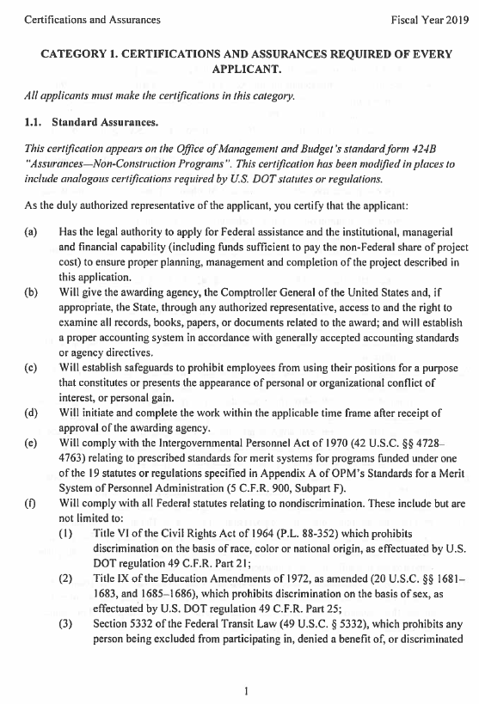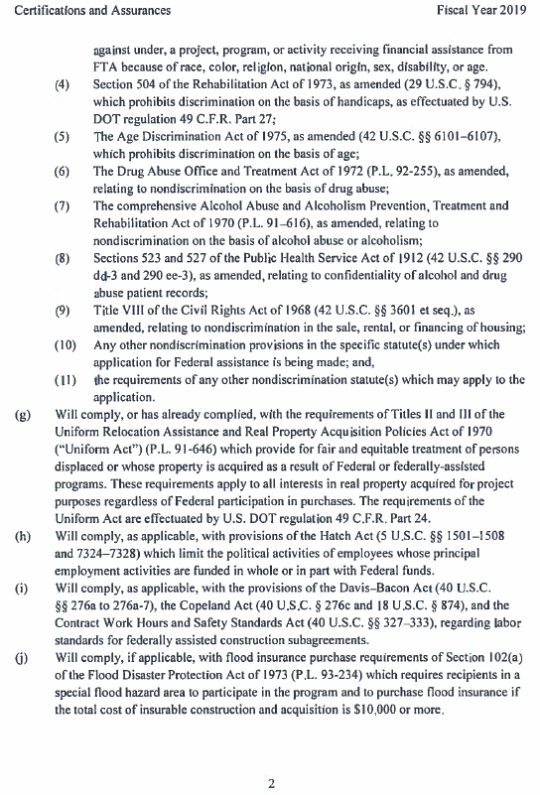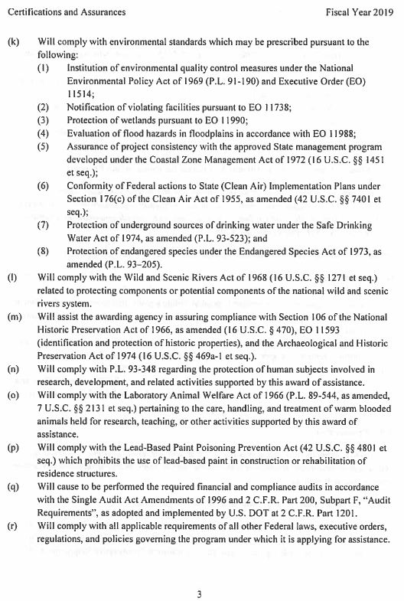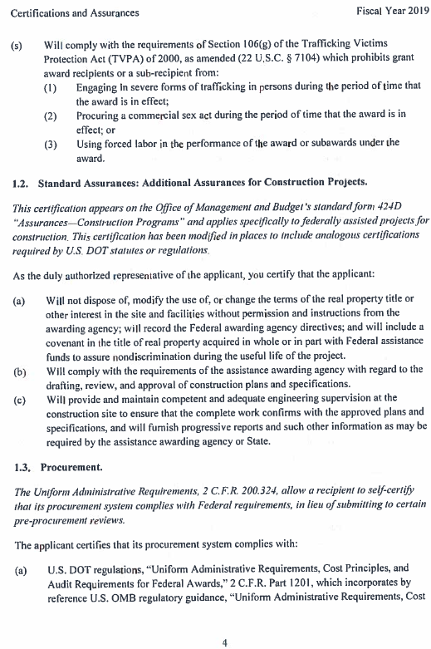
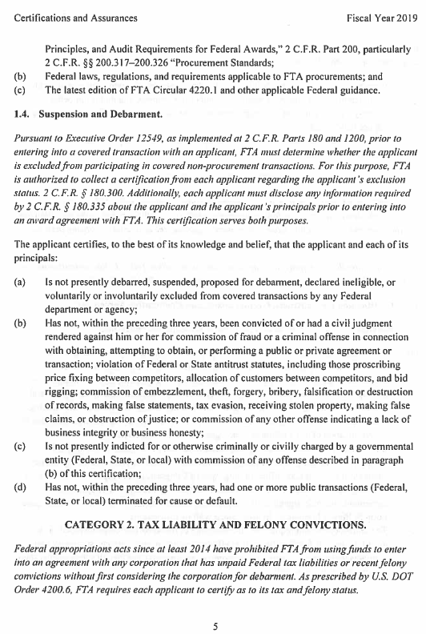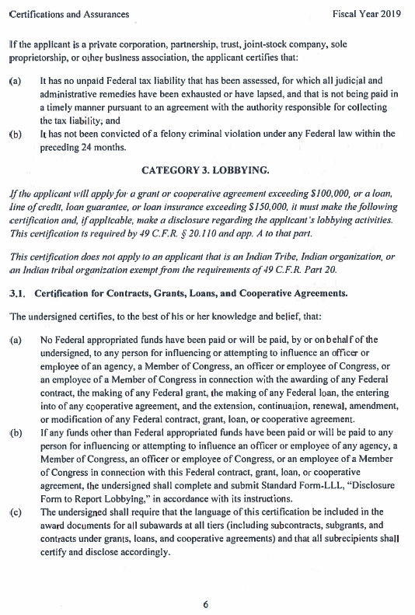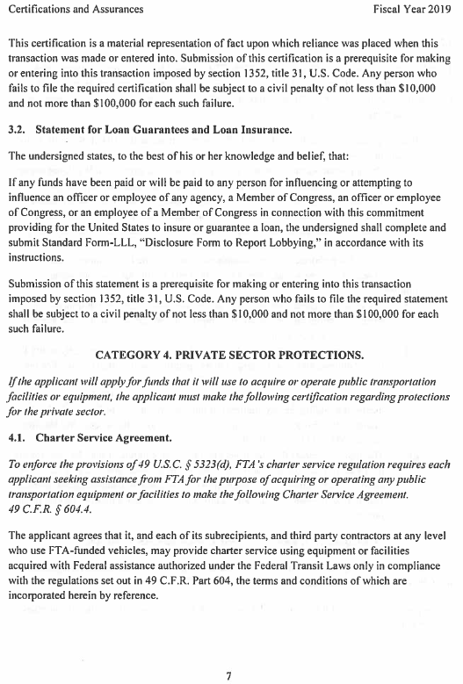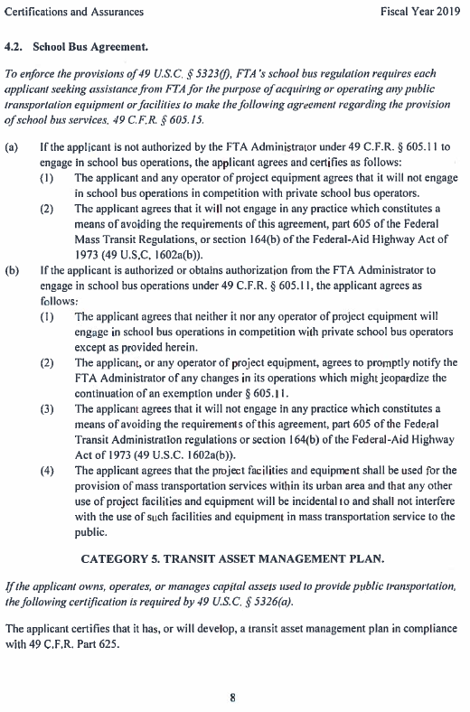
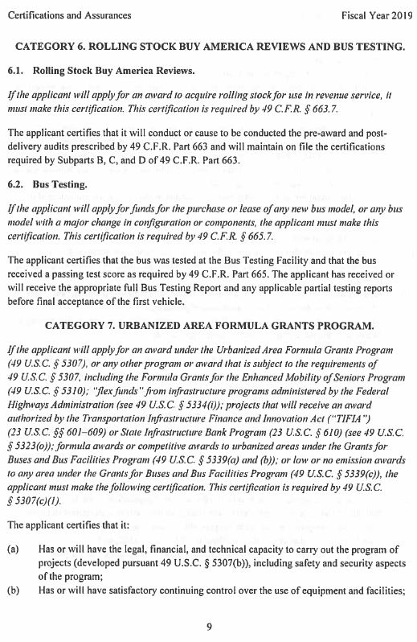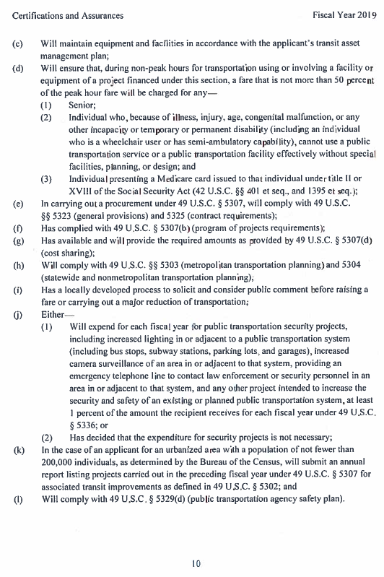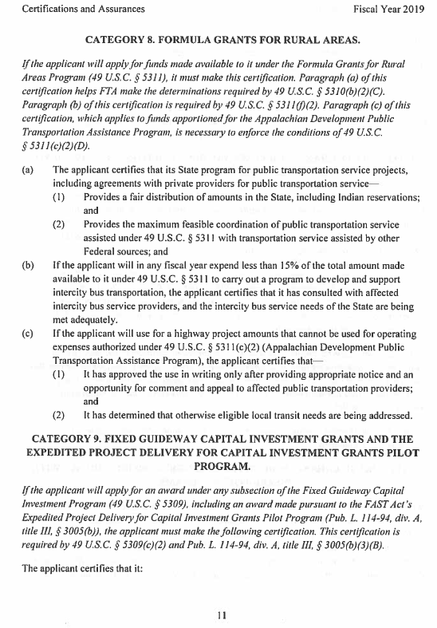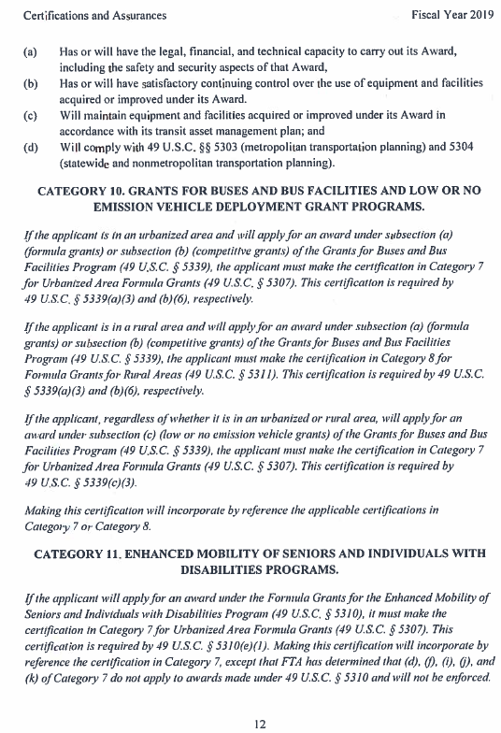
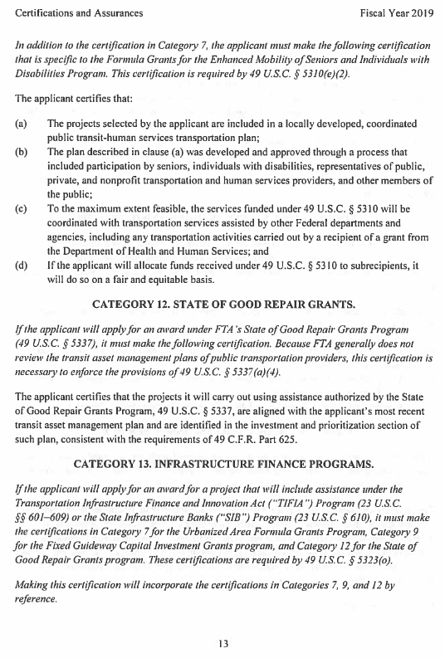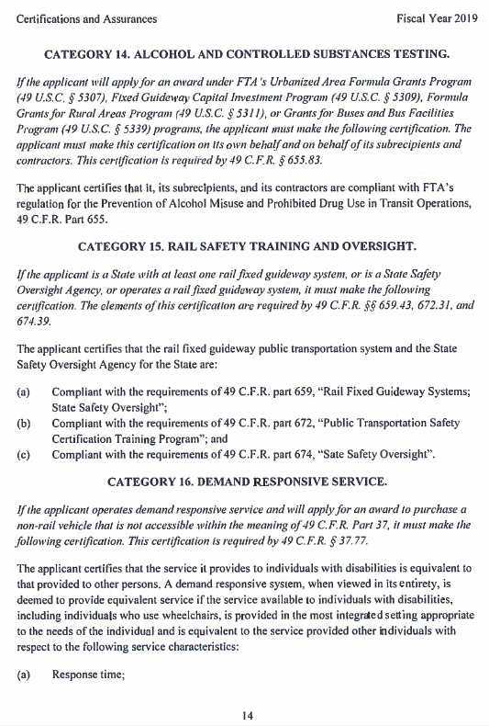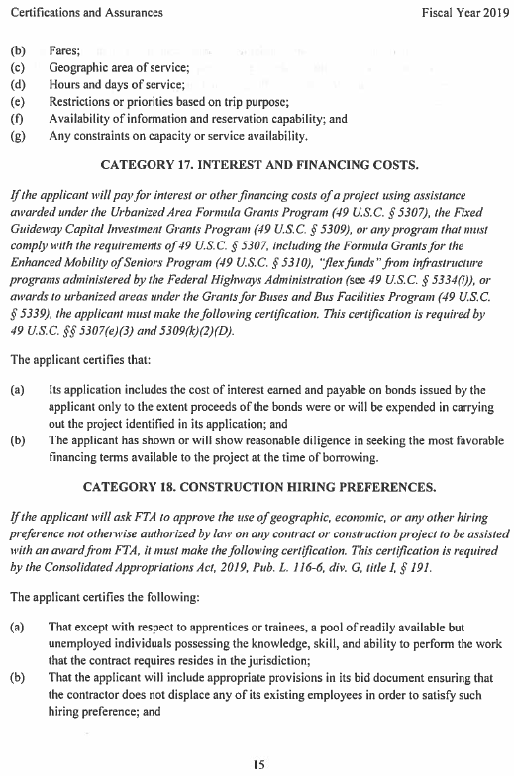
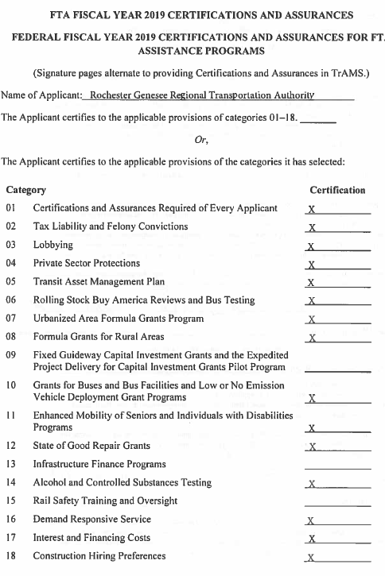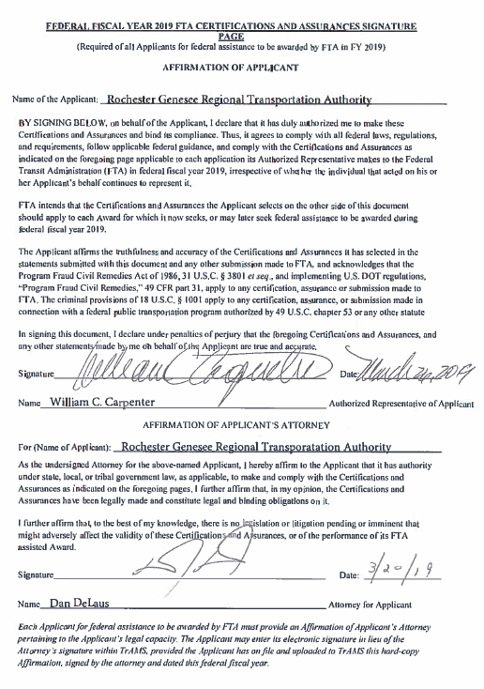
Under Category 1, in 1.1. Standard Assurances, item (f)(3) specifically states that the Applicant (R G R T A) will comply with all Federal statutes related to nondiscrimination and references It references federal transit law 49 U.S.C. § 5332, which prohibits any person being excluded from participating in, denied a benefit of, or discriminated against under, a project, program, or activity, receiving financial assistance from FTA because of race, color, religion, national origin, sex, disability, or age.
End of Exhibit 14.

Exhibit 15: MPO Certification
This exhibit will contain the scanned MPO Certification of Paratransit Plan after it is performed and signed by the Authorized Official, Director James Stack. The certification says that “The Genesee Transportation Council hereby certifies that it has reviewed the A D A paratransit plan prepared by the Rochester Genesee Transportation Authority for the subsidiary RTS Access as required under 49 CFR Part 37.139(h) and finds it to be in conformance with the transportation plan developed under CFR part 613 and 23 CFR part 450 (the FTA/FHWA joint planning regulation). This certification is valid for one year.”
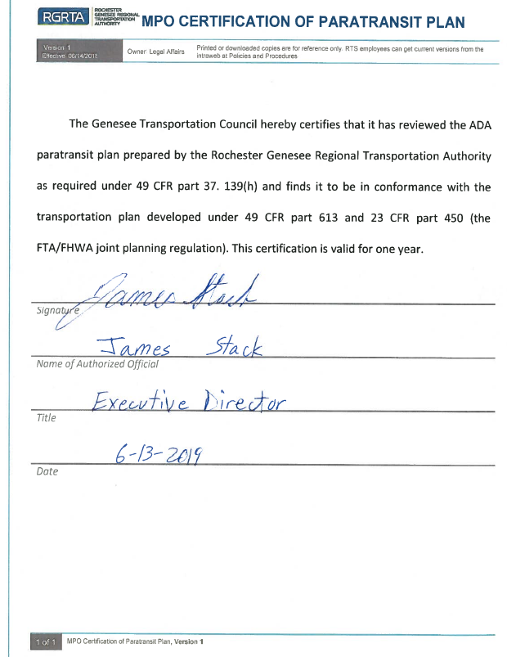
End of Exhibit 15.

Exhibit 16: Ratified Board Resolution RGRTA 34-2019
This exhibit will show the scanned pages of the ratified (signed) resolution RGRTA 34-2019 indicating that the R G R T A Board of Commissioners has approved and authorized the RTS Access Paratransit Plan for implementation during 2019 as practicable and in the Summer of 2020.
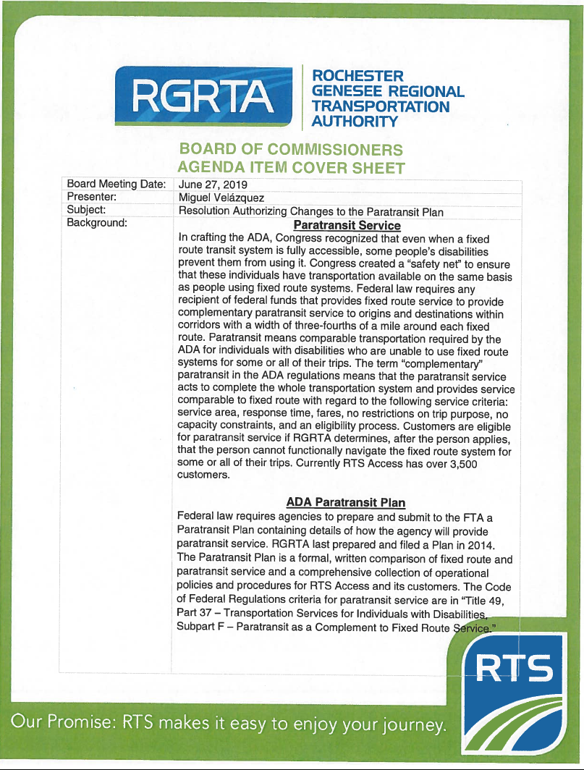
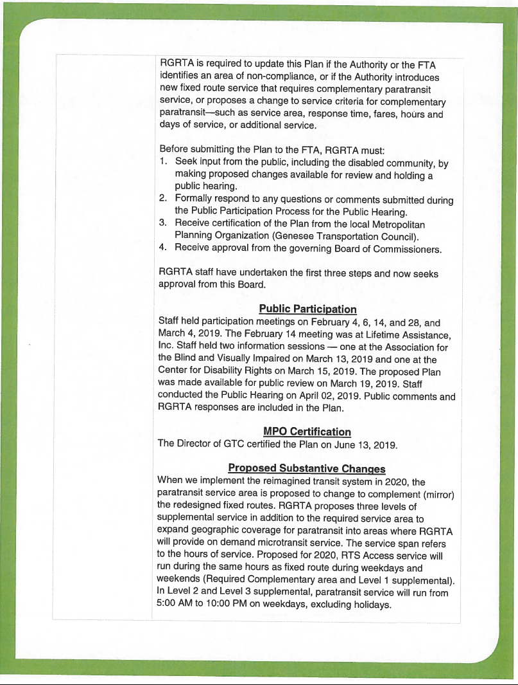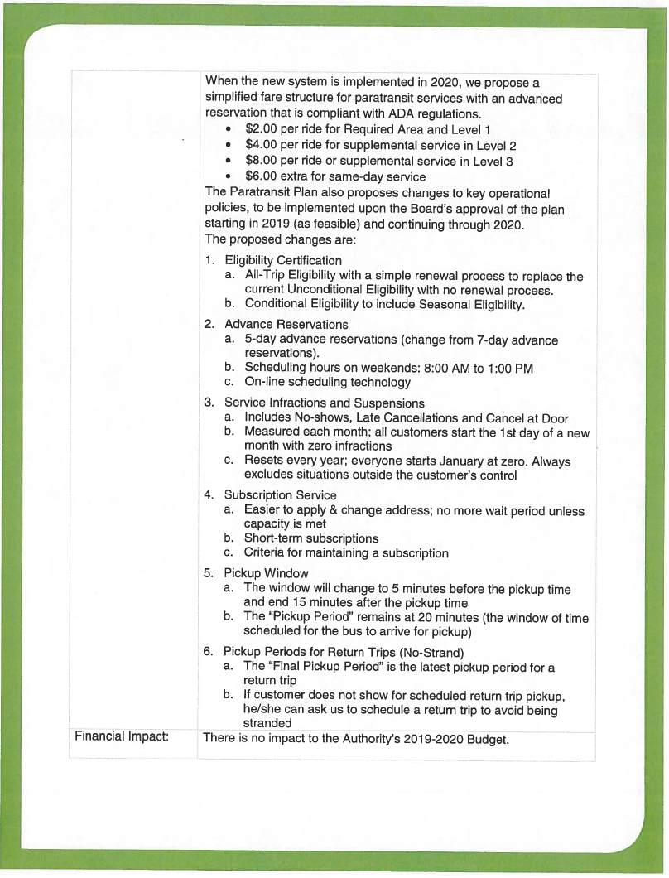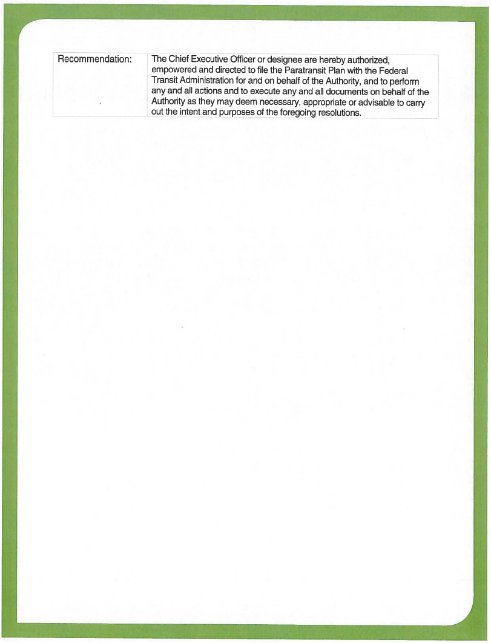
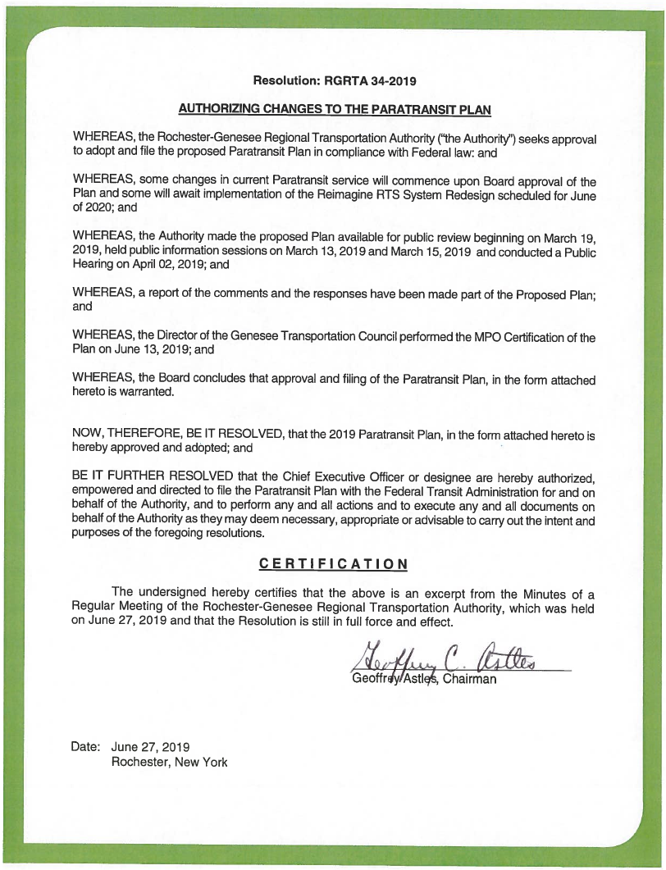

The text from ratified (signed) resolution R G R T A 34-2019 is as follows.

Resolution: R G R T A 34-2019

Board of Commissioners Agenda Item Cover Sheet
Board Meeting Date: June 27, 2019
Presenter: Miguel Velazquez
Subject: Resolution Authorizing Changes to the Paratransit Plan

Background

Paratransit Service
In crafting the A D A, Congress recognized that even when a fixed route transit system is fully accessible, some people’s disabilities prevent them from using it. Congress created a “safety net” to ensure that these individuals have transportation available on the same basis as people using fixed route systems. Federal law requires any recipient of federal funds that provides fixed route service to provide complementary paratransit service to origins and destinations within corridors with a width of three-fourths of a mile around each fixed route. Paratransit means comparable transportation required by the A D A for individuals with disabilities who are unable to use fixed route systems for some or all of their trips. The term “complementary” paratransit in the A D A regulations means that the paratransit service acts to complete the whole transportation system and provides service comparable to fixed route with regard to the following service criteria: service area, response time, fares, no restrictions on trip purpose, no capacity constraints, and an eligibility process. Customers are eligible for paratransit service if R G R T A determines, after the person applies, that the person cannot functionally navigate the fixed route system for some or all of their trips. Currently RTS Access has over 3,500 customers.

A D A Paratransit Plan
Federal law requires agencies to prepare and submit to the FTA a Paratransit Plan containing details of how the agency will provide paratransit service. R G R T A last prepared and filed a Plan in 2014.
The Paratransit Plan is a formal, written comparison of fixed route and paratransit service and a comprehensive collection of operational policies and procedures for RTS Access and its customers. The Code of Federal Regulations criteria for paratransit service are in “Title 49, Part 37— Transportation Services for Individuals with Disabilities, Subpart F—Paratransit as a Complement to Fixed Route Service.”
When the new system is implemented in 2020, we propose a simplified fare structure for paratransit services with an advanced reservation that is compliant with A D A regulations.
$2.00 per ride for Required Area and Level 1
$4.00 per ride for supplemental service in Level 2
$8.00 per ride or supplemental service in Level 3
$6.00 extra for same-day service
The Paratransit Plan also proposes changes to key operational policies, to be implemented upon the Board’s approval of the plan starting in 2019 (as feasible) and continuing through 2020. The proposed changes are:
- Eligibility Certification
- All-Trip Eligibility with a simple renewal process to replace the current Unconditional Eligibility with no renewal process.
- Conditional Eligibility to include Seasonal Eligibility.
- Advance Reservations
- 5-day advance reservations (change from 7-day advance reservations).
- Scheduling hours on weekends: 8:00 AM to 1:00 PM
- On-line scheduling technology
- Service Infractions and Suspensions
- Includes No-shows, Late Cancellations and Cancel at Door
- Measured each month; all customers start the 1st day of a new month with zero infractions
- Resets every year; everyone starts January at zero. Always excludes situations outside the customer’s control
- Subscription Service
- Easier to apply & change address; no more wait period unless capacity is met
- Short-term subscriptions
- Criteria for maintaining a subscription
- Pickup Window
- The window will change to 5 minutes before the pickup time and end 15 minutes after the pickup time
- The “Pickup Period” remains at 20 minutes (the window of time scheduled for the bus to arrive for pickup)
- Pickup Periods for Return Trips (No-Strand)
- The “Final Pickup Period” is the latest pickup period for a return trip
- If customer does not show for scheduled return trip pickup, he/she can ask us to schedule a return trip to avoid being stranded

Financial Impact
There is no impact to the Authority’s 2019-2020 Budget.

Recommendation
The Chief Executive Officer or designee are hereby authorized, empowered and directed to file the Paratransit Plan with the Federal Transit Administration for and on behalf of the Authority, and to perform any and all actions and to execute any and all documents on behalf of the Authority as they may deem necessary, appropriate or advisable to carry out the intent and purposes of the foregoing resolutions.

Resolution: R G R T A 34-2019 Authorizing Changes to the Paratransit Plan
WHEREAS, the Rochester-Genesee Regional Transportation Authority (“the Authority’) seeks approval to adopt and file the proposed Paratransit Plan in compliance with Federal law: and
WHEREAS, some changes in current Paratransit service will commence upon Board approval of the Plan and some will await implementation of the Reimagine RTS System Redesign scheduled for June of 2020; and
WHEREAS, the Authority made the proposed Plan available for public review beginning on March 19, 2019, held public information sessions on March 13, 2019 and March 15, 2019 and conducted a Public Hearing on April 02, 2019; and
WHEREAS, a report of the comments and the responses have been made part of the Proposed Plan; and
WHEREAS, the Director of the Genesee Transportation Council performed the MPO Certification of the Plan on June 13, 2019; and
WHEREAS, the Board concludes that approval and filing of the Paratransit Plan, in the form attached hereto is warranted.
NOW, THEREFORE, BE IT RESOLVED, that the 2019 Paratransit Plan, in the form attached hereto is hereby approved and adopted; and
BE IT FURTHER RESOLVED that the Chief Executive Officer or designee are hereby authorized, empowered and directed to file the Paratransit Plan with the Federal Transit Administration for and on behalf of the Authority, and to perform any and all actions and to execute any and all documents on behalf of the Authority as they may deem necessary, appropriate or advisable to carry out the intent and purposes of the foregoing resolutions.

Certification
The undersigned hereby certifies that the above is an excerpt from the Minutes of a Regular Meeting of the Rochester-Genesee Regional Transportation Authority, which was held on June 27, 2019 and that the Resolution is still in full force and effect.
Signature of Geoffrey C. Astles, Chairman
Date: June 27, 2019 Rochester, New York
End of Exhibit 16.
End of Exhibits for Section 6

Section 7: Plan Updates
Customers, agency representatives, and members of the public can submit comments and suggestions through http://rts.force.com/RTSContactUs or (585) 288-1700.
Annually, operations management for RTS Access will review the processes/procedures identified in the Plan and evaluate RTS Access for comparable paratransit service according to the requirements in 49 CFR Subtitle A, Part 37, Subpart F of the federal regulations.

7.1. Non-substantive Changes to the Plan
R G R T A may elect to update this Plan at its discretion for planning purposes, to correct errors, or to document improvements or clarifications to operational practices. Such changes will be considered non-substantive. The changes will go through an internal review and approval process using the R G R T A document management system and will require the participation and acceptance of the Chief Operating Officer and Chief Executive Officer. The updated Plan will be available to employees through the company intraweb and posted on the public website www.myrts.com.

7.2. Substantive, Required Changes to the Plan
R G R T A is required to update this Plan if the Authority or the FTA identifies an area of non-compliance, or if the Authority introduces new fixed route service that requires complementary paratransit service, or if the Authority proposes a change to service criteria for complementary paratransit—such as service area, response time, fares, hours and days of service, or additional service. Such changes will be considered substantive and will require public participation, opportunity for public comment, and at least one public hearing. R G R T A will also obtain the certifications and endorsements required under §37.139(h), including but not limited to a resolution adopted by the R G R T A Board of Commissioners authorizing the plan and a certification of conformance by the Genesee Transportation Council. The updated Plan will be available to employees through the company intraweb and posted on the public website www.myrts.com.
End of Section 7
End of RTS Access A D A Paratransit Plan for Summer 2020

