Paratransit Plan Exhibits 1 and 2 of 14

  - EXHIBIT 1: RTS SYSTEM MAP AND SCHEDULES
This exhibit provides the link to the RTS Service Map for April 2017 https://www.myrts.com/Portals/0/Schedules/RTS-System-Map-April-3-2017.pdf and the link to the portion of the RTS website containing the maps and schedules effective as of September 4, 2017 for RTS fixed routes https://www.myrts.com/Maps-Schedules/RTS-Monroe/Schedule-pdfs. This information is provided to give reviewers an understanding of the route structures, time tables, and service area for RTS fixed route.
End of Exhibit 1
  - EXHIBIT 2: PARATRANSIT SERVICE AREA MAPS
This exhibit uses text to describe the map representations of the Regular Service Area ADA 0.75 miles and the Supplemental Service Area 1.5 miles. Weekday Service Area. The RTS Access service area is a corridor with a width of ¾ of a mile on each side of each fixed route. At the end of a route, there is a semicircular “cap” on the corridor, consisting of a ¾- mile radius from the endpoint of the route to the parallel sides of the corridor. This is shown in the maps as a green area labeled as "Regular Service Area - ADA 0.75 Miles." RTS Access will provide paratransit service to any origin or destination point within a corridor fitting this description around any route in the RTS system during the same hours and days of service in the RTS system. Within the core service area, RTS Access will provide service to areas entirely enclosed by fixed routes. All RTS Access trips must begin and end within the service area. RTS Access provides a supplemental service 1½ miles beyond the ADA defined ¾-mile service area, for a total service area of 2¼ miles on each side. The supplemental service is provided for an added cost and only if space is available after accommodating requests for service within the ADA-defined service area. If space is available, supplemental trips can be scheduled Monday through Sunday and on holidays. RTS Access will expect customers who wish to use the supplemental service to accept the possibility of unavailable space when attempting to reserve a trip and pay the supplemental rate upon boarding for the bus for a scheduled supplemental trip. The maps show supplemental service as a blue area labeled as "Supplemental Service Area - 1.5 Miles."
The Weekday Service Area map shows the entire geographic area in which RTS Access provides complementary paratransit service in Monroe County. The weekday paratransit service mirrors the weekday RTS fixed routes.
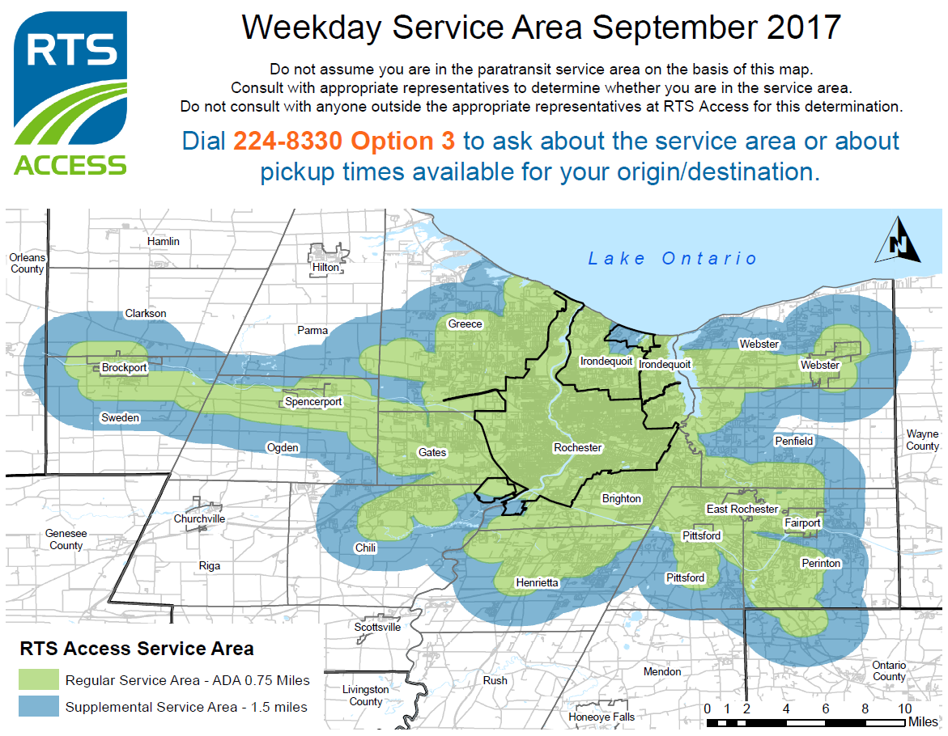
The Saturday Service Area map shows the geographic area RTS Access serves when providing service comparable to the Saturday RTS fixed routes in Monroe County. This area is smaller than the Weekday Service Area.
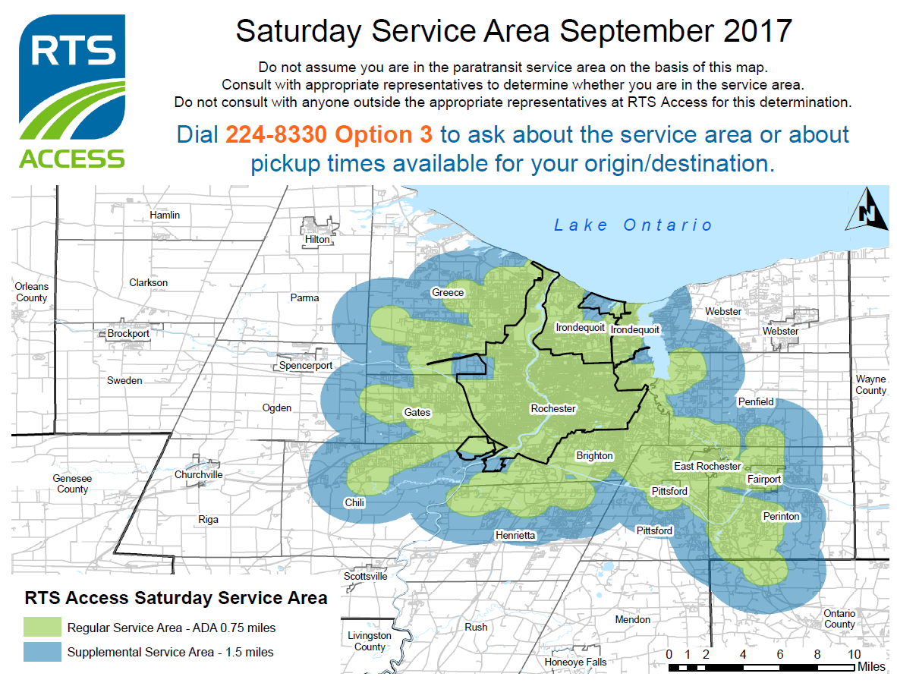
The Sunday Service Area map shows the geographic area RTS Access serves when providing service comparable to Sunday RTS fixed routes in Monroe County. This area is smaller than the Saturday Service area.
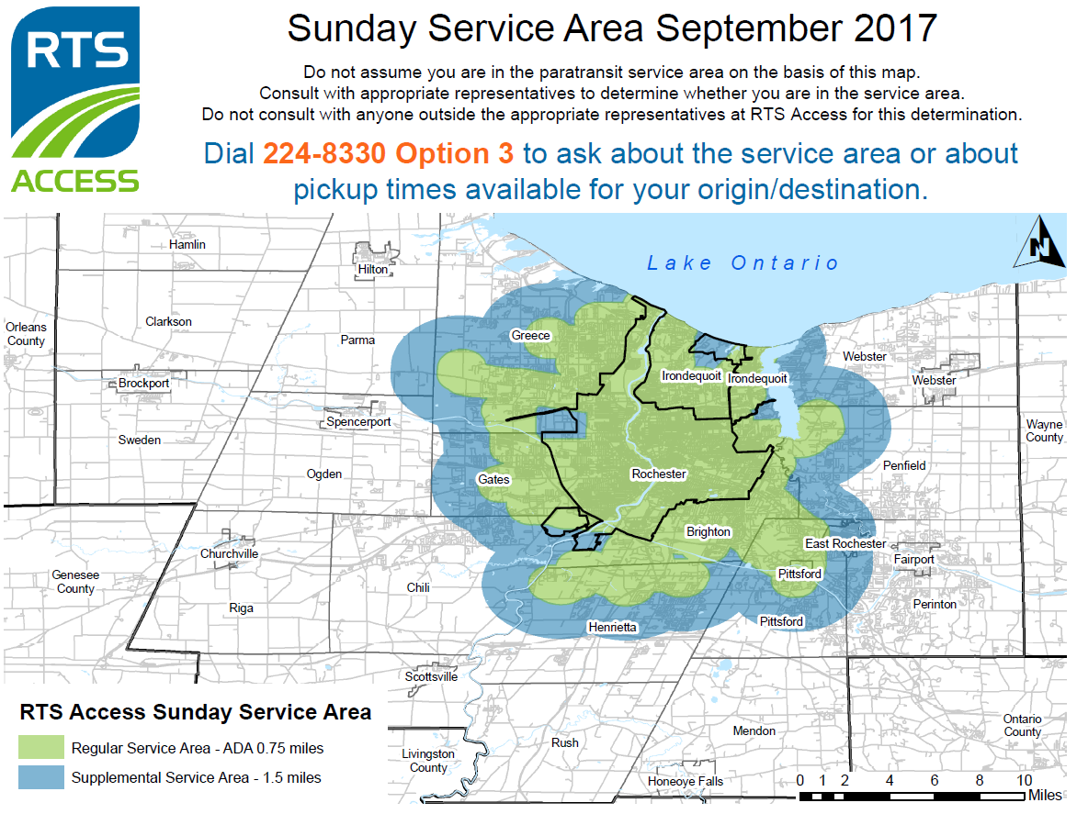
RTS fixed route service runs from 4:41 AM to 2:04 AM on weekdays, from 4:53 AM Saturday morning to 3:18 AM Sunday morning, and from 4:54 AM Sunday morning to 2:09 AM Monday morning. The fixed routes have specific schedules with start times for the first stop and end times for the last stop. To provide comparable paratransit service, RTS Access buses run within the same time-ranges as a comparable fixed route serving the same area. RTS Access customers call and schedule their time for pickup, but the pickup times cannot occur outside the time-range corresponding to a fixed route in that area. The RTS Fixed Route Schedules are available online at https://www.myrts.com/Maps-Schedules/RTS-Monroe/Schedule-pdfs. RTS Access customers can dial 585-224-8330 Option 3 for details about the available pick-up times. A Note on each of the maps says the following: Do not assume you are in the paratransit service area on the basis of this map. Consult with appropriate representatives to determine whether you are in the service area. Do not consult anyone outside the appropriate representatives at RTS Access for this determination. Dial 224-8330 Option 3 to ask about the service area or about pickup times available for your origin/destination.
End of Exhibit 2
There are 14 total Exhibits available for public comment.

