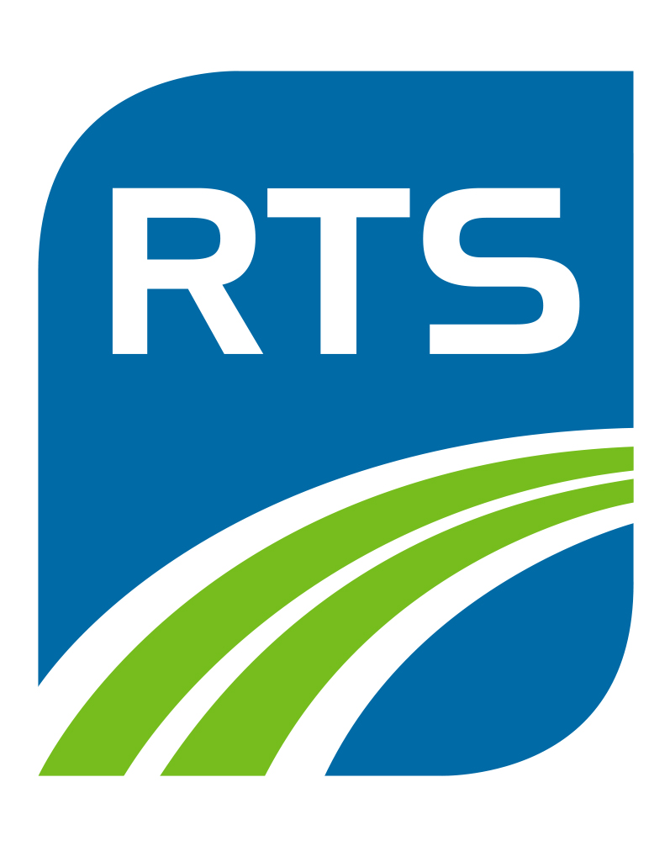
APPLICATION REQUEST FOR CREDIT TO PURCHASE BUS PASSES
Instructions: Please fully complete the form, print, sign, and mail a copy to RTS Customer Service at 1372 East Main Street, Rochester, NY 14607 or upload the completed and the scanned .pdf document online at myRTS.com/contact-us. Please allow 2 to 3 weeks to process the application. Thank you! Questions? Please contact us at 585-288-1700.
 |  |  | ACCOUNT STATUS: NEW RENEWAL
BUSINESS NAME |  |  | LEGAL NAME
BUSINESS ADDRESS |  |  | TELEPHONE
BUSINESS OWNER |  |  | TITLE
TYPE OF BUSINESS |  |  | HOW LONG IN BUSINESS AT THIS LOCATION
FEDERAL ID # |  |  | DUNN & BRADSTREET #
PLEASE ATTACH: | ANNUAL REPORT |  | BANK STATEMENTS |  | TAX RETURNS
IF NO ANNUAL REPORT AVAILABLE PROVIDE: |  | CURRENT ASSETS  $ |  | CURRENT LIABILITIES  $ |  | CASH ON HAND  $

REFERENCES

BANK | TRADE
YOUR BANK’S NAME | COMPANY NAME |  | COMPANY NAME
BANK ADDRESS | ADDRESS |  | ADDRESS
TELEPHONE | BUSINESS RELATIONSHIP |  | BUSINESS RELATIONSHIP
NAME OF CONTACT PERSON | NAME OF CONTACT PERSON |  | NAME OF CONTACT PERSON
ACCOUNT # | TELEPHONE | FAX | TELEPHONE | FAX
ACCOUNT TYPE | OFFICE USE ONLY |  | OFFICE USE ONLY
 | VERIFIED BY | DATE | VERIFIED BY | DATE

Everything that I have stated in this Request for Credit is correct and to the best of my knowledge. I understand that RTS will retain this application whether or not It is approved. RTS is authorized to check my credit history.
APPLICANT’S SIGNATURE |  | SOCIAL SECURITY # |  | DATE OF APPLICATION |  | DATE OF BIRTH

